Research Paper
Practice-Based Multidisciplinary Working: Themes and Considerations
Raziqa Virani
University of Essex

Abstract
Working in a Multidisciplinary Team (MDT) has its limits and challenges with professionals from different backgrounds and knowledge bases. MDT is a common form of organization within the healthcare profession to bring together the diverse knowledge and skills of Allied Health Professionals (AHPs) and healthcare services to jointly care and plan services provided to individuals with diverse needs. This essay aims to explain strengths and weaknesses within themes in communication alongside the Gibbs Reflective model in a practice-based MDT module in a University setting. Specifically, it investigates the use of technology and stereotypes witnessed between an MDT group of students from physiotherapy, speech and language therapy, and occupational therapy disciplines. The results demonstrate development in understanding effective forms of communication and stereotypes, as witnessed within the group, as well as the importance of the ease of message relay and relevance of occupational therapy. These results suggested that within a practice MDT student-led group in a University setting, it is vital for trust and open forms of communication to be the proper building blocks leading up to a safe and effective practice for future patient care.
Keywords: Stereotypes, Multidisciplinary Team, Communication, Occupational Therapy

Gibbs Reflective Cycle Model
For this research paper, I decided on using the Gibbs Reflective Cycle Model. This model was established in 1988 by Graham Gibbs, and its purpose was to give structure to how we learn from our experiences (The University of Edinburgh, 2020). Gibbs incorporates the following topics: description, feelings, evaluation, analysis, conclusion, and action plan, in a cyclical pattern (2020). The reasoning behind using this model is that the cyclic pattern is integral to how we reflect and learn in our daily lives. This pattern is a metaphor for how life’s moments play on one another, each building on top of the other, learning and growing from each experience. In my opinion, past and present experiences have a role to play in our reflections and communication with others. Compared to the Schön model, for example, which incorporates the individual reflecting on the event before and after it occurs, my reasoning for using the Gibbs model is the use of feelings in our reflections (Getting started with Reflective Practice, 2020). Feelings allow us to shape and drive our overall social identity i.e., “specific emotions are instrumental to the expression of a particular identity, leading [us to develop] emotional profiles [of ourselves]” (Verocchi, 2012, p.9). These emotions are present in a group setting: for example, when introducing ourselves to other members of the group during an initial meeting; when interacting with our family and friends; and how we help friends in need. Emotions are prominent in every aspect of our lives and are central to who and what we are as individuals.
In Occupational Therapy (OT), reflection and evidence-based practice are crucial skills that shape our thinking and decision-making process; they correlate with acquiring knowledge and learning from our past experiences, and this is present in our practice (Bannigan, 2009). OTs professionally use reflections in practice to appraise their skills, abilities, "personal beliefs and values as they relate to [they are] professional life" in occupational therapy (College of Occupational Therapists, 2015, p.42). OT’s therapy sessions use reflections as well for patient-centred care, to reconnect patients with their meaningful occupations; enabling them to focus on, “doing, being, becoming and belonging” aiding their overall, “reflection and self-discovery” (Hitch, Pépin, and Stagnitti, 2014, pp.231-246). This reflective process allows for better methods of communication and the effectiveness of technology and professional jargon use are vital to the development of the individual within a group dynamic.

Themes in Communication
“Communication occurs when health providers communicate in open, collaborative manner building trust amongst team members” (Winnipeg Regional Health Facility, 2016, p.1). The correlating themes concerning communication are critically and reflectively elaborated on below.
Technology
A strength observed in our interprofessional working (IPW) for our group poster is how effective our communication via technology was, given our understanding of our strengths and weaknesses via the Belbin Assessment tool (Appendix 5). Allied Health professionals (AHPs) utilize technology to improve learning and development, to ensure effective communication between other AHPs (Chief Allied Health Professions Officer’s Team, 2017). In OT, technology is used to help therapists work in “partnership” with clients, identifying “various needs [and] problems in a detailed holistic way”; as well as enhancing technology used in communication with other AHPs (Reynolds, 2005, p.192). Within this dynamic, technology “enables interprofessional collaboration at its highest level” (Troseth, 2017, pp.15-17). Information technology uses email, telephones, video conferencing (Appendix 1 & 2-highlighted portion in green and Appendix 3), which allows “information to be transferred more easily between members… [leading to] reduced professional isolation and results in enhanced patient care” (Day, 2013, p.95).
Description
The highlighted portion in the green of Appendix 1 & 2 is an example of how our group set up our initial communication. Given our diverse age range in our group, we were well acquainted with technology use and mutually agreed to use Facebook Messenger as the main method of communication. However, a potential weakness seen in our group was how difficult it was to convey the tone of voice over Facebook Messenger (Appendix 3 & 4). This can be seen as a drawback, as messages could be misinterpreted negatively and cause a misunderstanding between the group. As seen in Appendix 4, we felt the need to add certain caricatures or symbols to ease the conversation and make sure we conveyed kindness to others in the group; this meant that the communication in the group had a form of comfortability, even over technology. Appendix 5 is an example of our Belbin results, which allowed us to understand our team members better. Throughout this module, a positive aspect of our communication skills is how honest and agreeable we were with one another. We agreed on a schedule where we had weekly check-ins on our group members to ascertain their assignment progress via Facebook Messenger (Appendix 1&2). As a group, we mutually agreed on using OneDrive to upload our work completed for the poster. There were occasions where certain members of our group had to attend a doctor's appointment (Appendix 8), and this was honestly communicated to us in Facebook Messenger group chat in advance, which allowed us to prepare for our upcoming class meetings.
Feelings
The aforementioned events and the initial setup of our communication, as well as seeing how well we communicated together via Facebook Messenger as the module continued, gave me the feeling of accomplishment and productivity as assignment tasks devised by the group were started and completed promptly. Having everyone in the group agree on our schedule and use of One Drive made my respect for my group grow and, as well a feeling of excitement to work with like-minded individuals. It was a positive feeling to see how our initial communication was amicable and how its progression over time led us to be even more honest towards the end of the module, even if some days were affected by our feelings, moods, or other extrinsic factors (Appendix 8).
Evaluation
Previously my experience with using technology as means of communication with past group members was a negative one. Specifically, a lack of face-to-face communication led to misunderstandings due to tone issues. Moreover, group members not replying to messages or emails led to disjointed communication. However, as the group became proactive in suggesting what communication device to use, i.e., Facebook Messenger and OneDrive, how we were active in the group chat, and how we thrived in our communication, my initial apprehensions changed. One prominent example of the group's proactiveness is how effectively we dealt with a group member being in a country with a six-hour time difference to the rest of us due to COVID-19. In this sense, our communication thrived in a way that everyone was ensuring that we completed specific tasks for the poster symposium. If anyone were struggling, we would take the time to explain what further steps needed to be taken to complete the task (Appendix 4). On further evaluation of this event, I can understand how a proactive group communicates. Even if our moods were off with intrinsic or extrinsic factors, we were still able to thrive in this situation with our positive group dynamic. I also understand how technology can be a great tool of communication, as open communication leads to high effectiveness and overall success of team working (Schiller and Cui, 2010).
Analysis
One further reflection from this experience is that I should not let my past negative experience with technology hinder my present experiences. The initial establishment of using Facebook Messenger and OneDrive to communicate had a positive effect on the group dynamics. Moreover, using Belbin to “maximize [our] working relationship...enabled [us] to learn about [our]selves” via our strengths and weaknesses and devise a schedule for weekly group check-ins; this steered the group dynamics into a positive direction (Knoll et al., 2015, p.3). In my group, I will continue to use this technique and lead the group towards effective communication via technology. I will also ensure that my group can talk to each other more openly. However, if this does not occur or seem feasible, then changes can be made. Specifically, by asking other members what means of communication they find helpful, how have they benefited in the past with technology use, and how as a group we could provide as much support as possible.
Conclusion
In conclusion, I learned a lot about myself in relation to I can take more initiative when it comes to using technology to communicate. Concerning our group communication, a lack of face-to-face communication would typically have been difficult for me. However, with Facebook Messenger as our form of communication, I was able to be more proactive when communicating my past experiences with my group and allowing myself to be more open with this aspect. Under the section “Communication Standards” of the HCPC (health and care professions council), it states, “you must use all forms of communication appropriately…[and] work in partnership with colleagues” (Health & Care Professions Council (HCPC), 2018, p.6). This section in the HCPC is encouraging since our guidelines want AHPs to openly communicate with one another for the benefit of not only themselves but for our clients since effective communication, "ensure effective and safe patient care" (Weller, Boyd, and Cumin, 2014, pp.149-154). Concerning my overall development, I found it easier to send simple texts to my group to ask how they were getting along in their work and receiving a fast reply; this made communicating easier. Therefore, I will be using this form of communication more frequently in my future group work.
Action Plan
In the future, with technology and group communication, I will try to take an active role by setting up group dynamics initially and schedule how often other members should check on one another as a courtesy. If I find that members of the group are struggling at this initial communication step, or they are not technologically savvy, I will feel compelled to set up communication in the group. I would hope to find a common ground for everyone in the group to thrive concerning how we communicate and build on our team development.

Stereotypes
Stereotypes can be seen as a form of professional socialization that allows us to connect via values, skills, and knowledge about our overarching professional body as AHPs (Baxter and Brumfitt, 2009; Zarshenas, 2014). A weakness seen in our interprofessional working is the notion of stereotypes (Appendix 6). “Stereotypes [are] held by healthcare students [that] may affect interactions and communication…it is important to examine stereotypes of healthcare students that interfere with communication and collaboration (Cook and Stoecker, 2014, p.1). These types of negative stereotypes, i.e., use of own language related to a professional body (Appendix 7) or favoritism towards related AHPs, is a major contributor to "work dissatisfaction and poor communication" in interprofessional working (Mandy, Milton, and Mandy, 2004, pp.154-170). The stereotypes within our groups initially hindered our communication by preventing the natural comfortability within our group to take place; this caused a sense of separation within the group (Appendix 7). This was difficult due to fears of negative stereotypes of each other's professions (Appendix 6) and communication within the group dynamic itself (Appendix 7). However, after further discussion with the group in the upcoming weeks of the module and building that “sense of belonging” to a group, i.e., being a part of AHPs in general, we effectively developed our own MDT (multidisciplinary team how) for the better with constructive communication and understanding (Inzlicht and Good, 2005, pp.1-26).
Description
In the highlighted portion in yellow of Reflection Week 2 (Appendix 1), there were moments when stereotypes (Appendix 6&7) were evident in the module and between our group dynamic. Members of the group were specifically communicating with other members that were part of their professional bodies. I also felt the physiotherapists had complete confidence in their discussion answers, frequently using the language of their professional bodies (Appendix 7).
Feelings
This event made me feel excluded from the group, and I found it hard to speak up or communicate my ideas effectively to the other members. The overall group dynamic made me feel that my opinions would not matter, and therefore, I felt more comfortable talking to my OT colleague. I felt very disjointed from the group when the physiotherapists used their own professional "language" when describing their role for the assigned case study, as the jargon used was not one that I am used to when it comes to OT.
Evaluation
Previously, my thinking about AHPs was open, and I had a positive way of thinking; I thought that AHP's are welcoming towards one another and supportive. However, my way of thinking changed after noticing the stereotypes mentioned in class, and my interaction with individuals in my group negatively changed my perspective. This caused a sense of alienation within the group and led to ineffective communication. On further evaluation of the experience, I believe it was either hearing about specific stereotypes (Appendix 6) that changed my thinking, or being in an unfamiliar situation - specifically, the use of unfamiliar jargon (Appendix 7) - that may have affected why I perceived the group in a negative aspect.
Analysis
Upon further reflection of this experience, I feel that it would be beneficial for me to avoid stereotypes from obstructing my thinking. I need to be more open-minded and conduct myself in a positive and welcoming way in the group. This could be achieved by taking the initiative to introduce myself, talk about my past experiences to avoid communication errors, i.e., get first-hand interaction with the group free of bias, and start an icebreaking conversation with others in the group. If this were done initially, then other group members would have an open concept of communication with each other, without any form of negative aspect from one another. In the future, I believe that it is crucial to not allow specific fears or stereotypes I hear of certain professions to hinder my overall thinking. Moreover, I will now go into every situation with an open mind.
Conclusion
In conclusion, I have learned a great deal about myself and how I can try to react positively when conversing and working with other HCPs. This event was a great experience overall, as I was able to see how I developed from the first meeting and to the end of the module. By the end of this experience, the group became closer as we had effectively built on our open communication, and we had connected in a deep, yet professional manner.
Action Plan
In the future, when I come across this type of situation in OT, it is essential to not allow specific fears or stereotypes I hear of certain professions to hinder my thought process. If in the future, I hear negative stereotypes of other AHPs, I would do my best to communicate my positive interactions with AHPs, so that I can uplift and educate others on my enjoyable experience. I also believe that it will be crucial to explain to others what my background experience has been in; this way, it will show what level of communication applies to me. Therefore, communication will not be lost when it comes to the use of the other person's professional language, and they would be able to provide more explanation to myself and my group.

Occupational Therapy Relevance
According to the Accreditation Council for Occupational Therapy Education (ACOTE), occupational therapists must “be prepared to effectively communicate and work interprofessionally with those who provide care for individuals…to clarify each member’s responsibility in executing components of an intervention plan" (2011 Accreditation Council for Occupational Therapy Education (ACOTE®) Standards, 2011, pp.S6-S74). Technology is used in many aspects of Occupational Therapy, to “ensure [OTs] make [the] best use of what is available in our own practice” and communicate to other AHPs at other agencies for patient referrals (College of Occupational Therapists, 2015, p.42). However, one current issue seen within OT and IPW is “uni-professional mindset”. Here, dynamic patients in the hospital are referred and seen by providers from many different professions, each explaining their intervention. The patients are educated based on their educational background, without considering other healthcare workers alongside them, or how their intervention or education comes into play (Johnson, 2017, pp.CE1-CE6). Other health professionals need to consider other professions that they are working with and communicate effectively with other members before meeting a patient; this enables no overlap of information to occur and understanding of the interventions and education. If this issue were to continue it would not only affect how communication is conducted with other members of AHP groups, but it will also affect future patient care. We must ensure the communication is effective in all aspects to provide the best holistic care and allow for a speedy recovery.

Conclusion
In conclusion, for my future development in my career as an OT, I now fully understand the strengths and weaknesses of communication via technology and stereotypes, and how my future career as an OT can affect the group of professionals I work with. The main objectives in the future are to not give into stereotypes identified in the setting I am working in, and to create a positive dynamic between AHPs in my collaborative group. We must take on a leadership role and have open and honest communication with other members. This will enable our understanding of what forms of communication work effectively with different members, i.e., phone, email, texting, or messenger groups. I will endeavour to establish an initial basis of trust in future groups that I am a part of. I believe trust is the foundation for forms of open communication; this is will aid my interprofessional working allowing me to deliver the best patient-centred care possible.

References
American Journal of Occupational Therapy, 2011. 2011 Accreditation Council for Occupational Therapy Education (ACOTE®) Standards. 66(6_Supplement), pp.S6-S74.
Bannigan, K. and Moores, A. (2009). A Model of Professional Thinking: Integrating Reflective Practice and Evidence Based Practice. Canadian Journal of Occupational Therapy, 76(5), pp.342-350.
Baxter, S. and Brumfitt, S., 2008. Professional differences in interprofessional working. Journal of Interprofessional Care, 22(3), pp.239-251.
Cambridge-community.org.uk. 2020. Getting Started with Reflective Practice. [online] Available at: <https://www.cambridge-community.org.uk/professional-development/gswrp/index.html> [Accessed 4 April 2020].
Chief Allied Health Professions Officer’s Team, 2017. Allied Health Professions into Action: Using Allied Health Professionals to Transform Health, Care and Wellbeing. 1st ed. [ebook] London: NHS England. Available at: <https://www.england.nhs.uk/wp-content/uploads/2017/01/ahp-action-transform-hlth.pdf> [Accessed 25 April 2020].
College of Occupational Therapists, 2015. Code of Ethics and Professional Conduct. [ebook] London: Royal College of Occupational Therapists, p.42. Available at: <https://www.rcot.co.uk/practice-resources/rcot-publications/downloads/rcot-standards-and-ethics>
Cook, K. and Stoecker, J., 2014. Healthcare Student Stereotypes: A Systematic Review with Implications for Interprofessional Collaboration. Journal of Research in Interprofessional Practice and Education, 4(2)
Day, J., 2013. Interprofessional Working: An Essential Guide for Health and Social Care Professionals. 2nd ed. Andover: Cengage Learning
Health & Care Professions Council, 2018. Standards of Conduct, Performance and Ethics. [ebook] London: HCPC, Available at: <https://www.hcpc-uk.org/globalassets/resources/standards/standards-of-conduct-performance-and-ethics.pdf>
Hitch, D., Pépin, G. and Stagnitti, K., 2014. In the Footsteps of Wilcock, Part One: The Evolution of Doing, Being, Becoming, and Belonging. Occupational Therapy in Health Care, 28(3)
Inzlicht, M. and Good, C., 2005. How environments can threaten academic performance, self-knowledge, and sense of belonging. Stigma and Group Inequality: Social Psychological Approaches
Johnson, C., 2017. Understanding Interprofessional Collaboration: An Essential Skill for all Practitioners. AOTA Continuing Education Article, 22(11)
Knoll, S., Horton, G., Krull, C. and Dittmar, T., 2015. Belbin – the way forward for innovation teams. Journal of Creativity and Business Innovation, [online] 1, p.3. Available at: <http://www.journalcbi.com/ideation-using-analogies.html>
Mandy, A., Milton, C. and Mandy, P., 2004. Professional stereotyping and interprofessional education. Learning in Health and Social Care, 3(3)
Reynolds, F., 2005. Communication and Clinical Effectiveness in Rehabilitation. Edinburgh [u.a.]: Elsevier/Butterworth-Heinemann
Schiller, S. and Cui, J., 2010. Communication Openness in the Workplace: The Effects of Medium (F2F and IM) and Culture (U.S. and China). Journal of Global Information Technology Management, 13(2)
Troseth, M., 2017. Interprofessional collaboration through technology. Nursing Management (Springhouse), 48(8)
The University of Edinburgh. (2020). Gibbs' reflective cycle. [online] Available at: https://www.ed.ac.uk/reflection/reflectors-toolkit/reflecting-on-experience/gibbs-reflective-cycle
Verocchi, N 2012, ‘Me, My Self, and Emotion: Identity-Consistent Emotions and Consumption’, PhD thesis, University of Pennsylvania, Philadelphia
Weller, J., Boyd, M. and Cumin, D., 2014. Teams, tribes, and patient safety: overcoming barriers to effective teamwork in healthcare. Postgraduate Medical Journal, 90(1061)
Winnipeg Regional Health Facility, 2016. Competency 5: Interprofessional Communication. [online] Professionals.wrha.mb.ca., p.1. Available at: <https://professionals.wrha.mb.ca/files/collaborative-care-competencies-5.pdf>
Zarshenas, L., Sharif, F., Molazem, Z., Khayyer, M., Zare, N., & Ebadi, A. (2014). Professional socialization in nursing: A qualitative content analysis. Iranian journal of nursing and midwifery research, 19(4)

Appendix 1
Table 1 - Week 1 Reflections
HS810 and SE745 Week 1 Reflections | Date 10/7/19
Step 1 Describe (keep this section brief)  Describe the following objectively and in some detail. Reflect on key experiences noting significant or reflection-worthy experiences:  • When and where did the experience take place?  • Where did it take place?  • What did I do?  • Why did you do it?  • What did others do?  • Who else was there?  • Who wasn’t there?  • What actions did I/others take?  • What did I/other say or otherwise communicate?  • Who didn’t speak or act?  • What else happened that might be important (i.e., equipment failure, weather-related issues, etc.) | Teamwork with the group today went well. We got along quite well and really learned from and listened to each other. The session took place in the first level of the sports centre. I briefly explained my background and how I got to this point in the program and then listened to everyone explain their experiences. We also devised a schedule of when we would conduct daily check-ups via WhatsApp or Facebook Messenger. As one group member was not there, we would update her in the afternoon module of what happened in our meeting and then discuss with her with what types of communication-medium she would prefer.  In the afternoon module, it felt like we were all equally participating; however, I felt that I was unable to participate in these discussions, due to being too shy or worried about what others thought about my input or that my thoughts were not on par to what they wanted.
Examine  How did this experience make me feel (positively and/or negatively)?  o How did I handle my emotional reactions?  o Do I believe I should have felt differently than I did?  • What assumptions or expectations did I bring to the situation (including my assumptions about other persons involved) and how did they affect my actions?  o To what extent did they provide true?  o If they did not prove true, why was there a discrepancy?  • How have past experiences influenced the way I acted or responded to this situation?  o Am I comfortable with the influence past experiences has on me?  • What personal strengths/weaknesses of mine did the situation reveal?  o In what ways did they affect the situation positively/negatively?  o What might I do to build on strengths and overcome weaknesses?  • Why did I, or did I not, have trouble working/interacting with other people?  o What might I do differently next time to minimize such difficulties?  • What personal skills did I draw on in handling this situation?  o What personal skills would I like to have had I order to have handled it better and how might I develop them?  • How did this situation reveal my own attitudes or biases, toward other people, toward the organization in question, etc.?  o Do I need to make any changes? | This group meeting made me feel somewhat positive and negative; positive in the sense that I was able to meet new people, but negative in the sense that I was worried that they would not be so welcoming and open to me. These negative thoughts stemmed from my past group experiences, which hindered my overall thought process. I also considered that others would not carry their load of the work. However, given these past experiences, I still reacted well within the group setting and was very warm and welcoming to the other members of the group. As the day went on, I realized that my initial assumptions of the group were not true; everyone in the group was very nice and open to what I had to say, even if I was a little apprehensive. Throughout the day I learned to be open to others and not to be so judgemental, despite my past experiences; I realized that not everyone is the same. I felt uncomfortable that my past experiences could have such an effect on my present or my future so that is maybe something I should work on when working in a team setting.  Some strengths this has revealed about me is how I get along with others. However, it also showed that I struggle to interact with others in certain situations and I worry about how I am perceived by others. To build on my weaknesses I should try to be more open and take each new situation as a learning experience, instead of fixating on past experiences.  The personal skills that I can draw on to make this situation better is to see everything positively and to see that everyone is different; ultimately, I want to try to be more open to others and stay in this positive mindset. This situation revealed that I might be a little stand-offish when it comes to other people and group work, but I should try to be more open to the time and place of the situation and my group members. I also think that I should try to not be so shy, but instead try to speak more because my input matters as well.
Articulate (and implement) Learning  Review your responses from Steps 1 & 2 to assist in this final section of your reflection. You should articulate what was learned from your experience.  “I learned that…”  • Express an important learning, not just a statement of fact  • Provide a clear and correct explanation of the concept(s) in question so that someone outside of the course can understand  • Explain your enhanced understanding of the concept(s), as a result of reflecting on the experience  • Express in general terms, not just in the context of the experience to apply this learning more broadly to other experiences  “I learned this when…”  • Connect the learning to specific activities making it clear what happened in the context of that experience so that someone who wasn’t there could easily understand it  “This learning matters because…”  • Consider how the learning has value, both in terms of this situation and in broader terms, such as other organizations, communities, activities, issues, professional goals, courses, etc.  “In light of this learning…”  • Set specific and assessable goals, consider the benefits and challenges involved in fulfilling them  • Tie your learning back to your original goals  Future directions…  • In what ways will I use this learning, what goals shall I set in accordance with what I have learned to improve myself and/or the quality of my learning and/or the quality of my future?  What will you differently in future team meetings and workshops? | I learned that when it comes to certain group interactions, I should try to speak up more and not be worried about the group of people around me. I learnt that I should be more open to the new experience of being in a group setting. For example, in the afternoon class today I did not get particularly involved; instead, I just observed. Therefore, in the next class I should try to be open to the group around me and speak up more. This reflection has helped me understand what areas I need to improve on and how I can learn from others around me. In a broader sense, this could help me in situations with friends or at home when trying to voice my own opinion or not be so wary about new people joining my circle of friends.  I learned this when I was more standoffish to others around me, who I should have been more open to. For example, during the occasions when I did not participate within the group, or when I felt weary of others around me, I feel like this all connects back to being in a room of people or a group of people by fearing either what they think or how they see me. However, I learned that my opinions matter as well, and this is an important lesson that I can learn from this experience.  This learning matters because it will help me grow in my identity, as well as become a more open-minded Occupational Therapist (OT). I will be able to be more open to others around me and share my thoughts without having past events hinder my progression.  In light of this learning, I hope that in the next class, I will be able to speak up more and voice my opinions, as well as be able to participate more in the discussions without worry. To become a better “me” as I can be.  In terms of future directions, this experience will help me in the future by allowing me to be more confident in myself and to be more open to the people around me. This will help not only in my professional life but my personal life as well with friends and new changes that occur.  In future team meetings, I will ensure to give my input more in discussions.

Appendix 2 – Week 2 Reflections
Table 2 - Week 2 Reflections
HS810 Week 2 Reflections | Date 10/14/19
Step 1 Describe  Describe the following objectively and in some detail. Reflect on key experiences noting significant or reflection-worthy experiences:  • When and where did the experience take place?  • Where did it take place?  • What did I do?  • Why did you do it?  • What did others do?  • Who else was there?  • Who wasn’t there?  • What actions did I/others take?  • What did I/other say or otherwise communicate?  • Who didn’t speak or act?  • What else happened that might be important (i.e., equipment failure, weather-related issues, etc.) | Today the group meeting was back in the sports and health centre. I participated in the group discussions with my other group members. In the afternoon, we had a class in the North Teaching Centre, where I participated more with the group talking about Dave’s Story. This week seemed a lot better in terms of group communication as I was able to communicate better with more people in my group and other groups as well. Our group dynamic improved, which is nice, and we all communicated effectively; we have been using WhatsApp and Facebook Messenger to share links.  I noticed that initially, I did not communicate that much, but as the day progressed, I became more involved in the discussions.  However, I did note that each member of our group was talking to their own individual classmates i.e., the OTs conversing with the OTs, and the SLTs speaking only to the SLTs, etc. and upon further discussion with the other members of the group the Physios gave off a confident demeanour in all their answers during the discussion which I felt was not that inclusive of them.
Examine  - Your academic learning  Your professional and personal development as an AHP  - Your interprofessional working skills development | In relation to my academic learning, the articles and Dave’s story were very interesting and enlightening. I helped another OT student with understanding the articles we were assigned to read. For the development of an AHP dynamic, the articles taught me how different professions think about their status in the healthcare profession and how maybe other professions might not take my role or identity seriously in the workplace. I also learned, how parents/carers/patients might see my role as an OT. After reading the blog posts that were written by the mother whose son had a neurodegenerative disorder and her experience with that, I felt sad to hear that ‘the mother’ wanted to be seen as a human and not just as another number; I thought there must be some way to help her as well. As for the IP working skills development, I think that my relationship with my group has really improved in the sense that it is easier to talk to them and let them know what my opinions of certain articles or ideas are.  Listening to these different areas of expertise and being more open to their thought process, as well as giving them insight into what I was thinking as an OT, is a good learning and growing process.
Articulate Learning  Review your responses from Steps 1 & 2 to assist in this final section of your reflection. You should articulate what was learned from your experience.  “I learned that…”  • Express an important learning, not just a statement of fact  • Provide a clear and correct explanation of the concept(s) in question so that someone outside of the course can understand  • Explain your enhanced understanding of the concept(s), as a result of reflecting on the experience  • Express in general terms, not just in the context of the experience to apply this learning more broadly to other experiences  “I learned this when…”  • Connect the learning to specific activities making it clear what happened in the context of that experience so that someone who wasn’t there could easily understand it  “This learning matters because…”  • Consider how the learning has value, both in terms of this situation and in broader terms, such as other organizations, communities, activities, issues, professional goals, courses, etc.  “In light of this learning…”  • Set specific and assessable goals, consider the benefits and challenges involved in fulfilling them  • Tie your learning back to your original goals  Future directions…  • In what ways will I use this learning, what goals shall I set in accordance with what I have learned to improve myself and/or the quality of my learning and/or the quality of my future? | I learned today what patients and their family go through; for example, the videos that I watched in class of husbands taking care of their wife or a blog of the nurse taking care of her son gave me insight into different people’s experiences. I learnt how to be open to the opinions of people from other professions, as well as the opinions from other members of my group in relation to objectives of case studies and articles.  The result of this reflection helped me bring all the events that occurred today together so I can fully understand what I learned and what to gain from these experiences with team-building exercises, as well as listening and being open to their ideas.  This learning matters because it was good to see how this week has been different from the previous week; specifically, how this is more about learning and getting to know each other and connect on an IPL level with all our different backgrounds and cultures.  In light of this learning, I will continue to be more open and actively listening to my colleagues.  In the future, I will use today as an example to focus on understanding how patients and families feel when I become an OT. I will also ensure that in the future I listen to what my team has to say when it comes to certain team meetings about a patient; or a strategy to adapt when listening to what a physio has to say about muscle movement; or what an SLT has to say about a stroke patients’ speech.

Appendix 3 – Facebook Messenger Group Chat
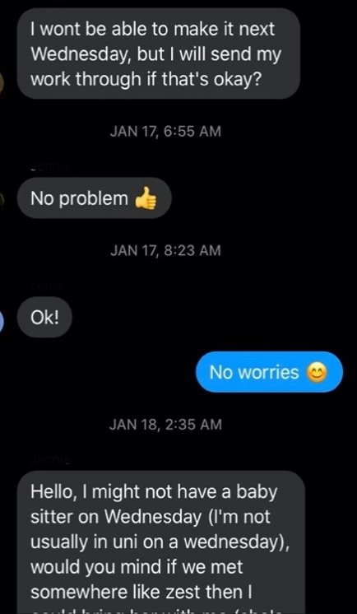
Figure 1 - Facebook Messenger Group Chat
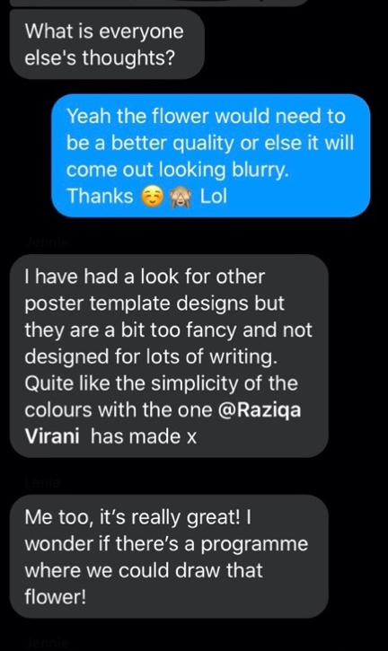
Figure 2 - Facebook Messenger Group Chat
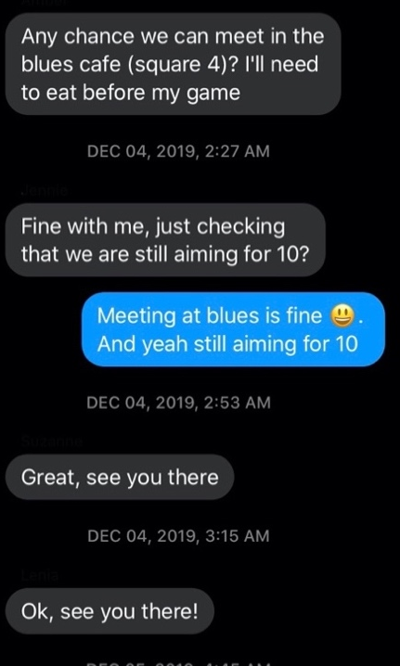
Figure 3 - Facebook Messenger Group Chat

Appendix 4 – Facebook Messenger Chat
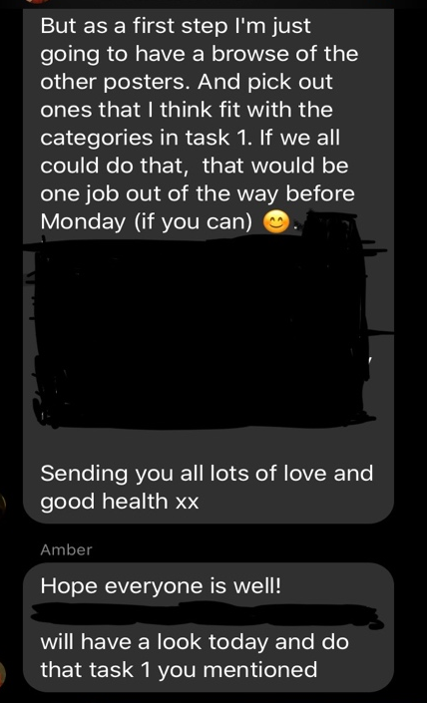
Figure 4 - Facebook Messenger Group Chat

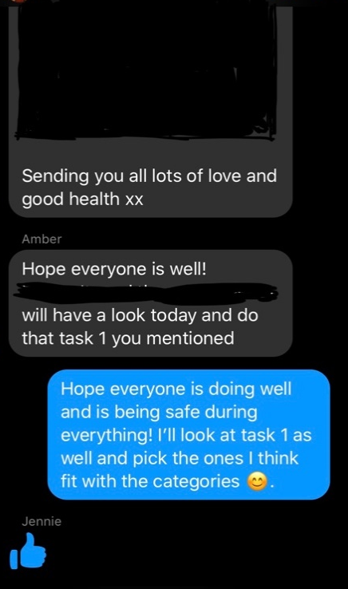
Figure 5 - Facebook Messenger Group Chat

Appendix 5 – Belbin Results for each student
Table 3 - Belbin Results
Student | Belbin Results
1-A | Chair, team worker, finisher
2-J | Team worker and resource investigator
3-L | Resource investigator and team worker
4-R | Finisher, team worker, chair
5-S | Monitor evaluator, team worker, and completer
1-H | Team worker

Appendix 6 – Stereotypes
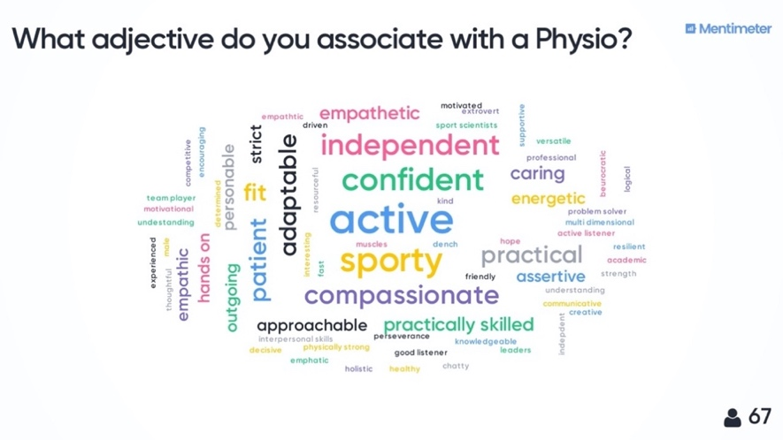
Figure 6 – Stereotypical adjectives associated with a Physio
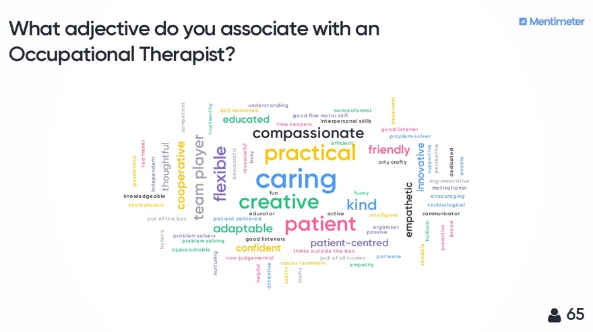
Figure 7 - Stereotypical adjectives associated with an Occupational Therapist

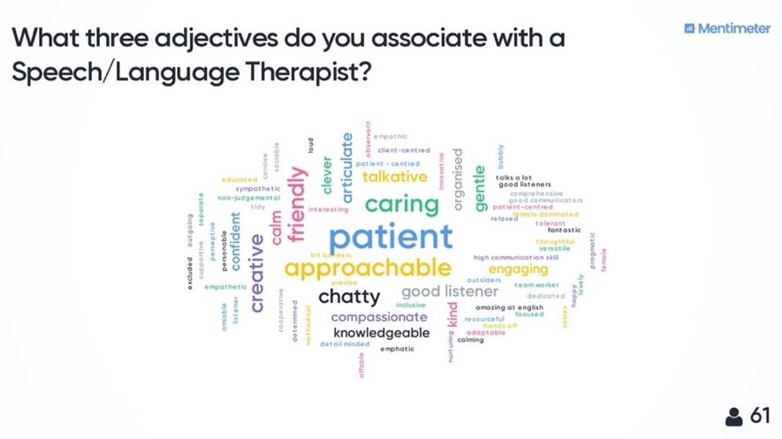
Figure 8 -Stereotypical adjectives associated with a Speech/Language Therapist

Appendix 7 – Team Meeting Reflections over Winter break
Table 4 - Team Meeting Reflections over Winter Break
HS810 and SE745 Winter Break Reflections | Date 12/4/19
Step 1 Describe (keep this section brief)  Describe the following objectively and in some detail. Reflect on key experiences noting significant or reflection-worthy experiences:  • When and where did the experience take place?  • Where did it take place?  • What did I do?  • Why did you do it?  • What did others do?  • Who else was there?  • Who wasn’t there?  • What actions did I/others take?  • What did I/other say or otherwise communicate?  • Who didn’t speak or act?  • What else happened that might be important (i.e., equipment failure, weather-related issues, etc.) | We had met at the blues grill next to fusion around 10 am. A few of the members in our group were 5-10 minutes late, so in the meantime we all caught up on how the course has been going, what we were doing over the weekend, and what our holiday plans would be for winter break. Communication previously had been over Facebook Messenger to discuss where and what time we would meet and what NHS value topics would go to whom. We did not check up on one another before this meeting to see how everyone is getting along with the poster portion. During our meeting, we discussed the case study in detail, what each of our own professions would do if we experienced a client like this and towards the end, we discussed what our assigned NHS values meant in context to this case study. We did have an issue with the part of the case study lying to the client; specifically, if it was ethical or not to lie to the client for the sake of keeping her hopes up. Ultimately, we discussed that we would come back to that at a later point.  During the meeting, we all took turns discussing our thoughts together as a group. We received interesting viewpoints from the physio on what they would be looking for in a patient concerning which bones are affected with the pulling motion from out of the tub, just as the client in the case study wanted to do. We all took an active role during the discussion, building off one another’s viewpoints. We also discussed what the poster should look like, what the template and colors should be, as well as what topics need to be on this poster. Overall, I felt that the meetings went well. We decided to meet one week before the IPL classes commence; we met after the break, so that we could discuss further what our own professional bodies (RCOT) say about the NHS values.
Examine  How did this experience make me feel (positively and/or negatively)?  o How did I handle my emotional reactions?  o Do I believe I should have felt differently than I did?  • What assumptions or expectations did I bring to the situation (including my assumptions about other persons involved) and how did they affect my actions?  o To what extent did they provide true?  o If they did not prove true, why was there a discrepancy?  • How have past experiences influenced the way I acted or responded to this situation?  o Am I comfortable with the influence past experiences has on me?  • What personal strengths/weaknesses of mine did the situation reveal?  o In what ways did they affect the situation positively/negatively?  o What might I do to build on strengths and overcome weaknesses?  • Why did I, or did I not, have trouble working/interacting with other people?  o What might I do differently next time to minimize such difficulties?  • What personal skills did I draw on in handling this situation?  o What personal skills would I like to have had I order to have handled it better and how might I develop them?  • How did this situation reveal my own attitudes or biases, toward other people, toward the organization in question, etc.?  o Do I need to make any changes? | The overall experience made me feel more positive about the poster project and helped clarify together what our specific poster should be looking like and what content it should have; it was nice being able to communicate and give ideas at this meeting of what the poster should entail. I believe that I handled my emotions and ideas well and conveyed my ideas in a positive and welcoming way.  My expectations for the meetings are that members would show up on time, however, I do realize that they were coming from class or were unsure where the building was and that should have been communicated in a better way. One way to do so would have been to provide directions to others in our group, such as, “the blues café is right next to fusion on square 4 above the Santander bank”; this would ensure clarity. I do not feel as though members of the group showing up later affected my mood in a general way, as I was understanding towards my peers and when they showed up, we caught up a little bit on winter break plans before talking about the assignment.  In past experiences, I have reacted in a negative way when members do not show up on time. This previously affected my mood; however, I learnt to be more understanding of someone else’s situation, as perhaps they have more things going on that might have caused them to be late and there is no reason to react negatively. Therefore, over the last few years, I have worked on this and learnt to respond more positively when people show up late. This could be seen as a past weakness that I have learnt to move forward from.  Occasionally, I heard from others in my program about how people in their group “do not do the work” or “are not working well with others in their group”. However, my experience has been very different; my group dynamic has been great, as the group members build off one another and take ideas from one another.  My overall attitude of the time spent was positive in the end and the group dynamic we had was very positive as well. It was nice to leave the group in a good manner and know what each of our roles were; that we all equally share responsibility. I want to try to take a more active role in checking on people in the group just to see how they are getting along; for example, by sending a message on Facebook Messenger to see how the work is coming along and if anyone needs any help.
Articulate (and implement) Learning  Review your responses from Steps 1 & 2 to assist in this final section of your reflection. You should articulate what was learned from your experience.  “I learned that…”  • Express an important learning, not just a statement of fact  • Provide a clear and correct explanation of the concept(s) in question so that someone outside of the course can understand  • Explain your enhanced understanding of the concept(s), as a result of reflection on the experience  • Express in general terms, not just in the context of the experience to apply this learning more broadly to other experiences  “I learned this when…”  • Connect the learning to specific activities making it clear what happened in the context of that experience so that someone who wasn’t there could easily understand it  “This learning matters because…”  • Consider how the learning has value, both in terms of this situation and in broader terms, such as other organizations, communities, activities, issues, professional goals, courses, etc.  “In light of this learning…”  • Set specific and assessable goals, consider the benefits and challenges involved in fulfilling them  • Tie your learning back to your original goals  Future directions…  • In what ways will I use this learning, what goals shall I set in accordance with what I have learned to improve myself and/or the quality of my learning and/or the quality of my future?  What will you differently in future team meetings and workshops? | I learned that even if others are late in the group, it is not a reflection on the quality of their work. The most important thing is if the work is done adequately and on time.  I learned this through the experience of talking to my group members. For example, when we had our group meetings and we discussed our sections, I discovered that they had done a great job in finding information on each of the NHS values and relating it to how a physio or SLT or OT would look at it from their perspective.  This learning matters because it can be related to anything in a general sense. For example, when meeting a friend for coffee or a family or partner for dinner it would be nice to have certain expectations, however, you cannot control how stressed the other person may be feeling, or their management of time. What matters instead is that the individual was present in the end and in this case – "did the work".  In light of this learning, I will endeavour to continue being welcoming to anyone who shows up late, and I will provide proper directions so they can find their way around. The goal for the next meeting that is scheduled for after the holidays is to discuss in more detail what our professional bodies say about the NHS values. I think this will be a great learning experience, as it will provide a chance for our group to grow even more together and build off one another in a more positive way. This will help me get better at how I work with groups and to see it more positively – some groups may not be ideal, but so long as the work is done promptly that is all you could ask.  In future team meetings I will continue to spread positivity to my group and have more open communication, just as we have been having now. I would like this to improve more with each time meeting.

Appendix 8 – Week 4 Reflections
Table 5 - Week 4 Reflections
HS810 Week 4 Reflections | Date 2/3/20
Step 1 Describe  Describe the following objectively and in some detail. Reflect on key experiences noting significant or reflection-worthy experiences:  • When and where did the experience take place?  • Where did it take place?  • What did I do?  • Why did you do it?  • What did others do?  • Who else was there?  • Who wasn’t there?  • What actions did I/others take?  • What did I/other say or otherwise communicate?  • Who didn’t speak or act?  • What else happened that might be important (i.e., equipment failure, weather-related issues, etc.) | The group met in the Learning Teaching Building and we then went to Zest to work on the afternoon presentation together, before going to our afternoon class. We collectively talked about the given case study and what needed to go into the PowerPoint presentation. There was one physio that was not there as she had a headache, but she did show up for the afternoon class. Moreover, one SLT was missing due to a doctor's appointment (which was communicated to us in the group chat on Facebook Messenger). We all communicated effectively and openly about what was needed for the afternoon PowerPoint presentation. We all had to decide who was going to present and since my presentation skills are weaker, I communicated this to my group, and they understood. However, this is where we had a difficult time deciding on who would go up and present, as no-one else communicated why they did not want to present.
Examine  Your interprofessional working skills development | We usually work effectively, however, upon further examination I felt as though everyone in the group was either exhausted from the weekend/night before, or since it was Monday morning, no-one in the group had the drive to participate in the group as usual.
Articulate Learning  Review your responses from Steps 1 & 2 to assist in this final section of your reflection. You should articulate what was learned from your experience.  “I learned that…”  • Express an important learning, not just a statement of fact  • Provide a clear and correct explanation of the concept(s) in question so that someone outside of the course can understand  • Explain your enhanced understanding of the concept(s), as a result of reflecting on the experience  • Express in general terms, not just in the context of the experience to apply this learning more broadly to other experiences  “I learned this when…”  • Connect the learning to specific activities making it clear what happened in the context of that experience so that someone who wasn’t there could easily understand it  “This learning matters because…”  • Consider how the learning has value, both in terms of this situation and in broader terms, such as other organizations, communities, activities, issues, professional goals, courses, etc.  “In light of this learning…”  • Set specific and assessable goals, consider the benefits and challenges involved in fulfilling them  • Tie your learning back to your original goals  Future directions…  • In what ways will I use this learning, what goals shall I set in accordance with what I have learned to improve myself and/or the quality of my learning and/or the quality of my future? | I learned that some days our group can communicate effectively but given certain circumstances – whether intrinsic or extrinsic – we may not communicate effectively. However, we were still able to get the afternoon presentation done and our colleagues enjoyed what we had to present. I felt as though we were able to get our point across, irrespective of how tired the other members of our group were.  This learning matters because it shows how well our group dynamic can be at the end; even though our communication has been impeccable most days, the day where we could not decide who should present and lost proper communication for a little bit, the members in our group were still able to take the lead when it came to presenting to the whole class.  In light of this learning, I was able to see how well my group functions when faced with difficulties. From this, I have now learnt that a strong group can have their off days, however, we can all lead in the end and get a great presentation out of it.

