Research Article

Stoicism, solidarity and cynicism: examining the role of Second World War posters in framing present-day British identity
Katherine Howells
King’s College, London

Abstract
The events of the Second World War are frequently recalled in modern British cultural discourse. The reuse and repetition of particular historical artefacts can have a powerful influence on the cultural memory and personal and national identities of people in Britain today, people whose experience is far removed from the realities of the wartime period. This paper focuses on one instance of this phenomenon: the appropriation and reuse of home front propaganda posters created by the British Ministry of Information (MoI) during the Second World War. Some of these posters have been republished in a variety of media over the last seventy years and are recognised today by large numbers of British people. This paper seeks to uncover what role the posters have in defining ideas and identities in the present. Drawing on data from a survey and interviews conducted with members of the public in spring and summer 2017, this paper will assess how particular Second World War images are able to influence present-day identities and historical consciousness. This research contributes to our understanding of how historical artefacts can have unintended long-term impacts on national culture, long after their original purpose and context has faded.
Keywords: Ministry of Information, Cultural Memory, British National Identity, Propaganda Posters, Home Front

Introduction
Cultural artefacts can help to shape the formation of identities. They provoke memories and communicate concepts that relate closely to a person’s sense of history and sense of self. The Second World War is considered an influential event for the formation of identities in Britain. Positive mythic interpretations of the experience of the British home front such as ‘the people’s war’, ‘the Blitz spirit’ and the ‘Dunkirk spirit’ have often been said to shape British identity in the decades after the war (Calder, 1992; Connelly, 2004; Eley, 2001; Mackay, 2003; McLaine, 1979; Noakes and Pattinson, 2013; Summerfield, 2010). These myths are created through memory of events, but also memory of cultural artefacts created during and after the war, including books, films, television programmes and images. This combination of multiple kinds of memories to produce myth is often explored in definitions of ‘cultural memory’.

In their 2014 book, British Cultural Memory and the Second World War, Lucy Noakes and Juliette Pattinson argue that cultural memory is a product of collaboration between different types of memory. Cultural memory of the Second World War ‘includes both personal memories and narratives of war as well as publicly produced war memories’ (Noakes and Pattinson, 2013, p.3). Public memories shape and are shaped by individual memories and this process or ‘cultural circuit’ which produces ‘cultural memory’ (Noakes and Pattinson, 2013, p.5). The relationship between memory, cultural artefacts and identities is reciprocal; neither memory nor identity is static or pre-existing, but each feeds off the other. When a person views and interprets a cultural artefact, this feeds into a cultural circuit whereby their cultural memory can be influenced and their conception of the past and their identities can be impacted. Their interpretation of the artefact can in turn be influenced by their existing conception of the past and identities.

It is crucial to consider in depth what impact individual cultural artefacts have on the formation of myths and the creation of identities. This paper focuses on one specific set of cultural artefacts: propaganda posters created by the Ministry of Information (MoI) in Britain during the Second World War. Using information gathered from surveys and qualitative interviews conducted with volunteers in Britain, I explore how people interpret the propaganda posters today and what influence they have on people’s capacity to shape and communicate their own identity. This research is part of a larger project, the Publishing and Communications History of the Ministry of Information, 1939-45, which is being undertaken by the Institute of English Studies in collaboration with the Department of Digital Humanities at King’s College London. It is funded by the Arts and Humanities Research Council.

The Ministry of Information and its campaigns
The Ministry of Information was established by the British government on 4 September 1939 to manage publicity and censorship at home and abroad. Its objectives were to make British war aims understood by the public, disseminate instructions and improve morale (McLaine, 1979, pp.18–19). The Ministry developed campaigns to achieve specific government objectives using a wide range of media including print, radio, film and exhibitions (Irving, 2016, pp.1–2).

A set of ten posters was selected from those created by the Ministry of Information. Seven were selected because they belong to three famous MoI campaigns: ‘Dig for Victory’, ‘Make Do and Mend’ and ‘Careless Talk Costs Lives’. These campaigns were promoted nationally during the war through a wide range of media. It is difficult to determine the precise level of effectiveness of individual propaganda efforts, particularly for ‘Careless Talk Costs Lives’ which had fairly intangible objectives, but the ‘Dig for Victory’ and ‘Make Do and Mend’ campaigns were considered effective, based on statistics for domestic food production (Smith, 2013, pp.221–225) and for attendance at Make-do and Mend classes (Simmonds, 1943).

The three campaigns were coherent in the sense that they were promoted using a unifying slogan, compared to other campaigns which employed multiple slogans. They are well-known today, with posters frequently reproduced and slogans referenced in speech and print. The reasoning behind the selection of the seven specific posters from these campaigns and the other three posters will be described later in this paper. Below is a brief outline of the histories of the campaigns and posters. Reproductions of all posters can be found in Appendix 1. Posters from the Imperial War Museum are reproduced under the IWM Non-Commercial Licence.

In 1939, the ‘Dig for Victory’ campaign was initiated by the Ministry of Agriculture and Fisheries in order to promote domestic food production in response to Germany’s blockade (Slocombe, 2010, p.35). In 1941, it produced a poster containing a photograph of a boot and spade, which is considered by the Imperial War Museum to be the most famous poster of the war [fig. 1] (Slocombe, 2010, pp.34–5). A campaign with the slogan ‘Make do and Mend’ was initiated on behalf of the Board of Trade in response to the introduction of clothes rationing in Jun 1941 (Slocombe, 2010, p.45). In 1942 a pamphlet cover was designed by artist Donia Nachshen with the slogan ‘Go Through Your Wardrobe’, which shows a woman surrounded by items of clothing [fig. 2] (“Core Record IWMPC - VADS,” 2018). The need for an anti-gossip campaign to defend against espionage was raised by Winston Churchill in 1940 (McLaine, 1979, p.81). A campaign was launched with the slogan ‘Careless Talk Costs Lives’, which appeared on humorous posters designed by well-known Punch cartoonist, Fougasse [fig. 3] (Slocombe, 2010, p.13). These posters are well-remembered particularly by those who experienced the British home front directly. A poster with the slogan ‘Keep Calm and Carry On’ was created in 1939 [fig. 4], one of a series of three posters. The other two were issued and received negative feedback from parliament, the press and the public (Irving, 2014; Lewis, 2017; Mass Observation, 1939, pp.52–57; Slocombe, 2010, p.5), so ‘Keep Calm and Carry On’ was never officially displayed.

In 1940, a poster was created with a photograph of Winston Churchill superimposed over tanks and planes and the slogan ‘Let Us Go Forward Together’ [fig. 5]. The slogan is a quotation which comes from his speech to the House of Commons on 13 May 1940, days after he became Prime Minister (HC Deb, 13 May 1940; Slocombe, 2010, p.7). Another poster was designed by in 1941 by Philip Zec, a cartoonist for the Daily Mirror (Slocombe, 2010, p.16). It was intended to encourage women to register for factory work, depicting a woman worker standing outside a factory with arms raised triumphantly and planes flying overhead [fig. 6].

During the war, MoI posters were considered ephemeral; they were created to meet a particular need and were not designed to have a long-term impact after the war. However, many have been repurposed in a variety of different media: in books, magazines, on television and also in online contexts (Kirton and Terras, 2013). People in Britain have therefore encountered these images in different kinds of media over the course of their lives. Some of the images are easily remembered and recognised because they have been seen so often. Images are republished to illustrate material about Second World War history, but also to illustrate material relating to current affairs, politics, lifestyle and many other topics. This variety in the uses of the images means that British people may associate with them meanings that are far more diverse than they would be had the images only ever been encountered in the context of the war.

Method
To study the role of the posters on cultural memory and the development of identities, surveys and in-person interviews were selected as appropriate methods. These methods allowed volunteers to be shown the posters and asked questions about their reactions, opinions and feelings. Five posters were selected for inclusion in the survey. The red ‘Dig for Victory’ poster [fig. 1] is the most famous from that campaign. ‘Go Through Your Wardrobe’ [fig. 2] is the cover of a pamphlet promoting the ‘Make Do and Mend’ campaign. ‘Careless Talk Costs Lives’ [fig. 3] and ‘Keep Mum She’s Not So Dumb’ [fig. 7] were chosen as examples of the ‘Careless Talk Costs Lives’ campaign. The former was chosen for its famous illustration by Fougasse, the latter for its unusual style of illustration and also for the gender issues that it raises, which could be interesting to explore in relation to identity. The final poster, ‘Keep Calm and Carry On’ [fig. 4] was selected due to its recent fame in British culture. For each of the images, questions were designed to reveal whether a participant recognised the image, why they thought they remembered it, where and when they thought they had seen it, what thoughts came to mind when they viewed it and whether they thought it might be a memorable image.

Volunteers for the survey were recruited using two methods: face-to-face and online. Information stands were set up in five locations – in Kew, Ealing, Croydon, Nottingham and Leeds – and people were approached from these stands and asked to complete a survey. The images were displayed on the stand itself with the question ‘do you recognise these images?’ in order to prompt interest from members of the public. An online version of the survey was promoted via Twitter and King’s College London publicity emails. The face-to-face method of recruitment, using public information stands, was employed in order to ensure that those recruited for the survey included people who were not internet-users or who were less comfortable using the internet. Relying entirely on online distribution would result in the recruitment solely of active internet users, which would affect results.

Both online and offline methods of recruitment were biased towards those people who had an interest in the Second World War, history or design. Both methods required volunteers actively to approach the stand or click on the link to take part in the survey and this necessitated a certain degree of curiosity and interest. Due to the nature of the survey, which took ten minutes to complete and required concentration and thoughtfulness on the part of the participant, this bias towards interested volunteers was to some extent inevitable. A total of 92 completed surveys were collected from the information stands and 209 were collected online.

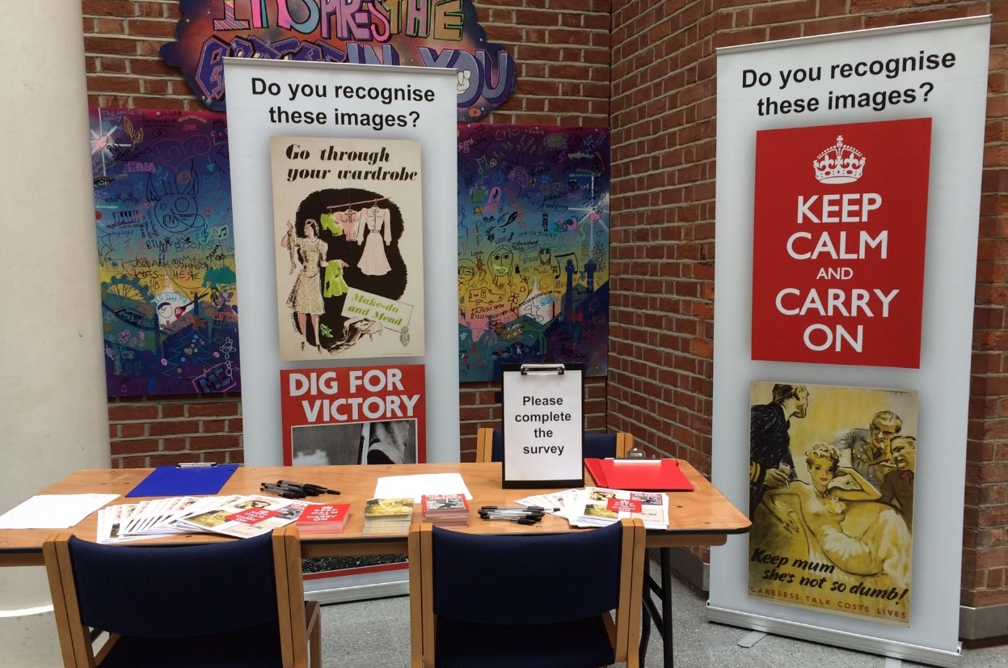
Information Stand at Croydon Clocktower, 19 April 2017, © 2017 Katherine Howells

Responses to the survey provided a pool of 252 volunteers who were eligible to be interviewed. Volunteers were selected to ensure that the data covered a broad range of ages and birth locations (see full details of participants in Appendix 2). Sixteen people were interviewed, with the interviews lasting between 45 and 90 minutes. The interviews were semi-structured in design; interviewees were asked about the same topics as in the survey but in more depth. Five new images were added to increase the breadth of the data collected. The new images consisted of an alternative ‘Dig for Victory’ poster [fig. 8], an alternative ‘Make Do and Mend’ poster [fig. 9], an alternative ‘Careless Talk Costs Lives’ poster using the famous slogan ‘Be Like Dad Keep Mum’ [fig. 10], a war work recruitment poster ‘Women of Britain Come into the Factories’ [fig. 6] and a poster depicting Winston Churchill’s face and a quotation from his speech [fig. 5].

The research revealed the range of ways in which the images are interpreted and understood by members of the public and gave some insight into how they can be used by people to help them shape and communicate their own identities. The discussion below focuses on five of the images that demonstrate most clearly the relationship between cultural artefacts and identity formation.

Solidarity and stoicism
When participants viewed the images and responded to them, they often did so by referencing existing national myths of the Second World War. They interpreted the images to represent concepts that are dominant both in these myths and in ideas of British national identity. The two themes that appeared most frequently when participants discussed the images are solidarity and stoicism. These concepts are integral parts of myths of the ‘people’s war’, the ‘Blitz spirit’ and the ‘Dunkirk spirit’.

The ‘people’s war’ is a phrase which conceptualises the Second World War in Britain as a war which involved everybody, including ordinary people on the home front, working together to achieve victory. It encourages an egalitarian view of wartime Britain as an era of camaraderie and solidarity. While the myth of the ‘people’s war’ is often exposed as idealistic, most notably by Angus Calder in his book The People’s War, it is still believed and perpetuated today. The phrase itself is commonly used in reference to the role of ordinary people on the British home front (“About The People’s War,” n.d.).

The ‘Dunkirk Spirit’ and the ‘Blitz Spirit’ are phrases which refer to the same mythic narrative about the British character. They both refer to a spirit of high morale, courage and strength despite the suffering and imminent danger of the evacuation of Dunkirk and of aerial bombing. The concept of stoicism is fundamental to these myths. The myths are commonly employed today in speech and by the press to highlight a perceived British character in the face of modern hardships such as terrorist attacks, the recession or even train delays (BBC News 2018; Helm and editor, 2008; Kelsey, 2010).

Stoicism and solidarity are key concepts for these myths and for dominant perceptions of the British national character; however their role in the British character is not new. Mark Connelly suggests that many of the ideas of Britishness associated with the Dunkirk myth, ‘Standing alone, fighting weird, wonderful and incomprehensible foreigners of all sorts against great odds’, were already in existence before the nineteenth century with reference to past military endeavours such as the Spanish Armada and the Napoleonic Wars (Connelly, 2004, pp.56–60).

The ideas of British stoicism and solidarity already existed before the war and were recognised by the Ministry of Information as useful ideas to help raise public morale. MoI propaganda films promoted these perceived positive national characteristics (Aldgate and Richards, 2007, p.316), and printed materials include terms like ‘steady’, ‘together’, ‘courage’ and ‘carry on’ (Lewis, 2017, pp.43-46). While it is difficult to ascertain the effect of these phrases and concepts on the wartime public, there is one example of stoicism and solidarity being used unsuccessfully. In 1939, a poster with the words ‘Your courage, your cheerfulness, your resolution will bring us victory’ was produced to encourage exactly these characteristics (Lewis, 2017, p.54). The poster was unpopular; some people considered it patronising and disliked the abstract term ‘resolution’ (Lewis, 2017, p.55; Mass Observation, 1939; McLaine, 1979, p.31). This example demonstrates the complexity of these concepts in the minds of the British people, even during the war itself.

In many cases, research participants interpreted the images in such a way as to assist them in drawing connections between existing national stories of myths, national identity, and their own personal identity. As well as national identity, the images also enabled some participants to communicate their own generational and gender identity.

Dig for Victory and Make Do and Mend
These two posters demonstrate how historical images help people to define and articulate their own national and generational identity. As participants viewed the images, they interpreted concepts from the objects and words within the image. ‘Dig for Victory’ was overwhelmingly associated with the idea of hard work, and ‘Make Do and Mend’ with rationing and economy. These meanings are fundamental to the existing cultural narrative of the British experience of the Second World War home front.

A second layer of meaning was then interpreted by many participants, including the concepts of solidarity and stoicism. In the examples below, respondents explain the content and meaning of the images in reference to people demonstrating solidarity in the face of war by ‘coming together’ and ‘working together’. These ideas feed directly into the dominant national myths of the ‘people’s war’ and the ‘Blitz spirit’.

“Evokes idea of country coming together in a common purpose.”
Male, b.1970, writing about Dig for Victory.

“Like the Dig for Victory poster it represents people doing what they can and working together for the common good.”
Female, b.1965, writing about Make Do and Mend

This demonstrates how these images act as frames for participants to articulate their own understanding of the story of the Second World War, which both feeds, and is fed by, existing dominant national myths. When viewing these images, participants’ minds were drawn from the specific objects contained within the image to larger concepts, beliefs and narratives which they were then able to communicate. While those examples demonstrate the role of the images in reinforcing existing war myths, the examples below demonstrate how this interpretation is extended. Research participants moved beyond the specific context of the Second World War and applied the associations they had made with British people in general.

“I think it taps into the British feeling of resilience and hard work during tough times.”
Female, b.1989, writing about Dig for Victory.

“It typifies the approach of the British to the war - we were all in it together and everyone had a role to play in the war effort.”
Female, b.1996, writing about Dig for Victory.

“‘Make-do and Mend’ sounds very British it reminds me of 'keep calm and carry on' in its abrupt answer to issues from facing hardships in clothing to bombings.”
Female, b.1997, writing about Make Do and Mend.

The posters enabled respondents to articulate their understanding of what it means to be British, and in many cases this understanding included concepts of hard work, solidarity and stoicism. Participants generalised from their interpretation of the image and their understanding of the experience of the Second World War home front to draw conclusions about British national identity. As respondents referred less to the specific Second World War context of the posters, they discussed their relevance to modern life. So, in the examples below, respondents applied the concepts they associated with ‘Make Do and Mend’: of economy, creativity and solidarity to modern causes of vintage fashion, sustainability and charity.

“I think of charity shops and vintage stores, of people in the war repairing clothes in order to save, but also of the comparison with hipster habits now of valuing vintage clothing and living in a more sustainable and ethical way.”
Female, b.1991, writing about Make Do and Mend.

“I like it - it's very contemporary and could/should be taken-up by a charity shop for a modern campaign.”
Male, b.1967, writing about Make Do and Mend.

These two posters also gave respondents the opportunity to frame their own personal identity, particularly in relation to their generation. In the examples below, people identified themselves as members of a certain generational group from their ability to recognise and remember a poster.

“I am sure it is memorable for everyone of my generation as it is immediately recognisable as to what it means.”
Female, b.1946, writing about Dig for Victory.

“I assume (perhaps mistakenly) that I am of the last generation to have heard it spoken as a child.”
Male, b.1959, writing about Dig for Victory.

Respondents also identified themselves as part of a generation in reaction to their perception of the values of other generations.

“I am aware of the slogan 'Make Do and Mend' but wonder how much resonance that has among the younger generations (i.e. younger than me - a post-war baby boomer!)”
Female, b.1956, writing about Make Do and Mend.

By speculating about the knowledge of younger people, this participant positions herself as a member of a ‘post-war baby boomer’ generation for whom the slogan ‘Make Do and Mend’ has meaning. By viewing and responding to the images, participants were able to communicate their own identities through the lens of national myth and through the lens of generational difference.

Keep Calm and Carry On
Respondents saw ‘Keep Calm and Carry On’ as a direct symbol of Britishness in itself. The slogan was frequently interpreted as communicating the concept of stoicism, a key element in the national myth of the ‘Blitz spirit’ and the ‘Dunkirk spirit’. The crown was interpreted as representing monarchy and empire by many respondents, giving a direct link to the British nation. In the examples below, participants communicated their understanding of British national identity through their interpretation of the image. In many cases, they exhibit an emotional response in doing this, defining themselves as members of the British nation through the use of the pronouns ‘we’ and ‘our’.

“The crown gives authority and reminds all of the empire.”
Male, b.1951, writing about Keep Calm and Carry On.

“It has totally embedded into our collective psyche. I think British people would see this as actually summing up what we think we are good at – facing challenges and being brave when needed.”
Female, b.1954, writing about Keep Calm and Carry On.

“Now it is seen as “Britishness” in a phrase. We are all proud of it and want to say “this is us”.”
Female, b.1953, writing about Keep Calm and Carry On.

“Makes one proud to be British.”
Male, b.1955, writing about Keep Calm and Carry On.

For many respondents, ‘Keep Calm and Carry On’ was a symbol of Britain before it was a symbol of the war. This is firstly due to the fact that the poster was never displayed during the war but only in recent years, so memories of it inevitably originate from modern sources. Secondly the poster does not include any features that link it to the 1940s period. This disconnection from the war makes the image a powerful symbol of national identity because it can be easily applied to modern contexts. In the examples below, one participant admitted surprise that the poster was a wartime poster, and another related it to modern-day terrorist attacks.

“I think I was surprised to learn that it came directly from the war.”
Female, b.1965, speaking about Keep Calm and Carry On.

“I think it’s still very relevant today, especially with the numerous terror attacks we suffer.”
Female, b.1989, writing about Keep Calm and Carry On.

Whether or not participants recognised the poster’s link to the war, they still interpreted it as communicating the concept of stoicism as a typically British characteristic. By viewing and responding to the image, participants were able to associate themselves with this characteristic and define their own national identity.

Women of Britain Come into the Factories and Let Us Go Forward Together
The two posters ‘Women of Britain Come into the Factories’ and ‘Let Us Go Forward Together’ were only included in the interview process and not the survey. For many interviewees, Winston Churchill’s face was a symbol of the Second World War and of British national identity. In the example below, one interviewee expressed emotion when talking about Churchill.

“For those of us who had imbibed memories and for whom it is as if we’d lived through the war, because it is like that for me, I mean Churchill saved us – and one feels very emotional.”
Male, b.1943, speaking about Let Us Go Forward Together.

Looking at the photograph of his face triggered memories for this person which in turn caused strong feelings of pride and gratitude. The interviewee also responded to the poster in a way that reinforces the existing national story of the Second World War as Churchill’s War, where Churchill was the sole hero of the Britain’s victory.

The ‘Women of Britain’ poster is often interpreted as a symbol of women’s liberation. The objects in the poster triggered memories of interviewees and encouraged them to reflect on their existing understanding of the story of the Second World War, that it was a time of increased independence for women. In the example below, one interviewee interpreted empowerment and used the word ‘us’ to demonstrate her own identification with this meaning.

“Women—sort of like empowerment and a sense of their liberation and I know that’s not what that is meant to symbolise, I know she’s looking more towards the men who are going to war, but that kind of image, it kind of signifies like a sort of sense of us finally, as women, moving forward a bit, breaking the traditional roles and breaking some boundaries.”
Female, b.1992, speaking about Women of Britain.

Cynicism
While respondents recognised the symbolic meanings within the posters and the existence of the national myths, they did not always agree with these interpretations. There was a distinct element of cynicism running through the survey and interview responses, as people communicated their interpretations of the images and their personal identities in reaction to what they perceive to the be the dominant narrative. In the example below, one interviewee explained their interpretation of the poster ‘Let Us Go Forward Together’.

“For me, Churchill, now there’s a lot of baggage there, in some ways I feel proud about the fact that we fought the second world war and we won and I feel like it was a noble cause, but – I feel like he’s kind of elevated to a status which is perhaps problematic and probably would have been problematic even for him, because obviously it wasn’t just one man who won the war, so I’d say it sort of creates mixed feelings in a way – some sort of doubts.”
Female, b.1987, speaking about Let Us Go Forward Together.

This participant recognised the power of the national myth of Churchill’s war, but expressed their discomfort with this myth and explained a more nuanced interpretation of Churchill.
Similarly, ‘Dig for Victory’ made one respondent feel uncomfortable with the patriotism that they felt when viewing it. They recognised that the poster successfully triggered thoughts, memories and emotions that encourage feelings of patriotism, but they made clear that rationally they did not find this interpretation of the image comfortable.

“It makes me feel like, yeah, yeah, yeah, pull together – and that’s slightly uncomfortable, in the sense of – in terms of nationalism, yeah, yeah, pull together, we will defeat enemies – that is slightly uncomfortable, now– it makes me feel like patriotic and that has a double edged sword, now, that’s a very, that’s an uncomfortable thing I think currently and I wouldn’t have felt that years ago– but at the same time it’s like this is part of my history, I’m English, I’m British, English, and this is part of my heritage.”
Female, b.1969, speaking about Dig for Victory

‘Keep Calm and Carry On’ encouraged the most cynicism from respondents. While most recognised the poster’s power as a symbol of a dominant national identity, some positioned their own identity against this. In the examples below, the participants associated this conception of national identity with modern events such as Brexit and identified themselves as against this.

“Irritation, boredom, a sense of frustration that we sentimentalise some kind of Dunkirk spirit at a time when we are experiencing a real international crisis around refugees and Brexit and so much more.”
Female, b.1971, writing about Keep Calm and Carry On

“I suppose it represents Britishness to me, and the British attitude of carrying on regardless. It reminds me of during the recent Westminster terrorist attack, when I think people did some mock-ups of it, or that was the tone of a lot of the images shared on social media. I think its "Britishness" annoys me a bit, because I hate all that nostalgia for the Empire, Rule Britannia stuff that I think has really become prominent recently, especially in the run-up to Brexit.”
Female, b.1992, writing about Keep Calm and Carry On

These examples demonstrate the subtle responses people have to historical images, which require in-depth interviewing to be fully revealed. People interpret historical images in light of contemporary concerns, their own personal beliefs and memories and historical knowledge. The images help people to make sense of these different influences and frame and communicate their own identities.

Conclusion
The posters examined in this study are artefacts from a very specific cultural context which are associated by members of the public with concepts relating to the Second World War. However, the survey and interview data collected through this research has revealed that the posters have a far more expansive role in influencing how people define and communicate their understanding of the past, their nation and their identity.

When the research participants viewed the images, they often interpreted concepts fundamental to dominant myths of the British war experience. The concepts that were most frequently referred to are solidarity and stoicism: necessary elements of the ‘People’s War’ and the ‘Dunkirk Spirit’ and ‘Blitz Spirit’ myths. In many cases, participants responses were both informed by and reinforce these myths. In the process of interpreting and responding, participants clarified their own personal identities. These identities can relate to the British nation and ideas of Britishness, but also to generation and to gender. It seems that viewing and considering an image can help a person to distil their memory, knowledge and beliefs and frame and communicate their identity in response to it.

Identities can be framed and communicated not only in accord with associated concepts and myths, but also in reaction to them. The research demonstrates that a person may interpret the same dominant concepts from an image and recognise the existence of the national myths associated with it, but at the same time may define their own identity against this orthodoxy, clarifying it with far more nuance than is usually revealed by survey-based research. This underlines the need for in-depth interviewing when attempting to explore the relationship between cultural artefacts and identity.

This study reveals long-term and complex impacts that historical and cultural artefacts can have on the way people think about the past and their own identities. An artefact such as a propaganda poster acts as one of many different influences on the mind of a person when they consider their own sense of nation, history and self. As a person encounters and attempts to make sense of an artefact, they also are able to make sense of their own thoughts and identities through the cultural frame of that artefact.

Appendix 1: Images
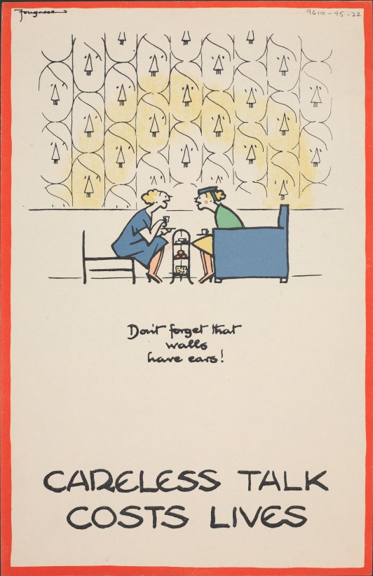
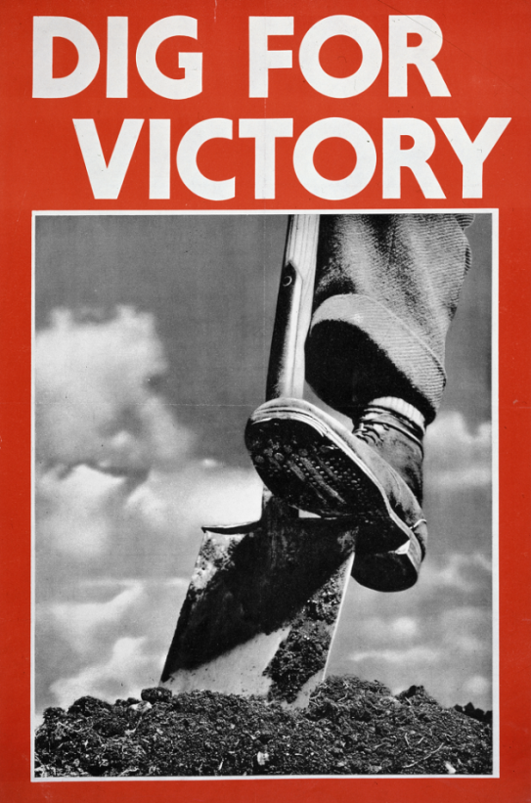
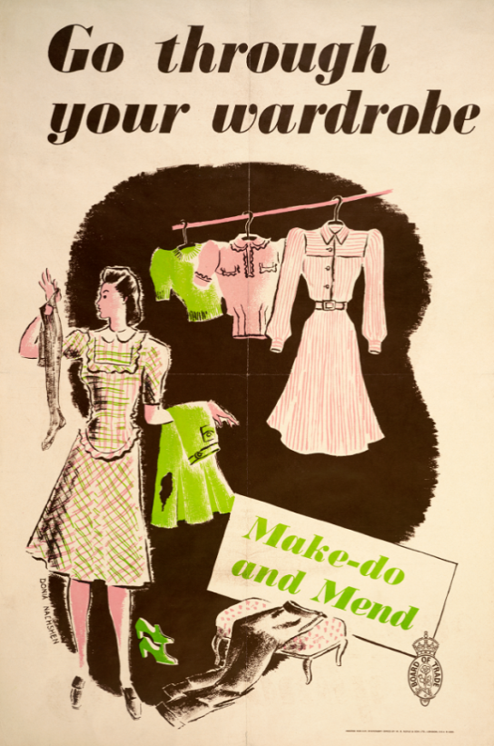
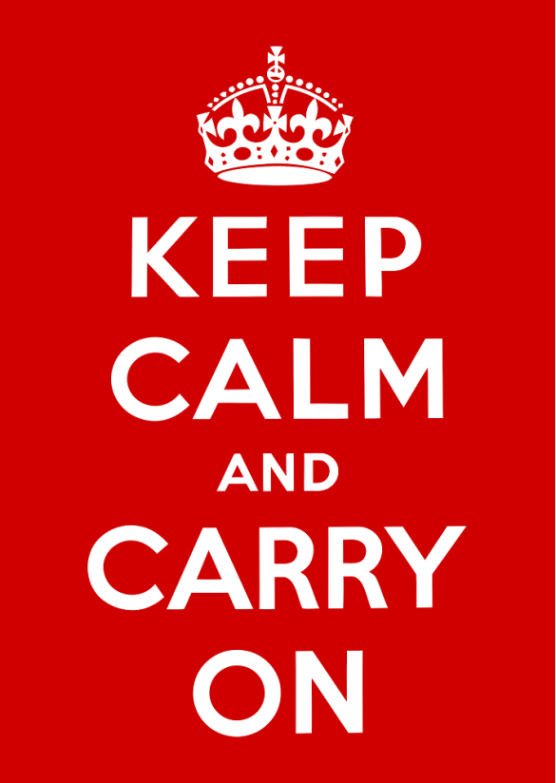
Figure 3 Careless Talk Cost Lives, 1940, © National Army Museum
Figure 1 Dig for Victory, 1941, © IWM (Art.IWM PST 0059)
Figure 2 Go Through Your Wardrobe, 1942, © IWM (Art.IWM PST 4773)
Figure 4 Keep Calm and Carry On, 1939, public domain (Wikimedia)
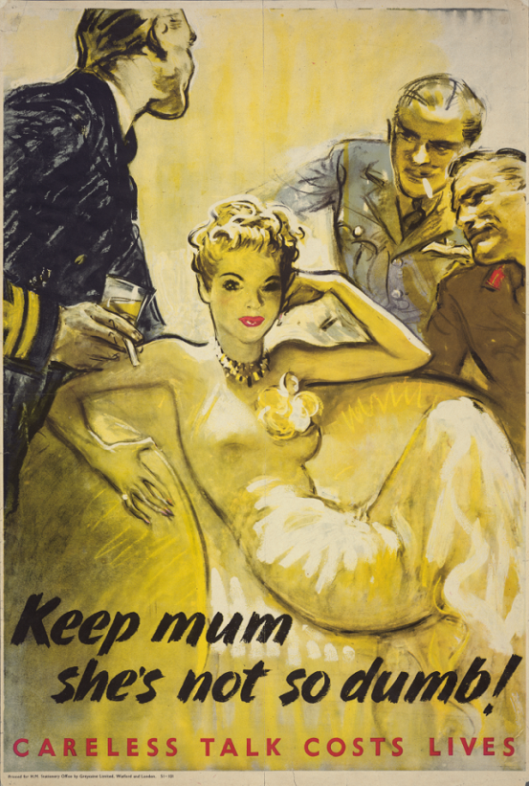  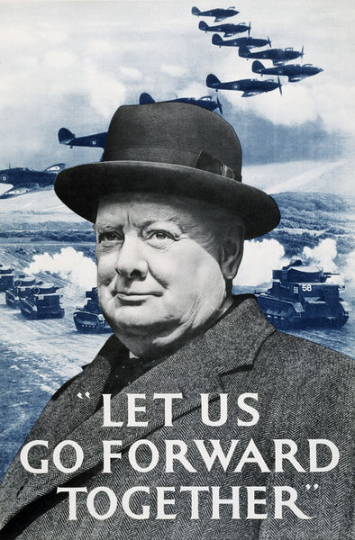  Figure 7 Keep Mum She’s Not So Dumb, 1941, © IWM (Art.IWM PST 4095)  Figure 5 Let Us Go Forward Together, 1940, © Victoria and Albert Museum, London | 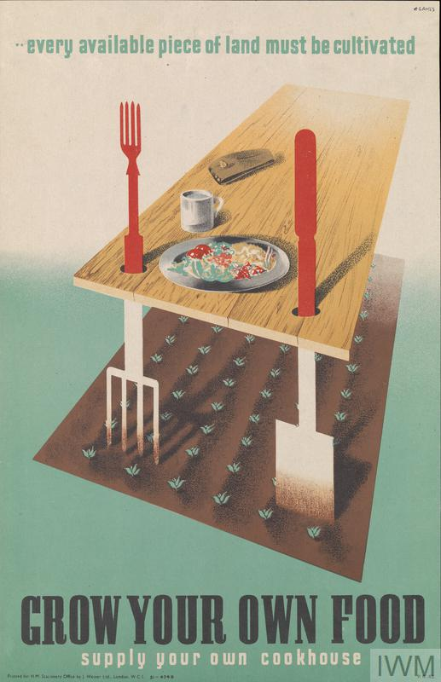  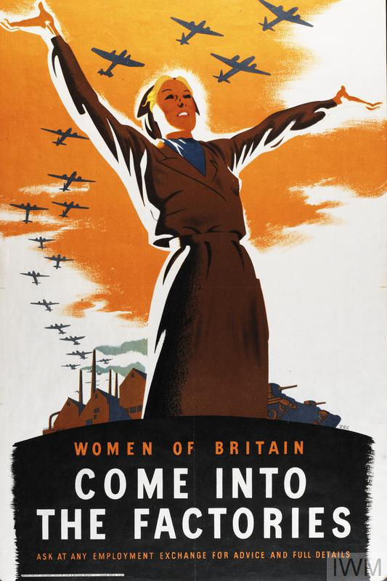  Figure 8 Grow Your Own Food, 1942, © IWM (Art.IWM PST 2893)  Figure 6 Women of Britain Come into the Factories, 1941, © IWM (Art.IWM PST 3645)
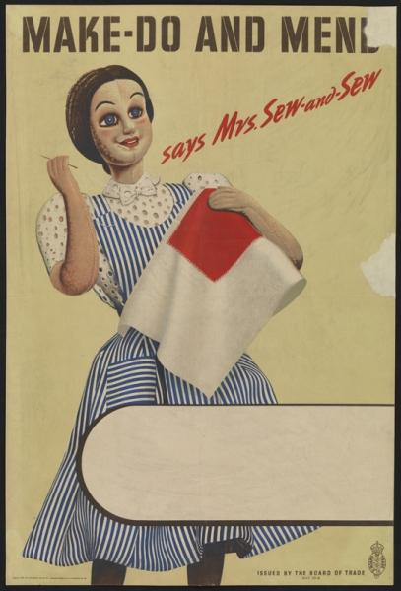  Figure 9 Make Do and Mend, 1943, © IWM | 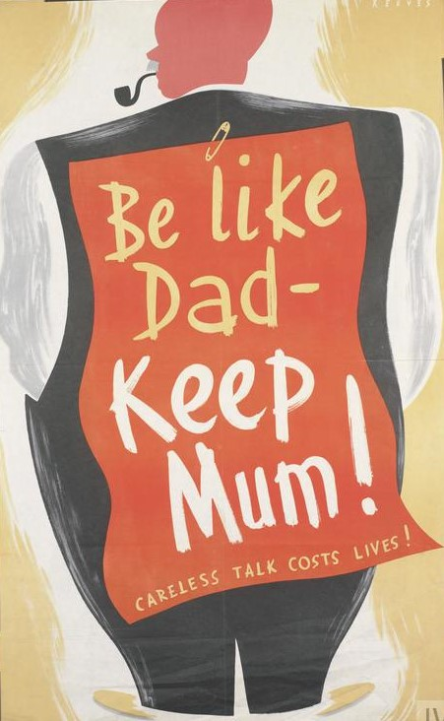  Figure 10 Be Like Dad – Keep Mum!, 1940, © IWM (Art.IWM PST 13946)

Appendix 2: Survey and interview participants
Table 1 Birth years of participants
Birth year | Number of survey respondents | Number of interviewees
1925-1930 | 4 | 2
1931-1939 | 11 | 1
1940-1945 | 10 | 3
1946-1955 | 47 | 2
1956-1965 | 40 | 1
1966-1975 | 38 | 2
1976-1985 | 31 | 1
1986-1995 | 55 | 2
1996-2001 | 16 | 2
TOTAL | 252 | 16

Table 2 Birth regions of participants
Birth region | Number of survey respondents | Number of interviewees
East Midlands | 11 | 1
East of England | 9 | 2
International | 36 | 2
London | 73 | 2
North East | 9 | 2
North West | 19 | 1
Scotland | 7 | 1
South East | 31 | 1
South West | 12 | 1
Wales | 9 | 1
West Midlands | 16 | 1
Yorkshire and the Humber | 15 | 1
Unknown | 5 | 0
TOTAL | 252 | 16

Table 3 Gender of participants
Gender | Number of survey respondents | Number of interviewees
Female | 129 | 9
Male | 120 | 7
Genderqueer | 1 | 0
Prefer not to say | 2 | 0
TOTAL | 252 | 16

Table 4 Highest level of education of participants
Highest level of education | Number of survey respondents | Number of interviewees
Secondary School | 16 | 2
Some College or Further Education | 56 | 4
Bachelor's Degree | 61 | 5
Master's Degree | 66 | 3
Advanced Graduate work or PhD | 46 | 2
Prefer not to say | 7 | 0
TOTAL | 252 | 16

References
About The People’s War [WWW Document], n.d.. OpenLearn. URL www.open.edu/openlearn/history-the-arts/history/about-the-peoples-war (Accessed 16 May 2018).
Aldgate, A., Richards, J., 2007. Britain Can Take It: The British Cinema in the Second World War, Second Edition. I.B.Tauris.
Calder, A., 1992. The People’s War: Britain 1939-1945. Random House.
Connelly, M., 2004. We can take it!: Britain and the memory of the Second World War. Pearson Longman.
Core Record IWMPC - VADS [WWW Document], 2018. URL vads.ac.uk/large.php?uid=33982&sos=0 (Accessed: 6 April 2018).
Eley, G., 2001. “Finding the People’s War: Film, British Collective Memory, and World War II”. Am. Hist. Rev. 106, 818–838. doi.org/10.2307/2692326
Helm, T., 2008. “Brown: we need Dunkirk spirit in 2009”. The Observer. URL www.theguardian.com/politics/2008/dec/28/economic-policy-gordon-brown (Accessed: 20 May 2018).
HC Deb (13 May 1940), vol. 360, col. 1501-2513. Available at: api.parliament.uk/historic-hansard/commons/1940/may/13/his-majestys-government-1 (Accessed: 6 April 2018).
Irving, H., 2016. “Towards ‘A New Kind of Book’: Publishing and the Ministry of Information, 1939-46.” Publ. Hist. Soc. Econ. Lit. Hist. Book Newsp.Mag. Publ. 75, 53–76.
Irving, H., 2014. Keep Calm and Carry On – The Compromise Behind the Slogan - History of government [WWW Document]. URL history.blog.gov.uk/2014/06/27/keep-calm-and-carry-on-the-compromise-behind-the-slogan/ (Accessed: 6 April 2018).
Kelsey, D., 2010. Mentioning the war : the myth of the “Blitz spirit” in British newspaper responses to the July 7th bombings (Ph.D.). Cardiff University.
Kirton, I., Terras, M., 2013. Where Do Images of Art Go Once They Go Online? A Reverse Image Lookup Study to Assess the Dissemination of Digitized Cultural Heritage. Museums and the Web 2013.
Lewis, B., 2017. Keep Calm and Carry On: The Truth Behind the Poster. Imperial War Museums.
Mackay, R., 2003. Half the Battle: Civilian Morale in Britain During the Second World War, 1st Edition. ed. Manchester University Press, Manchester; New York.
Mass Observation, 1939. Government Posters in War-time: Report from Mass-Observation. The Keep .42/1/C
McLaine, I., 1979. Ministry of Morale: Home Front Morale and the Ministry of Information in World War II. Allen & Unwin, London; Boston.
Noakes, L., Pattinson, J. (Eds.), 2013. British Cultural Memory and the Second World War, 1st edition. ed. Bloomsbury Academic.
“Passengers stuck on trains for 14 hours show 'Dunkirk spirit'” [WWW Document], 2018. BBC News. URL www.bbc.co.uk/news/uk-england-hampshire-43253130 (Accessed: 16 May 2018).
Simmonds, 1943. Minutes of meeting of Board of Trade Advisory Committee on Make-do and Mend held on 1st October, 1943. The National Archives. BT 64/3024
Slocombe, R., 2010. British Posters of the Second World War. Imperial War Museum, London.
Smith, D., 2013. The Spade as Mighty as the Sword: The Story of World War Two’s ’Dig for Victory’ Campaign. Aurum Press.
Summerfield, P., 2010. “Dunkirk and the Popular Memory of Britain at War, 1940—58.” J. Contemp.Hist. 45, 788–811. doi.org/10.1177/0022009410375260

Copyright Statement
© Katherine Howells. This article is licensed under a Creative Commons Attribution 4.0 International Licence (CC BY).

