Research Article

Whatever happened to the 1887 Exhibition?

“Tomorrow’s almost over, today went by so fast

It’s the only thing to look forward to – the past”

(Whatever Happened to the Likely Lads?)
Mark Stoddart
Northumbria University

Abstract
In 2018 Newcastle/Gateshead held The Great Exhibition of the North. The stated ambition was that it “… will showcase world-class art, culture, design and innovation from the North.” Their website stated: “It will reveal … how the North of England’s great art and culture, design and innovation has shaped all our lives and is building the economy of tomorrow. The dramatic story of the North, … will instil local pride and inspire people to pursue exciting lives and careers in the North. By attracting visitors from near and far, it will transform global perceptions of Northern England...” In 1887 Newcastle held an exhibition with remarkably similar aims. Yet this event is almost forgotten – information boards at the location have only two references to it and the main local museum has only a couple of items on display. Yet it attracted over 2 million visitors and made a financial surplus of over £4,000. By comparison the Millennium Dome attracted around 6.5 million visitors, cost £789 million and made a notional surplus of £25 million. Visitors came on excursion trains from around the UK, and a party of 207 Danish artisans, paid for by their government, made the trip across the North Sea. The event was put together quickly and it displayed a full range of North-Eastern industry, from a 100-ton gun to a woollen needlework picture of Moses. It was fully lit by electricity, had an extensive art gallery and a theatre. Archival material is almost non-existent (compare the 1887 Manchester Exhibition) and there is only one article in a local history publication. The paper will discuss how the exhibition came about and the role of business and workers, as well as contemporary reactions. It will question how far the past should inform the present, and will finish with provisional thoughts as to why the event has been largely forgotten.
Keywords: 1887 Royal Jubilee Exhibition, Newcastle upon Tyne, Industrial Heritage, Collective Amnesia, Rational Recreation

Introduction
The tallest tower in the Armstrong Building of Newcastle University sits above an arched entrance inscribed “Royal Jubilee 1887 Exhibition Tower”. At the time of writing this article, seven out of ten Google searches for this phrase refer to the 1887 Royal Jubilee Exhibition in Manchester. Of the three that refer to the Newcastle tower, two link to single images of it. The tower was built for the College of Physical Science with the foundation stone laid by Sir William Armstrong in June 1887, whilst the north-east wing opened in 1888. The building was officially opened by King Edward VII in 1906. The 1887 Jubilee Exhibition was by far the biggest public event in Newcastle in the latter part of the nineteenth century and one of a series of similar events across the North of England and Scotland. Yet the Newcastle Exhibition is the least recorded and known, even by those who work in the tower.

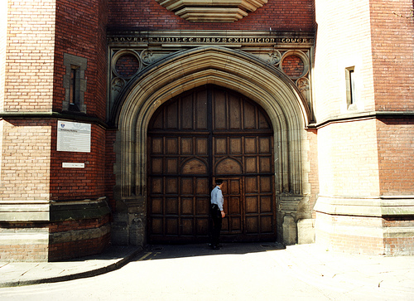
Fig. 1: Newcastle City Library Photo Collection 1

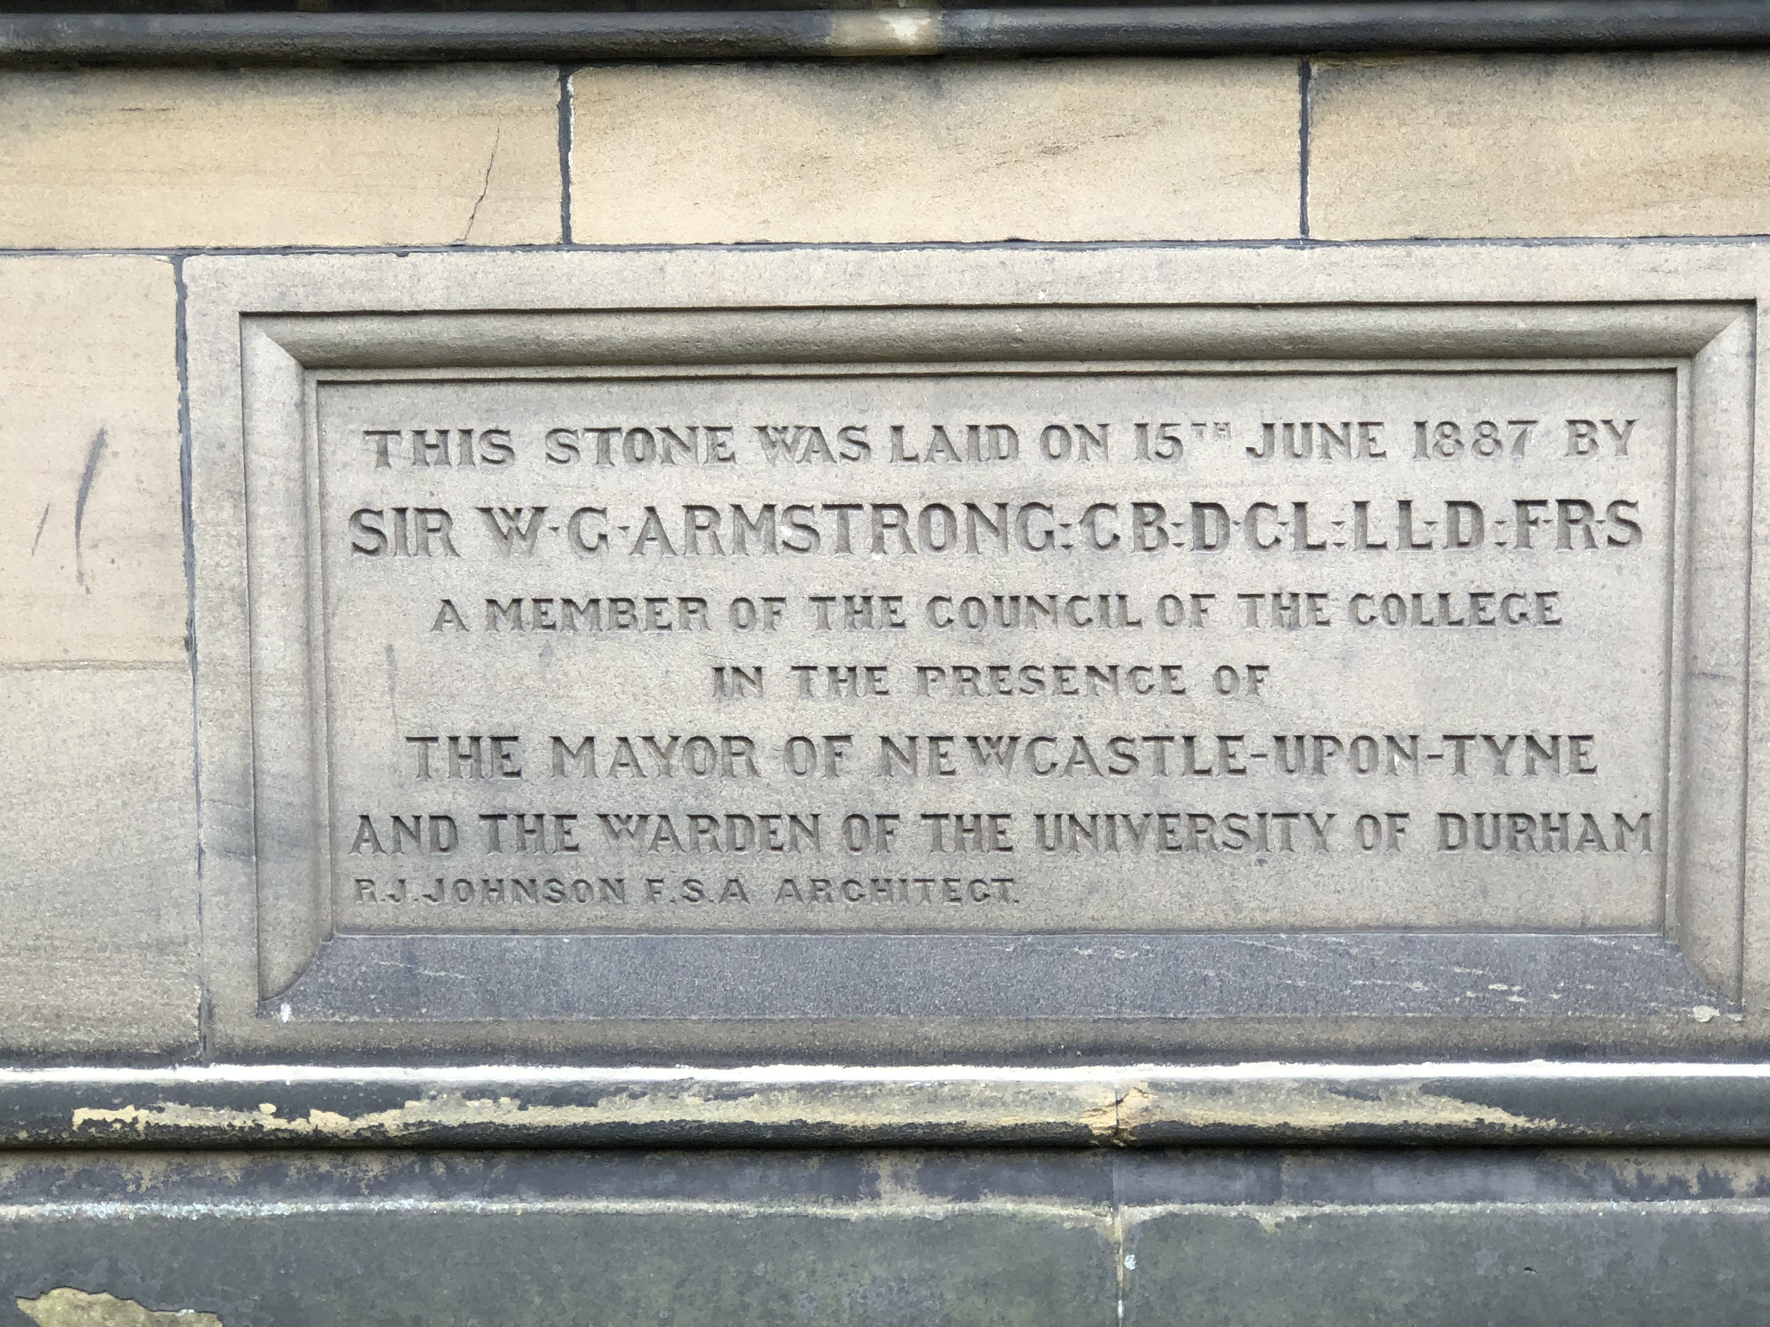
Fig. 2: Author's Collection 1

Liverpool (twice), Edinburgh, Manchester and Saltaire all held Jubilee Exhibitions between 1885 and 1887. Books have been written on the Liverpool and Manchester events, and Trafford Council maintains an extensive archive of material, including many photographs of the Manchester event (Murray Steele, Liverpool on Display (2012); A Good Day Out – English Exhibitions in the Golden Jubilee Era (2015)). Wikipedia entries exist for Manchester, Glasgow and Liverpool, and there are relics of the Edinburgh and Saltaire events in situ. The park where the Newcastle event was held is called ‘Exhibition Park’, still with the bandstand, originally a centrepiece of the Inner Court. Even here, there are only limited references to 1887 on the information boards.

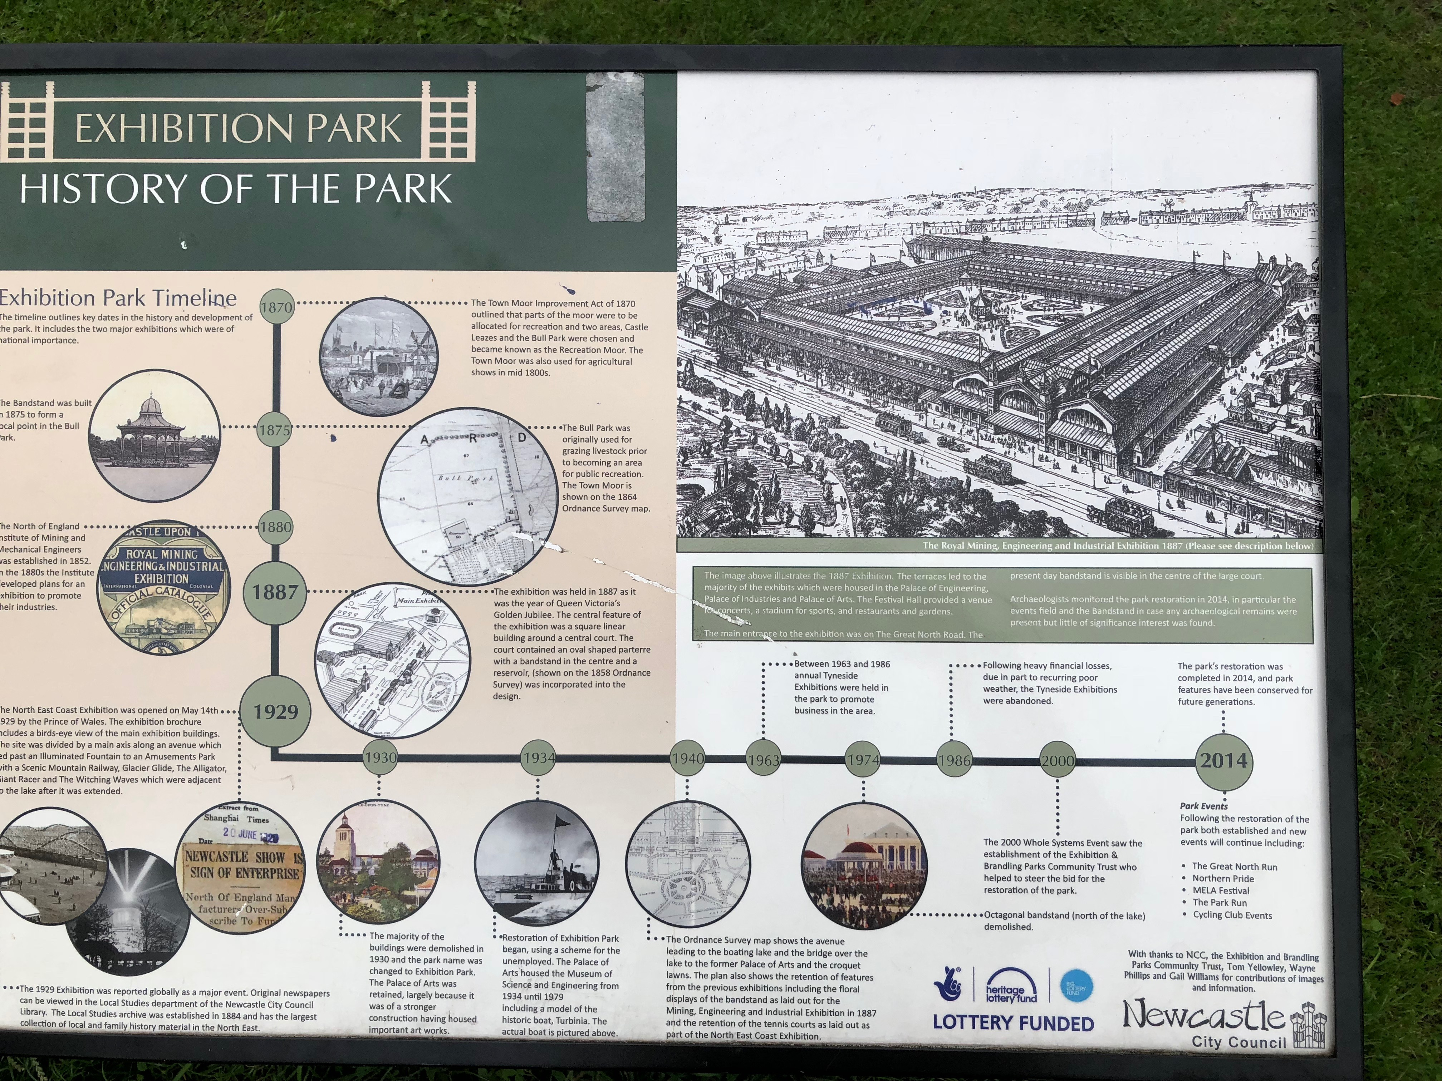
Fig. 3: Author's Collection 2

Two million people visited the showgrounds between May and October 1887, many arriving on the six hundred or so excursion trains run from as far afield as Peterborough and London. This was a big event, but it has been almost entirely forgotten. At a time when cost constraints restrict access to local archives yet £20m is being spent on ‘The Great Exhibition of the North’ in an attempt to redefine Newcastle to locals and visitors, we need to ask if a good balance has been struck.

The Context for the 1887 Exhibition
The winter of 1885/6 was one of the coldest in thirty years, with a severe economic slowdown across the country. Government inaction through 1886 and 1887 contributed to an environment of social discontent that saw riots in London and demonstrations and marches across the country, stoking middle-class fears of violence as the ‘residuum’ had become a visible entity rather than a hidden social problem. The North-East suffered as much as anywhere. The dramatic decline in the tonnage of shipping output from Palmer’s Jarrow shipyards from 1884 onwards shows the scale of downturn (Newcastle Daily Chronicle, 10th May 1887).

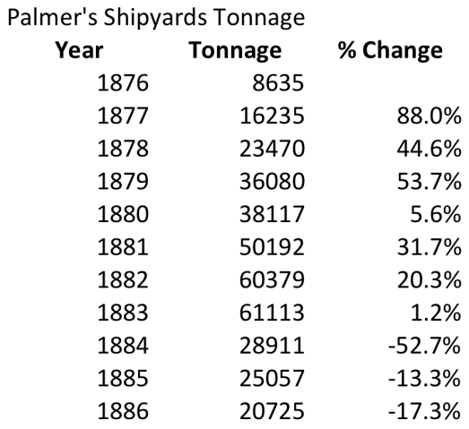
Fig. 4: Newcastle Daily Chronicle, May 10th 1887

In industrial sectors prominent in the North-East unemployment was significant during the 1880s, reflecting the cyclical nature of the UK economy as can be seen in the graph below.

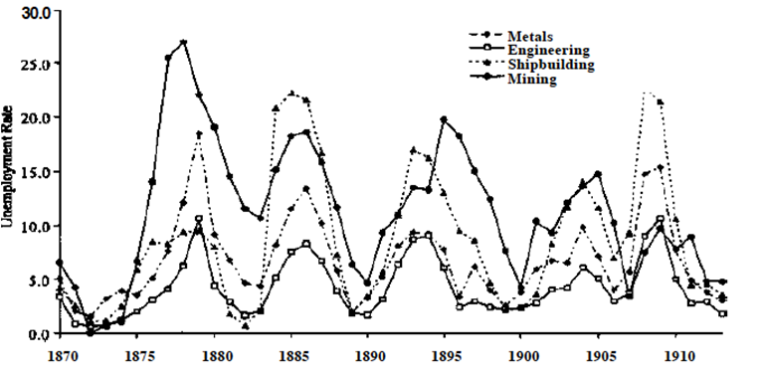
Fig. 5: Boyer and Hatton, 2002, p.658.

Despite the economic situation, Irish Home Rule dominated Westminster politics. The Liberal Unionists split from the government, and after a defeat in the Commons on the Home Rule bill in June 1886, Parliament dissolved. In the July election Salisbury returned to power supported by the Liberal Unionists. The winter of 1886/7 saw more intense cold weather, with further negative impacts on the economy. An obstructionist approach meant that the Government was tied down by the opposition and was not able to bring forward any legislation other than the Budget, so actions to address the economic downturn were seriously constrained.

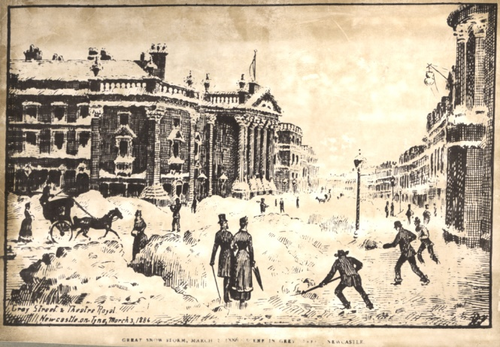
Fig. 6: Newcastle City Library Photo Collection 2

Whilst these issues consumed political energy, Queen Victoria was approaching her Golden Jubilee. The government was reluctant to get too involved, waiting for some external pull for celebration rather than pushing it themselves (Kuhn, 1987, pp.107-114). This potential for pull was small; the monarch’s popularity low, the Queen rarely seen in public. In 1886/7, political and economic circumstances were challenging so exhibitions were seen by big cities as opportunities to stimulate economic activity, promote local businesses, and reinforce local pride

Scholarship to date
At the time of writing, there are no peer-reviewed academic articles about the Newcastle Exhibition. There is an article published in Tyne and Tweed (a local history publication) by Stafford Linsley (1991/2), and two self-published books by Murray Steele (2012; 2015) contain sections on the exhibition. Both authors make extensive use of the limited archival material available, consisting in the main of Newcastle Council Minutes, the Prospectus and the Catalogue for the exhibition, an event and local guide book, published by Andrew Reid in 1887, and contemporary newspaper reports, especially a four page ‘special’ printed by the Newcastle Weekly Courant on Friday, 13th May 1887. Steele also uses extracts from the unpublished diaries of 23 year-old William Dunn, a shipping clerk and season ticket holder. What material there is can be found in the Tyne and Wear Archives, Newcastle University Library’s Special Collection and the City Central Library. Finding the material is difficult as there is nothing catalogued under obvious search terms such as 1887 Jubilee or 1887 Exhibition. There are few, if any, artefacts or ephemera remaining – these events produced commemorative plates, cups, handkerchiefs and the like, but the author has found none despite much searching.

Stafford Linsley’s (1991/2) article in Tyne and Tweed is based around contemporary reports. Murray Steele’s books (the first focusses on Liverpool, the second on Liverpool, Manchester, Saltaire and Newcastle) use a more extensive set of sources, but the section of the Newcastle event uses the same core as Linsley. There is little ‘new’ source material, although I have referenced another diary, that of Richard Lowry, together with some content in the 1887 edition of Bulmer’s History and Directory of Newcastle upon Tyne.

Steele (2015, p.4) argues that, apart from the second Liverpool exhibition, where they seem to have been irritated into action by the success of their Mancunian rival’s event, each of the Exhibitions was locally driven, planned and executed with little reference to the other events. The Newcastle evidence supports this; the Council Minutes only contain one reference to another exhibition, when, as recorded in the Corporation Minutes of Wednesday 24th November 1886 Councillor Youll said that the finances of the event needed to be properly managed “as they appear not to have been at Liverpool” to ensure a success for Newcastle. Steele (2015, p.4) noted that Manchester’s extensive archive of photographs and other material related to the event was preserved at the request of the City Corporation. Liverpool lost a lot of civic material during the blitz, their archive catalogue listing twenty-one items relating to their exhibition, two of which are Murray Steele’s books, and seven are newspaper articles.

The Age of Exhibitions
The concept came to Great Britain with the 1851 Great Exhibition bringing elements of the commercial, the competitive, national and regional pride and, in their patrons’ minds at least, arbitration of taste. (Briggs, 1988, pp.95-6). The Great Exhibition’s main aim was for Britain to show the world its role as an industrial leader. Whilst exhibits from around the world were encouraged, it was expected that these would underline Britain’s superiority. The commercial was inherent in the design of the event – through attracting as many visitors as possible from both home and abroad, it would act as a shop window for the Exhibitors and reach customers in a more effective way than the newly emerging advertising industry could, as well as encouraging local pride and, in the light of the widening franchise, provide an inclusive environment which would draw all social classes into a shared experience.

The 1886 Exhibitions
In the midst of a volatile political environment there were events taking place across the country that encouraged the thought that Exhibitions were the fashion of the hour. Opening in May 1886, the Colonial and Indian Exhibition in South Kensington drew more than 5 million visitors over 164 days. As Briefel records (Briefel, n.d., p.1) the Saturday Review considered that “… if any man can look at this and not come away with a new and a lively sense of the greatness of the country he belongs to, he must be a fellow of a very dull imagination and a very stupid temperament”. It focused on exhibits from around the Empire, including 34 ‘artisans’ from India (reputedly brought from Agra jail). (Briefel, n.d., p.3).

At the same time another Exhibition was opening in Edinburgh. Running from the 6th May to 30th October 1886, it was opened by Prince Albert Victor, Victoria’s grandson, and took place in a purpose-built pavilion on the city’s Meadows parkland. In keeping with other events, over 20,000 exhibits from around the world, including examples of mining, pottery, sugar-refining, paper-making, printing and railways were arranged within a large pavilion. Additionally, there was a large-scale reconstruction of a 17th-century Edinburgh street including the old gateway into the city, the Netherbow Port and the Black Turnpike (The Scotsman, 2013).

These events combined a formal industrial/commercial element with a less formal amusement section. They can be seen as fusion events, mixing high and low culture; elitism and popularity, aligning with expectations of rational recreation (Hoffenberg, 2001, p. xviii). This mixture was on the one hand contentious, but on the other intensely practical. The machines, products and tools were displayed almost as abstract examples of work, with little or no reference to the working lives of those who made or operated them (Hoffenberg, 2001, pp.184-185). These sections provided the competitive and commercial elements but they alone would not attract sufficient visitors. The key was to make the public not just visitors but participants hence the addition of amusement – Grace Darling’s Coble, the recreation of ‘Old Edinburgh’. It also reflected the change in thinking about the nature of popular entertainment and its role; rather than fearing ‘the mob’ it was becoming accepted thinking that exhibitions, fairs and the like were vehicles for creating a greater integration between classes – they were a potential source of order, not disorder. These two events attracted 7.7 million visitors (London 5 million, Edinburgh 2.7 million) (Steele, 2012, p.112). Both made a profit and the press and critics judged them as successful. Around the same time leading figures in Newcastle and Manchester were considering running similar events, and the news from Edinburgh and London must have been well received.

Origination
The Newcastle event originated with the North of England Institute of Mining and Mechanical Engineers. Meeting in late 1885, the Institute decided to hold an exhibition of mining appliances in Newcastle and to invite mining and mechanical engineers from the UK and abroad. Members of the Institute started to discuss the proposal with the Corporation of Newcastle in January 1886. The Mayor, Benjamin C Browne, and the Council saw an opportunity, and the scope was extended to cover all mining, engineering and industrial appliances, with the date being moved to 1887 recognising that the Edinburgh and Liverpool events were planned for 1886, and, “to mark in the annals of Newcastle-upon-Tyne the Jubilee year of the reign of her Gracious Majesty.” (Newcastle Corporation Minutes, 11th May 1887).

A public prospectus was created and a panoply of the great and good of North Eastern society formed an organising committee. The Duke of Northumberland became Patron, the Earl of Ravensworth President; thirteen Earls, four Bishops, twenty-eight MPs, and tweleve Mayors joined Sir William Armstrong, the Mayor and Sheriff of Newcastle, amongst the Vice Presidents. The first meeting, held on 15th April 1886 at the Literary and Philosophical Society, was described as one of the ‘most representative and influential meetings ever held in Newcastle’ (Newcastle Corporation Minutes, 11th May 1887). The Mayor argued that what a shop window is to a shopkeeper, an exhibition is to a manufacturer. He said they were also a way of finding out how others did things, including those abroad. An exhibition ‘would put Newcastle in a better position than it had ever occupied before, which is saying a great deal’ (Newcastle Weekly Courant, 13th May 1887). This was the aim of the event – to promote the town and its industries to as many people as possible.

The Official Prospectus does not mention the intended audience, but we can deduce some ideas from the proposed pricing structure. The initial entrance fee structure was straightforward – 2/6d on Wednesdays, and 1/- on other days. The higher price on Wednesday (common practice at other exhibitions) was designed to encourage attendance by people of quality. A Season Ticket could be purchased for a Guinea with a Workmen’s Ticket at half a Guinea available to men and women who worked with their hands for wages, and to clerks, shopkeepers or foremen who earned less than £2 per week. This was soon extended to include seamstresses, shop girls, female factory workers and domestic servants, but these tickets could not be used on Wednesdays. With a typical agricultural wage in the North East around 13/4d and artisan wages perhaps between 30/- and 38/- a week a family visit would have been expensive.

The Exhibition Executive Council agreed that the scope should be expanded to showcase electric lighting and the systems needed to produce it. By the end of April 1886, the Executive Council had secured agreement to hold the exhibition on Bull Park, adjacent to the Great North Road and on the south-eastern corner of the Town Moor. Conveniently it was decided to hold the Royal Agricultural Society’s Annual Show to coincide with the proposed exhibition, and by co-locating the two events, a total of 31.5 acres were available (Newcastle Weekly Courant, 13th May 1887). The Town Moor was (and still is) owned by the Freemen of the City, so the land was only lent, with the proviso that it had to be returned to its previous state. After some modifications, the plans were accepted by the Executive Council on 2nd September 1886 (Newcastle Corporation Minutes, 2nd September 1886). They provided an area of 270,000 square feet under cover in the main Exhibition Halls, and with additional buildings in the gardens, the total under cover was 430,000 square feet.

As with other events, a Guarantee Fund was set up – the Institute of Mining and Mechanical Engineers committed £1,000, Newcastle Corporation committed £5,000.The Tyne Improvement Commissioners then agreed to provide £2,000, and soon the fund stood at £34,552.10s. The Fund underpinned the Exhibition finances, to be called on only if entrance fees from visitors and rental from stallholders did not cover the costs. In the event, some £27,000 was realised from charges made to exhibitors for space, catering, printing and other contracts, thus covering the building costs so the Exhibition was effectively cost neutral before it opened. The Directors of the North Eastern Railway were persuaded to offer excursions to the event. Usefully, the Chairman of the Railway, John Dent, was an Exhibition Vice President, and Sir Lothian Bell, member of the Exhibition Executive Council was also a Board Member. They offered tickets at reduced rates with excursions running from as far afield as London and Peterborough, and by the close over 600 excursion trains had been run by the NER, a mutually beneficial collaboration.

By the end of January 1887, it was confirmed that The Duke of Cambridge would open the event on behalf of Queen Victoria. The Exhibition buildings were handed over at the end of February 1887, the first exhibits arriving at the end of March. Newspaper reports indicate that large crowds outside the grounds watched developments, and seats on top of tramcars going up North Road to Gosforth were a popular means of evaluating progress (Newcastle Weekly Courant, 8th April 1887). The larger exhibits required considerable effort, including a 44-ton Robert Stephenson & Co locomotive. Other exhibits, including a 6ft glass replica of Scott’s Monument suffered some damage in transit, but by April everything was in place (Linsley, 1991/2, p.49).

The ‘Attractions’
Attractions were not a new idea – there were as many sideshows as stalls at the Great Exhibition (Briggs, 1988, p.91). Fairs and exhibitions alike had always had something of a dual role – the Hiring Fairs, common across much of rural England until the outbreak of the First World War were as much about enjoyment as they were about securing another annual contract (Caunce, 2017, p.111-126). Added to this was the commercial benefit– the larger the paying audience the bigger the revenue, and the bigger the audience the larger the fees to be charged to the amusement providers.

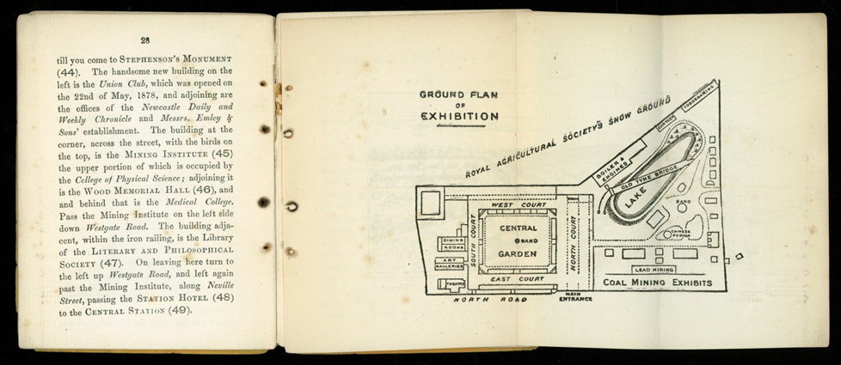
Fig. 7: Newcastle University Special Collection 1: Exhibition Plan from “A Day in Newcastle and its Jubilee Exhibition” published by A Reid.

The Exhibition was based around four ‘Courts’ with a central garden and bandstand. The North Gardens contained many of the ‘attractions’ including full-size replicas of a lead and a coal mine together with working examples of the haulage systems used in them. The coal mine had a replica of a coal seam where different methods of mining were demonstrated. Both the mines (and other parts of the Exhibition) were lit by electric light, provided by a generator housed in the Gardens (using fourteen 14 steam powered turbo-generators built by local firm Clarke, Chapman, Parsons and Co.) (Linsley, 1991/2, p.56). In a bold example of the competitive spirit of the Exhibition, the Executive Council chose multiple different generating systems. As the first city in the world to have a street fully lit by incandescent light bulbs, when the lights of Mosley Street were switched on on 3rd February 1879, Newcastle was a leader in this area so it made sense to promote this technology.

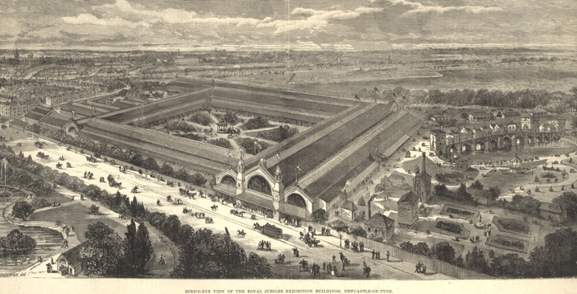
Fig 8: Newcastle City Library Photo Collection 3

The Newcastle amusements included a shooting and archery range resembling Alnwick Castle, a cigarette and cigar emporium, and a model dockyard selling mechanical toys. In addition, a toboggan run and a gravitational railway were at the northern tip of the gardens, both provided and run by Messrs Brown and Backhouse. Refreshments were available from a variety of stalls, and for those requiring cheaper fare, there was a canteen selling cold luncheons and beer at what were described as public house prices. There was also Mr Barker’s Cyclorama of Paris, a panorama depicting various incidents of the 1871 Franco-Prussian war. Finally, there was a model of the old Tyne Bridge as it would have looked in the late Middle Ages. Built at a scale of two-thirds for its length and height, but with its width at full scale it sat across a lake constructed from two pre-existing reservoirs.

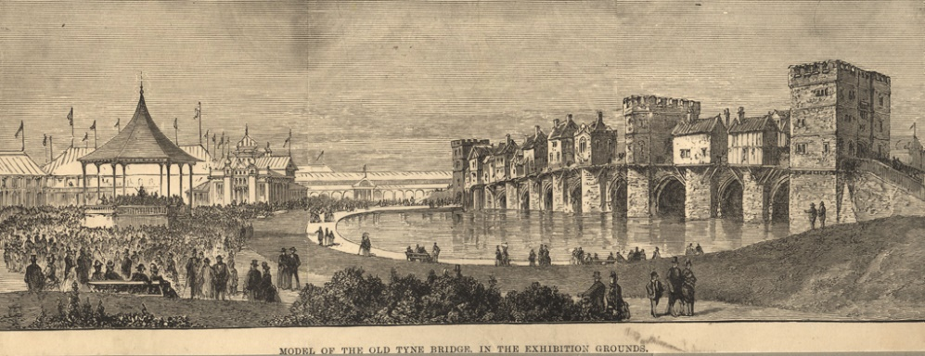
Fig. 9: Newcastle City Library Photo Collection 4

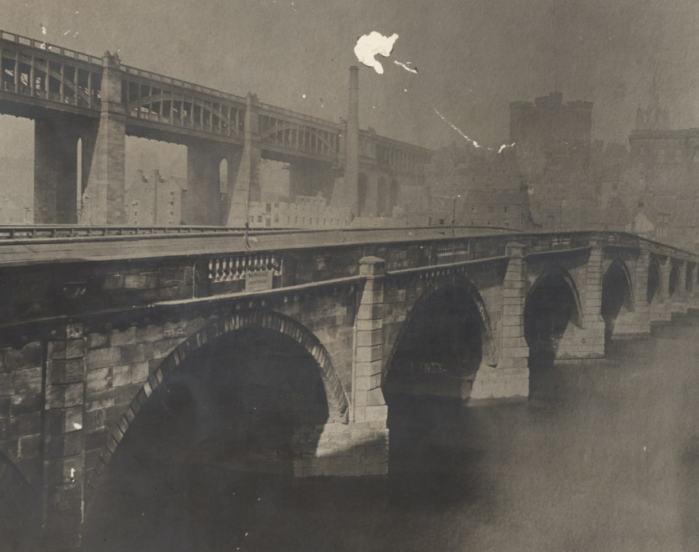
Fig. 10: Newcastle City Library Photo Collection 5 Photograph of the old Tyne Bridge alongside the High Level Bridge. Date unknown.

The building of a replica of a well-known local site was common at these Exhibitions. The most complete example was in the 1887 Manchester Exhibition – a recreation of a number of streets representing ‘Old Manchester and Salford’ (see Fig. 11). The Exhibition catalogue pointed out that this was not just a physical manifestation of the past; it was a living entity, the buildings being occupied by people replicating old crafts and dressed in costumes peculiar to the time.

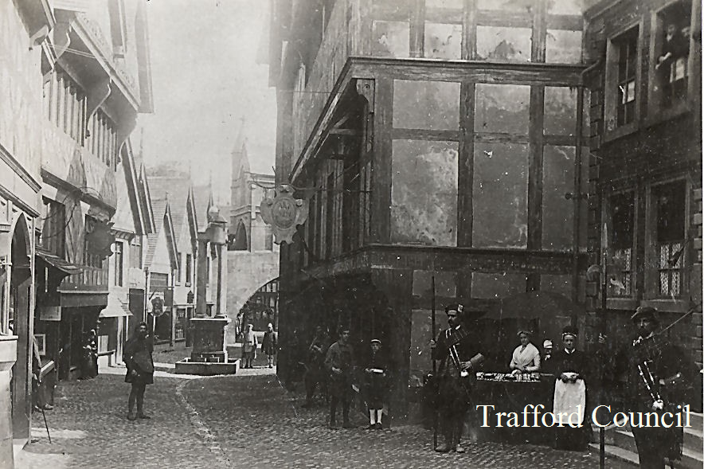
Fig. 11: Trafford Council Archives 1

Visitors
Visitors could purchase an Official Catalogue for 1/-, printed in Newcastle by R Robinson and Co, who paid a considerable amount for the privilege of being Official Printers to the Exhibition (Newcastle Weekly Courant, 4th March 1887). The highest weekly attendance (117,720) (Newcastle Corporation Minutes, 1887 Record, page lviii) during the first half of the Exhibition came during the week ending 16th July, the same week as the Royal Agricultural Show was held in the fields adjacent and the Prince of Wales visited both. On Thursday 14th July 38,139 people attended, the fourth highest daily total for the whole period. By the time the Exhibition closed on Saturday 29th October, 2,092,273 visitors had come through the gates (Newcastle Corporation Minutes, 1887 Record, page lviii). The single most popular day was the closing day, when 54,716 people visited, some 10,000 more than the previous high on Saturday 1st September. Overall, the Exhibition was reported to have made a surplus of £4,388, which was donated to the College of Physical Science (Daily Gazette for Middlesbrough, 21st October 1889).

This was not achieved easily however. By the end of the sixth week of the Exhibition some half a million people had come through the turnstiles, but the Exhibitors were not happy, feeling that numbers had been insufficient (Newcastle Courant, 1st July 1887). They had formed an ‘Exhibitors’ Association’ and set up an ‘Indignation Meeting’ with the Executive Council to share their concerns. It was alleged that there were more posters in Newcastle advertising the Jubilee Exhibition in Liverpool than the local event, and that unless more ‘popular’ events such as sport and band competitions were held the numbers would stay low. Better publicity was demanded, more railway excursions, better attractions and more music. However, it was not just due to failures by the Committee that takings were not as hoped; there were newspaper reports of aggressive touting for business on the Old Tyne Bridge that caused visitors to avoid the attraction (Newcastle Weekly Courant, 1st July 1887). The Executive Council responded quickly, placing posters at 100 additional railway stations; advertisements in 10 London newspapers with flyers made available at Newcastle Central Station for new arrivals. The Council also agreed to organise more ‘popular’ events such as sports, choral and brass band contests, and balloon ascents. They also abolished the 2/6d Wednesday tickets, pushing the Exhibition into becoming more like a festival than was ever envisaged in 1885. Performing elephants, variety shows and juvenile bicyclists were not part of the original intention to showcase Newcastle as a centre for engineering, but without these attractions it seems unlikely that over 2 million visitors would have come. And if they came for the elephants and also learned how a mine works, what did that matter? In the end pragmatism and commerce won – the need to get the visitors through the gates overcame any concerns. After the close of the Exhibition, there was debate as to whether the buildings and attractions should be kept as a permanent feature of the Town Moor. The Earl of Ravensworth wrote formally to the Corporation offering them the option. In the end a resolution was passed stating the Council, ‘most respectfully’ declined the offer.

One aspect not covered by either Steele or Stafford is the use of the exhibition as a vehicle for the ‘doing of good works’. An example is a report in the Newcastle Daily Chronicle on Tuesday 20th September 1887 of a visit by the Byker Mother’s Meeting. Byker, to the east of the City, had been hit hard during the economic downturn of the previous three years and Mrs Peacock and Mrs Pease (of Pendower Hall – a large hilltop mansion north of Armstrong’s factories) had helped to feed eighty to ninety mothers on a weekly basis during the depression, and had arranged for them to obtain paid sewing work at two pence an hour. The Chronicle reported that the party of over forty “neatly attired and happy looking mothers... [who] could scarcely be distinguished from other dames” saw the sites of the Exhibition and had a “capital tea at Lockhart’s”.

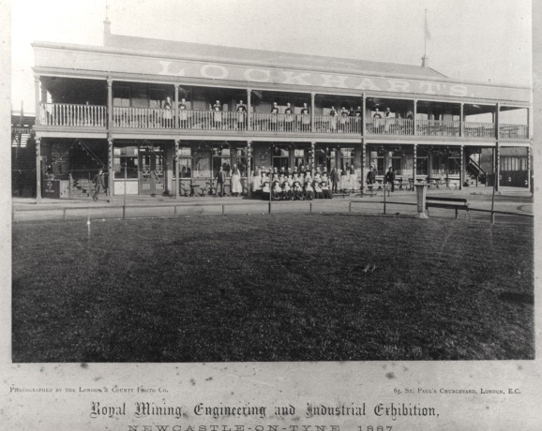
Fig. 12: Newcastle City Library Photo Collection 6

The costs of the excursion were covered by money subscribed for the purpose, and the article finished with the comment that “…Now that the opportunity has come, self-help has come with it.” Samuel Smiles would have approved.

Why is 1887 rarely remembered?
The 1929 Newcastle Exhibition, held on the same site, fulfilled a similar purpose – exhibiting regional products and providing an event to boost the confidence of the producers, workers and consumers. Attracting around 4 million visitors, some contemporary goods descend directly from the event – Newcastle Exhibition Ale was launched there and is still on sale. There is more memorabilia in circulation, and the Newcastle Discovery Museum (2018) has a dedicated section. The 1887 Exhibition has no archive, unlike Manchester and Glasgow which have extensive online archives. So far, all that has been found are three copies of the Newcastle catalogue, and the few photographs that remain are scattered across several sites.

There are some other, more cultural possibilities. The region sees itself (and perhaps the rest of country sees the region) as about coal, ships and engines, and especially the decline and disappearance of those industries. How these were promoted, marketed and sold is not part of that definition, as the focus is on an almost romanticised past, so an Exhibition falls outside that narrative. As the ‘Mining, Manufacturing and Engineering’ Exhibition the contemporary focus in newspapers was on these elements not the amusements, so ‘stories’ and ‘anecdotes’ are missing. There are two diarists who wrote about the event but they remain unpublished. Although 1887 was organised and managed without representatives of the groups whose work was being exhibited and promoted it was a genuine attempt to provide a boost for business as well as a popular attraction and this may not fit comfortably into the conventional ‘them and us’ narrative of hard-headed uncaring elites and noble workers. Steele’s conclusion that these events should be seen as primarily business ventures (Steele, 2015, p.149) is really only half the story. The exhibition was much more than that – the balance struck between education, elucidation and entertainment tells us much about the priorities of the elites putting the event together, and it tells us much about the priorities of those who attended. Work may have been at the core of the event’s intent, but it was not at the core of the ‘day trip to the Ex’.

A Good Day Out
Murray Steele’s book on the 1887 Jubilee Exhibitions is called A Good Day Out (Steele, 2015) and for the Exhibition Organisers this would be just want they wanted to hear. This phrase encapsulates the reasons why the events should be remembered but also why they may have been forgotten. The intention of the Newcastle Organising Committee was to promote the city and its products in the expectation of increasing business. They wanted at least to break even, and the firms who paid to occupy the stalls and shops, run the catering, and provide the attractions were there to make a profit. On one level the event was a business enterprise, and as worthy of attention as the development of department stores, music hall or sport as examples of rational recreation in increasingly consumerist society, where ‘A Good Day Out’ would be a mark of success.
Yet that would ignore the political and social construction of the event and the bringing together of work, networks, politics, society, art and economics under one ‘roof’. Even more significantly, the event was conceived, built, run and dismantled during a period of political uncertainty, and severe economic downturn, by people with no previous experience of doing so. That visitors were able to say it was ‘A Good Day Out’ under these circumstances makes it worthy of study. That being the case, why has the Newcastle event been largely forgotten? Again, we can find a clue in the ‘Good Day Out’ – other than the surplus the exhibition generated there is no extant evidence of it as a business success. The grounds were returned to their previous state within a few weeks of the close, and there no records remaining of products exhibited at the event generating new sales (that is not to say it did not happen, just to say that cause and effect cannot easily be established). So, in that sense, ‘A Good Day Out’ is all it was – whether you were one of Danish apprentices who came to the event; a mine owner looking at new mining equipment, or a clerk riding the toboggan and drinking at Lockhart’s, perhaps it was a day out, and no more than that. With few extant contemporary accounts, the Exhibition just came and went, and without drive from the City Council to create an archive (pace Manchester Corporation) it was quickly forgotten.

Table 1: Major UK Exhibitions 1851-1890 (Steele 2012, p.112)
Year | Location | Attendance | Profit / Loss
1851 | London | 6,039,145 | £186,000
1857 | Manchester | 1,336,715 | £304
1885 | London | 3,750,000 | (£5437)
1886 | Liverpool | 2,676,515 | (£19,135)
1887 | Manchester | 4,765,137 | £46,977
1887 | Newcastle | 2,002,273 | £3762
1887 | Saltaire | 823,133 | £4000
1888 | Glasgow | 5,748,379 | £43,000
1890 | Edinburgh | 2,414,129 | (£43,961)

References
Boyer, George R and Hatton, Timothy J. (2002) New Estimates of British Unemployment, 1870-1913, http://digitalcommons.ilr.cornell.edu/articles.
Briefel, Aviva. (2012) On the 1886 Colonial and Indian Exhibition. BRANCH: Britain, Representation and Nineteenth-Century History. Ed. Dino Franco Felluga. Extension of Romanticism and Victorianism on the Net.
Briggs, Asa, (1988). Victorian Things. London: Batsford.
Caunce, Stephen, (2017) “‘Dancing and drinking were the order of the day’ – the hiring fairs of Chester, Nantwich and Whitchurch in the late-nineteenth century” in the Journal of the British Association for Local History, Vol. 47, No 2, p111-126.
Daily Gazette for Middlesbrough, 1889. British Library Newspapers, tinyurl.galegroup.com/tinyurl/4tjPU8.)
Hoffenberg, Peter H, (2001). An Empire on Display: English, Indian, and Australian exhibitions from the Crystal Palace to the Great War. Berkley: University of California Press.
Kuhn, William M, (1987). Queen Victoria's Jubilees and the Invention of Tradition. Victorian Poetry, Vol. 25, No. 3/4, pp. 107-114.
Linsley, Stafford, (1991/2). The Royal Mining, Engineering and Industrial Exhibition, Newcastle upon Tyne, 1887. Tyne and Tweed 46.
Luckhurst, Kenneth W, (1951). The Story of Exhibitions London: Studio Publishing.
Mathur, Saloni, (2007). India by Design: Colonial History and Cultural Display, Berkley: University of California Press.
Newcastle Weekly Courant, (Friday 13th May 1887), The Newcastle Royal Jubilee Mining, Engineering and Industrial Exhibition Special Supplement, Author’s Collection
Newcastle Corporation, Council Meeting Minutes 1886 and 1887, Newcastle City Library.
Newcastle Weekly Courant, 1887, British Library Newspapers, tinyurl.galegroup.com/tinyurl/4tjSo3.
Reid, Andrew (Publisher) (1887), A Day in Newcastle and its Jubilee Exhibition, Newcastle University Library Special Collections.
Richards, Thomas, (1991). The Commodity Culture of Victorian England: advertising and spectacle, 1851-1914. Stanford: Stanford University Press.
Saturday Review, The Imperial Object Lesson. 8 May 1886: 632-33.
Steele, Murray, (2015). A Good Day Out – English Exhibitions in the Golden Jubilee Era. Self-published.
Steele, Murray, (2012). Liverpool on Display: the International and Jubilee Exhibitions, 1886 and 1887. Self-published.
Strong, Michele M, (2014). Education, travel and the 'civilisation' of the Victorian working classes. London: Palgrave MacMillan.
The Scotsman, (2013), “Lost Edinburgh: Edinburgh International Exhibition 1886”, [online] available at: www.scotsman.com/heritage/people-places/lost-edinburgh-edinburgh-international-exhibition-1886-1-2895307 [6th March 2018].
Wikipedia, (2018), “Royal Jubilee Exhibition”, [online] available at: en.wikipedia.org/wiki/Royal_Jubilee_Exhibition [6th March 2018].
Wikipedia, (2018), “Royal Jubilee Exhibition, Liverpool” [online] available at:
en.wikipedia.org/wiki/Royal_Jubilee_Exhibition,_Liverpool [6th March 2018].

Copyright Statement
© Mark Stoddart. This article is licensed under a Creative Commons Attribution 4.0 International Licence (CC BY).

According to the UK National Audit Office, the total cost of The Dome at the liquidation of the New Millennium Experience Company in 2002 was £789 million, of which £628 million was covered by National Lottery grants and £189 million through sales of tickets etc. A surplus of £25 million over costs meant that the full lottery grant was not required. However, the £603 million of lottery money was still £204 million in excess of the original estimate of £399 million required, due to the shortfall in visitor numbers. https://en.wikipedia.org/wiki/Millennium_Dome
Browne was a mechanical engineer who had trained at the Elswick works. He had been a senior partner and had been involved in the takeover of R&W Hawthorn in 1870. He eventually became Chairman of Hawthorn Leslie & Co in 1886.
This construct was the same for the Manchester Exhibition – The Earl of Sefton was President, and the Vice Presidents included 2 Dukes, 6 Earls, 28 MPs and 22 Mayors.
The Newcastle Weekly Chronicle (n.d.) records a visit by 207 Danes, chiefly artisans, who were send across to visit the exhibition on 21st July. The Mayor addressed them at the Exhibition site. The following day they inspected several engineering and manufacturing establishments on the Tyne, including the Elswick works.
Joseph Swan developed the first practical lamp and led the way in early electrical lighting. Swan supplied arc lamps to light the Picture Gallery at Cragside (Sir W.G. Armstrong’s house) in Northumberland in 1878, and for Mosley Street in Newcastle, the first electrically lit street in 1879.
One vocal opponent of the Corporation committing such a large amount was Alderman Barkas. Interestingly he is mentioned in the official record of the event as attracting one of biggest crowds to a lecture at the event – on ‘Animals that lived in Northumberland during the Coal Period’.
The Liverpool event saw a similar close collaboration – this time between the Tramways and the event. The Chairman of the Tram Company was the Mayor of Liverpool who presided over the Exhibition as well.
Prince George, 2nd Duke of Cambridge (George William Frederick Charles; 26 March 1819 – 17 March 1904) was a cousin of Queen Victoria. The Duke was an army officer by profession and served as Commander-in-Chief of the Army from 1856 to 1895. He became Duke of Cambridge in 1850.
Methods demonstrated included stope mining, longwall, and pillar and stall. Stope mining is the process of extracting the coal leaving behind an open space known as a stope. Stoping is used when the rock is sufficiently strong not to collapse, although in most cases artificial support is also provided. Longwall mining is where a long wall of coal is mined in a single slice; pillar and stall mining is where the coal is extracted across a horizontal plane, creating horizontal arrays of rooms and pillars. This technique is usually used for relatively flat-lying deposits, such as those that follow a particular stratum.
Brown and Backhouse were also involved in the construction of 1886 Liverpool Exhibition. http://www.gracesguide.co.uk/1886_Liverpool_International_Exhibition
This figure differs from that quoted by Steele (see Table 1).
The 1886 Liverpool event had much the same situation – by the end of the first month only 314,000 had come, and exhibitors complained about lack of publicity. The response included a 40ft placard placed in The Strand in London, and a touring display around Lancashire towns. See Steele p.29.
The Executive Committee was discussing railway excursions as early as March 1887. In a report in the Newcastle Courant on 18th March 1887, the Committee is reported as noting the desirability ‘that the whole of Midland towns should be tapped by the North Eastern Railway Company in conjunction with the Midland Railways.’
It should be noted that the 1886 Prospectus does contain a section on a Balloon Sub-Committee sitting under the Entertainments Committee. Chaired by Mr T Gray it had 8 members, so the balloon ascents may well have been planned long before the ‘Indignation Meeting’. North Country Lore and Legend of September 1887 records balloon ascents on 3rd and the 15th August by a Captain Dale.
See for example https://www.theguardian.com/uk-news/2014/may/10/north-east-avoid-becoming-britains-detroit, Beckett, Andy (2014), The north-east of England: Britain's Detroit?, The Guardian, May 10th

