Research paper

From Legal Mimicry to Algorithmic Integrity: Smart Sukuk and the Case for Embedding Sharia Compliance in Code

Hssan Alkhamees
University of Essex

Abstract
A persistent critique of modern Islamic finance is that many Sukuk merely replicate conventional bonds, achieving Sharia compliance through legal artifice rather than genuine risk-sharing. Smart Sukuk, that is blockchain-based instruments encoding contractual obligations into self-executing code, promise to replace this ‘creative Shariah compliance’ (Alkhamees, 2017) with algorithmic integrity. This article argues that while smart Sukuk genuinely improve certain dimensions of compliance, including payment automation, asset tracking, and the standardisation of Sharia interpretations across jurisdictions, they also create what it terms ‘architectural mimicry’: the partial relocation of trust problems into a new technological form. Drawing on case studies from Indonesia, Abu Dhabi, Malaysia, and Saudi Arabia’s emerging sovereign-scale tokenisation infrastructure, the article examines how early platforms such as Blossom Finance and Wethaq demonstrated the technology’s potential at micro-scale, while more recent state-supervised developments suggest a shift toward institutional infrastructure. It identifies the ‘oracle problem,’ the gap between on-chain representation and off-chain reality, as a central challenge, and examines unresolved jurisprudential questions surrounding smart contract immutability and Islamic contractual flexibility. The article concludes that smart Sukuk require not less human engagement but a different, more technically informed form of scholarly and regulatory oversight.
Keywords: Smart Sukuk; Blockchain; Sharia Compliance; Islamic Finance; FinTech; Smart Contracts; Oracle Problem
Date of Submission: 27.03.2026 Date of Acceptance: 28.07.2026

1. Introduction
Islamic finance offers Sharia-compliant alternatives to conventional banking and investment, and within this framework Sukuk provide a key mechanism for raising capital while adhering to principles of asset-backing and risk-sharing. The market has grown substantially: Fitch Ratings (2025) projects global outstanding Sukuk will cross $1 trillion in 2025, reflecting continued mainstreaming in international capital markets (Alvi et al., 2019). Yet a growing body of scholarship (Alkhamees, 2017; Hamza, 2020; Iftikhar and Saba, 2020; Delle Foglie et al., 2021) questions whether this growth reflects genuine Sharia-compliant innovation or merely the repackaging of conventional debt under an Islamic label. Alkhamees (2017) characterises this as ‘creative Shariah compliance’: a practice in which financial instruments are restructured to satisfy Sharia requirements in form but not in substance, often through the use of hilah (legal ruses) that circumvent the spirit of Islamic law. When an issuer of Mudaraba Sukuk stands ready with a liquidity facility to cover any shortfall in anticipated returns, the profit-and-loss sharing principle that is supposed to distinguish Islamic finance becomes, at best, nominal (Hamza, 2020). Smart Sukuk, which embed contractual obligations in self-executing code on a blockchain, promise to resolve this tension by making Sharia compliance continuous, transparent, and algorithmically enforced.
This article argues that the promise is more complicated than it appears. Smart Sukuk are a meaningful innovation: by encoding agreed Sharia parameters into code, they can standardise interpretations and automate payment scheduling, asset tracking, and usage-of-proceeds checks. Nevertheless, not all compliance can be automated. The broader interpretive judgements of Sharia governance must still be made by human actors before any code is written. The question of who ensures Sharia compliance shifts from auditors reviewing documentation to programmers writing algorithms and Sharia scholars approving code specifications, but it does not disappear. This article calls this phenomenon ‘architectural mimicry’: the structural replication of the same trust problems in a new technological form. The term is chosen deliberately. Just as legal mimicry describes the adoption of Islamic labels for economically conventional instruments, architectural mimicry describes the adoption of algorithmic transparency for a process that remains, at its foundation, dependent on human interpretation of religious law.
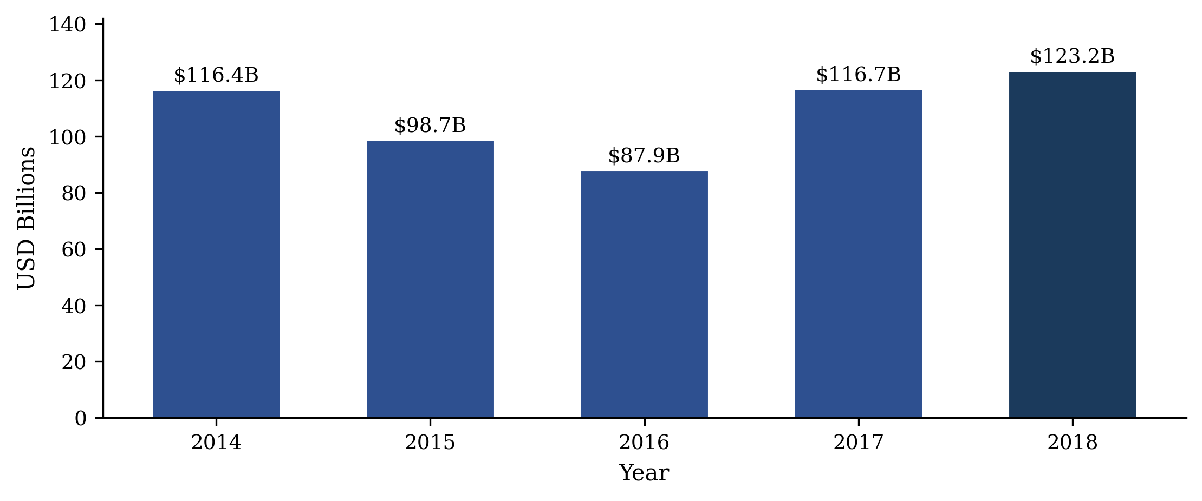
Figure 1. Global Sukuk Issuance, 2014–2018 (USD Billions). Source: Alvi et al. (2019).

2. The Compliance Deficit in Traditional Sukuk
Sukuk are certificates of equal value representing undivided shares in ownership of tangible assets, usufruct, and services, or in the assets of particular projects (AAOIFI, 2017, p. 468). Unlike conventional bonds, which represent a debt obligation bearing interest (riba), Sukuk returns should derive from underlying economic activity such as leasing (Ijara), cost-plus sale (Murabaha), or profit-and-loss partnership (Mudaraba) (Alkhamees, 2017; Iftikhar and Saba, 2020). Islamic financing thus operates through equity structures such as Musharaka (joint venture) or sale-based alternatives (Biancone and Radwan, 2018).
This concern does not apply uniformly: many Sukuk, particularly equity-based structures in emerging markets, do involve genuine asset ownership and risk-sharing, and AAOIFI has responded to compliance concerns through successive revisions to its Sharia standards (Asian Development Bank, n.d.; Biancone and Radwan, 2018; AAOIFI, 2017). Nevertheless, significant structural weaknesses persist: many issuances involve a Special Purpose Vehicle that nominally purchases and leases back an asset, with rental payments functionally equivalent to bond coupons and a purchase undertaking guaranteeing principal. In Mudaraba and Wakala Sukuk, if profits fall short of the anticipated return, the issuer’s liquidity facility covers the shortfall (Hamza, 2020). The economic substance of such instruments is often indistinguishable from conventional debt.
Economic similarity to conventional bonds does not, in itself, constitute a Sharia violation. Islamic law prohibits specific mechanisms such as riba and gharar, not the achievement of stable returns (Alkhamees, 2017; AAOIFI, 2017). Many scholars accept that Sukuk may deliver bond-like returns provided the underlying contracts are genuinely compliant: mimicry of outcomes is not the same as mimicry of prohibited mechanisms (Alkhamees, 2017; Hamza, 2020). The critique of legal mimicry should therefore be understood not as an objection to economic equivalence, but as a concern about whether the underlying structures involve genuine asset-backing and risk-sharing or are purely formal arrangements. The distinction matters because Islamic commercial law grounds its legitimacy in substance rather than form: a contract that replicates the economic effect of prohibited riba while adopting an Islamic label does not merely fail on technical grounds, but undermines the normative coherence of the entire Sharia compliance framework (Alkhamees, 2017).
Three further problems compound this compliance gap between formal Sharia labelling and substantive Sharia observance: multiparty contracts requiring separate partnership, agency, and profit-sharing agreements drive up costs and restrict issuance to governments and large corporations (Iftikhar and Saba, 2020; Alvi et al., 2019); divergent jurisdictional interpretation of Sharia law creates investor uncertainty and inhibits secondary market development; and weak post-issuance monitoring leaves investors unable to reliably verify whether underlying assets remain Sharia-compliant or have been substituted without disclosure (Iftikhar and Saba, 2020). It is these weaknesses, namely opacity, cost, and contractual rigidity, that proponents of blockchain technology argue smart contracts can remedy.

3. From Manual Auditing to Algorithmic Enforcement
Blockchain is a decentralised, cryptographically linked record-keeping system in which recorded data cannot be retroactively altered (Bashir, 2018); smart contracts, first conceptualised by Szabo (1996), are self-executing protocols that automatically enforce terms written directly into code.

Applied to Sukuk, smart contracts address the weaknesses above in three ways: real-time asset tracking ensures exclusive Sharia-compliant use, contractual execution (payments and profit distributions) is automated, and information access is democratised, reducing information asymmetry (Iftikhar and Saba, 2020). Sharia compliance thus becomes a continuously observable property of the instrument, rather than something verified only at issuance or audit.
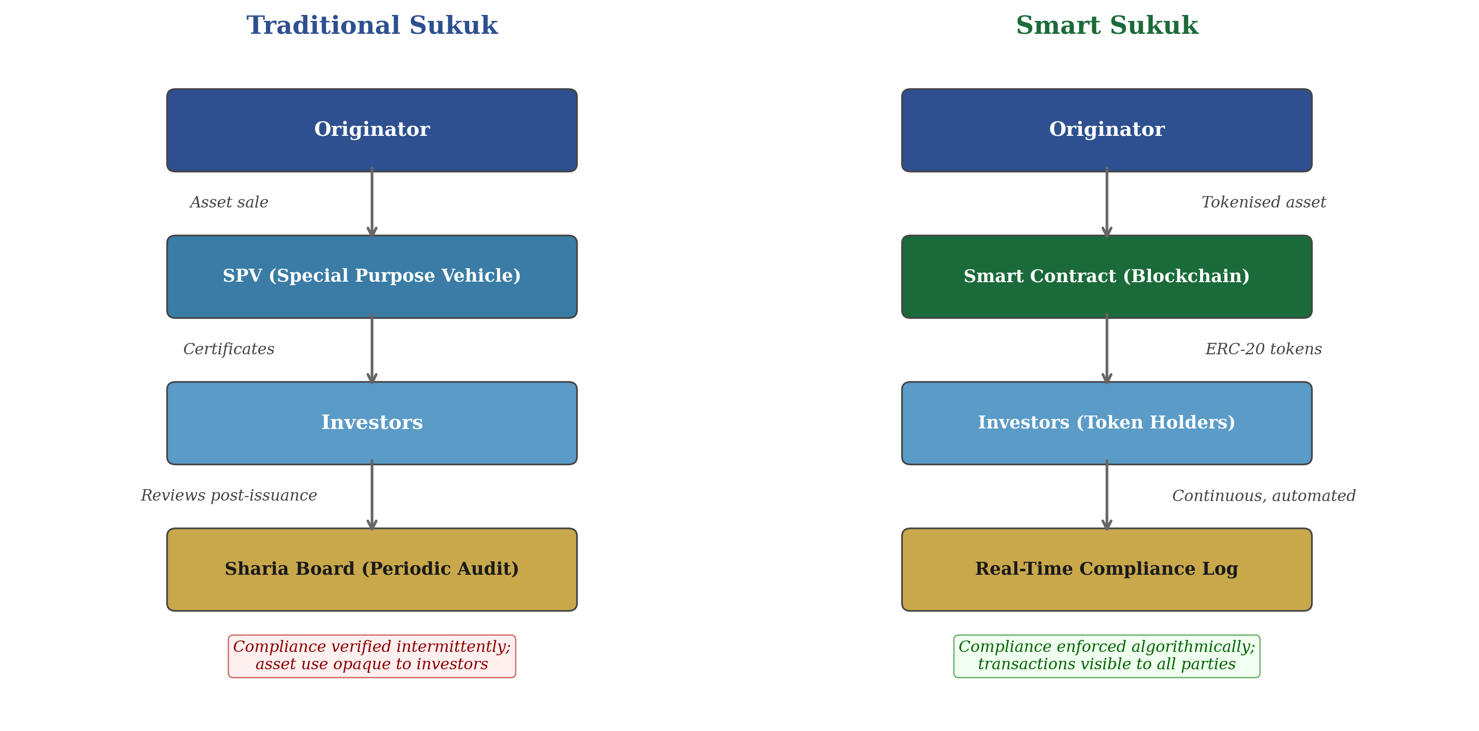
Figure 2. Structural Comparison: Traditional Sukuk vs. Smart Sukuk. Source: Author’s illustration.
The implications for specific structures are significant. Murabaha Sukuk, which constituted 31% of the global market in 2018 (Alvi et al., 2019), raise compliance concerns because investors indirectly acquire ownership benefits rather than tangible assets. With tokenised Murabaha smart Sukuk, however, tokenisation of base assets assigns partial ownership to token holders directly through the blockchain (Delle Foglie et al., 2021; Mousavi, Tohidinia and Mousavi, 2025). Smart Sukuk also offer cost advantages, with conventional issuance estimated at roughly twice the cost of equivalent Ethereum tokenisation, and standardised documentation could further reduce evaluation, negotiation, and secondary-market transparency costs, though these figures derive from modelling rather than observed market data (Mousavi, Tohidinia and Mousavi, 2025; Alvi et al., 2019; Ulusoy and Ela, 2018). Yet whether the data fed into the blockchain accurately reflects real-world conditions proves to be the technology’s most significant limitation, as the following case studies illustrate.

4. Emerging Implementations: Potential and Limitations
Several pioneering initiatives illustrate how smart Sukuk function in practice, though all remain small-scale pilots.

Table 1. Comparison of Emerging Smart Sukuk Implementations
Platform | Year / Location | Structure | Scale | Key Limitation
Blossom Finance | 2017, Indonesia | Mudaraba & Istisna Sukuk on Ethereum (ERC-20) | $50k and $1m | Micro-scale; scalability unproven
Wethaq | 2018, Abu Dhabi | Smart lease Sukuk on R3 Corda | Sandbox licence | Not full regulatory approval
Al Hilal Bank | 2018, Abu Dhabi | Blockchain Sukuk via Jibrel Network | $1m primary; portion of $500m | On-chain proportion unclear
Finterra | 2018, Malaysia | Waqf Chain for Islamic social finance | Not disclosed | Cannot legally use term 'Sukuk'
REGA Sandbox | 2026, Saudi Arabia | Sovereign property tokenisation, REGA/Real Estate Registry | 9 licensed platforms | Sandbox phase; full launch pending

The four 2017–2018 pilots above, Blossom Finance (Babas, 2020; Whitehead, 2018), Wethaq (Zawya, 2019), Al Hilal Bank, and Finterra, demonstrated technical feasibility but remained private, micro-scale, and constrained by sandbox or naming limitations; Finterra, notably, markets its instruments as “Islamic Redeemable Preference Shares” rather than Sukuk because existing securities regulation does not accommodate tokenised instruments under that name, illustrating the depth of the regulatory obstacle even for the most innovative platform in the field (Busari and Aminu, 2022).

Sovereign-Scale Developments: Saudi Arabia

More recent developments suggest the landscape is shifting from private micro-pilots toward state-supervised, institutional infrastructure. In 2026, the Saudi Real Estate General Authority (REGA) licensed nine digital platforms under a formal regulatory sandbox for fractional real estate tokenisation, following the completion of a sovereign-native tokenised property title transfer between two government entities, the National Housing Company and the Real Estate Development Fund, executed via the droppRWA infrastructure layer and directly integrated with the Kingdom’s Real Estate Registry (SPA, 2026a). Separately, the Saudi Central Bank moved open banking from sandbox testing into a licensed commercial regime the same year (SPA, 2026b). These developments do not resolve the jurisprudential questions examined below, but they indicate that the relevant trust relationship is migrating from private third-party providers toward state institutions, a shift this article returns to in Section 6.

5. Legal, Regulatory, and Jurisprudential Challenges

A significant challenge facing smart Sukuk is the absence of a recognised international legal framework for their issuance. Muryanto (2022), from a comparative study of Malaysia, Indonesia, and England, concludes that Islamic fintech requires purpose-built laws, Sharia supervisory boards adapted for digital instruments, and governance standards suited to the technological context. Kunhibava et al. (2024) identify both a regulatory deficiency in the legal frameworks supporting blockchain innovations in Islamic social finance and a policy shortcoming in managing the associated Sharia and legal risks. This legal vacuum is a fundamental obstacle because smart Sukuk, unlike conventional Sukuk, operate across the boundaries of financial regulation, digital asset law, and Islamic jurisprudence simultaneously. Without purpose-built frameworks addressing all three domains, even a technically sound and Sharia-approved smart Sukuk may be legally unenforceable, commercially non-transferable, or regulatorily impermissible in the very jurisdictions where it seeks investors.
The deeper challenge is jurisprudential in nature. While the absence of a legal framework imposes external constraints, the jurisprudential challenge is internal to the Sharia compliance project itself and therefore, in the author’s view, more fundamental: it questions whether smart Sukuk can ever be genuinely Sharia-compliant, not merely whether they are legally permissible. Under classical fiqh, certain contracts such as Mudaraba permit unilateral termination (Iqala) by either party (AAOIFI, 2017; Sa’ad, 2018). A deployed smart contract cannot ordinarily be amended or cancelled (Hamza, 2020; Iftikhar and Saba, 2020). Sa’ad (2018) suggests that a prior agreement stipulating irrevocability may resolve this tension, but this merely defers deeper questions that the existing literature has failed to address. Whether prior waiver of termination rights is valid depends on which school of Islamic law (madhhab) governs the transaction. Under the Hanafi school, contractual stipulations (shurut) that do not contradict the contract’s essential purpose are generally permitted, which might accommodate a waiver of Iqala as a permissible condition (shart) (Alkhamees, 2017, pp. 45–47). Under the Shafi’i school, however, stipulations not sanctioned by text or established custom are traditionally viewed with greater suspicion, and a blanket waiver of a Sharia-granted right of termination might be characterised as an impermissible restriction (Alkhamees, 2017, pp. 47–49). The Hanbali school’s more permissive approach offers a middle path, but this inter-school divergence means that a smart Sukuk programmed to be irrevocable might be Sharia-compliant in one jurisdiction and impermissible in another (Hamza, 2020; Muryanto, 2022). This is a significant challenge precisely because it is non-trivial to resolve through technical means: a smart contract must follow a single, fixed rule, yet the applicable rule varies by madhhab. A conventional Sukuk can manage this uncertainty through documentation that can be negotiated or litigated; a deployed smart contract offers no such remedy, so jurisdictional divergence directly undermines the portability and standardisation central to the smart Sukuk value proposition. The challenge is not necessarily insurmountable: smart contracts are not inherently irrevocable, and upgradeable or multi-signature governance structures could in principle accommodate jurisdiction-specific madhhab requirements, much as Sharia boards already approve jurisdiction-specific structures for conventional Sukuk.
More fundamentally, the question of whether a smart contract constitutes a modern form of al-‘uqud al-mustajiddah (newly evolved contracts), and therefore whether it falls within established jurisprudential categories or requires fresh ijtihad (independent reasoning), remains entirely unaddressed in the smart Sukuk literature. This is arguably the most important question the field must confront, because the answer determines which body of jurisprudential rules applies. If the smart contract is bound by classical contract rules in their entirety, the rich literature on Islamic contractual law provides authoritative guidance but may constrain technological design; if scholars have the freedom, and indeed the responsibility, to reason from first principles, the field faces extensive ijtihad on a technology whose implications are not yet fully understood. If a smart contract is merely a technological medium for executing a Mudaraba, it must comply with all the classical requirements of that contract type, including the right of Iqala (AAOIFI, 2017; Hamza, 2020). If, however, it is a new contractual form, then scholars must determine from first principles whether its immutability is compatible with the broader objectives (Maqasid al-Sharia) of Islamic commercial law, including the protection of property (hifz al-mal) and the prevention of harm (la darar wa la dirar) (Alkhamees, 2017). Until this classification is resolved, the question of whether the algorithmic enforcement of Sharia principles is itself Sharia-compliant remains open.
A third challenge concerns scholarly consensus on the settlement mechanisms that underpin smart Sukuk. Egypt’s Dar al-Iftaa has declared Bitcoin forbidden under Islamic law (Tawfeek, 2018), while the UK’s Wifaqul Ulama has ruled cryptocurrency permissible (Saleh, 2022). This divergence has direct implications: a smart Sukuk that settles in a cryptocurrency deemed haram by an investor’s jurisdiction is, for that investor, non-compliant regardless of how perfectly the underlying contract is coded. Unlike the oracle problem, which concerns data accuracy, this divergence concerns the permissibility of the settlement asset itself, adding another layer to the relocation-of-trust thesis: the choice of settlement currency is a jurisprudential decision, not merely a technical one, since trust is placed not only in the code and its designers but also in the fiqhi (jurisprudential) acceptance of the settlement asset itself.

6. The Oracle Problem and the Limits of Algorithmic Compliance
The limitations identified above converge on a single, fundamental problem that blockchain engineers call the ‘oracle problem’ (Iftikhar and Saba, 2020; Delle Foglie et al., 2021). A smart contract can enforce the terms programmed into it, but it cannot independently verify that the real world conforms to the data it receives (Bashir, 2018). The contract relies on an oracle, that is a third-party data feed, to supply it with information about off-chain events: whether an asset exists, whether it remains Sharia-compliant, whether a payment has been made in the physical world. If the oracle reports that a property underlying an Ijara Sukuk is being used in compliance with Sharia, the smart contract will continue executing rental payments accordingly, even if the property has, in fact, been converted to a non-compliant use. The Sharia violation occurs in the physical world, remains invisible on-chain, and generates distributions that investors receive without indication that the instrument has ceased to be compliant. This reproduces, at a deeper layer, the very divergence between form and economic substance that smart Sukuk were designed to eliminate: trust that was removed from the auditor and the legal document is now concentrated in the oracle provider, relocated rather than eliminated (Delle Foglie et al., 2021; Iftikhar and Saba, 2020).
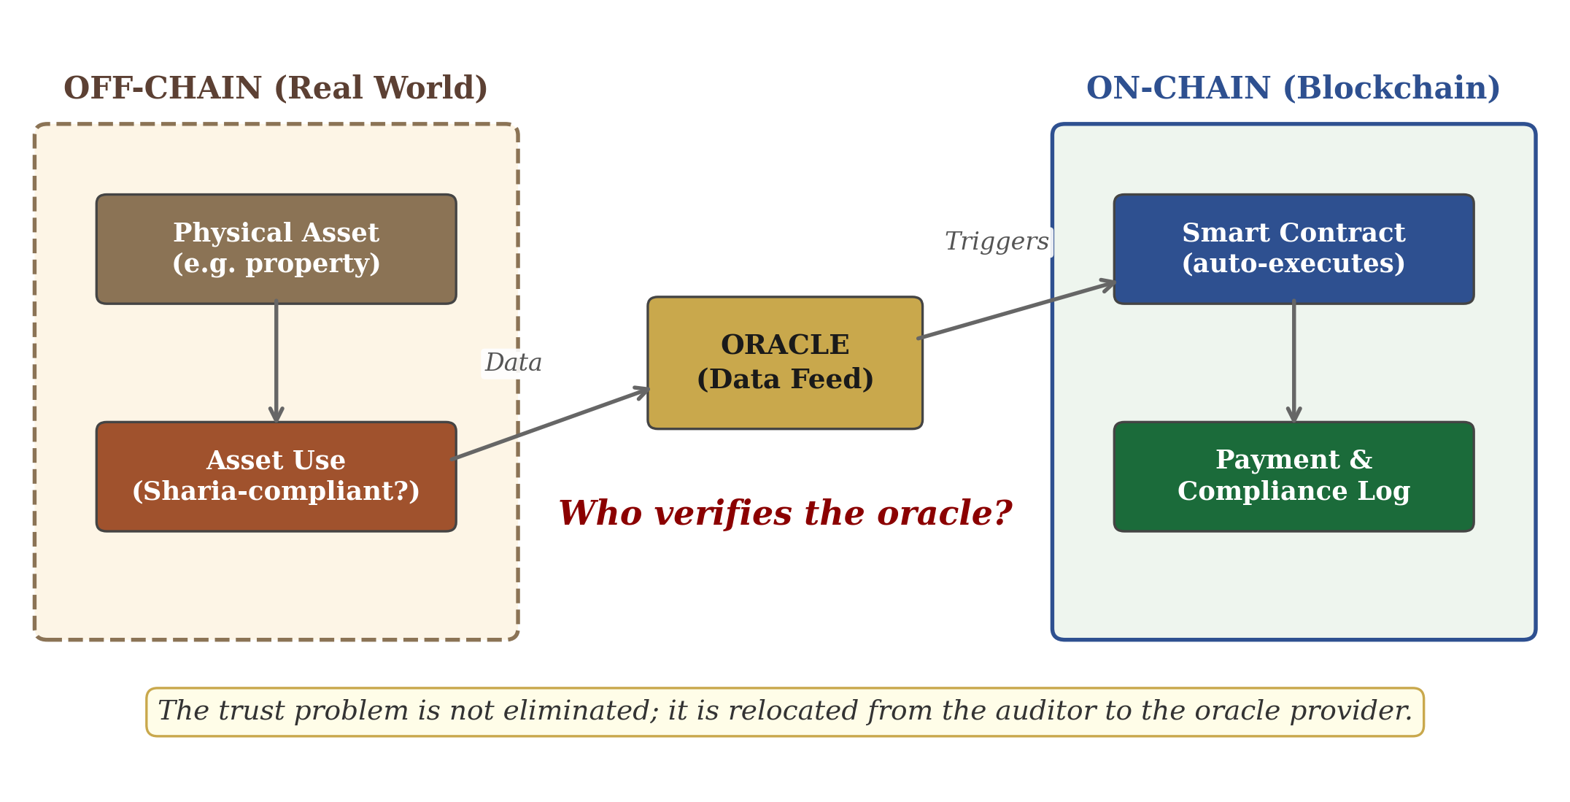
Figure 3. The Oracle Problem: On-Chain vs. Off-Chain Reality. Source: Author’s illustration.
The oracle problem is not necessarily as intractable as it may appear: oracles can be decentralised or Sharia board-governed, and IoT-based asset monitoring can narrow the on-chain/off-chain gap, while traditional Sukuk verification is not inherently more reliable, since Sharia auditors already depend on issuer disclosures that can be incomplete or misleading (Alkhamees, 2017). Nevertheless, the oracle problem remains a significant concern, and its significance follows directly from what smart Sukuk claim to achieve: if their purpose is to make Sharia compliance continuous and algorithmically enforced rather than dependent on periodic auditing, any mechanism that reintroduces human-mediated trust at the data layer undermines that central claim. It strikes at the heart of the smart Sukuk proposition. The oracle problem reveals that human judgement has not been removed from the system but pushed upstream, from the auditor to the oracle provider who feeds data into the chain. The answer to who ensures the oracle is telling the truth is inevitably another human institution. This is what this article terms ‘architectural mimicry’: even as smart Sukuk genuinely improve certain compliance processes, the fundamental challenge of verifying real-world Sharia compliance is relocated rather than resolved. Saudi Arabia’s emerging model, where a state land registry becomes the authoritative on-chain data source (Section 4), illustrates one response: oracle reliability shifts from a private intermediary to sovereign infrastructure, relocating the problem again rather than resolving it, a further instance of architectural mimicry.
Two further limitations reinforce this concern. First, a code error in a deployed smart contract, unlike a documentation error in a traditional Sukuk, may be uncorrectable and may already have triggered irreversible distributions, creating a class of Sharia risk with no precedent in classical fiqh; prohibitive infrastructure costs further concentrate decisions about code architecture and Sharia parameterisation in a small number of well-resourced institutions (Hamza, 2020). Second, even the most advanced implementations, from Al Hilal Bank’s $1 million issuance (2018) to Saudi Arabia’s sandbox-phase sovereign tokenisation (2026), remain pilots; whether their compliance benefits hold under institutional-scale volumes and secondary-market trading pressure remains untested, and this gap between pilot success and institutional viability is the technology’s most practical limitation (Delle Foglie et al., 2021).

7. Conclusion
This article has traced a trajectory from legal mimicry, through algorithmic integrity, to what it has called architectural mimicry: the partial relocation of certain trust problems into a new technological form, even as other dimensions of compliance, including transfer costs, transparency, and financial inclusion, are genuinely improved.
The oracle problem and the unresolved jurisprudential questions surrounding Iqala, madhhab variation, and the classification of smart contracts as al-‘uqud al-mustajiddah demonstrate that algorithmic enforcement cannot substitute for the human judgements that ultimately determine whether an instrument is genuinely Islamic. This is not a reason to reject the technology but to redirect its governance: relocating trust to the design stage, where Sharia scholars must approve code architecture before deployment, is arguably more rigorous than a system of periodic post-issuance auditing, provided that governance is technically literate enough to interrogate the code itself rather than merely the label attached to it. The question of whether a prior waiver of termination rights constitutes a permissible shart or an impermissible restriction under Sharia, and whether the answer varies by madhhab in ways that standardised code cannot accommodate, remains the field’s most pressing unresolved problem.
The ultimate question is not whether code can replace contracts, but whether the institutions of Islamic finance can adapt quickly enough to govern algorithmic finance. If they can, smart Sukuk may move the industry beyond what Alkhamees (2017) calls creative Shariah compliance. If not, algorithmic integrity may give way to a new form of legal mimicry.

Acknowledgements
I would like to thank Dr. Mohammed Khair Alshaleel for his valuable feedback on an earlier draft of this article.
AI Statement.

References
AAOIFI (2017) Shari’ah Standards. Manama: Dar AlMaiman for Publishing & Distributing. Available at: https://aaoifi.com/shariaa-standards/?lang=en
Al Hilal Bank (2018) ‘Al Hilal Bank executes the world’s first Blockchain Sukuk transaction’. Available at: https://www.alhilalbank.ae/en/news/2018/november/al-hilal-bank-executes-the-worlds-first-blockchain-Sukuk-transaction.aspx
Fitch Ratings (2025) ‘Global Outstanding Sukuk to Cross USD1 Trillion in 2025; Overall Credit Profile Stable’, 8 January. Available at: https://www.fitchratings.com/research/islamic-finance/global-outstanding-sukuk-to-cross-usd1-trillion-in-2025-overall-credit-profile-stable-08-01-2025
Alkhamees, A. (2017) A Critique of Creative Sharīʿah Compliance in the Islamic Finance Industry. Leiden: Brill. doi: 10.1163/9789004344433
Alvi, I.A., Rufai, A., Dadabhoy, I., Naseer, B., Fouad, T. and Sayyed, Z. (2019) IIFM Sukuk Report: A Comprehensive Study of the Global Sukuk Market. 8th edn. Manama: International Islamic Financial Market. Available at: https://www.iifm.net/sukuk-reports
Asian Development Bank (n.d.) Islamic Finance. Available at: https://www.adb.org/what-we-do/sectors/finance/islamic-finance
Babas, M. (2020) ‘Blockchain Technology Applications in the Islamic Financial Industry: The Smart Sukuk of Blossom Finance’s Platform in Indonesia Model’, Economic Sciences, Management and Commercial Sciences Review, 13(2), pp. 309–325. Available at: https://depot.univ-msila.dz/items/ffb64f8e-415a-4694-b817-8c3825fe2736/full
Bashir, I. (2018) Mastering Blockchain: Distributed Ledgers, Decentralization and Smart Contracts Explained. 2nd edn. Birmingham: Packt. Available at: https://www.packtpub.com/product/mastering-blockchain-second-edition/9781788839044
Biancone, P.P. and Radwan, M. (2018) ‘Social Finance And Unconventional Financing Alternatives: An Overview’, European Journal of Islamic Finance, 10. doi: 10.13135/2421-2172/2818
Busari, S.A. and Aminu, S.O. (2022) ‘Application of blockchain information technology in Ṣukūk trade’, Journal of Islamic Accounting and Business Research, 13(1), pp. 1–15. doi: 10.1108/JIABR-10-2019-0197
Delle Foglie, A., Panetta, I.C., Boukrami, E. and Vento, G. (2021) ‘The impact of the Blockchain technology on the global Sukuk industry: smart contracts and asset tokenisation’, Technology Analysis & Strategic Management, pp. 1–15. doi: 10.1080/09537325.2021.1939000.
Hamza, O. (2020) ‘Smart Sukuk Structure from Sharia Perspective and Financing Benefits: Proposed Application of Smart Sukuk through Blockchain Technology in Islamic Banks within Turkey’, European Journal of Islamic Finance. doi: 10.13135/2421-2172/3983.
Iftikhar, S. and Saba, I. (2020) ‘Blockchain Based Smart Sukuk as Shariah Compliant Investment Avenues for Islamic Financial Institutions in Pakistan’, Journal of Finance & Economics Research, 5(1), pp. 30–45. doi: 10.20547/jfer2005103.
Kunhibava, S., Muneeza, A., Mustapha, Z., Khalid, M. and Kiran, G. (2024) ‘Blockchain use case in Islamic social finance’, ISRA International Journal of Islamic Finance, 16(1), pp. 93–110. doi: 10.55188/ijif.v16i1.659.
Mousavi, S.H., Tohidinia, A. and Mousavi, S.M. (2025) ‘Transforming Islamic Finance: The Impact of Blockchain and Smart Sukuk’, ACCESS Journal: Access to Science, Business, Innovation in Digital Economy, 6(1), pp. 184–201. doi: 10.46656/access.2025.6.1(10).
Muryanto, Y.T. (2022) ‘The urgency of sharia compliance regulations for Islamic Fintechs: a comparative study of Indonesia, Malaysia and the United Kingdom’, Journal of Financial Crime, 30(5), pp. 1264–1278. doi: 10.1108/JFC-05-2022-0099.
Sa’ad, A.A. (2018) ‘Smart Sukuk Structure From Shari’ah Perspective: The Application Of Mudarabah Smart Contract’, e-Proceedings of the Global Conference on Islamic Economics and Finance. Kuala Lumpur, 24–25 October. Available at: https://irep.iium.edu.my/67145/
Saleh, A. (2022) Wifaqul Ulama (UK) on the Permissibility of Cryptocurrency. Available at: https://portal.shariasource.com/documents/4463
Saudi Press Agency (SPA) (2026a) REGA Launches Regulatory Sandbox Featuring Real Estate Tokenization. Available at: https://www.spa.gov.sa/en/N2511536
Saudi Press Agency (SPA) (2026b) SAMA Commences Licensing of Fintech Companies to Provide Open Banking Services. Available at: https://www.spa.gov.sa/en/N2546753
Szabo, N. (1996) Smart Contracts: Building Blocks for Digital Markets. Available at: https://www.fon.hum.uva.nl/rob/Courses/InformationInSpeech/CDROM/Literature/LOTwinterschool2006/szabo.best.vwh.net/smart_contracts_2.html
Tawfeek, F. (2018) ‘Egypt’s Dar al-Iftaa deems bitcoin currency as forbidden in Islam’, Egypt Independent, 1 January. Available at: https://egyptindependent.com/egypts-dar-al-iftaa-deems-bitcoin-currency-forbidden-islam/
Ulusoy, A. and Ela, M. (2018) ‘Secondary market of sukuk: An overview’, Uluslararası İslam Ekonomisi ve Finansı Araştırmaları Dergisi, 4(2), pp. 17–32. doi: 10.25272/ijisef.452577
Whitehead, M. (2018) Islamic Finance Upgraded: Smarter Sukuk Using Blockchain. Blossom Finance. Available at: https://blossomfinance.com/press/islamic-finance-upgraded-smarter-sukuk-using-blockchain
Zawya (2019) ‘Wethaq’s smart contract based Sukuk platform expands Sharia capabilities with Shariyah Review Bureau’, Zawya, 14 February. Available at: https://www.zawya.com/en/press-release/wethaqs-smart-contract-based-Sukuk-platform-expands-sharia-capabilities-with-shariyah-review-bureau-r2zo8xfs

Copyright Statement
© Hssan Alkhamees. This article is licensed under a Creative Commons Attribution 4.0 International License (CC BY).

