*Research Article*

Ztohoven: The Modern Dissidents?

Jamie Taylor

University of Essex

# Abstract

Over the last decade, the artist collective Ztohoven have inspired debate and controversy, usually to the embarrassment of the Czech authorities. Ztohoven's inventive methodology explores how one can turn a system’s attitudes and framework against itself. This paper will first focus upon understanding who Ztohoven are, by analysing their work from the previous decade. The argument will be made that Ztohoven are a modern embodiment of previous Czech dissidents, protesting against a new system but fighting similar shortcomings. For this paper I will focus on key public works produced by Ztohoven. I will try to demonstrate methodological, intellectual and thematic links with past dissidents of the Communist era in Czechoslovakia. To provide evidence for my argument, I will use a combination of Ztohoven’s public statements alongside academic and journalistic articles.

Keywords: Ztohoven, Modern dissidents, Modern, Czech

# Who are Ztohoven?

Ztohoven are a collective of artists in the Czech Republic. The group’s name ‘Ztohoven’ translates to both ‘The way out’ and ‘The hundred shits’, aptly communicating the tone that runs throughout their work. Quoting Ztohoven figurehead Roman Tyc, Michael Kimmelman of the New York Times has argued that the group possesses a typical Czech approach to politics and even dissent: “Because of the past, Austria, communism, fascism, someone always stepping on our necks, we have had no choice except to Svejk around” (Kimmelman, 2008). The ‘Svejk’ Roman Tyc speaks of is a folk hero who represents the jocular behaviour of Czechs when confronted with attack or oppression. Ztohoven incorporate humour and satire into all their works, an approach that garners much support.

Commenting on Ztohoven’s piece *The Media Reality*, Kimmelman observes such a reaction by the public, claiming “it drew a mild, tolerant, even amused public response, in contrast to how terrorism-related pranks, or what might seem like them, have been widely greeted elsewhere” (Kimmelman, 2008). Ztohoven tread a line between political activism and art that is difficult to distinguish. Individual issues are pursued, similar to past dissents like Charter 77.[1] Peter Zikla, a current member of Ztohoven, summarised the group’s politics as follows: “We do not indicate our point of view (...) we try to pose good questions, to hold up a mirror to society so that there’s the possibility of seeing reality from a different angle and, consequently, having a debate about it.” (Infoshop News, 2013)

By doing this the group share methodological similarities with the approach advocated in Vaclav Havel's *The Power of the Powerless* (1978). Havel, former Charter 77 dissident and later first President of the Czech Republic, argues for the pursuit of individual issues to draw attention to existing government shortcomings (Havel, 1978). Esther Belvis Pons of Performa Magazine also interprets Ztohoven’s actions as exploiting public spaces and using these to interact with society, a strategy also prominent within contemporary art: “The politics of contemporary art navigates through the spaces that construct the social, and as Ztohoven pointed out, for them these are: the institutional space, the public space and media space. Contemporary artists find in the bordering and unexplored spaces a position from which they can temporarily trigger action; an action that can be politically ambiguous too” (Pons, 2013).

The group use humour in order to both escape and critique problems in society. This echoes the tradition of prominent dissidents like Egon Bondy[2] who used vulgarity or absurdity to satirise the state.

Ztohoven’s practice of ‘culture jamming’, in which they manipulate and change the meaning of objects in the public sphere, also replicates this tradition. Roman Tyc’s traffic light project, in which he changed traffic light bulbs, portraying amusing or satirical images (see Figure 1), is one example of culture jamming used by the group:

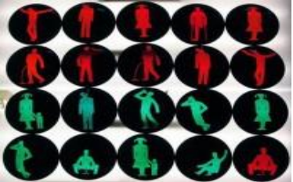

Figure 1 Roman Tyc’s traffic lights, 2007

Ztohoven can also be situated within a broader trend of contemporary art, namely it is so-called 'social turn'. The group's focus on inclusive, social and public art makes them an ideal example. This is particularly true when one considers the intention of Ztohoven's pieces - to generate collective interaction and dialogue through art, Claire Bishop (2006) explains this apparent characteristic of contemporary art's social turn, “the creative energy of participatory practices rehumanizes – or at least de-alienates – a society”. Furthermore, the groups valuing of the political alongside the importance of engagement outside galleries and conventional artistic spaces places them within this broader dynamic trend.

This 'social turn' has received intensified attention in recent years. Events such as the 7th Berlin Bienalle; *The Truth Is Concrete* marathon symposium in Austria; *Disobedient Objects* at the Victoria and Albert or on a smaller scale, *The Politics of the Social in Contemporary Art* event at the Tate Modern are all examples of newly fostered interest regarding art and protest. During the 7th Berlin Bienalle members of the Occupy movement[3], amongst others, used the festival to demonstrate protest strategies and techniques with contemporaries.

Equally this self-proclaimed purpose of The *Truth is Concrete* communicates a consensus with Ztohoven: "Truth is concrete" brought together art that not only represents and documents, but that engages in specific political and social situations – and activism that not only acts for the sake of acting but searches for intelligent, creative means of self-empowerment." (Die Wahrheit Ist Konkret, 2012). Thus, Ztohoven can be located somewhat within a dynamic movement in contemporary art and social practice that intends to challenge and shape political discourse. This is very much why Ztohoven can be considered dissidents for the modern world.

# Ztohoven: Modern Dissidents?

Ztohoven's public statements and artistic pieces convey a distinct strategy of appealing towards ‘common sense’ ideals, sharing similarities with the concept of ‘Primitivism’[4] championed by the Czech musical dissident movement of the 1960s and 1970s. Examples include Ztohoven's *Citizen K* and *Subconsci-ous Raped[5].*

Furthermore, Ztohoven's actions can be interpreted as tackling the same issues dissidents have often sought out. This largely pertains to the control of information. Ztohoven attempt to satirise the prevailing ideology of the status quo and by doing so, highlight its disingenuous nature. Jiri Rak, a prominent Czech historian, describes Ztohoven’s impact and methodology thus: “When people make fun of something, they are making themselves free of it”. He continued: “[t]hat’s the condition of the small nation. It’s a defence for everyone today in the globalized world […] I think the goal of Czech mystification is to show us that we live in a world continually mystifying us — the politicians, the advertisers […] Thank God for Ztohoven.” (Kimmelman, 2008).

Thus, in the eyes of Rak one can see the group's cause to “demystify” modern Czech life is very much the same aim of any dissident group - to communicate a different reality to the current order and through this produce critical dialogue.

Ztohoven's combination of humour and protest shares much with previous peaceful protests of the Czech people. Specifically, it shares similarities with the actions of unarmed protesters presenting flowers to police officers prior to the 1989 revolution, and, perhaps more acutely, the protest of students running up and down Politických vězňů[6] in a row, intending to cause nothing more than a situation of disorder for the Communist authorities. Ztohoven’s *The Media Reality[7]* reflects this act of non-violently challenging the status quo to provoke debate or to simply shake people “from their lethargy”. (Kimmelman, 2008)

Despite the hugely different political circumstances, the issues of a citizenry trapped by political inertia combined with a widely perceived moral and democratic deficit amongst the economic and political powers-that-be are still at the centre of Czech life. In this sense Ztohoven can be viewed as the dissident by-product of the modern Czech Republic which, although critiquing a new form of authority, fulfils the role of past Czech dissidents in a new era. Contemporary parallels to Ztohoven elsewhere can be identified in the Yes Men and the Critical Art Ensemble, conveying how this development is not unique to the Czech Republic. The Yes Men disguise themselves as figures of the establishment (called “identity correction”), a form of culture-jamming, and use this to satirise governments and figures of authority.

The core aim of these actions, similar to Ztohoven, is to highlight their role in dehumanising the public and provoke greater critical judgement towards governments. Equally, the Critical Art Ensemble focuses around the use of technology to provide visceral illustrations of how government actions have harmed people all over the world. This emphasis on criticising government actions, whilst focusing on technology and primarily media to communicate these injustices is also a key aspect of Ztohoven's works, which quite possibly drew inspiration from the Critical Art Ensemble.

These other instances of dissenting art collectives convey how Ztohoven are a Czech embodiment of a more widespread movement. This strengthens the claim that Ztohoven are modern dissidents, acting within a wider trend in art to engage with current political phenomena. Czech dissidents of the past also had counterparts across Communist Europe such as the Orange Alternative movement in Poland who also used art, inspired by Dadaism and Surrealism, to challenge Government authorities. (Pomaranczowa Alternatywa, 2004). With these points in mind the works of Ztohoven can now be analysed to further illustrate their similarities with dissidents of previous decades.

# The Moral Reform

Ztohoven’s most recent piece, *The Moral Reform* has a distinct resonance with the Czech tradition of dissent and likewise shares an undeniably humorous and ingenious method. The group impersonated members of the Czech parliament via text messages, sending them to various politicians during the hearing of a Czech politician being indicted for corruption. The messages advocate a reintroduction of morals back in to politics and an end to corruption: “Let's separate politics from business.”; “Somebody must step out of the circle of corruption and say: ENOUGH!” (Ztohoven, N. D.).

These messages aimed to contrast the political elite’s own accepted principles with their actions, a tactic used by Czech dissidents in Charter 77.[8] Vaclav Havel in *The Power of the Powerless* (1978) also argued that by appealing to laws and principles the state claims to advocate one can turn the state against itself, achieving incremental if minor victories. Clearly this piece was hoping to create a discourse between Czech politicians and the general public: “The installation at the DOX published the telephone numbers of Czech government officials, including the President, alongside a cell phone that allowed members of the public to send text messages directly from the exhibition space.” (Infoshop News, 2013). This was also attempted by dissidents with Charter 77 and the Committee for the Defense of the Unjustly Persecuted[9]. In both cases these actions served to bring the legitimacy of their respective governments in to question, namely because the addressed politicians resisted opening a meaningful dialogue. This shows an important similarity in both Ztohoven's and past dissident's aims and outcomes, primarily to question the validity of authority when it behaves contrary to its self-proclaimed principles.

# The Media Reality

In this earlier action Ztohoven distorted the accuracy of mainstream news by hacking an aerial in the Krkonose Mountains on June 17, 2007 and superimposing a nuclear mushroom cloud over the usual image of the mountains:

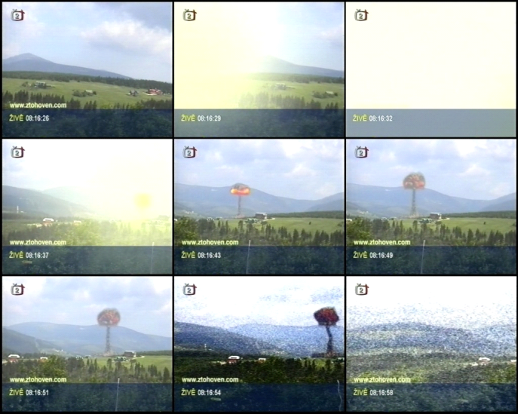

Figure 2 The Media Reality (2007)

The broadcast did however include the Ztohoven webpage address along the bottom of the screen. This reinforces the argument that they should not be considered simply as political agitators and instead perceived as jestful artists. Importantly this conveys a divergence between Ztohoven and dissidents of the past, namely that Communist-era dissidents were considered a direct threat to the stability of the state. Nonetheless both used controversy and humour and neither threatened violent action, thus the only real difference is how Ztohoven are perceived. Of course this is a malleable characteristic which is subject to change, as was the perception of past Czech dissidents in relation to the geo-political landscape of Communist Czechoslovakia.

Ztohoven's stunt raised an important question regarding the fallibility of mainstream media, a key source of influence in the modern Czech state. Ztohoven stated their intentions as such: “Our aim is not to intimidate society or manipulate it, which is something we witness on a daily basis both in the real world and that created by the media. On June 17 2007, [we] attacked the space of TV broadcasting, distorting it, questioning its truthfulness and its credibility.” (Spiegel, 2008) Looking at this statement, including the accolades received from the Czech National Gallery, it is clear that the group's action reflected an anxiety amongst many members of the national art intelligentsia. This, coupled with the latent humour of the project, provided Ztohoven with a degree of flexibility that was surprisingly reciprocated by the Czech legal system as their criminal charges were eventually dismissed. Kimmelman reflected similar sentiments regarding the public response to *The Media Reality*: “Hardly anyone here seems to want Ztohoven to receive more than a legal slap on the wrist (...) Neither have fellow artists protested the trial in the streets, nor made a freedom of speech issue out of it.” (Kimmelman, 2008)

An important point of comparison is also thrown into relief by Kimmelman's assertion that other artists were not protesting in the streets. This highlights an important difference between Ztohoven and past dissidents. Ztohoven act autonomously and have not inspired collective action as did groups like the Plastic People of the Universe or DG307[10]. One consideration as to why the individualistic nature of modern capitalist societies is reflected in its protest and art. Equally the fact that society now has no single centralised power structure to agitate against also adds to this explanation. Nonetheless the popularity of the group does convey there is a collective element to the group's works. It could be that the experience of protest has become more individualised, or even intellectualised today, entailing less demand for more straight-forward displays of physical presence.

# The question mark above Prague Castle

Ztohoven’s first public installation, *The Question Mark above Prague Castle,* shows Ztohoven actively engaging with questions created by the legacy of dissidents. In this intervention, a giant neon heart, which was attached to Prague castle on Havel’s request, was modified by Ztohoven to present a question mark coinciding with the end of Havel’s presidency. Significant debate was provoked regarding the meaning of this action, however in its simplest interpretation it is asking the question ‘what is next?’

Arguably this was intended to spark scrutiny over how, or if, Havel’s legacy would be continued. Ztohoven's statement on their official page accompanying the work echoes this sentiment, raising the issue of how a 'sentient' stepping down from power raises questions about the future of 'the Czech throne' and the path Czech society will follow. (Ztohoven, N.D.)

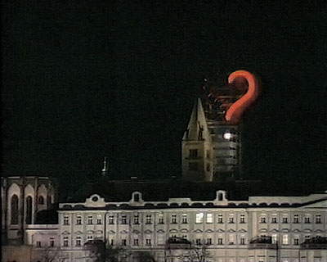

Figure 3 The question mark above Prague Castle (2003)

Jana Kománková's comments from Ztohoven confirm that Havel himself approved of the act: “We felt that a question mark would much better express those times, so we covered half of the heart. The cops came and wanted to intervene (...) Havel said that if this was supposed to spark a reason for a general discussion about the nature of the public sphere, then it’s ok.” (Kománková, 2011)

Thus, with the outgoing President Havel giving permission to Ztohoven's stunt the shared value of discussion and questioning of the public sphere conveys directly the comparable qualities of dissidents old and new.

# Citizen K

The final piece of Ztohoven’s work that I will be investigating is *Citizen K*: a film examining identity in the Czech Republic. Via the use of facial morphing software the group obtained identification cards using another member's name; lived under this false identity for 6 months; participated in elections; travelled abroad; gained a gun licence and even got married.

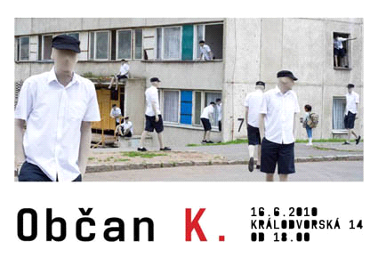

Figure 4 Promotional picture for Citizen K (2010)

This piece addresses perceived deficits in modern society regarding identity and the dehumanisation of citizens by modern bureaucracy. Ztohoven's accompanying statement on their official webpage reads as follows: “For all of us I entered the places that others fear to enter and perceived the vanity, the absurdity of obedience. How frail and how easily abused is that which should serve us. We are not numbers, we are not biometric data (...) If we do not wish to fear our own face, we must save it!” (Ztohoven, N. D.) Again, Ztohoven exploit the state’s own mechanisms, highlighting the absurdity and irrationality of its processes to satirise it. By doing so they escape, if only temporarily, the absurdity of these processes. This reflection expressed in an article on the London Czech Centre website arguably achieves the mindset Ztohoven were hoping to produce: “Each of us is individually responsible for our privacy, and we shouldn’t let anyone manipulate us into a position we don’t want to be in.” (London Czechcentre, 2013)

It can thus be observed that Ztohoven employ a form of absurdity to discredit how the Czech state quantifies its citizens. This follows from the strategies of those opposed to the perceived absurdity of the Communist state, which was for this reason subject to constant absurdist jibes by Czech academics and artists, who also had relative disregard for the legal consequences they might incur for their behaviour.

# Conclusion

The actions and statements made by the Ztohoven collective provide evidence that the group owes great inspiration from the dissident movements of Czechs throughout the era of Communism. The use of humour, vulgarity, single-issue and ‘apolitical’ campaigning is something continued today by Ztohoven, but initially founded in the dissident movements of the Prague Spring and beyond. Battling against injustice, using public spaces to challenge the status quo and educate the public, are all central to Ztohoven's actions. Inverting the state's mechanisms to achieve protest follows a distinct line tracing back to the Communist era whilst creating controversy at the risk of arrest and even imprisonment shows a self-sacrifice not dissimilar to dissidents of the past. Appealing to common-sense ideals and attempting to demystify the flow of information conveyed to the public by governments and corporations shows a similar struggle to all dissident movements in trying to convey a differing reality and thus provoke critical judgement and change. Despite huge changes in the political, social and economic landscape of the Czech Republic, issues of public oppression, psychological and ideological control, and the ongoing attempt to achieve a “moral reconstitution of society” (Havel, 1990) are still issues that have transcended the Communist era. These have been pursued via ever developing and ingenious means by Ztohoven, who are the contemporary embodiment of Communist-era dissidents.

**References**

Bishop, C. (2006) ‘Claire Bishop: 'The Social Turn': Collaboration and Its Discontents*', Artforum,* February, pp. 179-185. Available at: <http://onedaysculpture.org.nz/assets/images/reading/Bishop%20_%20Kester.pdf> (Accessed: 16 August 2014).

Czech Centre. (2013) *Ztohoven: The politics of the social in contemporary art*. Available at: <http://london.czechcentres.cz/programme/travel-events/ztohoven-at-the-tate-modern/> (Accessed: 20 February 2013).

Die Wahrheit Ist Konkret (2012) Available at: <http://www.truthisconcrete.org/> (Accessed: 18 August 2014).

Havel, V. (1978) *The Power of the Powerless*. Available at: http://vaclavhavel.cz/showtrans.php?cat=esejeHYPERLINK "http://vaclavhavel.cz/showtrans.php?cat=eseje&val=2_aj_eseje.html&typ=HTML"&HYPERLINK "http://vaclavhavel.cz/showtrans.php?cat=eseje&val=2_aj_eseje.html&typ=HTML"val=2_aj_eseje.htmlHYPERLINK "http://vaclavhavel.cz/showtrans.php?cat=eseje&val=2_aj_eseje.html&typ=HTML"&HYPERLINK ""typ=HTML (Accessed: 11 July 2014).

Infoshop News. (2013) *Ztohoven: Ten Years of Question Marks*. Available at: <http://news.infoshop.org/article.php?story=20130126202046637> (Accessed: 10/02/13).

Kimmelman, M. (2008) ‘That Mushroom Cloud? They’re Just Svejking Around’, *The New York Times*, 24 January.Available at: <http://www.nytimes.com/2008/01/24/arts/design/24abroad.html?pagewanted=all&_r=1&>

(Accessed: 1 March 2013).

Kománková, J. (2011) *Ztohoven: Things can change!* Available at: <http://bloguje.czechtek.net/880367-exclusive-interview-with-ztohoven-art-group.php> (Accessed: 20 February 2013).

Pomaranczowa, A. (2004) *Orange Alternative -the story.* Available at: <http://www.pomaranczowa-alternatywa.org/orange%20alternative%20overview.html> (Accessed: 20 August 2014).

Pons, E. B. (2013) ‘The Politics of the Social in Contemporary Art’, *Performa Magazine*, 26 February. Available at: <http://performamagazine.tumblr.com/post/44083533715/the-politics-of-the-social-in-contemporary-art> (Accessed: 30 February 2013).

Spiegel Online. (2008) *A Czech War of the Worlds: Mushroom Cloud Pranksters to Stand Trial*. Available at: <http://www.spiegel.de/international/zeitgeist/a-czech-war-of-the-worlds-mushroom-cloud-pranksters-to-stand-trial-a-526688.html> (Accessed: 19 February 2013).

Ztohoven. (N.D.) *Citizen K*. Available at: <http://www.ztohoven.com/?page_id=50&lang=en> (Accessed: 15 February 2013).

Ztohoven. (N.D.) *The Moral Reform.* Available at: <http://ztohoven.com/mr/msg-en.html> (Accessed: 19 August 2014).

Ztohoven. (N.D.) *The Question Mark Above Prague Castle*. Available at: <http://www.ztohoven.com/?page_id=32&lang=en> (Accessed: 19 August 2014).

1. Charter 77 was a prominent civic movement based upon a document of the same name which criticised the Czechoslovakian government for not upholding international human rights agreements. High-profile figures in the movement included Vaclav Havel; Jiri Hayek and Jan Patocka.
2. Egon Bondy was a philosopher, poet and writer and an important figure in the Prague Underground movement due to his association with the Czech dissident band the Plastic People of the Universe.
3. The Occupy movement is an international protest movement against social and economic equality most famously known for its Occupy Wall Street protest in 2011.
4. Czech primitivism developed out of the underground movement, promoting a salt-of-the-earth working-class who were not afraid of vulgarity but also embodied notions of authenticity and genuineness lost in the Communist regime.
5. Both of these pieces call into question the accuracy and truthfulness of identity and consumerism in modern life, arguably pushing for a return to a more tangible and realistic form of living.
6. Politických vězňů is a street located near Prague's city centre.
7. *The Media Reality* was a Ztohoven stunt in which a Czech news broadcast was hijacked to superimpose an image of a fictional mushroom cloud onto its usual opening broadcast sequence. This specific piece will be discussed in detail later in this paper.
8. Charter 77 used the example of international human rights agreements to highlight the Czechoslovakian government's failures to look after its citizens.
9. The Defense of the Unjustly Prosecuted, founded largely by Charter 77 signatories focused on Human Rights, becoming a member of the International Federation for Human Rights and aimed to educate the general public about the plight of dissidents.
10. Both the Plastic People of the Universe and DG307 were bands connected with the Prague Underground Movement, a sub-culture perceived as a threat to the Communist Party due to their non-compliance with the cultural diktat exhumed by the Communist party.