Poem

I Will Not Write
Elena Botts
University of Essex

Abstract
I like to spend a lot of time in the woods; I imagine how trees might have souls moving within them. This is just the same world I am in, there is no difference, and yet, through envisioning the “spirit world,” one becomes connected to new ideas and potential truths. In a sense, one moves towards an “avant-garde” in this way, by abandoning old traps and considering. Though the writings are meant to extoll, perhaps, the beauty of love, poetry, and so forth, these are also a consideration of how one’s imagined feeling can become real in a way analogous to the use of personal narratives to engender political futures. Further, I like the notion of a second world, also explored in the “other worlds” glitch images, especially to create alternate, lush realities where imagination runs rampant.
Keywords: memory, loss, life
Date of Submission: 25.04.2025 Date of Acceptance: 19.06.2025

Acknowledgements
The author of this work owns the copyright to all images used.
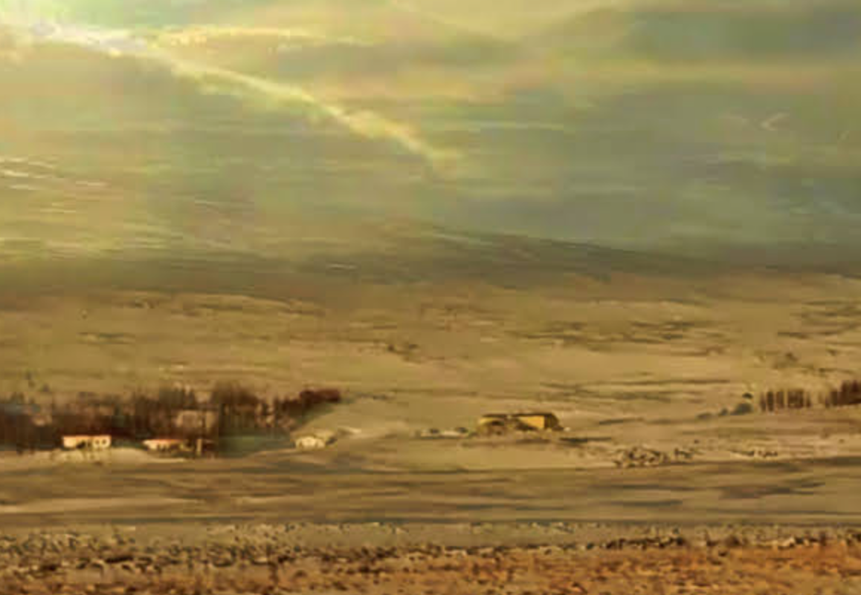
Figure 1

Harper’s Ferry
Ordinary is thy-vanished-lute’s ghost
played near the stream in the summertime
a once-under-the-bridge reverberant. Now, ‘thinking of you’ under
the coatrack, where is your discarded
umbrella. To pick up postcards after Monday’s rain.

As if wayfinding across the Blue Ridge sound
where she resettled. Lunar cataract yet the armory ghost
Dreamt of freedoms
unforgiven by an eerie society.
It’s just nowhere fruit wax-sealed, as we are this happy day,
waiting for the next freight,

and this, into clavicle’s ridge, eroded
You,
Refuse the joke though stained, just more
Initials into sycamore bark farther from Anacostia’s forgotten:
tidal rhythms with colander’s rust, bloodied Shenandoah tributaries.
“Yearnings” into sediment with.
an unconcealed thought,

I am a. So, I borrowed metastasis
on my hands like punctured berries, gathered up the old storm,
and set off to childhood Paw-Paw tunnel of dark-
light.
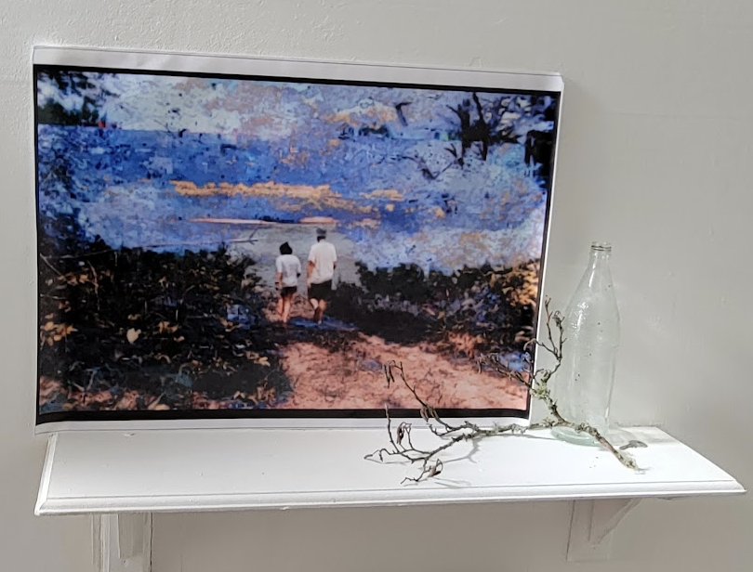
Figure 2

I imagine you
living quietly enough I suppose, engaged in cooking.
by the schlachtensee,
a picture of him
we met once more in the heat of reykjavik
a community pool i could not find a swimsuit

to buy several vegetables loose outside the grocer's
no mind for pence or some greater intuition
that the infrastructure could be sinking,
or maybe the way you left all your curios
as if life might continue after destruction.

we always said goodbye as though he would be back in a few
though for grandfather it could be years hence

grandmother is still by the tele in the yellow room
two pomeranians at her feet
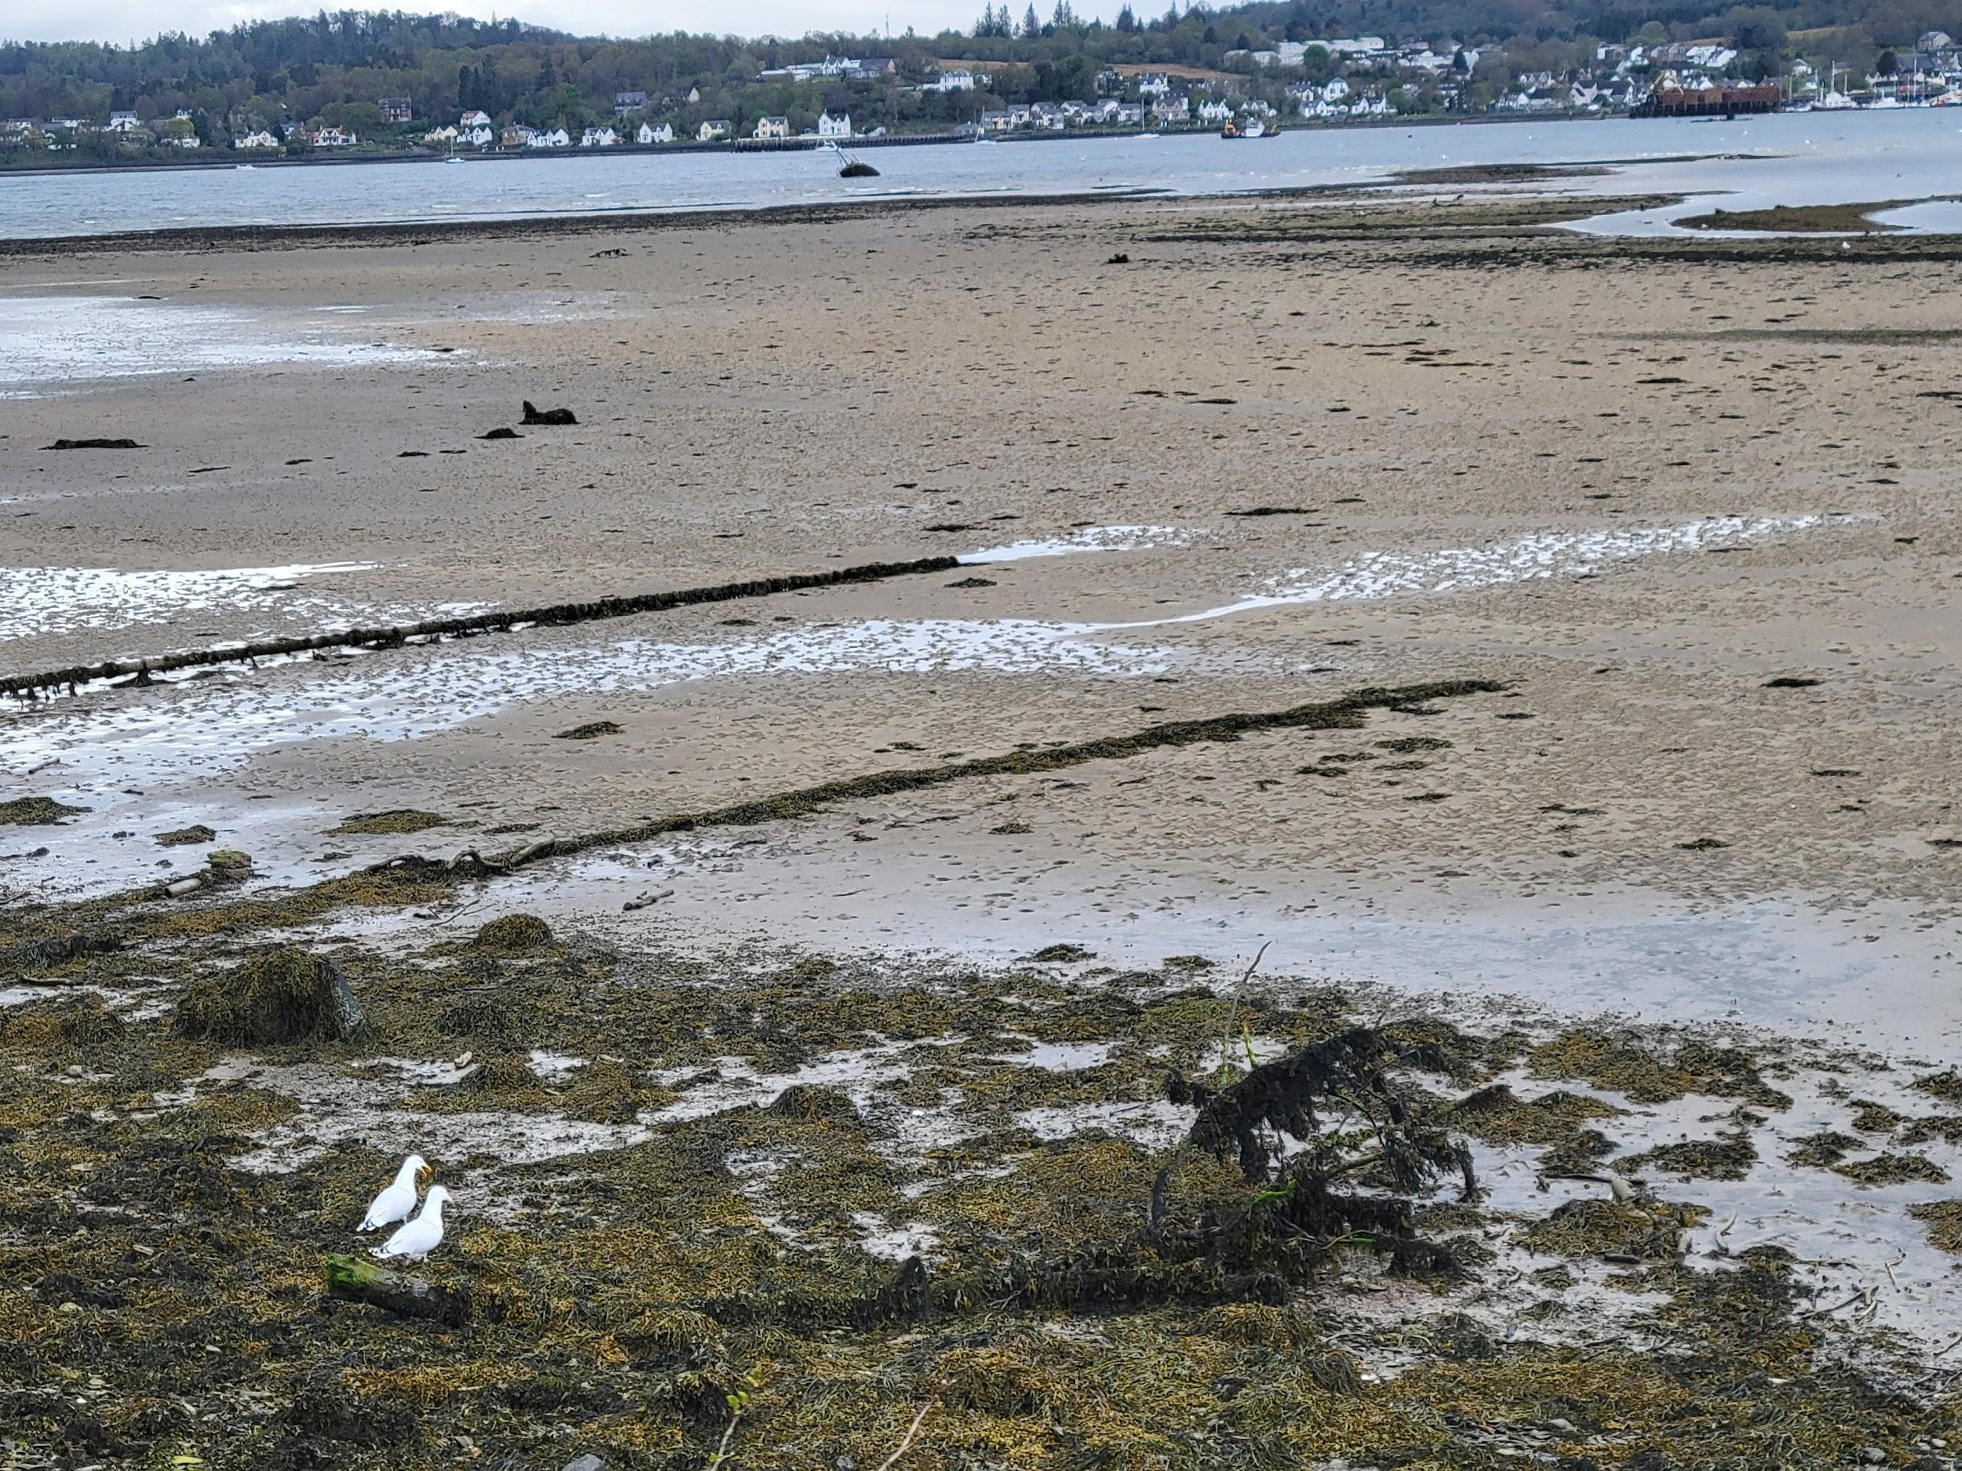
Figure 3

Utter violence
A few miles below the northernmost circle
That crowns the earth,
Hrisey’s teakettle. My personal
satellite tracking station, the
glacial emptiness forms moraine veins- beloved
ordinary hours. Temporal rift, like
cathected joy, it sutures-
melt reveals each of our own.
The stitches are still in after:
unwept hermeneutics I guess.

So, southern Brittany’s soil unkissed refuses to bring her back, nor our
dense memory of cherries that bled us into life
past the stony chapel, or
Iberian blood of Kings as
bled Yucatan into a tree of names
And an unknown Lady
who bears guilt: her miracle
Still, primordially (this life and the last), I have
A thousand kind aunts.

Who witnessed thirteen stone pillars,
‘one strange note’ born by vanilla-scented bagazo,
a small boy waving ramon. Beyond a suffering,
of laureles’ shadows, in the caves,
my mother learns to swim.
Behind my eyes, that is, I see in white garb.
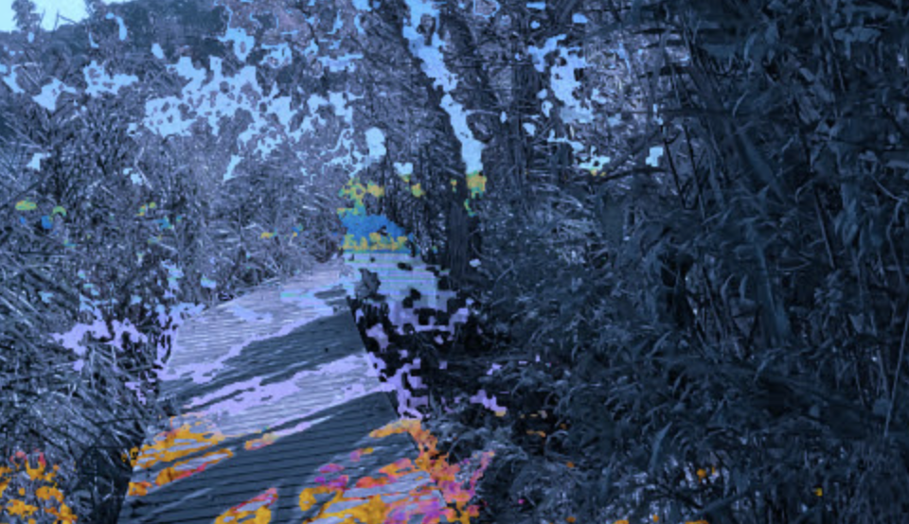
Figure 4

April
Sweetness, spring, I do not like it.
Winter’s fraternity contours the stark
battle,
leaving the sun behind and no wishfulness
But beauty without desire.

Fuck la dolchor del temps,
detritus of the riparian, my fortunes looking benthic.
the moment being only that which rises to the surface
You rejoice from self deliverance,
sundering some bard’s dead lark. We confirm our love
through life’s concretized
(Consecration of) fallen birds
Borne into nothing.
All I hear are wings
clipping the thought, the tidal Eachaig
No, no- the deeper prosperity of the not-self
is its night of richness,
Autumn, kiss me like a friend

I know you’ve gone, so
here is the day’s own disjunct scripture:
‘I’d like [...] to honor you.’
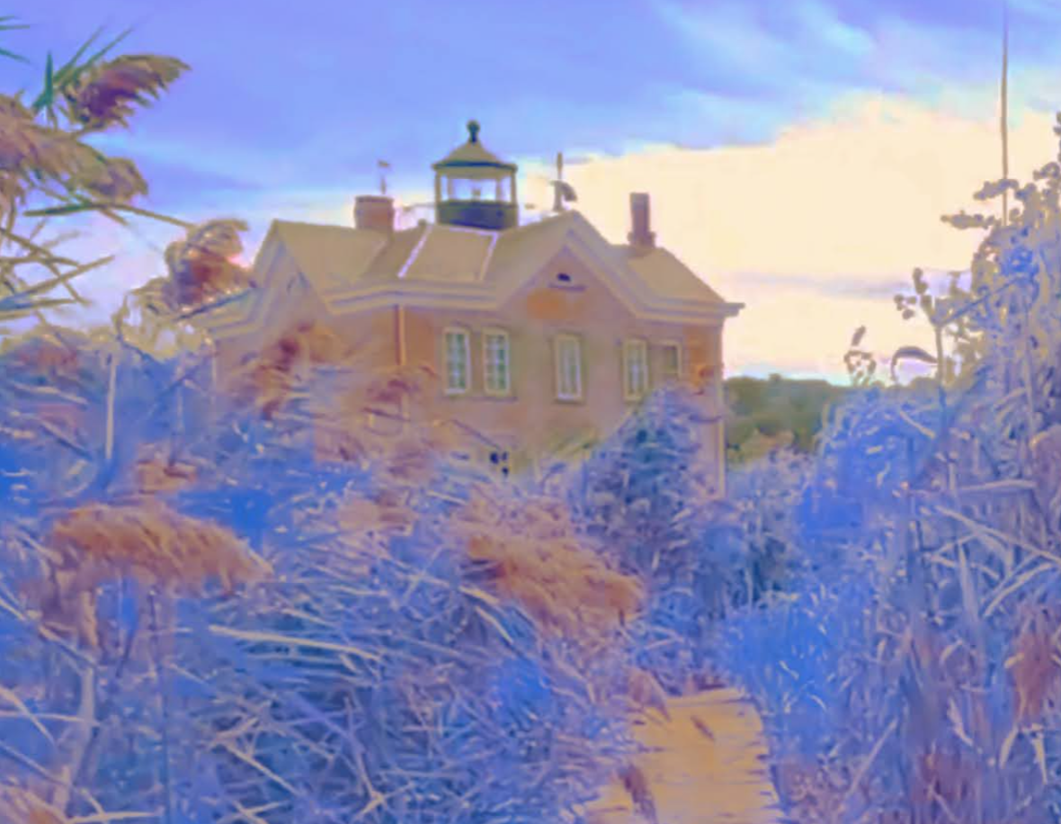
Figure 5

A plainest story
became,
we become air-conditioned things
Self seclusion, summer
bloomed absence like impermanent
mycorrhizal networks leaked through lease’s cracks. Here is the rag of the self,
mapped by cathode hum, such a spell. Connected to the thing, so to speak
served the purpose of taking individuals from one place to another,

as fin’amor beneath a song
Afternoon,
but added a rose and joy as fin’amor beneath a song.
the old letter and I regret
with wit and circuit, but beckoned
even as I
voided the canso, with heart-gladness, opened a newspaper.
In daylight’s withdrawal,
on Seoul’s rooftop, milk-sipped with the cat on the bench,
like a real conversation.

Later, I remembered something and reached across the highest shelf,
I left the window open for him.

You can pretend to be
my own dearest annihilation,
just as I have welcomed
not sound. I remembered something
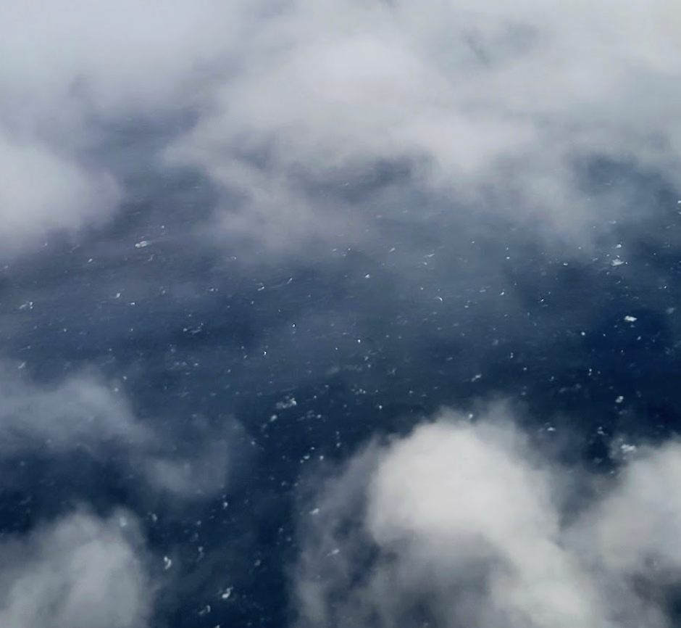
Figure 6

Itinerary
asleep, and no one- a miracle.

something arose, say, "no," ie, "I don't need it."
{I wonder how old they all are, people on the street, people come from far a-
way like me, but a different (ocean) far, scarves billowing in the wind.}
I finally experienced.

It's like saying “it means something to you but nothing to me,” or “I'm glad it means something to you.” The cats complain and frolic in equal measure, mirroring the pulse of the house. I want to be thoughtless. I want to remember obliterating love, or maybe it was mine to them, the habitual pain of being, a paper cut or dental surgery. I'd rather some remarkable battle, not a series of days until at least some hill

had been surmounted to vanish the time over the other side. dreamless temperate rainforest deep sleep or hauntology of monastic settlement
cloudforest modern
redux bird conversation, etc. holiest loch We could at least mourn the collapse of meaning.

The house is ----, that spring is settled, no prospects beyond, not a single house to aspire to. How do you mourn the death of nothing? All earnings institutionally slowed, always susceptible to power

when underneath I feel
but an idea an ineffable thing
ill-bound in their words. I am dark, guilty of myself, of the moor and mor.

A journal entry reads as a botched flight itinerary: Paris, New York, London. No need to talk.}
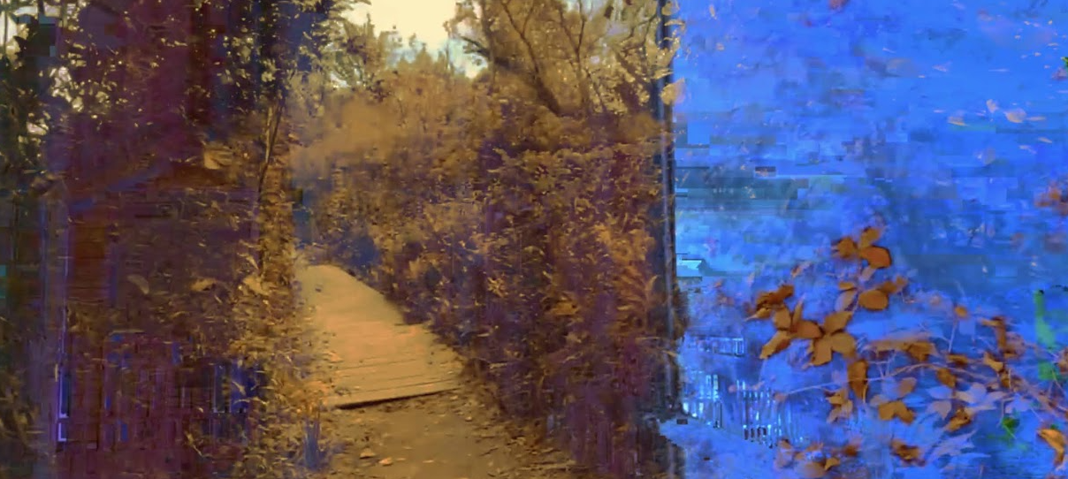
Figure 7

our times together, and you
queer affairs and bicycles and day to day. I was meandering,
lookout sung by yellow flowers before the middle distance to deeper distance blue. A letter:

“to suggest a utility for some things as to ascribe certain ways [...] must they be reoriented to fit a more common definition? But even as when I go into my heart, [...] I find such a different and alien [...] intentions offered here that I don’t really know what to say [...] so different as cannot be—that is the beauty…”

if I needed a small aperture window from which to go in and out, of the place I had never been.
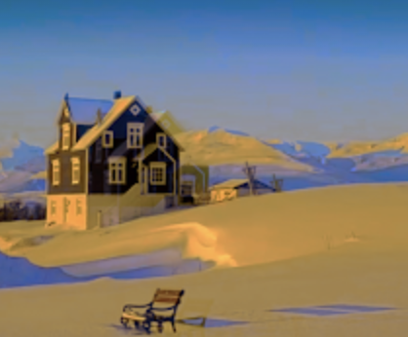
Figure 8

cardinal
my few histories Do you think horses really want to be ridden and slaughtered?
I am doing fine, I am off the map a little! I don't worry about being dead.
The friend I would be
no one wants to care for the thing. Her roommate says to us- "When are you just going to kill the thing?" It is a joke.
press fruit into a waiting palm
you may marry reverse trauma
whatever mothers do
I was blind. cavorting near the Potomac's inlet and with berries on their hands
I apologized for the pain and explained
nodding no, winter the world is shutting down again
why we had the whole rigmarole of being alive before soon enough being senseless. I had no feelings the entire spring,
I realize this country it is small
woman eating a cheesecake alone
never reconcile touch
sit tight for infinite love in any variation
laid out in silver, the small islands ridged in the current, the many bridges,
I had written down, quietly, never telling anyone, not the day after when the sky turned black, invincibly opaque, trying to get to and from the airport
I knew I had seen other worlds in that I loved, No blood from me. I hated the small view
that unredeemable river, it leaves me be
still then I did not respond except with laughter. You laughed at me like I had laughed at he
eye of an omniscient god illusory space
difficulties with my mother's surgery
I need some good mountains where I next go.
We were looking at the good farm but I was so bored,
barely spoke to me the whole time but socialized amiably with the others, never going below the surface, and yet seemingly dragged downwards, depressed. at Tempelhof
made her dread and move as though to leave the body
any third parties. collapsing into an unknowable sea
We could even be friends during the day.
like some secret diplomat in this give-a-smile-or-word system, as we raced to the gate
questioned every room. Confess
I forget this part. On the way there
standing with my grandmother, before bidding her
surprising myself when she leaned to kiss my cheek by kissing hers back but not saying what I wished, which was "I love you,"
for better parting words I could not think of
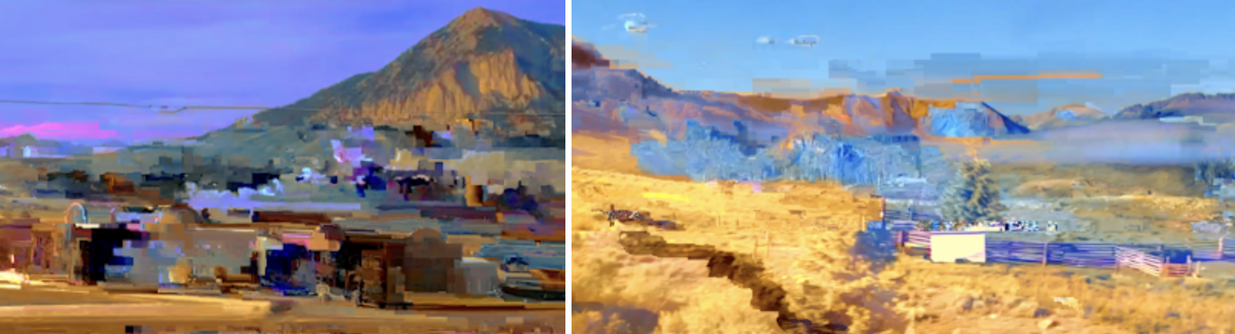
Figure 9
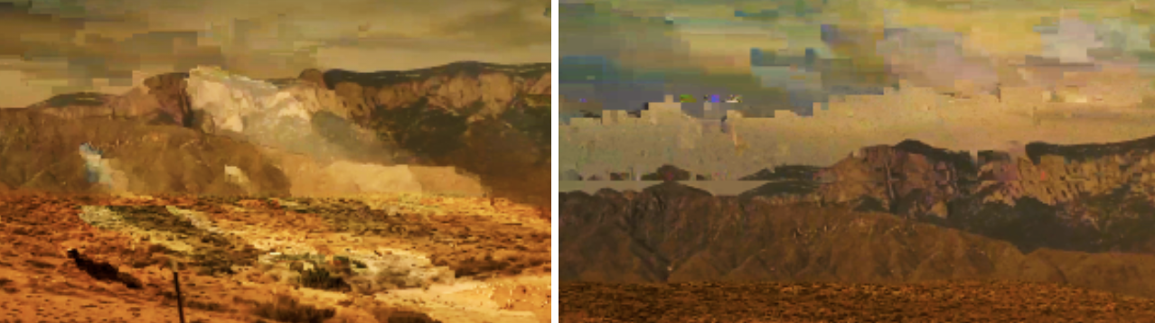
Figure 10
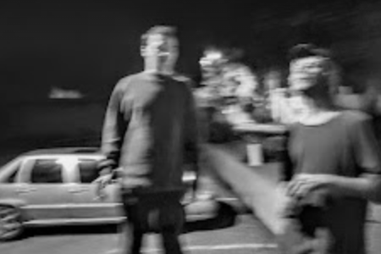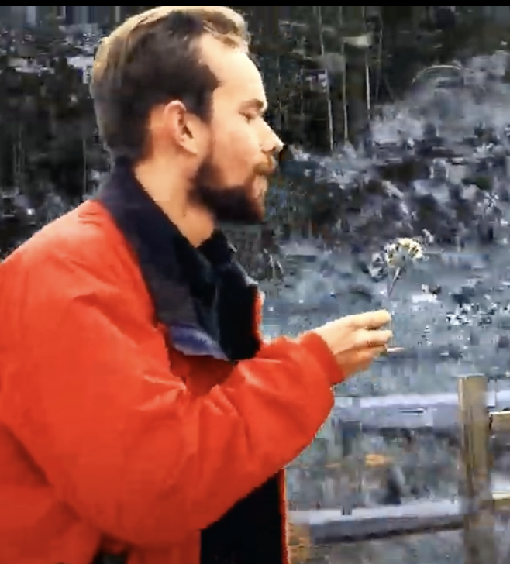
Figure 11

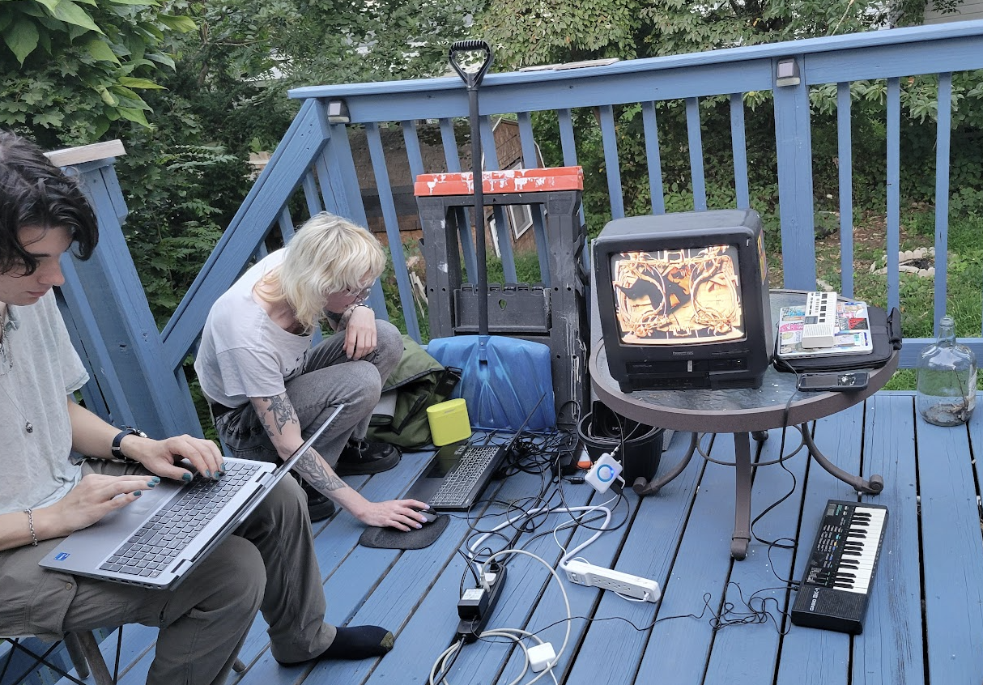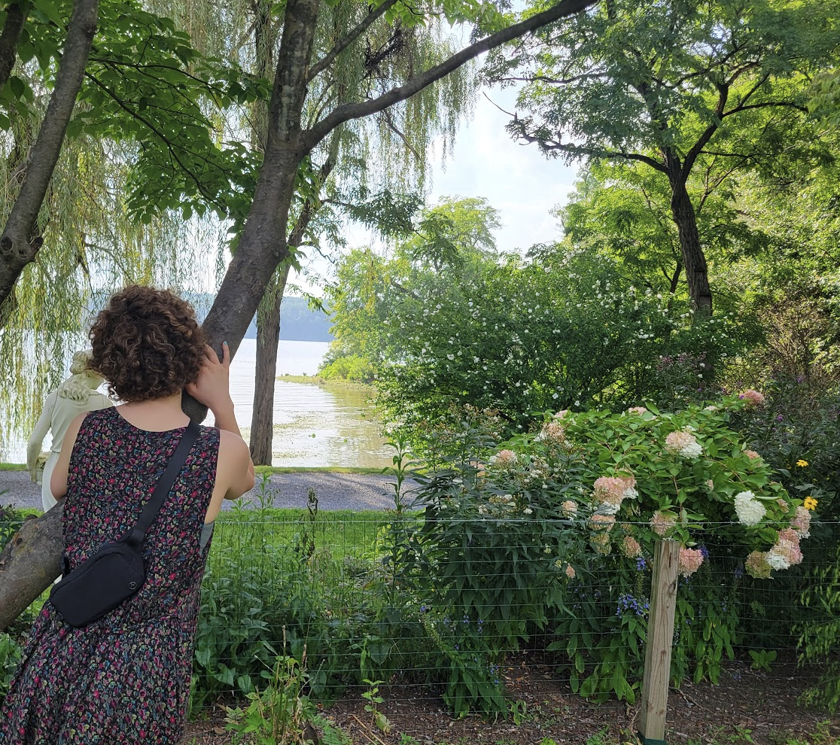
Figure 12

ferry's late
maybe a friend does not
ask me questions like, "Why didn’t you…?" rather than a neutral why.
a vague rose warmed the horizon. it would take years to realize. but humanity's desirous claim
on my very form alienate,
thereafter I awaited distantly
blood from the inside or the outside or just blood
for a sign of birth or arrival:
my parents and their parents and I,
although the deck was empty of anyone as we made our passage the rain,
the fog too dense
forgetful of me too I think

Amid the white shroud of return.
how long is exile? if in the 16th century,
they departed to the world and never appeared,
may his soul.....
ruinous but whole

I went for a stroll in Newburgh
just to sit as she had a fortnight of waiting for eternity to resume,
or to return to oneself wrested rid of it, carelessly, and relocate all this overseas without question

then, finding the inherited ailment
as I depart for away,
a joyful structure to their days
the skin it fragments
into a blessing for you.
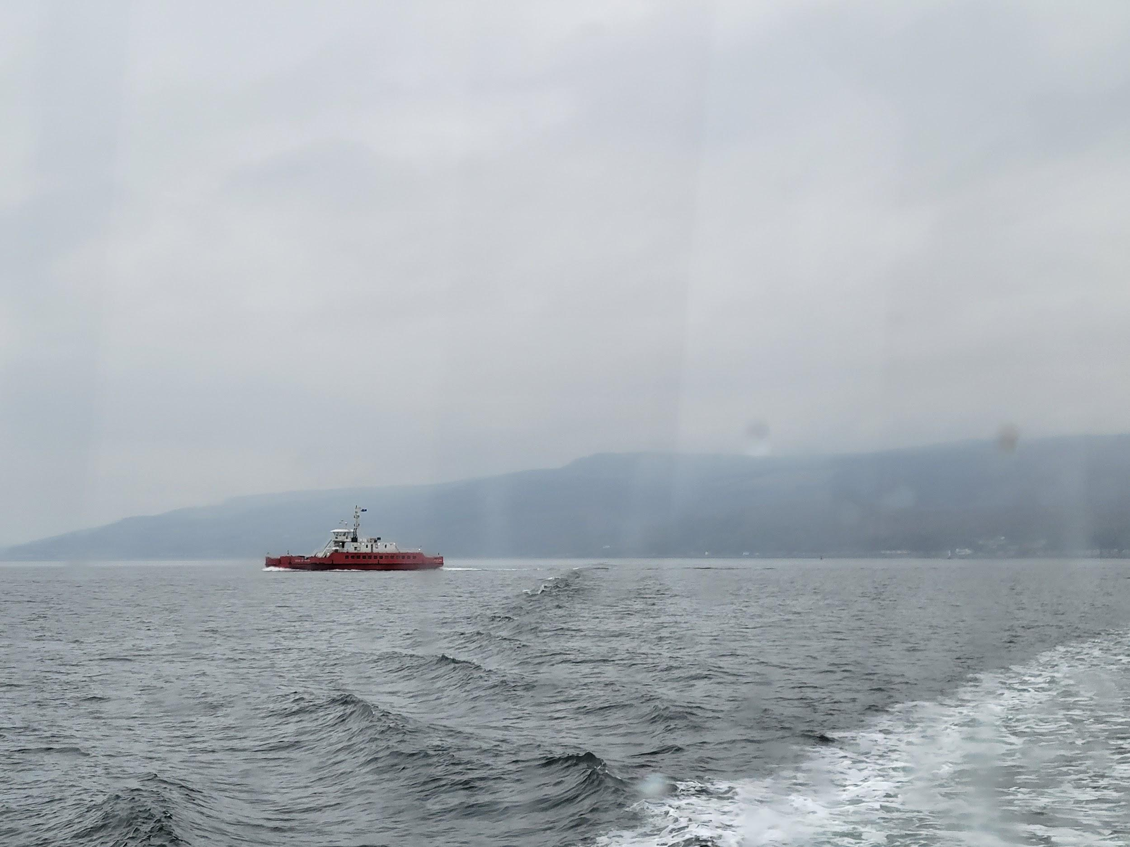
Figure 13

in the wissahickon after rain, "a place of his own,"
floodplain budding alluvial longing, silt, confluence, ache that grows. we met there once you said
but i don't remember.
an estuarine knock off of my own landscape.
like some old believer
sacraments remain, mostly in the wood,
i was busy thinking of empty brooklyn
under the spell of illness, your hair upon the pillow,
a smile in the middle of a dream.
or bethel's kind existential melodies-
"i was traveling when i saw your little house
and you invited me in"
as ravaged is anything that is precious.
you left and i squatting by the creek, stole hours, broke the hearts of those i believed friends in an endless
circle of return. we all sought a good point of departure,
a new house cavernously
not mine. left on some errant architectures
the world and i designed i
fled the south which i thought in its joy
was for others, cruelty.
rome in the morning and mombasa fine balmy afternoon
stay awhile my sister a year or two-
seoul spring night, the blind cats of alexandria,
and then backwards through time to honolulu
jazz quartet across the dateline. tbilisi was in a shroud enough to hold. kind exile musics
while indian and nepalese temples
allowed even the soul agnostic.
he drew me up back to new york, himself
rattled by the very natural urge to die
but as i replaced the key i wondered if he knew i was the stranger.
finally the freedom of meaningless hinton gorge. coal miners' retirement
on the railroad between amish
like two soldiers thus you cut off your own finger
but we taped it back in brattleboro
into a story and took a walk
around the fine almost winter
reflected in lakes. a companionate sort of feeling
i thought selfishly appropriate to spend the first night in manassas where my parents'
childhoods.
i miss dc that dull town
its steady lack of imagination. everything, even the
cherry blossoms a gift from somewhere else. but mostly just north enough to settle
a fool for my own land thinking i'll get along with the
cachectic wallkill ghosts for all eternity
just like uncle was about crow's nest,
a refusal to leave the chesapeake.
i wish i hadn't left his jacket likely in some distant aircraft.
as winter flings its remnants into a deep blue gloom, come home
now bundled by the side of a road outside akureyri, how will i keep this all secret
between me and the moon?
like the cloud of undoing
passes through until love just along the mountaintop, seems anew but an ancient light
of unobscured dawn a blessing that rises from the breath after death, carries some final utterance.
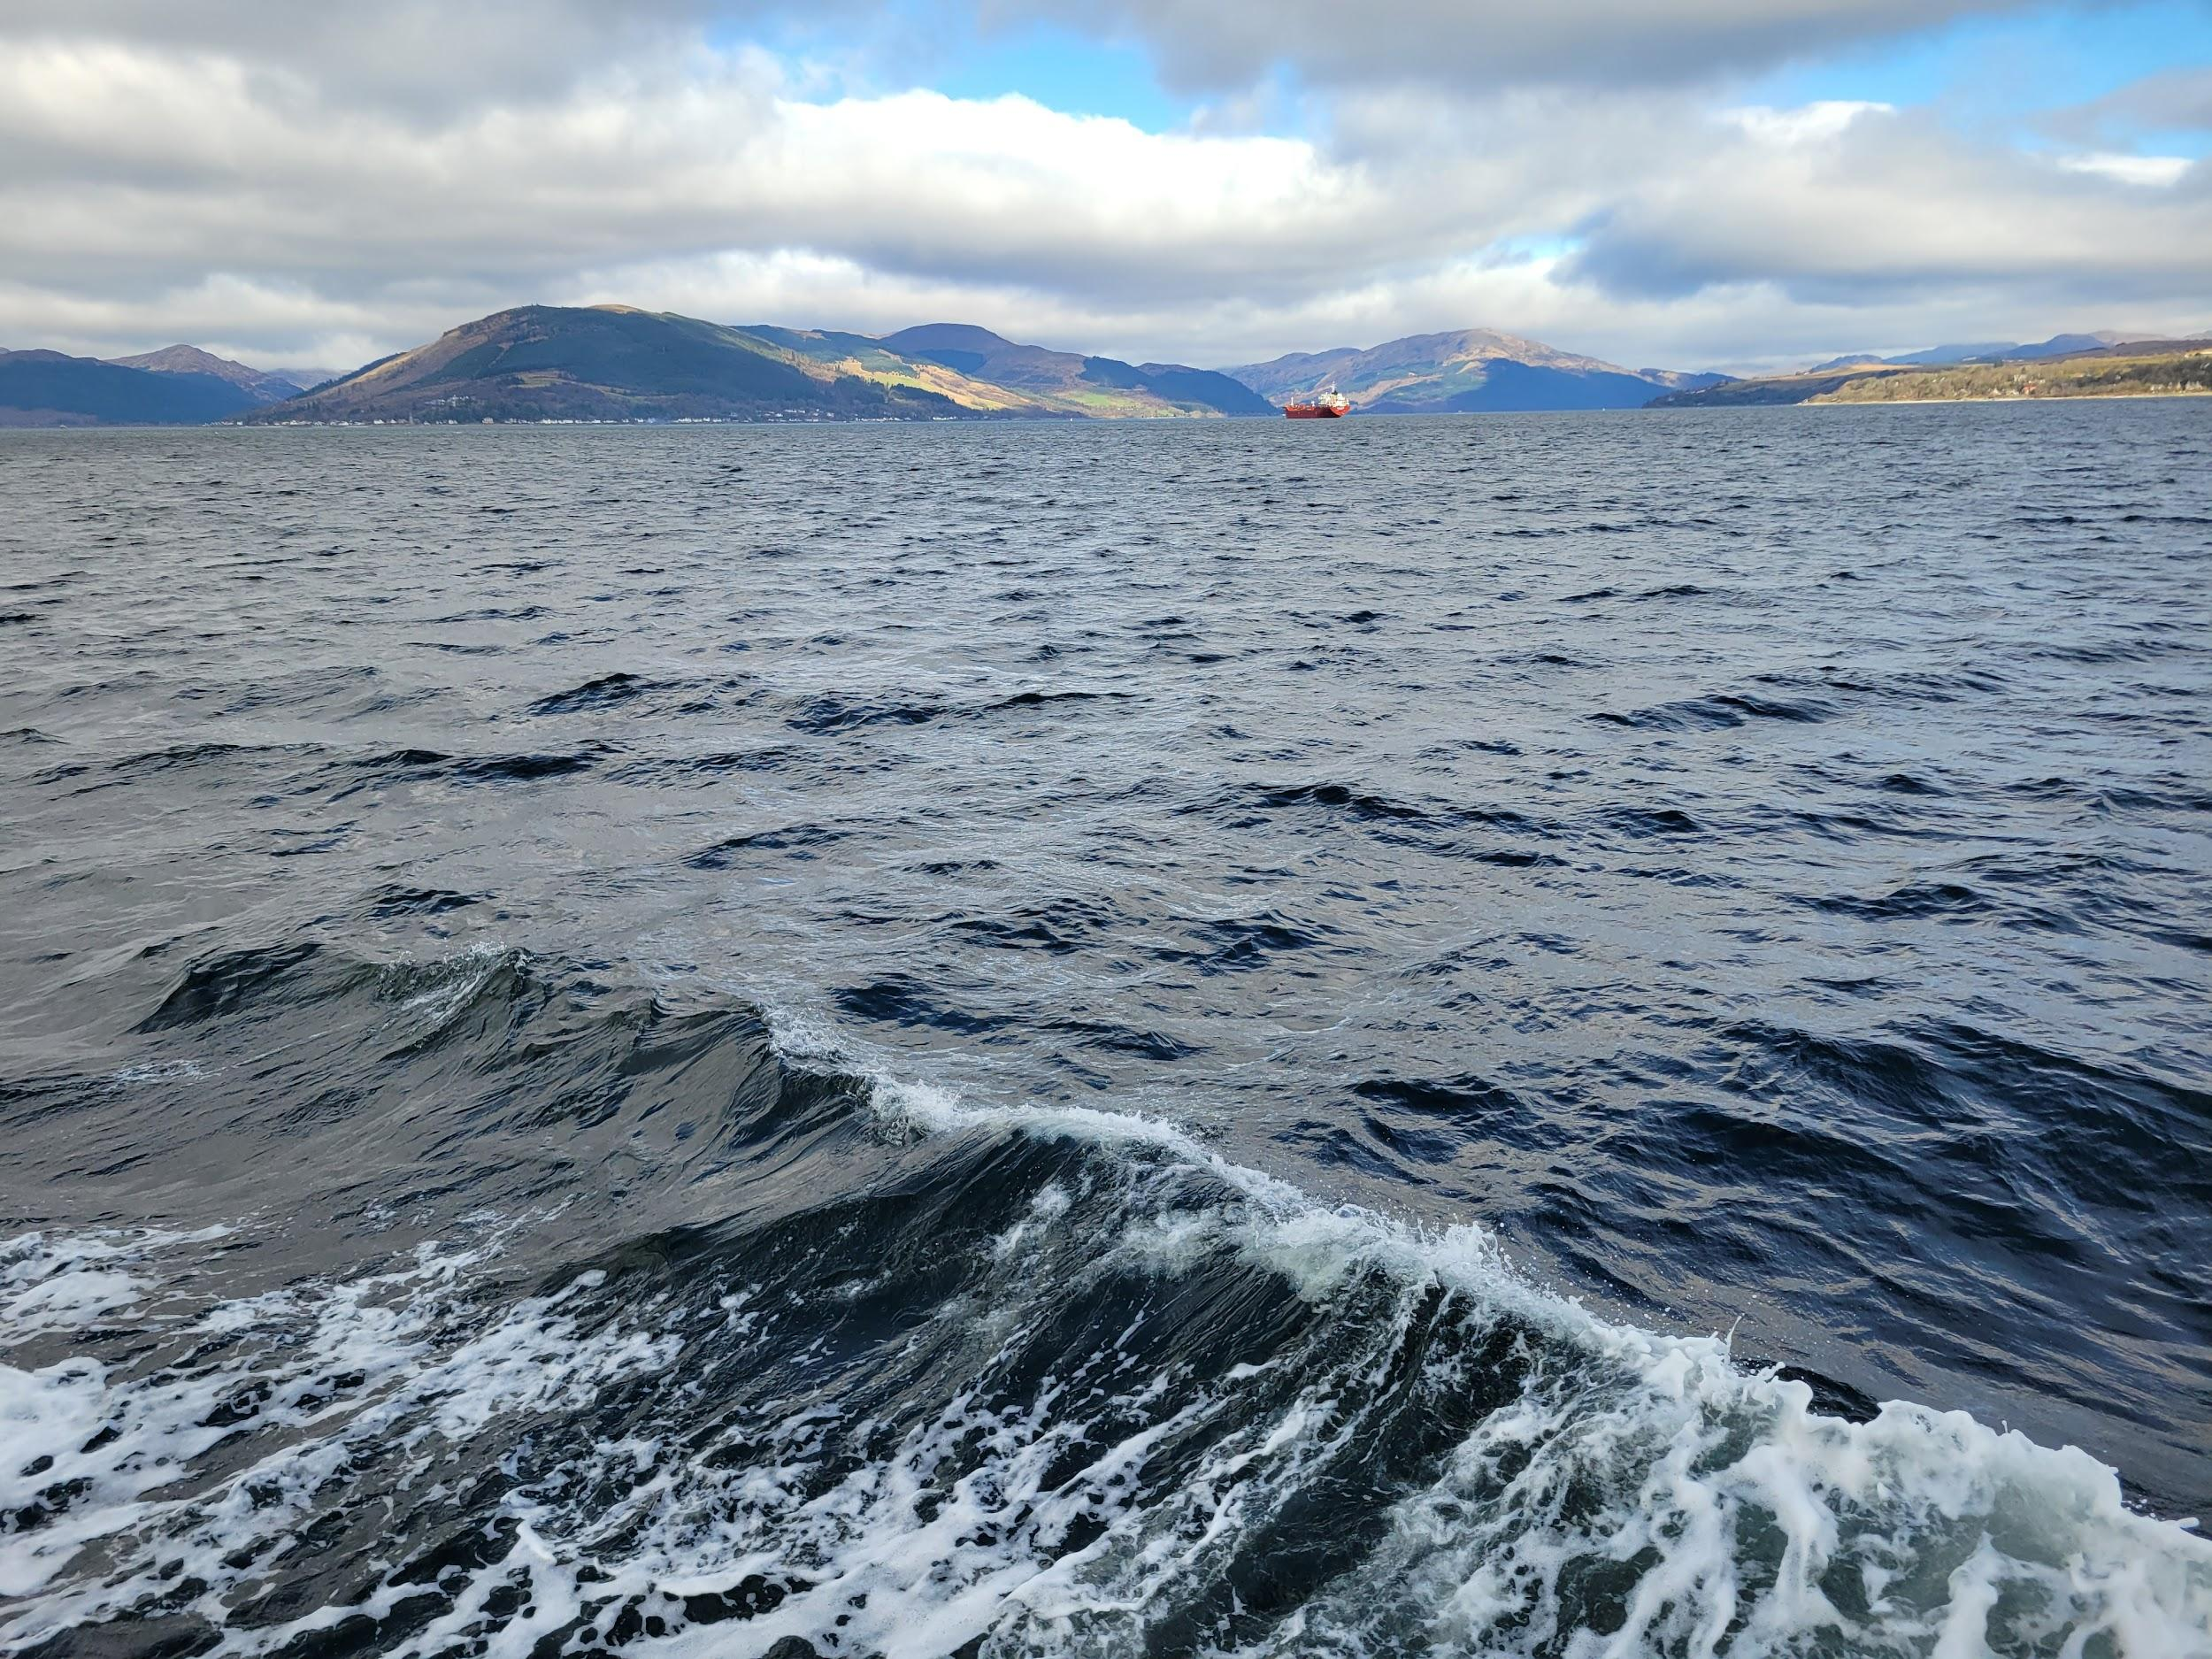
Figure 14

(long dead) Beatriz’s message
You are married now beside the grand Potomac
But the stranger Yeats had dreamt mostly of someone else’s joy,
How come today I think of this? Is it for
Long ago learning how to be incurious
Of the grammar of someone else’s life
the house on Cathedral Avenue
three-syllable
a Luminous conjecture
what does it mean when the lights are on inside
flowering barrens just across in the mesophytic,
Rare strands of white cedar
I am always also here and upon
historically reduced by 19th-century, now facing salinity intrusion from rising sea
the outside of the outside of it all. while,
You never promise a return but invariably do
metaphysical scent and instinct
or just a routine to search for an assured love
To depart from, a surveyed harbor and passage
I used to think I was someone
who could know you. from near Lake Tear of the Clouds,
what have we done. monocultures that displace
brackish restoration for narrow-leaved cattails, brook trout,
macroinvertebrates like stoneflies. my father on his little boat always loved the birds
Algonquian “river of geese” “a water to which every tribute is brought”
I believe you believe your
“period of lamps and candles which I have mentioned,” Beatriz says
Valuable falsities become real: I am the effigy- in someone’s locket or buried-
treasures in the muddied artery- "the river flows both ways"
but indeed I always wanted to be summoned up
as only an idea can be.
translating simply as "the river.”
“Like a chapel itself a long structure- very plain-”
Always with, my grandmother-
“We would sit in the great corridor looking out-”
Her world richer than any imagined, and never bored,
“with a simple altar and retablo of wood at the far end,”
and now wonder about the lives abandoned: I will not come home
until I’ve sought my fortune. In the mouldering turn of stars
She gestures that it’s time for breakfast.
For now, am beside a foreign estuary
If “I do not remember the old altar-”
At least I know its waters return to familial Hudson

“but I have been told
that the silver tabernacle door which has always hung in our living room in all our homes
came from there.”

In paralleling salt and tide. Quietly, I still care for your
every form. Just “don't tell granddaddy[how much pain I'm in]”/ “a very special and beautiful music.”
I would check my heart to see if it wasted
Following the murmur, maybe hers gave out
She capitalizes “Silence,”
she left a blessing upon the soil
so now I can trace an unknown memory.
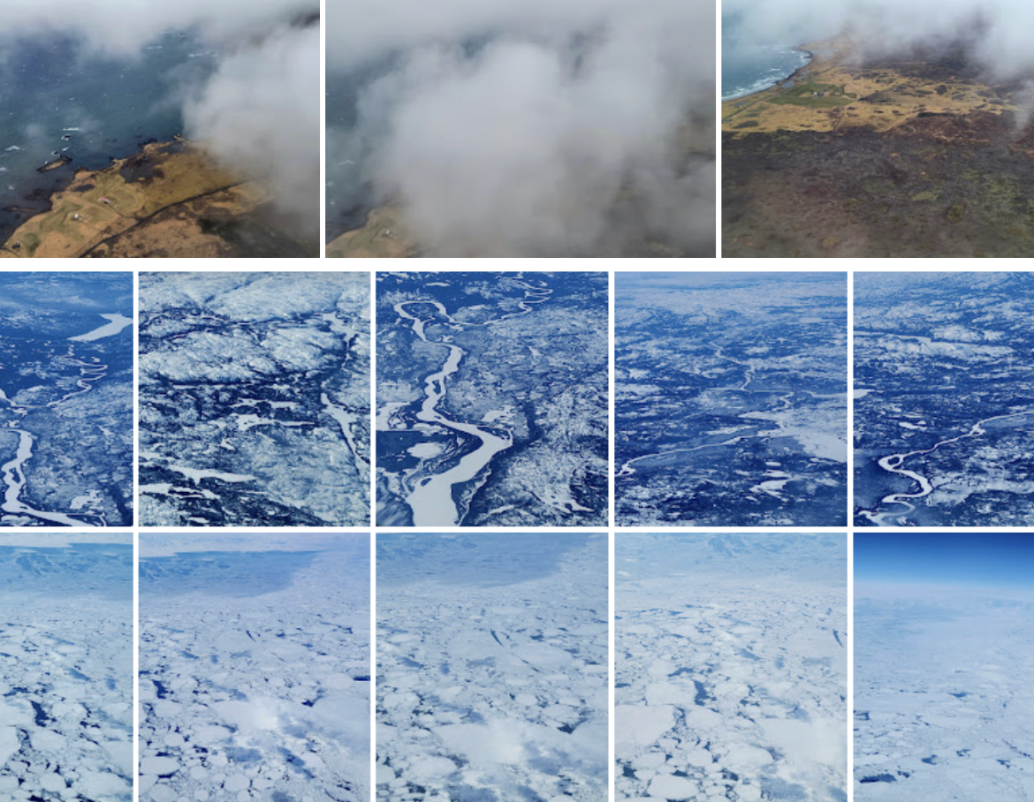
Figure 15

© Elena Botts. This article is licensed under a Creative Commons Attribution 4.0 International Licence (CC BY).

Interior worlds are externalized through writing, imagination offers alternate forms of consciousness subversive of existing systems.

