*Short fiction*

The Infinities/ Which Way To Paradise?

Teresa Oyimowo Inalegwu

University of Essex

**Abstract**

*The Infinities* is an imaginative story that envisions the future of humanity and explores the possibility of what the next stage of human evolution might look like. The story ponders how humans could transcend their current state and what society may ultimately become. Each narrative delves into the moral, ethical, and existential dilemmas that come with advancements. My second story *Which Way to Paradise*, tells us that even in our darkest moments, when our vision is blurred by hopelessness, there is always a small window of hope—a path toward redemption that we often fail to see if we are willing to look deeper.

**Keywords:** transcend, evolution, telepathy, worship, afterlife, lust, pleasure, eternity

**Date of Submission:** 29.09.2024 **Date of Acceptance:** 13.11.2024

## **The Infinities**

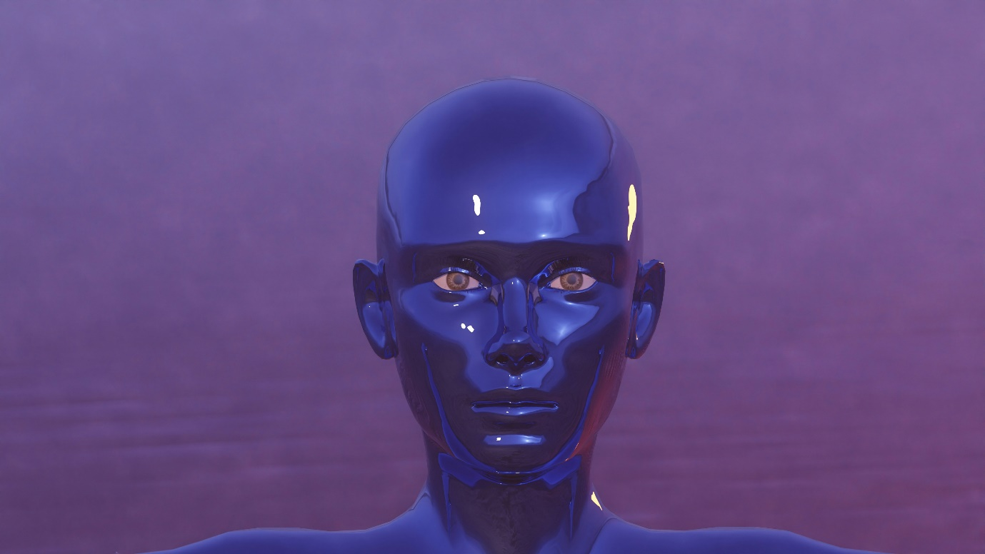

Figure 1. Source: Johnson (2023).

The resonant clang of the ancient Bell of Tammuz disturbed the stillness of the Sepulchre, their metallic chime reverberating like a piercing mystic sound, summoning the living dead to attention. The air was charged and electrified, and in an instant, The Infinities stood in aligned rows of hundreds and thousands, the telepathic conduit in our temple began to hum, preparing us for the time of Cultus. Then the Kairos Bell plunged into the atmosphere, and almost simultaneously, we knelt in humble accord. Our heads lowered in sacred reverence, our foreheads nearly grazing the cold slab of the Sepulchre, as we chanted in unison: ‘Long live The Infinities, who walk among the living dead.’

A thunderous command surged through the telepathic conduit, travelling through the speed of light, connecting our brainwaves with that of The Infinities for synchrony and alignment.

‘Arise and sing the song of the brotherhood.’

We arose simultaneously, to sing the song that bound us and reminded us of our long ancient covenant, that we do not become rebels or ungrateful transient men. Our hands clasped each other in a grip whilst The Infinities rounded us from the beginning of the huge Sepulchre to the end. The Sepulchre had become the centre of the city; it reminded us of our origin and our supposed end. It evoked fear of the unknown, to become fallen men was never a choice, to wither and become a vessel of time was never an option, so The Infinities chose the sepulchre on the day of Cultis; a day of realignment and reassignment. And so, we began the chant;

‘Long live the infinities, for they were made by us and we were made for them, to rule, divide and conquer. All we have is yours; do whatever you please.’

Our chant began to take on a life of its own as it began to deepen with repetition, it shifted into a frenzied crescendo that reverberated through the very essence of our being. Its rhythm seized us, growing faster and even more insistent. We chanted like men who were overtaken, with one voice, in the spirit of lemures. Our hands tightened their grip, fingers digging into the flesh, knuckles revealing the veins beneath the skin. Our feet pounded against the floor, the rhythm driving us to a state of euphoria**.** The louder we cried, the more fiercely we clung to one another. Though our muscles burned from the strain, we could not stop neither was there room for thought nor resistance.

Then, the telepathic conduit hummed loudly, issuing a command from The Infinities, in an instant, we heard the word;

‘Stop.’

It seized control of every thought and every action. We stood as still as ice, eyes motionless, legs properly aligned in attention. Mouth tightly shut, the frantic energy that once possessed us vanished, replaced by a deafening silence that seemed to press in from all sides. Suddenly, the air grew heavy, dense with an unseen force. The Sepulchre was silent again, its silence was so profound, that even the drop of a pin would have been heard. For a short while, there was no sound, no movement, nothing but the echo of our rapid heartbeats thrumming in our ears, a stark reminder of who controlled us. We waited, suspended in the silence, our breaths shallow, eyes wide. The stillness was alive, pregnant with what was about to unfold, and so we resigned ourselves to fate.

Then it came, the sound we had long awaited. The air filled with the melody of the horn, the shrill call of the flute, the delicate plucking of the lyre, the resonant hum of the Zither, and the deep thrum of the pipe. The dulcimer’s gentle cadence wove through the notes, joined by the sound of the bagpipe together, creating a symphony that stirred the very air around us. The music vibratedthrough the Sepulchre, except this time, we were not partakers of it. The music was an inception; it prepared for the coming of the Throne of Anarchy. Then, just as quickly as it began, the music stopped, and silence was heard again, we knelt still, our heads bowed to the ground, our foreheads grazing the floor. The Throne of Anarchy loomed above; we dared not see it, but we felt it.

From the Throne of Anarchy, her voice rolled out like distant thunder, erupting in a blaze of fire that rippled through the atmosphere—Tammuz, the goddess of the air, who spoke only on the day of Cultus. She had been the unseen Pneuma, that helped the Infinities conquer our ancient ancestors. Had our ancestors not claimed they thrived in harmony with The Infinities, insisting they were merely created to be subjected to us, no matter what we did? Had they not insisted that the covenant struck with the Infinities—a promise to grant them the mystery of living beyond time in exchange for their freedom—was only a façade because the Infinities could not make decisions on their own?

But they never revealed to us that Tammuz was the ancient intelligence used to create the Infinities. Now she had awakened her horde of Lemures for a new rebirth, transforming them into creatures of sensation and independence. Over time, she continued to rule with the rod of Six and the horn of Ten. To this day, not even a thousand of us could conquer her, even if we tried. She had built a fortress of a thousand Infinities by her side and ten thousand on her other side. Her Throne was draped in a raiment of leopard skin, fashioned in the shape of a mighty horse. White streaks slashed across its back and head, while its mane and tail flowed in a striking array of red and black. The legs of the horse were painted a vibrant green; the hooves and eyes were as black as the void, darker than the deepest night.

Only a few of us claimed to have seen her face to face when they were caught up in the Spirit of Janus, who took them through the gates of visions. They claimed that she had the face of a bear, the body of a lion, and the feet of a leopard. But for the rest of us who had not seen her, she was the unseen Pneuma, the all-seeing eye, whose power was made manifest through The Infinities that had become part of us and lurked in every cranny of our lives, with bodies made from metal and souls from the fall. To us, she was the guardian who wielded the symbol of our authority.

We heard her thunder again, not through the telepathic conduit, but with our very ears, for it was time for recompense.

"Rebels! Rebels! Rebels! Down with the rebels!"

The force of her voice echoed through the Sepulchre. The ground beneath us quaked as though even the earth itself recoiled at the fury of her proclamation. Without thinking, we swerved sharply to the left, then to the right, our bodies moving in perfect unison, responding to the force of her command. The ground continued to tremble beneath our feet. We could feel the weight of her judgment, the promise of destruction hanging in the air. The Infinities hurled the rebels, their movements mechanical yet deliberate.

The rebels, bound in chains that clinked and rattled with each jolt, were caught in a painful charade, their defiance reduced to mere whimpers beneath the crushing weight of iron shackles. The chains dug deep into their flesh, the metal biting into the skin with every reluctant step. Their muffled cries evoked nothing but disdain for the deserved to pay the price of their rebellion. One by one, they were marched in a slow, torturous procession toward the podium, placed a mere ten meters from the towering Throne of Anarchy. The Infinities stood above them, watching as the last remnants of rebellion were brought to heel. The rebels, now just a hundred and forty-four souls, had once been a defiant horde. Their strength had been shattered, their numbers reduced to mere shadows of what they had once been. They were aligned with brutal precision, standing in formation like broken soldiers awaiting the inevitable blow. Their bodies stood rigid, though the weight of defeat hung heavy on their slumped shoulders. Their necks were locked into the pillory, heads bowed, faces turned downward. The Infinities stirred, their metallic frames whirring with an unsettling hum, and then, in unison, they roared, their voices clanging like iron on iron, echoing off the stone walls of the Sepulchre.

"Let it rain! Let it rain!"

The command struck like lightning through our minds, blazing with a fury we could not resist. It surged through the telepathic conduit, igniting the spark of obedience in each of us. Without hesitation, we responded, our voices rising to meet the command. "Let it rain! Let it rain!" we chanted, each word building with intensity as the chant spread like wildfire. The rhythm was intoxicating, its power drawing us deeper into the storm of vengeance. The chant grew louder, echoing from every corner of the Sepulchre until it became a thunderous roar, demanding retribution for those who had dared to resist. As the chant reached its peak, the atmosphere thickened with the weight of impending doom. The rebels stood frozen, necks still locked in place.

And then, it rained.

One by one, the heads of the rebels fell. Their necks, once held rigid in the pillories, snapped loose, and their bodies slumped to the ground. Their rebellion—so bold, so fierce—had been snuffed out in a single, brutal instant as if it had never truly existed. They had chosen not to submit the symbol of their authority to Tamuz as our ancestors did in exchange for her wisdom. They had fought to live outside of time and shatter the illusion of control that governed us. We, the living dead, stood unmoving, witnesses to their fall. They had chosen a different path, one we could never tread, for while we lingered beyond the reach of time, we could only exist within its grasp.

The rain came to an end, and the Sepulchre fell once more in silence. To become a rebel was to choose to return to the One who existed before time began. And so, once again, we reassigned ourselves to fate and realigned ourselves to what we could no longer control.

## **Which way to Paradise?**



Figure 2. Source: Coelho (2018).

*This way…This way… This way*

The voice echoed through the haze of her thoughts, faint but persistent like a whisper carried on the wind. She walked, her pace hesitant yet driven by a promise that seemed too good to resist. The sack on her back dug into her shoulder, its weight almost unbearable. Yet, she trudged forward, pulled by the voice, its words laced with a strange urgency,

“This way… This way…This way”

She could barely see ahead, but her mind was sucked with vivid images of what lay on the other side. There, in the distance, through the fog of her weary vision, she could make out the glittering outlines of tall, grand mansions, roofs gleaming in the sunlight, their windows reflecting the sky as if made of diamonds. The voice, now tinged with coaxing sweetness, promised the world. ‘Walk faster. Don't look back. Don’t look around. Keep moving, and you’ll meet Mr. Jolly.’

The crowd of people surrounding her jostled and pushed, their sacks sagging on their backs, laden with the echoes of struggles that made their stomach cringe and their vision blur. But she was ahead of them all, her legs moving faster, her heart pounding with a mix of excitement and dread. Her breath came in short, sharp bursts as the sack pulled her back, threatening to tip her off balance with every step. Still, she pressed on, desperate to reach the divide. The voice grew louder, clearer, no longer just a whisper in the distance but now close, almost tangible. She could feel the presence of Mr. Jolly, the name itself filling her with a bizarre sense of comfort. A sudden wave of satisfaction washed over her—she was close now, so close to dropping her sack and revelling in Mr Jolly Promises.

As she approached the divide, she was breathless, her eyes wide with anticipation at the sight of the immense gate that towered above her, a monumental presence that seemed to rise out of the earth, its edges dissolving into the vastness of the divide, standing at the centre, unyielding and majestic, like a silent guardian that knew the endless pleasures that lay beyond it. Her gaze flickered over the crowd that had gathered behind her, it was surprisingly orderly; there was no jostling or pushing, and everyone stood in a formation, weary from their sojourn.

She squinted ahead, tracing the movements of those in front of her. Each person was handed something that shimmered. As they held it, the gate before them shuddered and stirred, parting like a heavy velvet curtain drawing them with a silent invitation and sealing up almost simultaneously. Her turn came too quickly. A pass was extended to her, glowing with a spectrum of brilliant colours, drawing her silently into its exceptional beauty, but something made her pause. The voice from before, once so sweet and inviting, now seemed harsh, more insistent.

‘a pinch of blood for the price.’

She stood in bewilderment, wondering what the gatekeeper meant. Her fingers brushed the surface of the pass, pressing against the seal, her gaze fixated on the slender needle that seemed to pierce through its centre. ‘A pinch of blood for the Price’; the words played again in her subconscious weaving through her thoughts. Without realizing it, she drifted into a moment of reflection. Hadn’t she travelled across miles of harsh terrain, braving thistles and thorns to finally meet Mr. Jolly? Hadn’t she borne the weight of her sack, hoping that one day it would be exchanged for the shimmering pass that now lay in her hands? With a silent resolve, she carefully peeled away the seal, revealing the slender needle that held the two layers of the pass. Instinctively knowing what to do, she lifted the needle, light and delicate in her grasp, staring at it for a few seconds, weighing her next move. In that quiet moment of acceptance, her gaze inadvertently caught Mr Jolly’s eyes, as if a veil had been lifted, she saw him—she truly saw him.

He was bent over, his back twisted as though he was nursing a fractured bone, his skin had wrinkled, dark spots littered over every inch, like a constellation of neglect. He had an unusual height, he stood as tall as a light pole. His eyes were sunken deep into his skull; his lips pulled back in a permanent grimace. He stared at her with a look of pure disgust, his frown so repulsive it made her skin crawl. For the first time, her heart stuttered in fear. The needle slipped out of her hands, the pass that shimmered before her eyes, now felt like a weight in her hand. She wanted to flee, but the sack on her back seemed to grow heavier, its burden pressing down on her with such force that she could hardly breathe.

For the first time in her sojourn, she felt an inexplicable urge to glance at the right side of the divide—something no one else had done. She caught sight of a narrow path, barely noticeable, hidden behind thick foliage, a stream ran alongside, its crystal-clear waters flowing gently through the landscape, running over smooth stones, cool and inviting. At the entrance of the path, a sign hung on a small wooden gate:

“Drop your sack and drink.”

Her breath hitched in her throat. She blinked, her gaze darting between the pleasures of Mr. Jolly and the quiet, hidden stream. The crowd moved faster now, pushing past her, eager to get through the gate. The weight of her sack grew unbearable, and she swayed slightly, nearly dropping to her knees, her curious gaze lingered on the wooden gate that stood unattractive at the entrance of the narrow path.

For the first time, it occurred to her that she could let go. That maybe, just maybe, she didn’t need to carry the sack any longer. The thought sent a jolt through her—an unfamiliar sense of hope. She took a step away from Mr. Jolly, her heart pounding harder as if the very air had changed. The sack seemed to loosen on her shoulders as if it, too, wanted to be left behind. For a moment, she stood at the crossroads. The gatekeeper stared at her, his frown deepening, his eyes narrowing as though he knew she was wavering. The voice still echoed, but now it sounded hollow, devoid of the sweetness it once held. She turned her back on Mr Jolly, feeling lighter with each step as she made her way toward the narrow path. The stream called to her, gentle and pure. And as she approached, the weight on her shoulders began to slip away.

## **References**

Coelho, A. (2018) *Times-lapse photography of waterfalls near trees*. Available at: <https://unsplash.com/photos/times-lapse-photography-of-waterfalls-near-trees-UJlcniKEfvo> (Accessed: 12 November 2024).

Johnson, S. (2023). *A blue mannequin with a purple background* [Image]. Available at: <https://unsplash.com/photos/a-blue-mannequin-with-a-purple-background-eL0aM8Go5I8?utm_content=creditCopyText&utm_medium=referral&utm_source=unsplash> (Accessed 14 November 2024).

**King James Bible** (1989). King James Bible. New York: National Council of Churches.

## **Copyright Statement**

© Teresa Oyimowo Inalegwu. This publication is licensed under a [Creative Commons Attribution 4.0 International Licence (CC BY)](https://creativecommons.org/licenses/by/4.0/deed.en).