Research Article
Short-term impacts of marine traffic on the behaviour of dolphins in the Aegean Sea
Danielle Alice Roth
University of Essex

Abstract
With an expected further increase in marine traffic comes progressive negative environmental impacts on cetaceans. This study investigates the impact of motorised vessel presence on Delphinus delphis and Tursiops truncatus behaviour in the eastern Aegean Sea using a time budget analysis of their behaviour in the presence and absence of motorised marine traffic. Behaviour was categorised using an ethogram and BORIS software was used to obtain the total duration of each state and category for the time budget analysis (Elias et al., 2021; Friard and Gamba, 2016). When comparing the percentage frequency of time per sighting that D. delphis and T. truncatus were visually observed from the research vessel exhibiting each behaviour in the presence and absence of marine traffic, the results showed that feeding, socialising, and travelling were more prevalent in vessel presence, whilst energy intensive behaviours such as, diving, porpoising and sharking were the opposite. A key finding of this study was that there was no significant difference in the percentage time either species spent resting in the presence or absence of vessels. Additionally, the results found that both species exhibited different changes in behaviour during vessel presence and absence. This study concludes that increased travelling and stress behaviours can have biologically significant consequences on the physical fitness, energetic budget, health, and reproductive output of D. delphis and T. truncatus populations. Improving our understanding of how marine traffic intensity can impact the short and long-term behaviour of these populations is essential to aid in their preservation.

Keywords: dolphins, short-beaked common dolphin, Delphinus delphis, common bottlenose dolphin, Tursiops truncatus, behaviour, marine traffic, Aegean Sea, Greece.

Date of Submission: 12.07.2024 Date of Acceptance: 15.01.2025

Introduction
With more than 220,000 vessels navigating through its waters yearly, the Mediterranean Sea is one of the busiest waterways in the world (Inch et al., 2018). As global shipping is expected to grow by 4% per year, shipping activity in the Mediterranean will also increase in the number of routes, traffic intensity, and size of ships (WWF, 2022). With this growth comes increasing negative environmental impacts, such as chemical pollution, noise pollution, and collisions with cetaceans (WWF, 2022). Whilst transportation of goods and fishing is essential, many shipping and navigational routes cross habitats that are vital to numerous highly mobile marine mammal species (Inch et al., 2018).
Delphinus delphis, the short-beaked common dolphin, and Tursiops truncatus, the common bottlenose dolphin, are two of the Mediterranean sea’s resident species (Inch et al., 2018; Figures 1 and 2). Their populations are of high concern for conservationists, due to their role in the ecosystem as apex predators (Inch et al., 2018). Delphinus delphis was once abundant and widely distributed in the Mediterranean but is now classified as ‘endangered’ in the International Union for Conservation of Nature’s (IUCN) Red List of Threatened Animals, due to population declines since the 1960s (Inch et al., 2018). Additionally, Tursiops truncatus is classified as ‘vulnerable’ by the IUCN in the Mediterranean Sea, following a decrease in population size in recent decades (Mussi et al., 2019).

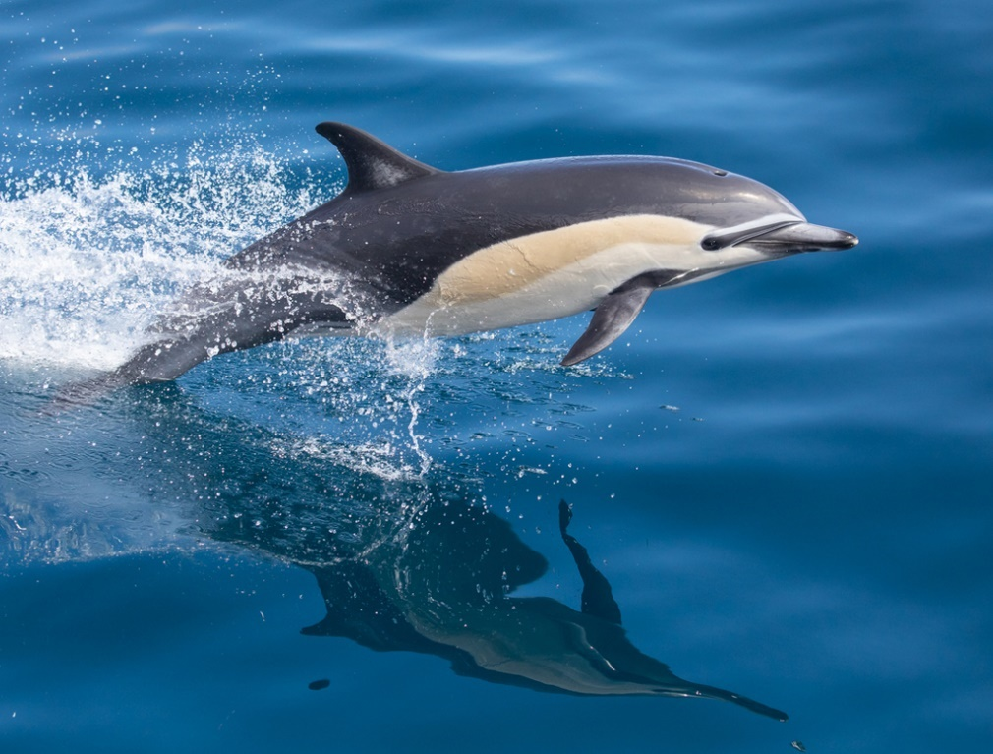
Figure 1. Delphinus delphis, the short-beaked common dolphin (Husic, 2021).
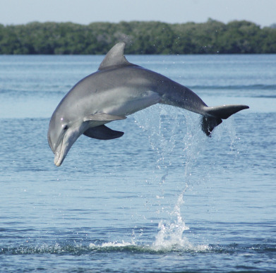
Figure 2. Tursiops truncatus, the common bottlenose dolphin (Wells and Scott, 2017).

Natural Dolphin Behaviours
Ethograms are catalogues of behaviours that a group of animals may exhibit (Elias et al., 2021). They are used to categorise the two states (diving and swimming) and six categories (feeding, porpoising, resting, sharking, socialising, and travelling) of types of behaviour in dolphins (Elias et al., 2021). States are used to describe long-duration behaviours. Events, such as bow-riding and leaping, describe short-duration behaviours whereas categories are a combination of the state and event to make a more specific behavioural record (Pennino et al., 2016).
Cetaceans naturally dive for feeding, mating, and predator avoidance (Ponganis, 2015; Beurteaux, 2017). Dolphins also dive to communicate underwater; they use echolocation to navigate and locate prey (Alaska Sea Grant, 2013). They often hunt nocturnally where feeding behaviour regularly occurs close to the water surface (Elias et al., 2021; Neri et al., 2022). Porpoising is when dolphins leap out of the water whilst swimming (Weihs, 2002). It is used as a more energetically advantageous method of swimming longer distances, as it reduces drag associated with continuous underwater swimming (Au and Weihs, 1980; Au et al., 1988). Resting in dolphins is usually nocturnal and can include surface, bottom, and swim resting (Gnone et al., 2001; Sekiguchi and Kohshima, 2003). Dolphins exhibit unihemispheric slow-wave sleep or resting, whereby they shut off one side of their brain at a time. They also typically only rest for a few hours at a time (Lyamin et al., 2008). Sharking occurs when a dolphin swims just below the surface of the water with its dorsal fin above the waves (Elias et al., 2021). The reason for sharking is dependent on the situation at the time, it can be observed during feeding, however, it can also show that the dolphin is highly active and curious, or in other situations, behaving in a tranquil or inconspicuous manner (Ritter, 2002; Heithaus and Dill, 2009). Dolphins depend on socialising for communicating, mating, hunting and defence (Wells et al., 1987; Lusseau et al., 2003). Travelling is when a dolphin is swimming in a consistent direction with regular surfacing intervals (Elias et al., 2021). New et al. (2013) found that travelling behaviour was exhibited when in fear as a means of escape and associated with hunger to meet the necessity to feed.

Short-Term Effects of Vessel Presence on Dolphin Behaviours
Dolphins are renowned for approaching and interacting with vessels, therefore the increase in marine traffic could cause a change in their short and long-term behavioural trends (Hawkins and Gartside, 2009). Behavioural responses to vessels can be related to engine noise, the physical vessel presence, or a combination of the two (Pennino et al., 2016). A study published in 2006 by Lusseau shows that the travelling and diving behaviour of T. truncatus becomes more frequent in the presence of motorised marine traffic, and they tend to avoid vessels which are intrusive and unpredictable such as recreational vessels and motorboats, as a stress response. Similarly, a study by Miller et al. (2008) shows an increase in dolphin travelling behaviour and a decrease in feeding behaviour in the presence of high-speed vessels. However, studies by Miller et al. (2008) and Papale et al. (2011) show that feeding behaviours can be initiated in the presence of fishing vessels, with dolphins actively pursuing and feeding off the by-catch expelled from the boats, suggesting that not all marine traffic has an immediate negative impact on the dolphin’s energy budget, especially if they are receiving a meal which might have otherwise cost them more energy to hunt themselves (Bonizzoni et al., 2023).
Results from Hawkins and Gartside (2009) show that T. truncatus’ travelling behaviour declines but socialising increases when vessels are present. Lusseau (2006) discusses that socialising via visual and physical communication may provide an efficient way to communicate in a noisy environment such as in the presence of marine traffic. However, Papale et al. (2011) states that fast boats cause an interruption of all activities and reduce the frequency of behaviours related to feeding, socialising, and resting. They also show that when boats are within 200 m, resting behaviour is absent and diving behaviour is less frequent (Papale et al., 2011). However, a study carried out by Neumann and Orams (2006) indicates that species of dolphins that usually exhibit schooling behaviour, such as D. delphis, are less likely to be disturbed by vessel presence.

Long-Term Effects of Vessel Presence on Dolphin Behaviour
Overall, studies show that the presence of long-term marine traffic induces stress in dolphins, thus impacting their activity budgets, which further leads to a decline in population health (Neumann and Orams, 2006; Miller et al., 2008). Lusseau (2006) concludes that increased stress, area avoidance and decreased resting, feeding, and socialising have biologically significant consequences on the energetic budget, physical fitness, health and reproductive output of individuals and their population. In addition, Miller et al. (2008) state that slower growth rates and a decline in an individual’s health due to reduced foraging efforts could result in lower fecundity for females and decreased competitive ability for males. Results from Inch et al. (2018) show that in areas with high vessel presence, the number of sightings of D. delphis and T. truncatus decreases, and they relocate to areas with fewer disturbances. The resulting long-term effects may be more detrimental and could include decreased survival rates or permanent emigration (Neumann and Orams, 2006).
Although the impacts of vessel presence on cetaceans have been studied in many areas, very little is known about the short and long-term effects of marine traffic on the behaviour of both D. delphis and T. truncatus in the Aegean Sea. There is a need for further research in this field of study to analyse whether the impacts of vessel presence on dolphin behaviour are influenced by vessel type, distance, and noise emission. The results of current studies demonstrate some of the short-term effects, but it is unclear whether these effects will contribute to long-term challenges such as population displacement, reduced health, and reduced viability of the population (Miller et al., 2008). This study aimed to increase the available data and knowledge in this field of study to improve understanding of how the increasing threat of marine traffic intensity can impact the short and long-term behaviour of cetaceans. The results of this study can help to design and develop conservation measures to aid the preservation of not only species in the Aegean Sea but global cetacean populations as well.

Research Objectives and Hypotheses
This study aimed to analyse the impacts of vessel presence on Delphinus delphis and Tursiops truncatus behaviour in the eastern Aegean Sea in the summer and autumn of 2021 and 2022. This was achieved through a time budget analysis of the behaviour of the two species in the presence and absence of motorised marine traffic.

Null Hypotheses:
- Neither species exhibit changes in behaviour in the presence of marine traffic compared to behaviours in the absence of marine traffic.
- Delphinus delphis and Tursiops truncatus exhibit the same changes in behaviour in the presence of marine traffic.

Alternative Hypotheses:
- Both species exhibit changes in behaviour in the presence of marine traffic compared to behaviours in the absence of marine traffic.
- Changes in behaviour exhibited by Delphinus delphis are different from those exhibited by Tursiops truncatus in the presence of marine traffic.
- Diving and travelling behaviours are more prevalent in the presence of marine traffic.
- Feeding, porpoising, resting, sharking, and socialising behaviours are more prevalent in the absence of marine traffic.

Methodology

Study Area
The Aegean Sea, which covers roughly 214,000 km², forms a part of the Mediterranean Sea and is situated between Greece and Turkey (Inch et al., 2018; Chirosca and Rusu, 2020). Boat surveys were carried out along the south coast of Samos Island, Greece, in the eastern Aegean Sea in the summer and autumn of 2021 and 2022 (Figure 3). The marine environment around Samos Island in the eastern Aegean Sea supports a diverse array of motorised vessels. Traditional small-scale fishing boats are used by the local fishing industry, whilst larger fishing vessels operate in the deeper, more distant waters, targeting larger or more migratory species (Archipelagos Institute of Marine Conservation, 2011). Sailing boats, yachts and small motorboats are often used for recreational purposes and are part of the region's tourism industry. Ferries and cargo boats are primary modes of transport, facilitating the movement of passengers and goods between Samos, other islands, and the mainland (Archipelagos Institute of Marine Conservation, 2011).

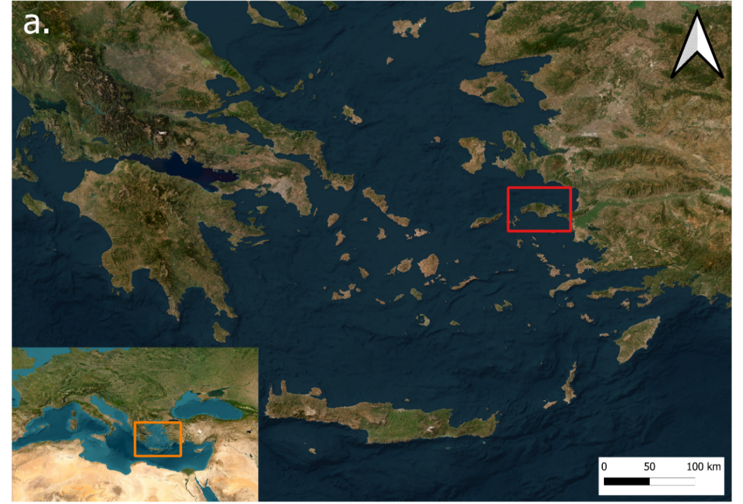
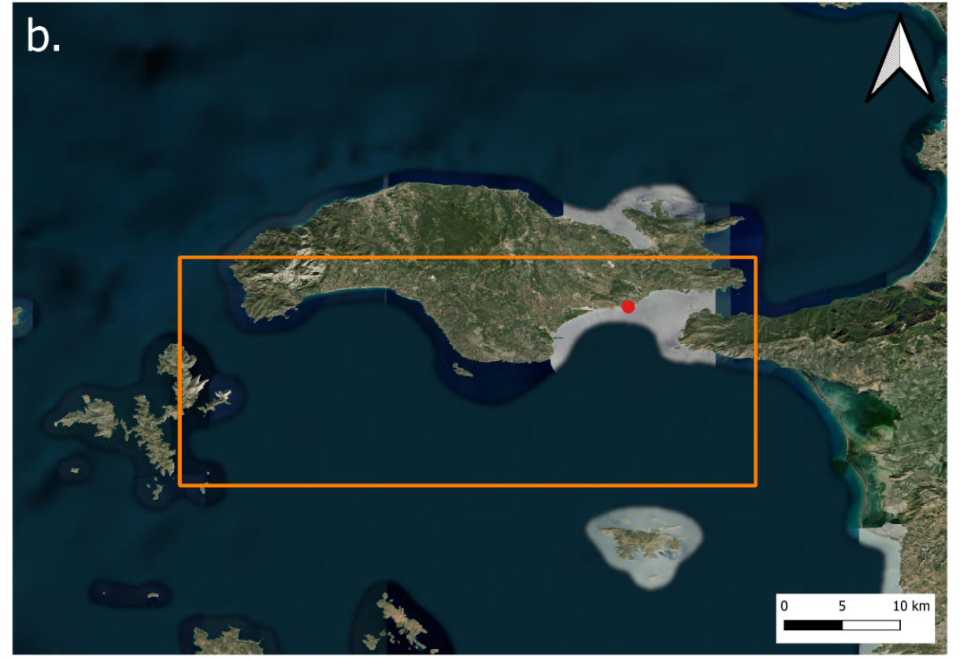
Figure 3. Maps of the study area. (a) The orange box shows the location of the study area in the Mediterranean Sea and the red box shows the location in the Aegean Sea. (b) The 1,000 km² study area is shown inside the orange box. The red point locates the starting point of each survey, the port Marina of Pythagorio.

Resources and Equipment
Data was collected through boat surveys onboard a research vessel, the Aegean Explorer, provided by the Archipelagos Institute of Marine Conservation (Archipelagos Institute of Marine Conservation, 2011). The boat was a 21.74 m motorboat with two 450 hp engines (Archipelagos Institute of Marine Conservation, 2023). The crew consisted of six to ten trained observers, a supervisor, and a captain. Boat-based visual surveys were only carried out during daylight hours and under good weather conditions (Beaufort Sea State ≤ 3) for the crew’s safety and because sightings were harder to observe in harsher conditions (Wheeler and Wilkinson, 2004). A risk assessment was written and adhered to throughout the study.

Data Collection
Opportunistic vessel-based surveys were carried out within the study area in the summer and autumn of 2021 and 2022. During surveys, a PAMGuard Recorder Module was set to record the survey route and sightings' GPS coordinates (Gillespie et al., 2009). Throughout the surveys, the boat maintained a maximum speed of 7 knots to minimise the disturbance to dolphins. To spot them, the sea surface was continuously scanned, from the boat to the horizon using binoculars from all angles by three to four trained observers.

When a pod of Delphinus delphis or Tursiops truncatus was sighted, the boat decreased in speed and followed the pod until it was lost from view. During a sighting, vessel presence or absence (excluding the research vessel) was attained by scanning the sea surface from the boat to the horizon using binoculars. Behavioural data was collected by recording the pod using a SONY HDR-CX240 video camera. At the start of the video, the boat survey number, sighting number, date, time, and species, were clearly stated. The videos were narrated throughout, stating the behaviours exhibited using an ethogram (Elias et al., 2021; Table 1). Behaviour was collected using the focal group sampling method of noting the behaviour exhibited in at least 50% of the individuals (Mann, 2001). Table 1 below contains two behavioural states (diving and swimming) and six behavioural categories (feeding, porpoising, resting, sharking, socialising, and travelling) (Elias et al., 2021).

Table 1. Ethogram used in this study.
Behavioural States and Categories | Description
Diving | Dolphin dives in, no steadily directional movement – often occurs when feeding.
Swimming | Dolphin is swimming below 1m underwater, randomly at any speed. Categories occur while swimming.
Feeding | Dolphin is feeding close to the surface of the water; frequently moving in circles and diving in different directions; often indicated when birds are concentrated in an area.
Porpoising | Dolphin is travelling fast in repetitive abrupt lunges over the water surface with shallow submergences in between; rapid forward progress in dorsal position.
Resting | Dolphin is logging near or on the surface of the water.
Sharking | Dolphin is swimming just below the surface of the water with its dorsal fin above the waves; without rhythmic up-and-down movement; looks like a shark fin.
Socialising | Dolphins are in almost constant physical contact with each other, often displaying surface behaviours and no steadily directional movement.
Travelling | Dolphin is swimming in a consistent direction with regular surfacing intervals.
Source: Elias et al. (2021).

Data Analysis
After the surveys, the sighting videos were analysed using BORIS (Behavioural Observation Research Interactive Software), a software that allows the analysis of observations from videos using an ethogram (Friard and Gamba, 2016). Using BORIS, the total duration of each state and category was obtained and a time budget analysis was produced for each sighting (Friard and Gamba, 2016). The marine traffic and behavioural data from each sighting were later entered into an excel document.

Using QGIS version 3.34.0-Prizren, a map was created to show the distribution of D. delphis and T. truncatus pods recorded during the surveys (QGIS.org, 2024). To analyse the frequency of each behavioural category with and without marine traffic, each sighting was categorised into individual datasets by species, year, and season. Seasons were calculated using the equinox and solstice dates for each year (Time and Date AS, 2023). Within these datasets, the frequency of each behavioural category was indicated in percentage time per sighting alongside vessel presence or absence.

Firstly, the D. delphis summer 2021 dataset was analysed using R Studio version 2023.09.1+494.pro2 (RStudio Team, 2020). The percentage of time per sighting spent diving without marine traffic was tested for normality using the Shapiro-Wilk statistical test (Shapiro and Wilk, 1965). This was repeated for the percentage of time spent diving with marine traffic. If the results for both variables were normally distributed, a Bartlett test was conducted to test for homogeneity of variances (Arsham et al., 2011). If the results showed that both sets were normally distributed, a parametric Welch Two Sample T-test was conducted to compare both variables to understand whether there was a significant difference in the percentage of time diving with or without marine traffic (Lu and Yuan, 2010). If the results of the Shapiro-Wilk or Bartlett tests did not meet the assumptions of normality or homogeneity, a non-parametric Wilcoxon Rank-Sum test was conducted to compare both variables to understand similarly whether there was a significant difference in the percentage time diving with or without marine traffic (Wilcoxon, 1945). This method of statistical analysis was repeated for each behavioural category and each dataset. Boxplot graphs were designed to visualise the impact of marine traffic on behaviour by plotting the relative frequencies of each observed category and its relation to vessel presence or absence.

Results
In total, Delphinus delphis was sighted 124 times (Figure 4); 49% was in the presence of marine traffic, whilst 51% was in its absence (Table 2). Tursiops truncatus was sighted 42 times in total (Figure 3.1); 57% was with marine traffic, and 43% was without (Table 2).
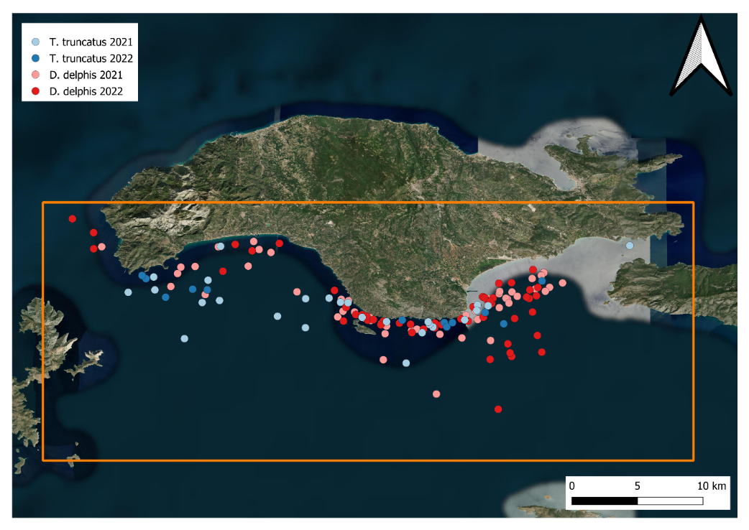
Figure 4. A map of the study area illustrating where sightings were recorded. The orange box shows the location of the study area. The light blue dots represent sightings of T. truncatus in 2021, dark blue dots represent T. truncatus sightings in 2022, pink dots represent D. delphis sightings in 2021 and red dots represent D. delphis sightings in 2022.

Table 2 below includes both species (Delphinus delphis and Tursiops truncatus) and the number of sightings recorded in the presence and absence of marine traffic during each season and year. MT = Marine Traffic.
Table 2. The number of sightings of each species recorded in the presence and absence of marine traffic.
Species | Dates | No. of sightings with MT | No. of sightings without MT
D. delphis | Summer 2021 | 20 | 17
 | Autumn 2021 | 15 | 17
 | Summer 2022 | 12 | 16
 | Autumn 2022 | 14 | 13
T. truncatus | Summer 2021 | 6 | 6
 | Autumn 2021 | 10 | 6
 | Summer 2022 | 4 | 3
 | Autumn 2022 | 4 | 3
Source: Authors.
When comparing the frequency of D. delphis and T. truncatus exhibiting each behaviour in the presence and absence of marine traffic, the results found that feeding and travelling were more prevalent in vessel presence, whilst diving, porpoising, sharking and socialising were more prevalent in vessel absence (Table 3). There was no significant difference in the percentage time D. delphis or T. truncatus spent resting with or without marine traffic (Table 3).

Table 3 includes all behavioural categories, the species (Delphinus delphis and Tursiops truncatus), and dates whereby a significant difference in behaviour in the presence and absence of marine traffic was calculated. W = Wilcoxon Rank-Sum test. t = Welch Two Sample T-test.

Table 3. A summary of the statistical analysis results of each behavioural category in the presence or absence of marine traffic.
Behaviours | Species | Dates | Statistical Results (prevalent in:)
Diving | D. delphis  T. truncatus | Summer 2021  Autumn 2022 | Absence (W = 96.5; p < 0.05)  Absence (W = 0; p < 0.05)
Feeding | T. truncatus  T. truncatus | Autumn 2021  Autumn 2022 | Presence (W = 52; p < 0.01)  Presence (W = 52; p < 0.05)
Porpoising | T. truncatus | Autumn 2021 | Absence (W = 15; p < 0.05)
Sharking | T. truncatus | Autumn 2021 | Absence (t_{5.04} = -2.04; p < 0.05)
Socialising | D. delphis | Summer 2022 | Presence (W = 133; p < 0.05)
Travelling | D. delphis  D. delphis | Summer 2021  Autumn 2022 | Presence (W = 234.5; p < 0.05)  Presence (W = 0; p < 0.05)
Source: Author.

Diving was found to be more prevalent without marine traffic in D. delphis in the summer of 2021 (Figure 5a); W = 96.5; p < 0.05) and in T. truncatus in the autumn of 2022 (Figure 5b; W = 0; p < 0.05). Conversely, there was no significant difference in the percentage time that D. delphis spent diving with or without marine traffic in autumn 2021 (t₂₆ = 0.43; p = 0.668), summer 2022 (W = 102; p = 0.798) and autumn 2022 (W = 88; p = 0.902; Figure 5a). Equally, there was no significant difference in the percentage time that T. truncatus spent diving with or without marine traffic in summer 2021 (t_{9.57} = 0.23; p = 0.823), autumn 2021 (W = 34; p = 0.704) and summer 2022 (t_{3.28} = 0.96; p = 0.401; Figure 5b).
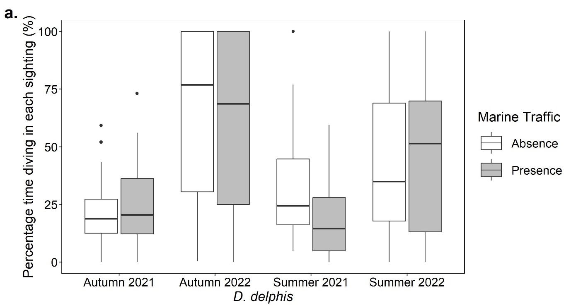
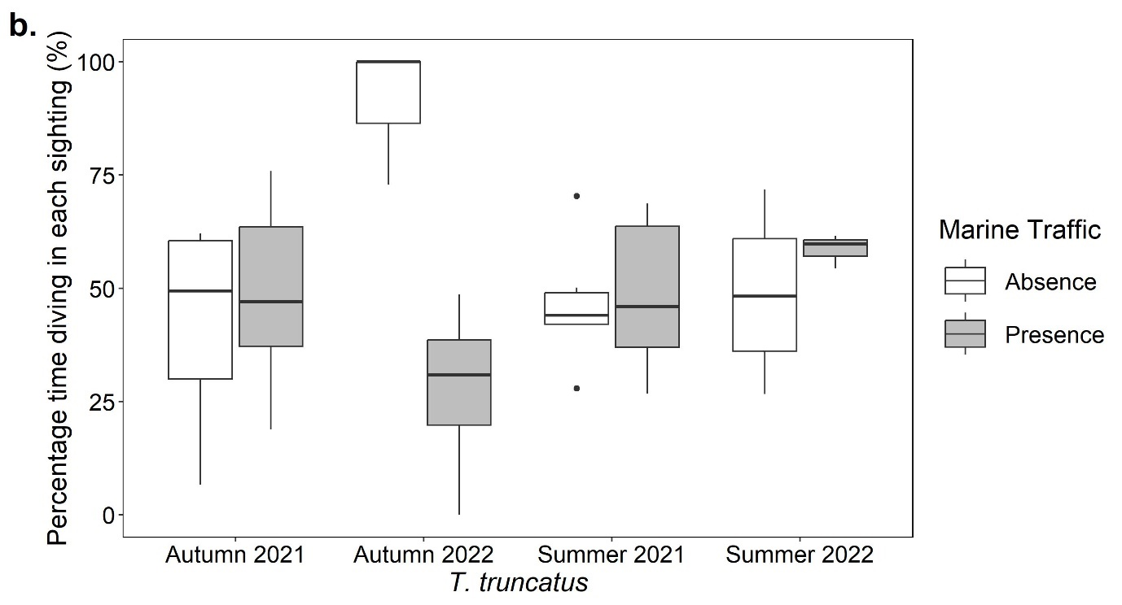Figure 5. Diving behaviour boxplots. Boxplots showing the percentage of observational time for each sighting (%) that (a) Delphinus delphis and (b) Tursiops truncatus exhibited diving behaviour in the presence and absence of marine traffic in the autumn of 2021 and 2022 and the summer of 2021 and 2022.
The percentage of time T. truncatus spent feeding in the autumn of 2021 (W = 52; p < 0.01) and autumn of 2022 (W = 52; p < 0.05; Figure 6b) were significantly higher with marine traffic. Inversely, there was no significant difference in the percentage time that T. truncatus spent feeding with or without marine traffic in the summer of 2021 (Figure 6b; W = 18; p = 1). Similarly, there was no significant difference in the percentage time that D. delphis spent feeding with or without marine traffic in summer 2021 (W = 142.5; p = 0.401), autumn 2021 (W = 152; p = 0.308), summer 2022 (W = 98.5; p = 0.914) and autumn 2022 (W = 78.5; p = 0.513; Figure 6a). There was no feeding behaviour in T. truncatus recorded in the summer of 2022.
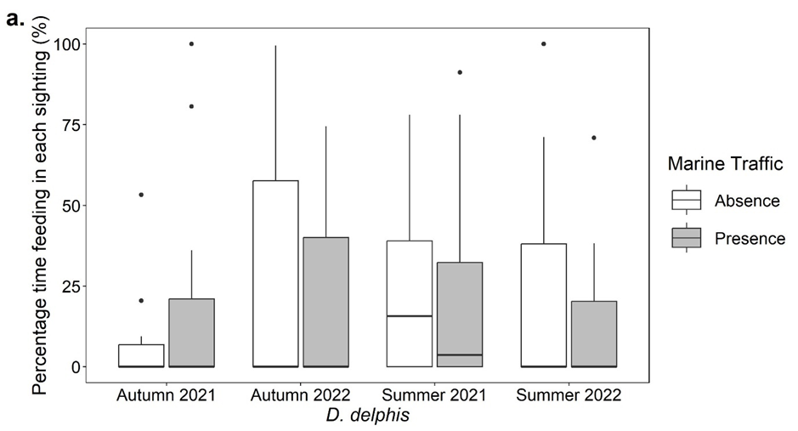
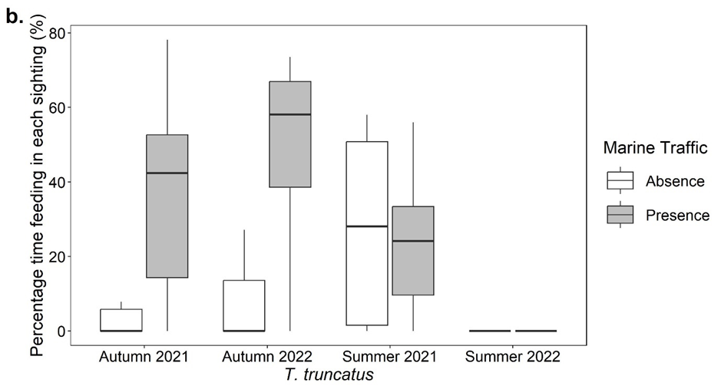
Figure 6. Feeding behaviour boxplots. Boxplots showing the percentage of observational time for each sighting (%) that (a) Delphinus delphis and (b) Tursiops truncatus exhibited feeding behaviour in the presence and absence of marine traffic in the autumn of 2021 and 2022 and the summer of 2021 and 2022.
Porpoising was found to be more prevalent without marine traffic in T. truncatus in the autumn of 2021 (Figure 7b; W = 15; p < 0.05). Inversely, there was no significant difference in the percentage time that D. delphis spent porpoising with or without marine traffic in summer 2021 (W = 177; p = 0.676), autumn 2021 (W = 107; p = 0.297) and autumn 2022 (W = 97.5; p = 0.375; Figure 7a). There was no porpoising behaviour in T. truncatus recorded in the summer of 2021, summer of 2022, and autumn of 2022 or in D. delphis in the summer of 2022.
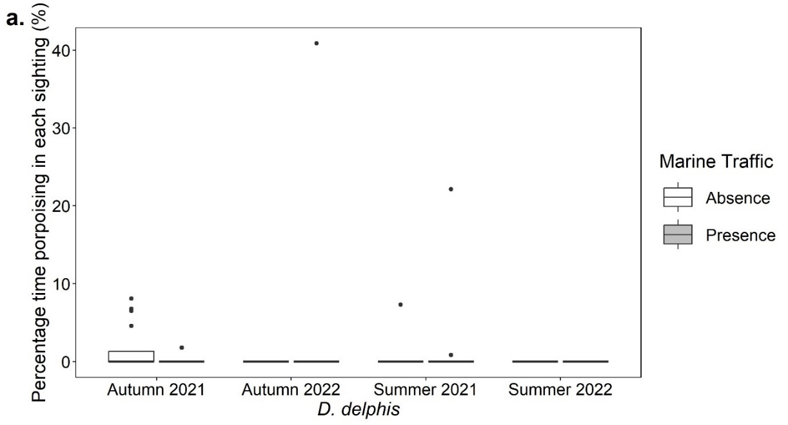
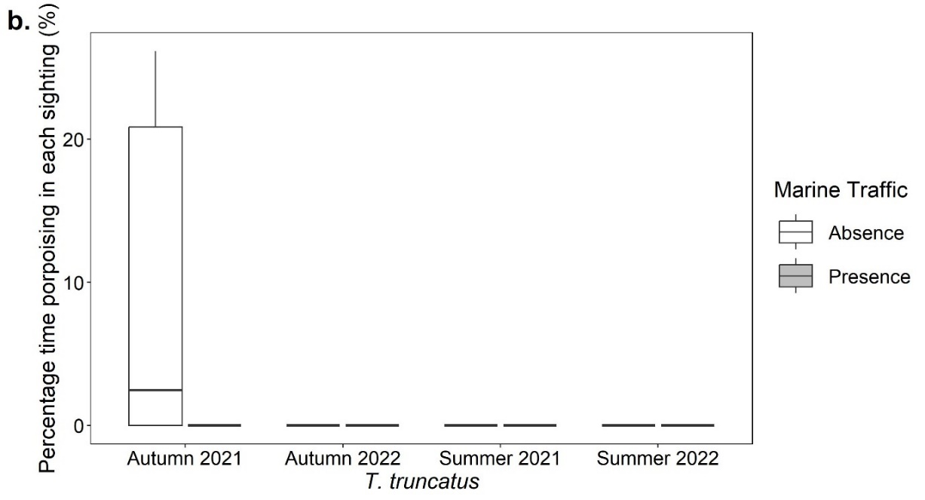
Figure 7. Porpoising behaviour boxplots. Boxplots showing the percentage of observational time for each sighting (%) that (a) Delphinus delphis and (b) Tursiops truncatus exhibited porpoising behaviour in the presence and absence of marine traffic in the autumn of 2021 and 2022 and the summer of 2021 and 2022.
There was no significant difference in the percentage time D. delphis spent resting with or without marine traffic in summer 2021 (W = 150; p = 0.129), autumn 2021 (W = 129.5; p = 0.922), summer 2022 (W = 104; p = 0.279) and autumn 2022 (W = 97.5; p = 0.374; Figure 8a). Equally, there was no significant difference in the percentage time that T. truncatus spent resting with or without marine traffic in the summer of 2021 (Figure 8b; W = 15; p = 0.405). There was no resting behaviour in T. truncatus recorded in the autumn of 2021, summer of 2022, or autumn of 2022.
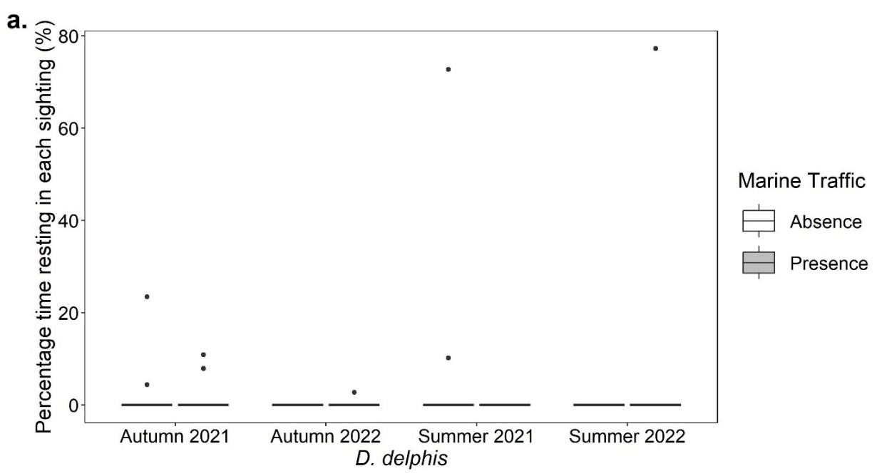
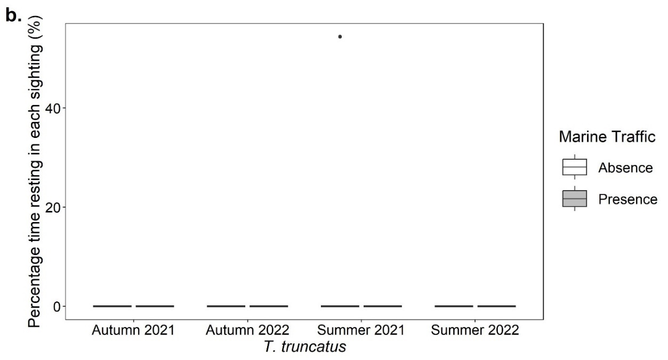
Figure 8. Resting behaviour boxplots. Boxplots showing the percentage of observational time for each sighting (%) that (a) Delphinus delphis and (b) Tursiops truncatus exhibited resting behaviour in the presence and absence of marine traffic in the autumn of 2021 and 2022 and the summer of 2021 and 2022.

Sharking was found to be more prevalent without marine traffic in T. truncatus in the autumn of 2021 (Figure 9b; t_{5.04} = -2.04; p < 0.05). Conversely, there was no significant difference in the percentage time that T. truncatus spent sharking with or without marine traffic in summer 2021 (W = 17.5; p = 1) and summer 2022 (W = 6; p = 1; Figure 9b). Equally, there was no significant difference in the percentage time that D. delphis spent sharking with or without marine traffic in summer 2021 (W = 170; p = 1), autumn 2021 (W = 103; p = 0.271), summer 2022 (W = 80; p = 0.344) and autumn 2022 (W = 93; p = 0.925; Figure 9a). There was no sharking behaviour in T. truncatus recorded in the autumn of 2022.
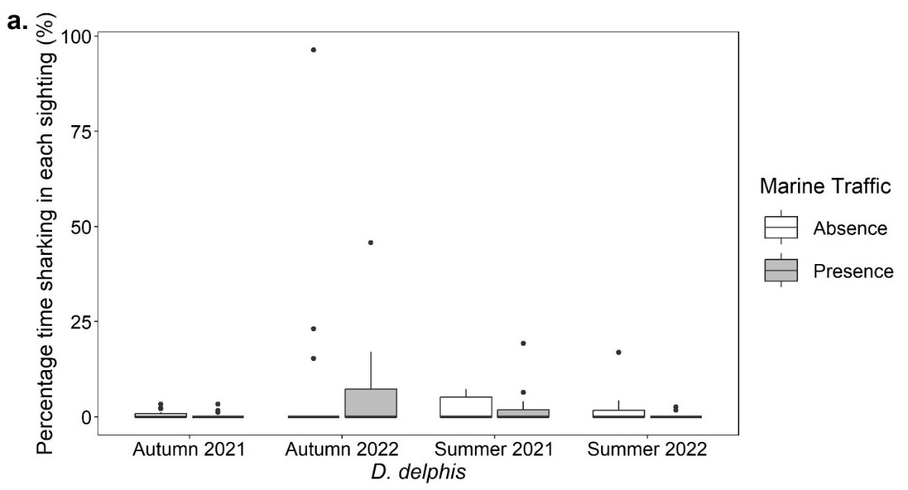
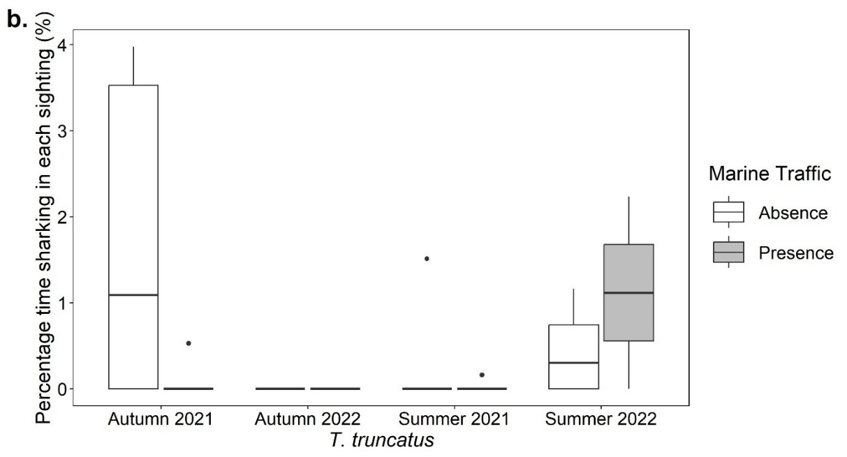
Figure 9. Sharking behaviour boxplots. Boxplots showing the percentage of observational time for each sighting (%) that (a) Delphinus delphis and (b) Tursiops truncatus exhibited sharking behaviour in the presence and absence of marine traffic in the autumn of 2021 and 2022 and the summer of 2021 and 2022.
The percentage of time D. delphis spent socialising in the summer of 2022 was significantly higher with marine traffic than in its absence (Figure 10a; W = 133; p < 0.05). Inversely, there was no significant difference in the percentage time that D. delphis spent socialising with or without marine traffic in summer 2021 (W = 197.5; p = 0.363), autumn 2021 (W = 96; p = 0.237), and autumn 2022 (W = 90; p = 0.969; Figure 10a). Similarly, there was no significant difference in the percentage time that T. truncatus spent socialising with or without marine traffic in summer 2021 (W = 21; p = 0.405), autumn 2021 (t_{5.02} = -1.21; p = 0.282) and summer 2022 (t_{3.34} = 1.09; p = 0.349; Figure 10b). There was no socialising behaviour in T. truncatus recorded in autumn 2022.
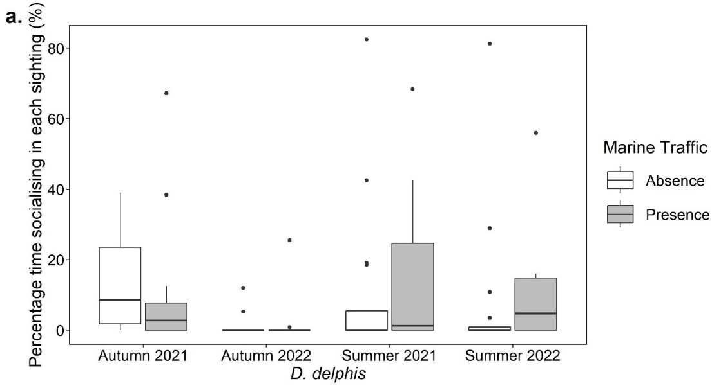
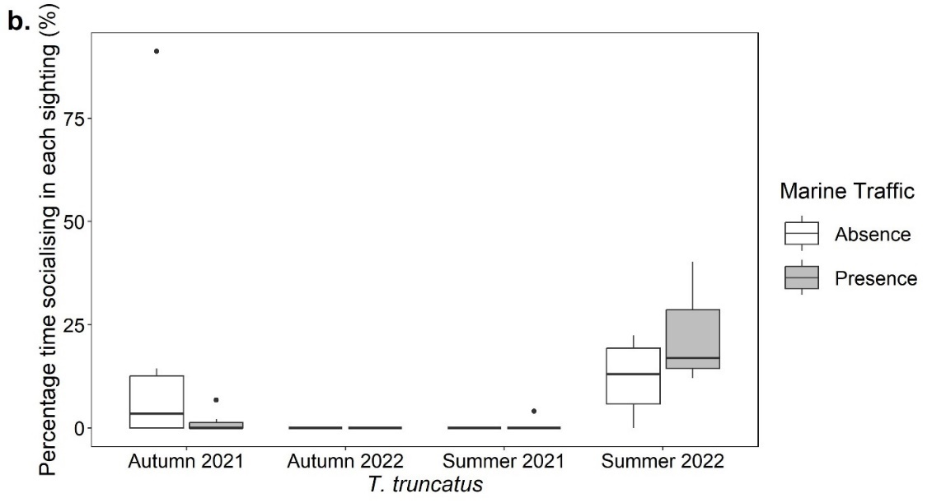
Figure 10. Socialising behaviour boxplots. Boxplots showing the percentage of observational time for each sighting (%) that (a) Delphinus delphis and (b) Tursiops truncatus exhibited socialising behaviour in the presence and absence of marine traffic in the autumn of 2021 and 2022 and the summer of 2021 and 2022.

Travelling was found to be more prevalent with marine traffic in D. delphis in the summer of 2021 (W = 234.5; p < 0.05) and the autumn of 2022 (W = 0; p < 0.05; Figure 11a). Inversely, there was no significant difference in the percentage time that D. delphis spent travelling with or without marine traffic in the autumn of 2021 (t₂₈ = -1.27; p = 0.215) and the summer of 2022 (W = 96; p = 1; Figure 11a). Similarly, there was no significant difference in the percentage time that T. truncatus spent travelling with or without marine traffic in summer 2021 (t_{9.98} = 0.77; p = 0.459), autumn 2021 (W = 28; p = 0.869), summer 2022 (t_{4.37} = -0.32; p = 0.767) and autumn 2022 (W = 7.5; p = 0.564; Figure 11b).
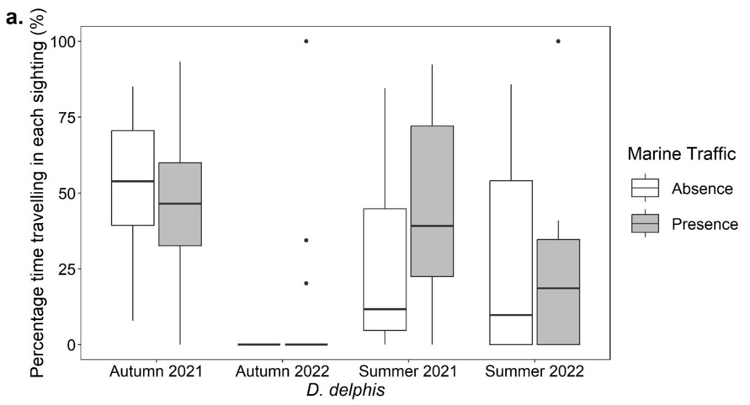
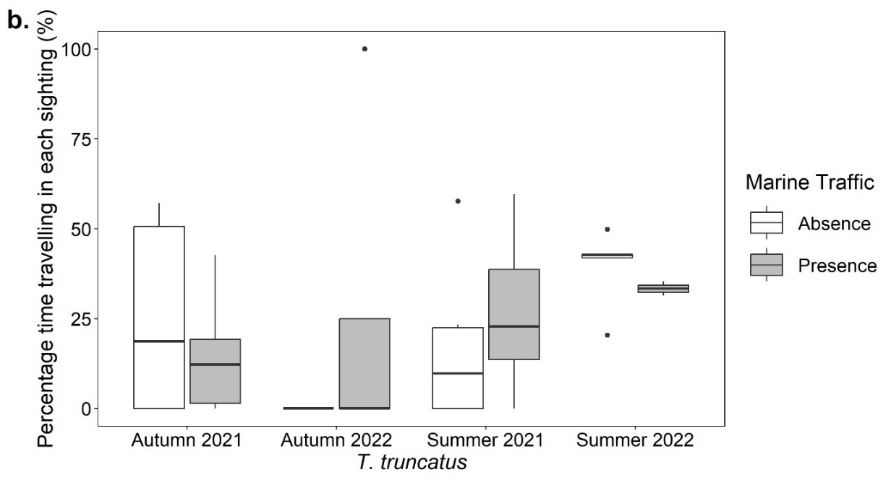
Figure 11. Travelling behaviour boxplots. Boxplots showing the percentage of observational time for each sighting (%) that (a) Delphinus delphis and (b) Tursiops truncatus exhibited travelling behaviour in the presence and absence of marine traffic in the autumn of 2021 and 2022 and the summer of 2021 and 2022.

Discussion

Project Goals and Major Findings
This study analysed the impacts of vessel presence on the behaviour of both Delphinus delphis and Tursiops truncatus in the eastern Aegean Sea. This was achieved through a time budget analysis of the behaviour of both species in the presence and absence of vessels. When comparing the percentage frequency of time that D. delphis and T. truncatus exhibited each behaviour, with and without marine traffic, the results found that feeding, socialising, and travelling were more prevalent in vessel presence, whilst diving, porpoising and sharking were the opposite. While some of these results support the alternative hypotheses (porpoising, sharking, and travelling), others did not (diving, feeding, and socialising). Additionally, it was found that the activity budgets of both species were affected by the presence of marine traffic. However, vessel presence or absence did not affect the resting behaviour of either species. Furthermore, the results support the alternative hypothesis that both species exhibited different changes in behaviour during vessel presence and absence.

Interpretations
The results of this study support the alternative hypothesis that both species will exhibit changes in diving behaviour in the presence or absence of marine traffic. The results also support the null hypothesis that both species will exhibit the same changes in behaviour. However, the results do not support the alternative hypothesis that diving will be more prevalent in the presence of marine traffic. In line with the results of this research, dolphins are well known for interacting with vessels, therefore there may have been instances where the dolphins were surfacing to investigate the research vessel but as it was not a trawler or tourist vessel providing food, so they lost interest and proceeded to dive, increasing the frequency of diving in vessel absence (Neumann and Orams, 2006; Miller et al., 2008; Papale et al., 2011). The significant results of diving behaviour from this study contradict the claims of Lusseau (2006) who found that the diving behaviour in T. truncatus becomes more frequent and erratic in the presence of vessels (Lusseau, 2006).
The findings do not support the alternative hypotheses that both species will exhibit changes in feeding behaviour in the presence or absence of marine traffic or that feeding will be more prevalent in the absence of marine traffic. However, the results do support the alternative hypothesis that changes in behaviour will be different in both species. Similar to the results of this research, Hawkins and Garside (2009) alongside Papale et al. (2011) observed an increase in feeding behaviour in T. truncatus with fishing and tourist vessels (Papale et al., 2011). This is explained by dolphins actively pursuing and feeding off the by-catch or bait expelled from these vessels (Miller et al., 2008; Papale et al., 2011). Trawling vessels present in this study during the autumn period may have been fishing for T. truncatus prey species which could explain why T. trancatus feeding behaviour significantly increased when vessels where present in the autumn. D. delphis feeding behaviour however remained unchanged, suggesting they had little interest in feeding on vessel bycatch. The statistically significant results of this study contradict the claim by Inch et al. (2018) that with an increase in vessels, there is a higher potential for disruption in feeding activities (Inch et al., 2018). Neumann and Orams (2006) alongside Miller et al. (2008) found that high-speed vessels and close vessel proximity to dolphins cause a decrease in feeding behaviour (Neumann and Orams, 2006; Miller et al., 2008).
The outcomes of this study do not support the alternative hypothesis that both species will exhibit changes in porpoising behaviour in the presence or absence of marine traffic. However, they do support the alternative hypotheses that changes in behaviour will be different in both species and that porpoising will be more prevalent in the absence of marine traffic. Au and Weihs (1980) alongside Au et al. (1988) found that porpoising is used as a more energetically advantageous method of swimming longer distances underwater (Au and Weihs, 1980; Au et al., 1988). It may be that porpoising behaviour decreases in vessel presence as dolphins are known for changing their natural behaviours to investigate vessels therefore, suppressing porpoising behaviour (Hawkins and Gartside, 2009; New et al., 2013).Differing to the hypothesis and results, Hawkins and Garside (2009) found that porpoising behaviour increased in vessel presence which could be due to the reduction in the energetic costs of bow-riding in the slipstream of a vessel (Hawkins and Gartside, 2009).
The findings of this study support the null hypothesis that neither species will exhibit changes in resting behaviour in the presence or absence of marine traffic. The results do not support the alternative hypothesis that resting will be more prevalent in the absence of marine traffic. The results relating to the resting behaviour from this study contradict the claims of Lusseau (2006) that during resting, dolphins descend deeper into the water column when interacting with an intrusive vessel which could be linked to an avoidance of boat noise. Constantine et al. (2004) and Lusseau (2006) also found that surface-resting behaviour decreases as marine traffic increases (Lusseau, 2006). As resting behaviour usually occurs nocturnally and includes bottom and swim-resting, it was difficult to identify all forms of resting from the vessel-based surveys. Therefore, this may explain why there is limited resting behavioural data in this study as only surface-resting was recorded (Gnone et al., 2001; Sekiguchi and Kohshima, 2003).
This study’s results do not support the alternative hypothesis that both species will exhibit changes in sharking behaviour in the presence or absence of marine traffic. However, they do support the alternative hypotheses that changes in behaviour will be different in both species and that sharking will be more prevalent in the absence of marine traffic. Contrary to the hypothesis and results, de Boer (2004) found that sharking behaviour is often related to feeding when close to trawlers (de Boer, 2004). Ritter (2002) and Heithaus and Dill (2009) both state that sharking can occur when dolphins are calm, this could explain why more sharking behaviour was seen in the absence of vessels; especially as New et al. (2013) states that close vessel proximity can induce fear in dolphins. Statistically significant changes in porpoising and sharking behaviour were found only in T. truncatus potentially because they are larger and stronger than D. delphis, so they have more energy to pursue the vessels for longer. Neumann and Orams (2006) also observed that D. delphis are less likely to be disturbed by vessel presence (Neumann and Orams, 2006).
The findings do not support the alternative hypotheses that both species will exhibit changes in socialising behaviour in the presence or absence of marine traffic and that socialising will be more prevalent in the absence of marine traffic. However, the results do support the alternative hypothesis that changes in behaviour will be different in both species. In line with the results and hypothesis, Pennino et al. (2016) concluded that socialising can be a behavioural response to vessels related to engine noise and physical vessel presence (Pennino et al., 2016). Similarly, it was found that vessel propeller noise can create a masking effect that reduces the potential for dolphin vocalisations as it is no longer an effective means to communicate (Saintignan et al., 2017; Hawkins and Gartside, 2009). The significant socialising results of this study contradict the claims of Papale et al. (2011) that fast boats cause an interruption of all activities and reduce the frequency of socialising behaviour as this study found socialising behaviour to significantly increase for D. delphis during summer 2022. It is suggested that this result also contradicts New et al. (2013) who stated that socialising is a positive and playful interaction between dolphins which can be suppressed when they feel fear or stress, as it is assumed that the dolphins would be more stressed in the presence of marine traffic.
Moreover, the results of this study do not support the alternative hypotheses that both species will exhibit changes in travelling behaviour in the presence or absence of marine traffic. However, the results do support the alternative hypothesis that changes in behaviour will be different in both species and that travelling will be more prevalent in the presence of marine traffic. Opposing to the hypothesis and results, Constantine et al. (2004) and Miller et al. (2008) discovered that travelling behaviour increases with vessels that they perceive to be a threat (Constantine et al., 2004; Miller et al., 2008). Additionally, New et al. (2013) found that dolphins will automatically switch their activity to travelling if they experience fear caused by close vessel proximity (New et al., 2013). Travelling behaviour in D. delphis may be more affected by vessel presence as they are more curious than T. truncatus therefore, they might be more likely to surface to inspect vessels and then travel away when disturbed by them, increasing the frequency of travelling in vessel presence.

Implications
This study found that feeding increases in the presence of vessels, which may be due to the bycatch from fishing vessels and the bait from tourist boats. With an increase in bycatch and bait, dolphins may begin to decrease natural hunting behaviours and acclimatise to receiving food easily from vessels. Additionally, consuming large amounts of bycatch may have knock-on effects on the ecosystem as dolphins are keystone species; they are vital to maintain ecological balance within the food web, without which trophic cascades could be triggered. An increase in close vessel encounters may increase the frequency of injuries by vessel propellers or fishing gear which can be fatal. Furthermore, dolphins may be negatively impacted by engine noise at such close range. A decrease in dolphin populations would have a large impact on the surrounding ecosystem as dolphins play key roles in nutrient cycling, maintaining habitat health and biodiversity (Amb Prasad, 2024).
It was found that the day-time resting behaviour was not affected by the presence of vessels. This could imply that dolphins are already becoming acclimatised to vessel presence. On one hand, these results illustrate that dolphins do not show signs of stress in the presence of vessels and could therefore coexist with them. However, this does not necessarily mean that a further increase in marine traffic will have a similar effect on dolphin behaviour, with increases in marine traffic come increased risks to cetacean health (Pennino et al., 2017).
An increase in travelling behaviour in the presence of vessels is a cause for concern as dolphins expend more energy travelling. Increased marine traffic may have significant consequences on dolphins’ energetic budgets as they experience more stress and avoid areas of high vessel intensity. Therefore, less energy remains for foraging and reproduction, leading to a decrease in these populations which are already endangered or vulnerable (Lusseau, 2006; Miller et al., 2008).

Limitations and Recommendations
It is important to consider that analysing the effect of marine traffic can involve limitations, given that cetaceans spend most of their time underwater so some of their behavioural reactions will have been elusive to the observer. Furthermore, this study could only evaluate the summer and autumn seasons of 2021 and 2022 because it was restricted by the weather and sea state. These dates included dolphin mating and breeding seasons, which may have impacted their normal behaviour (Blasi et al., 2020). This also led to a limited sample size which may have affected the reliability of the results. The sample size differed between species as T. truncatus tended to be found in deeper areas that were further away from the starting point of each survey, most of the survey effort was focused in shallower areas, where D. delphis sightings were more common, whilst travelling to the T. truncatus common areas. Therefore, the D. delphis data may be more reliable as it has a larger sample size. There was occasional difficulty distinguishing between behaviours occurring further away and around other vessels, thus the behavioural budget analysis for these behaviours may be less accurate. Inter-observer variability must also be taken into consideration.
Additionally, as feeding and resting behaviours often occur nocturnally, this study is not a complete reflection of how vessels impact these behaviours. Moreover, as this research was vessel-based, the absence of marine traffic data still included the research vessel, and dolphins did exhibit curiosity towards it. Therefore, this may have affected the validity of the results, yet impacts of marine traffic were successfully detected. Lastly, the impact that vessel type, intensity, speed, or distance has on the behaviour of dolphins cannot be concluded from this study. However, the short-term impacts of marine traffic presence on the behaviour of D. delphis and T. truncatus in the eastern Aegean Sea were successfully identified.
Further research could collect additional data over a longer period and wider study area to achieve more accurate results. This study found that the impacts on both species are different therefore they should be further observed independently. Additional research could consider ethogram events, which can provide a further understanding of how other types of behaviours are impacted by vessels. Future studies could also examine the effects of varying vessel types, speeds, and distances on the behaviour of cetaceans. Research on the short-term impacts of vessels is needed to mediate any potential long-term effects, such as reduced health, and viability of cetacean populations. Some research has been done on how to help dolphins predict the behaviour of research vessels, using acoustic cues (Lusseau, 2006). Implementing this strategy to all marine vessels could help to minimise the impact of marine traffic on these populations and can help human marine activities co-exist with minimal harm to cetaceans.

Conclusion
This study aimed to advance knowledge and understanding of the short-term impacts of vessel presence on the behaviour of Delphinus delphis and Tursiops truncatus in the eastern Aegean Sea using a quantitative activity budget analysis of the behaviour of both species in the presence and absence of marine traffic. The results found that feeding, socialising, and travelling were more prevalent in vessel presence, whilst diving, porpoising and sharking were the opposite. However, vessel presence or absence did not affect the resting behaviour of either species. Additionally, the results found that both species exhibited different changes in behaviour in the presence of vessels and across different seasons and years. This study concludes that increased travelling and stress behaviours alongside an increased dependency on bycatch and bait expelled from vessels could have significant consequences on the health, physical fitness, energetic budget, and reproductive output of D. delphis and T. truncatus populations. A further increase in marine traffic could have detrimental impacts on cetacean populations.
Some of the limitations of this study include the limited sample size, difficulty distinguishing between certain behaviours, and vessel-based data collection. These should be taken into consideration surrounding the reliability and validity of the results. Further research could collect additional data over a longer period and wider study area to further increase the available data in this area. Additionally, future research could examine the effects of varying vessel types, speeds, and distances on the behaviour of cetaceans.
This study has addressed a gap in knowledge by increasing the available data on the short-term impacts of marine traffic on dolphins in the eastern Aegean Sea. As there is limited available information regarding how sharking and porpoising behaviours are impacted by marine traffic, this research provides some understanding of this. The results of this study can help to design and develop conservation measures to aid the preservation of global cetacean populations.

Acknowledgements
I am extremely grateful to (i) my supervisor, Dr. Michelle Taylor (University of Essex), for providing guidance and feedback throughout this research project, (ii) Dr. Eoin O’Gorman, for his help regarding statistical analyses, (iii) the Archipelagos Institute of Marine Conservation, who allowed me to use their facilities for research and their data from the past few years, (iv) the Archipelagos interns who helped with collecting the data, (v) my placement supervisor at the Archipelagos Institute, Beatriz Tintore, whose knowledge, and expertise inspired me to write this research, (vi) my classmates at the university of Essex and during my internship, for their help and support, (vii) my boyfriend for his endless emotional and moral support, and (viii) my parents and siblings for their editing help, encouragement, and unconditional support.

References
Alaska Sea Grant (2013). Marine mammal adaptations | Marine education. Available at: https://seagrant.uaf.edu/marine-ed/mm/fieldguide/adaptations.html [Accessed: 16 Feb. 2024].
Amb Prasad, D. (2024). Marine mammals and their role in maintaining oceanic ecosystem. Unified Visions, 1, pp.288–295. https://doi.org/10.25215/819818984X.31
Archipelagos Institute of Marine Conservation (2011). Home - Archipelagos. Available at: https://archipelago.gr/ [Accessed: 7 Oct. 2023].
Archipelagos Institute of Marine Conservation (2023). Facilities & technology - Archipelagos. Available at: https://archipelago.gr/facilities-technology/ [Accessed: 7 Oct. 2023].
Arsham, H. and Lovric, M. (2011). Bartlett’s Test. In: Lovric, M. (eds) International Encyclopedia of Statistical Science. Berlin, Heidelberg: Springer. https://doi.org/10.1007/978-3-642-04898-2_132
Au, D., Scott, M.D. and Perryman, W.L. (1988). Leap-swim behavior of ‘porpoising’dolphins. Cetus, 8(1), pp.7-10. https://swfsc-publications.fisheries.noaa.gov/publications/CR/1988/8807.PDF
Au, D. and Weihs, D. (1980). At high speeds dolphins save energy by leaping. Nature, 284(5756), pp.548-550. https://doi.org/10.1038/284548a0
Beurteaux, D. (2017). Some dolphins are bad divers. Hakai Magazine. Available at: https://hakaimagazine.com/news/some-dolphins-are-bad-divers/ [Accessed: 15 Feb. 2024].
Blasi, M.F., Bruno, C. and Boitani, L. (2020). Female reproductive output in a Mediterranean bottlenose dolphin Tursiops truncatus population. Aquatic Biology, 29, pp.123–136. https://doi.org/10.3354/ab00732
Bonizzoni, S., Gramolini, R., Furey, N.B. and Bearzi, G. (2023). Bottlenose dolphin distribution in a Mediterranean area exposed to intensive trawling. Marine Environmental Research, 188, p.105993. https://doi.org/10.1016/j.marenvres.2023.105993
Chirosca, A.M. and Rusu, L. (2020). Marine traffic on Mediterranean Seas and its divisions. Mechanical Testing and Diagnosis, 9(4), pp.12–18. https://doi.org/10.35219/mtd.2019.4.02
Constantine, R., Brunton, D.H. and Dennis, T. (2004). Dolphin-watching tour boats change bottlenose dolphin (Tursiops truncatus) behaviour. Biological Conservation, 117(3), pp.299–307. doi:10.1016/j.biocon.2003.12.009. https://doi.org/10.1016/j.biocon.2003.12.009
de Boer, M.N., Kieth, S. and Simmonds, M.P. (2004). Cetaceans and Pelagic Trawl fisheries in the Western approaches of the English Channel. The Report of the 2004 WDCS/GREENPEACE Winter Survey. Whale and Dolphin Conservation Society Science Report. Available at: https://www.nauta-rcs.it/resources/Docs/greenpeace_report.pdf [Accessed: 2 Mar. 2024].
Elias, N., Gimenez, L., Field, N. and Lohrengel, K. (2021). An ethogram for the bottlenose dolphin (Tursiops truncatus) population in Cardigan Bay (Masters’ dissertation). Bangor University in collaboration with Sea Watch Foundation. Available at: https://www.seawatchfoundation.org.uk/wp-content/uploads/2022/12/Noor-Elias-MSc-Thesis.pdf
Friard, O. and Gamba, M. (2016). BORIS: a free, versatile open-source event-logging software for video/audio coding and live observations. Methods in Ecology and Evolution, 7(11), pp.1325–1330. https://doi.org/10.1111/2041-210X.12584
Gillespie, D., Mellinger, D.K., Gordon, J., McLaren, D., Redmond, P., McHugh, R., Trinder, P., Deng, X.Y. and Thode, A. (2009). PAMGUARD: Semiautomated, open source software for real‐time acoustic detection and localization of cetaceans. The Journal of the Acoustical Society of America, 125(4_Supplement), pp.2547-2547. https://doi.org/10.1121/1.4808713
Gnone, G., Benoldi, C., Bonsignori, B. and Fognani, P. (2001). Observations of rest behviours in captive bottlenose dolphins (Tursiops truncatus). Aquatic Mammals, 27(1), pp.29-33. Available at: https://www.aquaticmammalsjournal.org/wp-content/uploads/2009/12/27-01_Gnone.pdf
Hawkins, E.R. and Gartside, D.F. (2009). Interactive behaviours of Bottlenose dolphins (Tursiops aduncus) during encounters with vessels. Aquatic Mammals, 35(2), pp.259–268. https://doi.org/10.1578/am.35.2.2009.259
Heithaus, M.R. and Dill, L.M. (2009). Feeding strategies and tactics. Encyclopedia of Marine Mammals (Second Edition), pp.414–423. https://doi.org/10.1016/b978-0-12-373553-9.00099-7
Husic, C. (2021). Photo 158954338: Common dolphin (Delphinus delphis). iNaturalist. Available at: https://www.inaturalist.org/observations/95726738 [Accessed: 13 Mar. 2024].
Inch, K.M., Pietroluongo, G. and Hepburn, L.J. (2018). Population abundance, distribution, and socioeconomic analysis of Delphinus delphis and Tursiops truncatus in relation to vessel presence in the Eastern Aegean Sea. Journal of Marine Biology & Oceanography, 7(2), pp.1–17. https://doi.org/10.4172/2324-8661.1000190
Lu, Z. and Yuan, K. (2010). Welch's t test. In N. J. Salkind (Ed.), Encyclopedia of research design (pp.1620-1623). Thousand Oaks, CA: Sage.
Lusseau, D. (2006). The Short-term behavioral reactions of bottlenose dolphins to interactions with boats in doubtful sound, New Zealand. Marine Mammal Science, 22(4), pp.802–818. https://doi.org/10.1111/j.1748-7692.2006.00052.x
Lusseau, D., Schneider, K., Boisseau, O.J., Haase, P., Slooten, E. and Dawson, S.M. (2003). The bottlenose dolphin community of doubtful sound features a large proportion of long-lasting associations. Behavioral Ecology and Sociobiology, 54(4), pp.396–405. https://doi.org/10.1007/s00265-003-0651-y
Lyamin, O., Manger, P., Ridgway, S., Mukhametov, L. and Siegel, J. (2008). Cetacean sleep: An unusual form of mammalian sleep. Neuroscience & Biobehavioral Reviews, 32(8), pp.1451–1484. https://doi.org/10.1016/j.neubiorev.2008.05.023
Mann, J., Connor, R.C., Tyack, P.L., Whitehead, H. and Weinrich, M.T. (2001). Cetacean societies: Field studies of dolphins and whales. The Journal of Wildlife Management, 65(2), p.366. https://doi.org/10.2307/3802917
Miller, L.J., Solangi, M. and Kuczaj, S.A. (2008). Immediate response of Atlantic bottlenose dolphins to high-speed personal watercraft in the Mississippi Sound. Journal of the Marine Biological Association of the United Kingdom, 88(6), pp.1139–1143. https://doi.org/10.1017/s0025315408000908
Mussi, B., Vivaldi, C., Zucchini, A., Miragliuolo, A. and Pace, D.S. (2019). The decline of short‐beaked common dolphin (Delphinus delphis) in the waters off the Island of Ischia (Gulf of Naples, Italy). Aquatic Conservation: Marine and Freshwater Ecosystems, 31(S1), pp.87–100. https://doi.org/10.1002/aqc.3061
Neri, A., Sartor, P., Voliani, A., Mancusi, C. and Marsili, L. (2022). Diet of bottlenose dolphin, Tursiops truncatus (Montagu, 1821), in the Northwestern Mediterranean Sea. Diversity, 15(1), p.21. https://doi.org/10.3390/d15010021
Neumann, D.R. and Orams, M.B. (2006). Impacts of ecotourism on short-beaked common dolphins (Delphinus delphis) in Mercury Bay, New Zealand. Aquatic Mammals, 32(1), pp.1–9. https://doi.org/10.1578/am.32.1.2006.1
New, L.F., Harwood, J., Thomas, L., Donovan, C., Clark, J.S., Hastie, G., Thompson, P.M., Cheney, B., Scott‐Hayward, L. and Lusseau, D. (2013). Modelling the biological significance of behavioural change in coastal bottlenose dolphins in response to disturbance. Functional Ecology, 27(2), pp.314–322. https://doi.org/10.1111/1365-2435.12052
Papale, E., Azzolin, M. and Giacoma, C. (2011). Vessel traffic affects bottlenose dolphin (Tursiops truncatus) behaviour in waters surrounding Lampedusa Island, south Italy. Journal of the Marine Biological Association of the United Kingdom, 92(8), pp.1877–1885. https://doi.org/10.1017/s002531541100083x
Pennino, M.G., Arcangeli, A., Prado Fonseca, V., Campana, I., Pierce, G.J., Rotta, A. and Bellido, J.M. (2017). A spatially explicit risk assessment approach: Cetaceans and marine traffic in the Pelagos Sanctuary (Mediterranean Sea). PLOS ONE, 12(6), p.e0179686. https://doi.org/10.1371/journal.pone.0179686
Pennino, M.G., Pérez Roda, M.A., Pierce, G.J. and Rotta, A. (2016). Effects of vessel traffic on relative abundance and behaviour of cetaceans: the case of the bottlenose dolphins in the Archipelago de La Maddalena, north-western Mediterranean Sea. Hydrobiologia, 776(1), pp.237–248. https://doi.org/10.1007/s10750-016-2756-0
Ponganis, P. (2015). 1. Diving behavior. Diving physiology of marine mammals and seabirds. Cambridge University Press. pp. 1–21. https://doi.org/10.1017/cbo9781139045490.002. ISBN 9781139045490
QGIS.org. (2024). QGIS Geographic Information System. QGIS Association. Available at: http://www.qgis.org
Ritter, F. (2002). Behavioural observations of rough-toothed dolphins (Steno bredanensis) off La Gomera, Canary Islands (1995-2000), with special reference to their interactions with humans. Aquatic Mammals, 28(1), pp.46–59.
RStudio Team (2020). RStudio: Integrated development for R. RStudio, PBC. Boston, MA. Available at: http://www.rstudio.com/
Saintignan, S. and Archipelagos Institute of Marine Conservation (2017). Behaviour of Delphinus delphis and Tursiops truncatus around Samos Island. Archipelagos Institute of Marine Conservation. Available at: https://archipelago.gr/en/marine-mammals-july-2017/ [Accessed: 19 Sep. 2022].
Sekiguchi, Y. and Kohshima, S. (2003). Resting behaviors of captive bottlenose dolphins (Tursiops truncatus). Physiology & Behavior, 79(4-5), pp.643–653. https://doi.org/10.1016/s0031-9384(03)00119-7
Shapiro, S.S., and Wilk, M.B. (1965). An analysis of variance test for normality (complete samples). Biometrika, 52(3–4), pp.591–611. https://doi.org/10.1093/biomet/52.3-4.591
Time and Date AS (2023). Seasons in Samos – First day of Spring season. Available at: https://www.timeanddate.com/calendar/seasons.html?n=5206 [Accessed: 7 Oct. 2023].
Weihs, D. (2002). Dynamics of dolphin porpoising revisited. Integrative and Comparative Biology, 42(5), pp.1071–1078. https://doi.org/10.1093/icb/42.5.1071
Wells, R.S. and Scott, M.D. (2017). Lateral view of an adult common bottlenose dolphin, Tursiops truncatus, off Sarasota, Florida. Encyclopedia of Marine Mammals (Third Edition). Available at: https://www.sciencedirect.com/science/article/abs/pii/B9780128043271000728 [Accessed: 13 Mar. 2024].
Wells, R.S., Scott, M.D. and Irvine, A.B. (1987). The social structure of free-ranging bottlenose dolphins. In: Genoways, H.H. (eds) Current mammalogy. Springer, Boston, MA. pp.247–305. https://doi.org/10.1007/978-1-4757-9909-5_7
Wheeler, D. and Wilkinson, C. (2004). From calm to storm: The origins of the Beaufort Wind Scale. The Mariner’s Mirror, 90(2), pp.187–201. https://doi.org/10.1080/00253359.2004.10656896
Wilcoxon, F. (1945). Individual comparisons by ranking methods. Biometrics Bulletin, 1(6), 80–83. https://doi.org/10.2307/3001968
World Wide Fund For Nature (WWF) (2023). Maritime traffic. Available at: https://www.wwfmmi.org/medtrends/shifting_blue_economies/maritime_traffic/ [Accessed: 21 Sep. 2023].

Copyright Statement
© Danielle Alice Roth. This article is licensed under a Creative Commons Attribution 4.0 International Licence (CC BY).

