Research Article
Measuring the effectiveness of Smartphone apps on change in healthy diet consumptions in the UK: Mediating role of nutritional awareness and modification in lifestyle

Ziyu Ma, Yutong Feng, & Junkai Wang
University of Essex

Abstract
Despite food being crucial for health and survival, factors like busy lifestyles, low self-control, and unhealthy eating habits—along with inadequate exercise and high-calorie diets—can compromise well-being, underscoring the importance of consciously managing one’s consumption choices. The main aim of this study is to measure the effectiveness of smartphone apps on change in healthy dietary consumption in the UK to assess their importance. The researchers used a survey questionnaire to collect objective data from respondents and used SPSS for descriptive and inferential statistical analysis to answer the research questions. The results reveal that the aesthetics of health applications exert a significant positive impact on the healthy dietary consumption of users in the UK. However, the functionalities, social orientation, perceived ease of use, and perceived usefulness of the applications do not explain the variations in the dietary consumption behaviours which are the unexpected result of this research. Moreover, this study finds that nutritional awareness and lifestyle modifications due to usage of health apps positively affect the dietary consumption behaviours of users in the UK. This research suggests automation of food consumption apps, involvement of the experts and ease of use of the health apps to improve the experience of the users.
Keywords: smartphone apps, dietary health, nutritional awareness, modification in lifestyle
Date of Submission: 28.02.2024 Date of Acceptance: 18.12.2024

Introduction

Background to the Study
Food consumption plays a key role in promoting health and nutrition and is a basic need for human survival (Coughlin et al., 2015). However, people’s food choices are often negatively affected by factors such as busy lifestyles, low levels of self-control, and unhealthy eating habits (Koenigstorfer et al., 2014). In addition, lack of adequate physical exercise and excessive intake of high-calorie and high-fat foods also have adverse effects on health and physical fitness levels (Ferrara et al., 2019). Therefore, individuals need to effectively manage their diet and consumption behaviors and choose foods that contribute to health.

Although the potential of smartphone health apps in tracking users’ health indicators (such as pulse, calorie consumption, and physical activity) and providing information on the nutritional value of food has been widely recognized (Chen et al., 2015; Min et al., 2019), there is still a lack of research on how these apps practically affect users’ eating behaviors. Existing literature focuses on the technical functions and user experience of apps but lacks in-depth empirical analysis of their specific role in improving eating habits and promoting healthy lifestyles. In addition, research on how smartphone health apps can indirectly affect healthy eating behaviors by increasing nutrition awareness and lifestyle changes is still limited, especially in a social context like the UK, where technology acceptance is high, but obesity is a serious problem.

To fill this research gap, this study uses an empirical method to explore the impact of smartphone health apps on users’ healthy eating behaviors, considering the mediating role of nutrition awareness and lifestyle changes. Specifically, this study uses British citizens as the research population, a survey questionnaire to collect users’ attitudes and behavior data on the use of health apps and investigate the relationship between related variables through statistical analysis. By revealing the mechanism of action of health apps in promoting healthy eating behaviors, this study not only provides theoretical support for the development of more effective health apps, but also provides practical suggestions for policy makers and public health advocacy.

This study selected British citizens as the research subjects, mainly based on the following key reasons. First, the obesity rate in the UK has increased by 64% since 1993, reflecting the prevalence of unhealthy eating behaviors and the health problems caused by them among residents (HCL, 2023), which highlights the importance of the study. Second, as a developed country, the UK has a high degree of technology acceptance, with about 29% of residents using fitness apps and 17% using health apps related to nutrition and diet (Statista, 2023), providing an ideal sample group for the study. In addition, the multicultural composition of the UK makes the research results more representative, while national policy support and social attention to health and nutrition provide a good social background for the research. Finally, the high education level and literacy rate of British residents help them understand and effectively use smartphone health apps, making the research data more reliable and valuable for promotion. The above factors together lay the foundation for the rationality and significance of the UK as the research context.

Research indicates that, in the UK, the issue of being overweight is serious for people between the ages of 45 and 74 years (HCL, 2023), as shown in Figure 1. This means that many citizens would, in old age, become overweight adults due to limited participation in physical activity and the consumption of fatty and unhealthy foods (HCL, 2023). However, approximately 29% of citizens of the UK use fitness applications, while 20% use fitness trackers. Only 17% use health applications relating to nutrition, symptom checking, medication, and dietary recommendations (Statista, 2023). It is therefore important to study how smartphone applications are contributing to changing the food consumption and choices of foods by UK citizens.

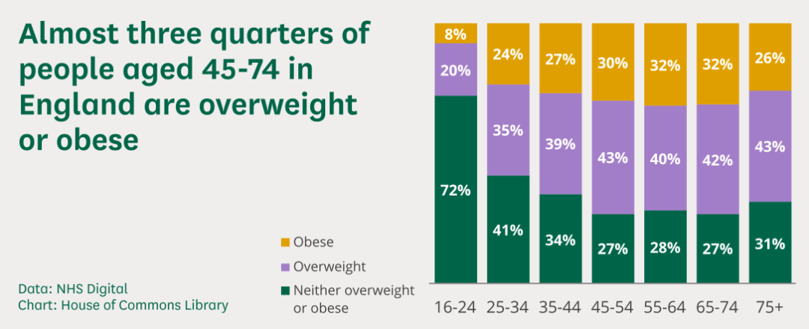
Figure 1. Obesity in the United Kingdom (House of Commons Library, 2023).

Problem Identification
Health issues such as diabetes, heart attack, hypertension, and kidney damage are increasing, necessitating the improvement of people’s awareness of food consumption and nutrition (Min et al., 2019). Several studies prove that the usage of smartphones for tracking people’s food consumption habits and physical activities enable them to choose their activities and select appropriate foods to maintain good health, thus eliminating the negative impacts of food consumption (Ferinella et al., 2014; Zhang et al., 2015; Ming et al., 2018). There is limited information and research on the mediating roles of the modification in lifestyle and nutritional awareness between smartphone applications and people adopting healthy diets (Ferinella et al., 2014; Zhang et al., 2015; Ming et al., 2018; Samad et al., 2022). Further, there is a research gap on this topic in the UK context, which encourages the researchers to conduct this study in this country alone. Therefore, this study seeks to establish whether UK citizens use smartphone-based health applications to obtain tips for nutrition and food diets.

Research Significance
Lack of awareness of the health effects of consuming unhealthy and fast foods has serious consequences in the form of the development of serious diseases (van Dillen et al., 2008). People rarely change their dietary patterns until they are made aware of how food consumption influences their health, and how to manage their diet. Changes in people’s food consumption and lifestyles are needed to improve the effectiveness of health advice and to prevent the development of disease (Banerjee et al., 2020). As per the findings from previous studies (Dennison et al., 2013), health tracking and diet management applications on smartphones provide facts and data about fitness and the impact of food consumption on the human body, which provide advice and records of physical activities, exercises, and other factors.

Therefore, this study supports the understanding of the importance of mobile applications in increasing people’s awareness of health and diet and the need to change dietary habits. It helps by measuring the contribution of mobile applications to the changing of consumer habits and the improvement of health concerns. The study generates results that can be interpreted and generalised for the promotion of healthy food consumption and physical activities among middle-aged people.

Literature Review

Concept of Health-related Smartphone Apps and their Features
Smartphone usage is growing year on year worldwide, meaning that acceptance of smartphones is high globally (Samad et al., 2022; Banerjee et al., 2020). These mobile phone applications are designed to track health and fitness support the management of people’s physical and mental health (Min et al., 2019). Some qualitative studies have been conducted on smartphone-based health applications and their features (Coughlin et al., 2015). Smartphone applications related to health and diet include features such as tracking of physical activity, after-food activity, exercise, running, and pulse rate (Chen et al., 2015). Peng et al. (2016) contend that social competition fulfils consumers’ health needs by identifying instant sources of help and suggestions for fitness activities and healthy dietary consumption. Also, lack of time and lack of necessity for people to use health apps may reduce their continued usage of them (Venkatesh et al., 2012).

Theoretical Foundations
Behaviour change theory holds that three important factors are used for investigating individuals’ behaviours (Edwards et al., 2016). These are: beliefs about behaviour, social norms, and beliefs about the ability of individuals to perform a behaviour (Weston et al., 2020). Behavioural change occurs when someone faces a familiar situation, but they have to change their behaviour and undertake sudden action. There are accepted beliefs about the behaviours of individuals and how much pressure they are able to experience and tolerate; social norms are associated with larger cultural groups, and their rules have implications for consumer preferences and their choices. The third important issue is control factors in terms of ease or difficulty in performing behaviours, with various ones having implications for behaviours and consumption habits (Weston et al., 2020). This study uses this theory to predict changes in health consumption behaviour in the UK which is a dependent variable of the study. It finds how people use smartphone applications to obtain and evaluate information about their health and nutrition. Thus, the main hypothesis of the study is:
H1: Smartphone health apps have a significant impact on the UK users’ healthy dietary consumption behaviours.

In addition, health belief model was developed by social scientists in 1950 to comprehend the failure of efforts to encourage people to adopt disease prevention strategies. This model is derived from psychological and behavioural theory and includes two components of health-related behaviours: the desire to avoid illness and beliefs about specific health actions to prevent illness. Dennison et al. (2013) conclude that clinicians and academics have an interest in harnessing smartphone applications as tools for the collection and dissemination of information on health-related behavioural intentions. This study identifies and describes the features, opportunities, and challenges of using these applications, although it has some limitations. Therefore, the current study applies quantitative research to determine the impact of health applications on the dietary consumption behaviours of UK citizens.

Conceptual Framework

Aesthetics
Samad et al. (2022) contend that an application’s visual appeal is the key factor of its success and in maximising user engagement. Food consumption tracking and food recommendation applications featuring good layout, design, and presentation are likely to improve users’ satisfaction levels. Along with this, the design and gamification of mobile applications increases people’s motivation and engagement to use them (Samad et al., 2022). Thus, this study develops and assesses a hypothesis related to the effect of aesthetic application on consumers’ engagement and people’s changing food consumption behaviours.
H1a: The aesthetics of a smartphone health application has a significant impact on the UK users’ healthy dietary consumption behaviours.

Functionality
The food consumption tracking feature of an application is very important because it acts as an alert signal, rendering users cautious about health issues and undertaking more physical activities in order to burn calories and consume low-calorie and non-fatty foods (Nayak et al., 2020). Apps which identify the foods consumed by users help by estimating nutritional needs and recommending foods for a better-balanced diet (Stancu et al., 2022). Similarly, flexibility in menu recommendation and nutrition have implications for the usage and engagement of users of an application (Peters et al., 2018). The applications cannot track food consumption without accurate details being provided by users (Samad et al., 2022). Further, Banerjee et al. (2019) assert that calorie-counting apps provide information regarding weight which support the assessment and monitoring of weight and calories by changing diets and tracking health measures. This study assesses and describes the effectiveness of calory counting apps in effecting behavioural change and weight management.

There is little research involving UK consumers and how the functionality of health-based smartphone applications influences them. Therefore, this research project addresses this gap and evaluates the relationship between functionality and healthy diet consumption behaviours.
H1b: The functionality of smartphone health applications has a significant impact on the UK users’ healthy dietary consumption behaviours.

Socially-oriented Features
Stancu et al. (2022) assert that people have years to improve their social networks, and the social connectedness feature of applications exerts an influence on them. Thus, this confirms the hypothesis on the relationship between social functionality or orientation of an application and dietary consumption behaviours of users in the UK (Stancu et al., 2022). This improves the uniqueness of this research study and provides insights for smartphone application developers to create this feature and improve the performance of applications. Hence, the hypothesis will be:
H1c: The social orientation of smartphone health applications has a significant impact on the UK users’ healthy dietary consumption behaviours.

Perceived Ease of Use
The usability of smartphone applications is an important factor in influencing users’ interest in them (Liu et al., 2021). This is because people appreciate an application which can be used with little effort and with high convenience. Yan (2021) explains that the positive impact of PEoU on consumers’ healthy dietary consumption behaviours and user satisfaction with an application mediates the relationship between variables. A health application's easy-to-use features also increase people's interest in using it (Liu et al., 2021). Thus, this study develops and tests the hypothesis of how perceived ease of use of smartphone-based health applications increases people's interest in using them, and how they influence their healthy diet patterns and behaviours.
H1d: Perceived ease of use of smartphone health applications has a significant impact on the UK users’ healthy dietary consumption behaviours.

Perceived Usefulness
The perceived usefulness of health apps may be related to data sharing options, fitness suggestions, social networking, and other factors which improve the user experience of food recommendation and fitness and health tracking apps (Min et al., 2018). Data export and sharing options are key features which enable users to gain a full insight into these health and tracking applications. Consumers’ trust levels change their perception of the usage of these health-based applications; research focusing on fitness and health applications on smartphones explores their education-related features which provide tutorials and meet people’s needs in terms of competence development (Samad et al., 2022). Therefore, this study simulates and tests the impact of the perceived usefulness of smartphone applications on the healthy dietary consumption behaviours of UK consumers and/or users.
H1e: The perceived usefulness of smartphone health applications has a significant impact on the UK users’ healthy dietary consumption behaviours.

Smartphones and Nutritional Awareness
Coughlin et al. (2016) conclude that the rapid advancement of technologies encourages the usage of smartphone health applications for the promotion of health promotion research. Smartphone applications are low-cost interventions which are likely to be useful for the improvement of health, dietary consumption, and nutrition to manage weight and obesity in the general population (Coughlin et al., 2016). Therefore, this research study has been designed to measure the role of smartphone-based health applications in influencing the consumption behaviours and role of nutritional awareness among users of United Kingdom.
H2: Smartphone health apps have a significant impact on the nutritional awareness of UK users.

Research Related to Health Application Features and their Impact on Lifestyle Change
According to David et al. (2023), the mobile health interventions affect the behaviour of the user and influence the lifestyle of the consumers. The findings from the survey of respondents in this study revealed that the health tracking application such as blood pressure monitoring, text message, and other physical strength monitoring features of the applications cause significant change in the behaviour of consumer (David et al., 2023).Therefore, the researchers in this study have designed the research to focus on the impact of the health application features on lifestyle of the application users in United Kingdom. Further, Holmen et al (2014) explained that self-management and health regulations are crucial for people to be healthy and fit. Thus, the current study evaluates the effect of mobile health application features on the behaviour and lifestyle change of users in UK. The hypothesis will be:
H3: Smartphone health apps have a significant impact on modifications in the lifestyles of UK users.

Impact of Nutritional Awareness and Modifications on Lifestyles and Consumption Behaviours
Van Dillen (2008) contends that people’s awareness of nutritional values influences their choice of foods. Worsley (2000) argues that people’s nutritional awareness potentially positively changes their attitudes towards the consumption of different foods. This point is supported by Spronk et al. (2014), who describe women as being more health-conscious and knowing more about nutrition and foods which affect their health; this increases their likelihood of consuming nutritious foods compared to men. Parmenter et al. (2000) argue that nutritional awareness affects people’s eating behaviours. Food intakes are improved through nutritional awareness because knowledge of the health effects, nutrition, and calories of food intakes helps people to ensure that they consume only healthy foods (Parmenter et al., 2000). Therefore, the current research study focuses on determining the association of nutritional awareness provided by health apps with the healthy dietary consumption of users in the UK. The hypotheses will be:
H4: People’s nutritional awareness has a positive impact on UK users’ healthy dietary consumption behaviours.
H5: Lifestyle modification has a positive influence on the healthy diet consumption behaviours of UK smart phone users.

Theoretical Model and Hypothesis
Behaviour change theory and health belief model are the foundation of this research. The theories convey that health-related behaviour can be changed with technology aesthetic and other features. Based on analysis, it is noted that literature discusses the smartphone health application concept and its features in order to determine its functioning and quality. Numerous studies contribute to the relevant body of literature defining the features of health-based smartphone apps, with several identifying and exploring their impact on people’s dietary consumption. Thus, this research study is designed and structured to review the opinions of UK citizens towards smartphone applications and the impact of usage of these apps on healthy lifestyle and healthy dietary consumption behaviours.

Nutrition is an important element of healthy diet consumption, and consumers’ nutritional awareness potentially changes app users’ behaviours. For this reason, the authors consider this to be the most important factor affecting the relationship between variables and evaluation of how nutritional awareness and lifestyle modifications mediate the impact of health apps on dietary consumption of users in the UK. Figure 2 below shows the conceptual framework of the study.

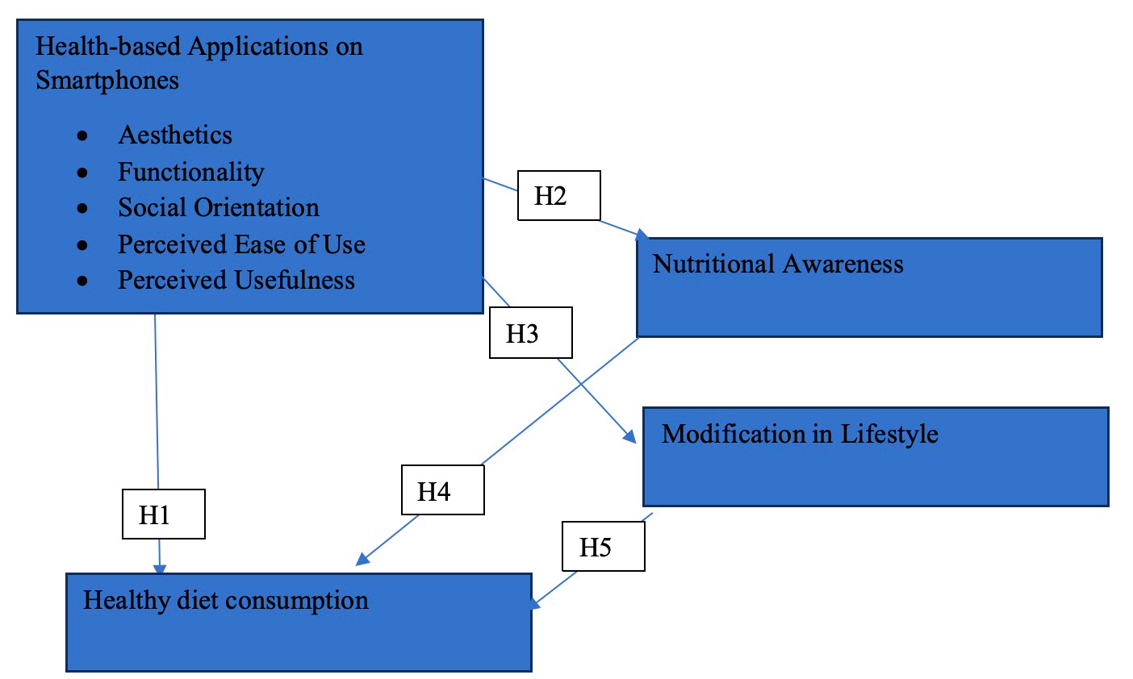
Figure 2. Conceptual Framework (Source: Authors).

The following hypotheses and theoretical models are developed, based on the research gap.
- H1: Smartphone health app has a significant impact on the UK users’ healthy dietary consumption behaviours
- H1a: The aesthetics of a smartphone health application has a significant impact on the UK users’ healthy dietary consumption behaviours
- H1b: The functionality of smartphone health applications has a significant impact on the UK users’ healthy dietary consumption behaviours
- H1c: The social orientation of smartphone health applications has a significant impact on the UK users’ healthy dietary consumption behaviours
- H1d: Perceived ease of use of smartphone health applications has a significant impact on the UK users’ healthy dietary consumption behaviours
- H1e: The perceived usefulness of smartphone health applications has a significant impact on the UK users’ healthy dietary consumption behaviours
- H2: Smartphone health apps have a significant impact on the nutritional awareness of UK users.
- H3: Smartphone health apps have a significant impact on modifications in the lifestyles of UK users.
- H4: People’s nutritional awareness has a positive impact on UK users’ healthy dietary consumption behaviours
- H5: Lifestyle modification has a positive influence on the healthy diet consumption behaviours of UK smart phone users.

Research Methodology

Research Philosophy
Taking the research objectives as a priority, the authors adopted positivism to determine and measure the relationship between smartphone apps and healthy dietary consumption in the UK. Positivist philosophy supports the determination and measurement of the hypothesis related to the impact of smartphone applications on changes in people's healthy dietary consumption behaviours in the UK. The researchers in this study thus used a positivist philosophy which supports the use of the scientific method of evaluating the dimensions of the smartphone applications for healthy consumption and their impact on consumers’ consumption behaviours.

Research Approach
The main objectives of this study relate to the impact of health-based smartphone applications on the consumption of healthy diets by consumers in the United Kingdom. There are implications for the choice of the research approach because two kinds of approaches are applied in research, i.e. the deductive and inductive approaches. In view of the purpose of the study, the authors applied a deductive approach to determine and evaluate the role of smartphone applications in changing the dietary consumption behaviour of buyers in the UK. Another important reason for the selection and use of the deductive approach is that it has an association with positivist philosophy, rendering research specific and supporting its generalisability (Elias, 2012).

Research Method
In view of the research objectives, the researcher contends that quantitative research is likely to support the determination and confirmation of previous theories regarding the effectiveness of smartphone applications in changing British citizens’ dietary consumption by creating nutritional awareness. Another important factor supporting the selection of this method is a deductive approach which requires objective data to process statistical and scientific methods for the evaluation and examination of the link between the variables (Matthews and Ross, 2010). In this way, the researcher asserts that quantitative research is helpful in validating how smartphone applications play an important role in changing consumer behaviour in the UK.

Data Collection
The authors used primary, rather than secondary, research to collect the data. Primary research is useful in identifying and obtaining fresh information. In contrast, secondary research enables the collection of ready-made data which improve the researcher's knowledge of the research topic and related aspects (Matthews and Ross, 2010). However, secondary data may not be applied in processing the data in statistical analysis for presenting evidence and validating previous theories (Bell et al., 2018). In view of the purpose of this study and its nature, the authors used primary research to provide new and fresh insight into the views of participants about health-based smartphone applications. The author used a survey questionnaire because this study focuses on quantitative research.

The authors used social media platforms to access the participants and conduct the survey, shared a link to Google Forms for the questionnaire with the participants via Facebook Messenger, which facilitated its easy distribution and return (Saunders and Lewis, 2012). All questionnaires were written in English, which the users of smartphone applications in the UK could easily understand. The authors appropriately followed up each participant after sharing the questionnaire with them, subsequently collecting the completed questionnaire within 17 days of the distribution date in order to expedite the research.

Sampling Process
In this study the researchers used a convenience sampling technique to recruit a sample of 145 users of health-based smartphone applications in the UK. Convenience sampling is non-probability sampling which enables a researcher to choose participants based on their fit to the purpose of a study (Saunders and Lewis, 2017). On the other hand, random sampling allows researchers to choose the participants quickly without full discussion of the sampling units (Saunders and Lewis, 2012).
The researchers used a cross-sectional time horizon to determine the impact of health-based smartphone applications on users in the UK. Lack of time and budget for the research process influenced the decision to avoid usage of the longitudinal research horizon (Saunders and Lewis, 2017). Therefore, this study includes different variables to determine the impact of smartphone applications, and to compare the impact of the dimensions of applications on the buying behaviours and dietary consumption of users in the UK.

Data Analysis
The authors used the Statistical Package for the Social Sciences (SPSS) analysis software for assessing the objective data gathered through the survey of the users of smartphone applications in the UK (Saunders and Lewis, 2017). Different methods included regression analysis, correlation analysis, descriptive statistics, normality test, reliability test, demographic analysis, and others (Saunders and Lewis, 2012). In summary, this study employed a positivist philosophy, deductive approach, explanatory design, quantitative research, survey questionnaire, convenience sampling method, SPSS data analysis, and cross-sectional time horizon in order to achieve the research purpose.

Potential Biases
This study was affected by potential bias and the answers provided by participants in the questionnaire might have been influenced by subjective judgment and deviated from the actual situation. For example, participants might have exaggerated the role of health apps in changing eating behaviors, improving nutrition awareness, and improving lifestyles, or underestimated the influence of other factors (such as social orientation or functionality). To reduce bias, future studies should combine behavioral data of health apps (such as login records, frequency of function use) and objective indicators (such as nutrition knowledge tests or third-party observations) for verification.

Results and Findings
This section of the research paper discusses the analysis of survey data collected from 119 participants to investigate the effectiveness of smartphone apps on changes in healthy dietary consumption in the UK. The data are analysed using SPSS software, which employs various statistical methods including reliability analysis, analysis of variance (ANOVA), and regression analysis, to examine the relationships between variables.

Reliability Analysis
A pilot study was conducted to check whether the items included under different constructs were reliable or not. To ensure the reliability of the questionnaire, 20 responses were collected and analysed. The Cronbach’s alpha score for all constructs was found to be above 0.70 (as shown in Table 1), indicating the questionnaire’s high reliability. This suggests that it was suitable for conducting a thorough investigation into the research topic.

Table 1. Reliability and validity.
Scale | Number of Items | Reliability (Cronbach Alpha)
Aesthetics | 3 | 0.935
Functionality | 4 | 0.905
Social orientation | 3 | 0.834
Perceived ease of use | 4 | 0.907
Perceived usefulness | 5 | 0.916
Nutritional awareness | 16 | 0.973
Modification in lifestyle | 2 | 0.969
Healthy diet consumption | 5 | 0.902
(Source: Authors)

Demographic Information on Participants
Table 2 shows the distribution of gender among the 119 participants. Of the total participants, 54 (45.4%) are male and 65 (54.6%) are female.

Table 2. Gender.
 |  |  | - Gender
 |  | Frequency | Percentage | Valid Percentage | Cumulative percentage
Valid | Male | 54 | 45.4 | 45.4 | 45.4
 | Female | 65 | 65 | 54.6 | 54.6
 | Total | 119 | 100.0 | 100.0
(Source: Authors)

Table 3 displays the distribution of participants across different age groups. Of the total 119 participants, 35 (29.4%) were between 18 and 25 years old, 33 (27.7%) were between 26 and 35 years old, 25 (21.0%) were between 36 and 45 years old, and 26 (21.8%) were between 46 and 55 years old.

Table 3. Age groups of participants.
 |  | - Age group
 |  | Frequency | Percentage | Valid percentage | Cumulative percentage
Valid | Between 28-25 years | 35 | 29.4 | 29.4 | 29.4
 | 26-35 years | 33 | 27.7 | 27.7 | 57.1
 | 36-45 years | 25 | 21.0 | 21.0 | 78.2
 | 46-55 | 26 | 21.8 | 21.8 | 100.0
 | Total | 119 | 100.0 | 100.0
(Source: Authors)
Table 4 shows that all 119 participants responded affirmatively, indicating that they have smartphone apps.

Table 4. Usage of smartphone apps.
- Do you have smartphone apps?
 |  | Frequency | Percentage | Valid percentage | Cumulative percentage
Valid | Yes | 119 | 100.0 | 100.0 | 100.0
(Source: Authors)

Table 5 indicates that all participants use health-related mobile phone apps.

Table 5. Usage of health-related mobile phone apps.
- Do you use health-related mobile phone apps?
 |  | Frequency | Percentage | Valid percentage | Cumulative percentage
Valid | Yes | 119 | 100.0 | 100.0 | 100.0
(Source: Authors)

Table 6 illustrates the duration of app usage among the 119 participants. Of the total participants, 19 (16.0%) had been using an app for one to three months, 20 (16.8%) for three to six months, 28 (23.5%) for six months to one year, and 52 (43.7%) for more than one year. It had been noticed that the majority of the participants have been using health-related apps for more than one year.

Table 6. Span of experience of using health apps.
- For how long have you been using this app?
 |  | Frequency | Percentage | Valid percentage | Cumulative percentage
Valid | 1 month to 3 months | 19 | 16.0 | 16.0 | 16.0
 | 3 months to 6 months | 20 | 16.8 | 16.8 | 32.8
 | 6 months to 1 year | 28 | 23.5 | 23.5 | 56.3
 | More than 1 year | 52 | 43.7 | 43.7 | 100.0
 | Total | 119 | 100.0 | 100.0
(Source: Authors)

Table 7 displays the responses of participants to the question: “Do you still use health-related mobile apps?” All 119 participants responded affirmatively, indicating that they still use health-related mobile apps.

Table 7. Continuity of using apps.
- Are you still using health-related mobile apps?
 |  | Frequency | Percentage | Valid percentage | Cumulative percentage
Valid | Yes | 119 | 100.0 | 100.0 | 100.0
(Source: Authors)

Table 8 indicates that the majority of participants had experienced an increase in their nutritional awareness since using the mobile application. Majority (70.6%) reported a large extent of increase, while 15.1% reported some extent of increase. However, 14.3% of participants reported little extent of increase. Overall, the findings suggest that a mobile application has the potential to positively impact nutritional awareness, although individual responses may vary.
Table 8. Awareness of nutrition.
- Do you feel that your awareness of nutrition has increased before and after using this mobile application?
 |  | Frequency | Percentage | Valid percentage | Cumulative percentage
Valid | To great extent | 63 | 52.9 | 52.9 | 52.9
 | To large extent | 21 | 17.6 | 17.6 | 70.6
 | To some extent | 18 | 15.1 | 15.1 | 85.7
 | To little extent | 17 | 14.3 | 14.3 | 100.0
 | Total | 119 | 100.0 | 100.0
(Source: Authors)

Table 9 shows that a significant proportion of participants experienced positive changes in their lifestyle after using a mobile application. 51.3% reported a large extent of change, indicating a notable impact. Additionally, 15.1% reported some extent of change, further highlighting the positive influence of an app. However, it is noteworthy that 21.8% of participants perceived no change in their lifestyle. Overall, the findings imply that a mobile application has the potential to positively influence and contribute to lifestyle changes, although individual responses do vary.

Table 9. Lifestyle change due to health-related mobile applications.
- Do you feel that before using and after using this mobile application your lifestyle has changed?
 |  | Frequency | Percentage | Valid percentage | Cumulative percentage
Valid | To a great extent | 46 | 38.7 | 38.7 | 38.7
 | To a large extent | 15 | 12.6 | 12.6 | 51.3
 | To some extent | 18 | 15.1 | 15.1 | 66.4
 | To a small extent | 14 | 11.8 | 11.8 | 78.2
 | To no extent | 26 | 21.8 | 21.8 | 100.0
 | Total | 119 | 100.0 | 100.0
(Source: Authors)

The data collected from the participants (Table 10) indicate that the most common cognitive-behavioural therapy techniques included in the app are goal setting, self-monitoring, feedback and reinforcement, boosting, and incentives.

Table 10. Following cognitive behavioural therapy for weight loss.
- Does the app include the following cognitive behavioural therapy measures for weight loss?
 |  | Frequency | Percentage | Valid percentage | Cumulative percentage
Valid | Goal setting | 31 | 26.1 | 26.1 | 26.1
 | Self-monitoring | 28 | 23.5 | 23.5 | 49.6
 | Feedback and reinforcement | 25 | 21.0 | 21.0 | 70.6
 | Boosting | 16 | 13.4 | 13.4 | 84.0
 | Incentives | 19 | 16.0 | 16.0 | 100
 | Total | 119 | 100.0 | 100.0
(Source: Authors)

Descriptive Statistics
The dataset contained information on nine variables associated with aesthetics, i.e.: functionality, social orientation, perceived ease of use, perceived usefulness, nutritional awareness, lifestyle modifications, healthy diet consumption, and health-related activities. The sample size for all variables was 119. The results (Table 11) indicate that lifestyle modification had the highest average score among all variables, with a mean of 4.0420. In contrast, health-related activities had the second-highest score, with a mean of 3.8319. However, it should be noted that descriptive statistics cannot be used to conclude an entire population. Hence, a regression analysis was undertaken in this section to analyse the health-related impact of healthy diet consumption.

Table 11. Descriptive Statistics.
 | N | Minimum | Maximum | Mean | Std. Deviation
 | Statistic | Statistic | Statistic | Statistic | Statistic
A | 119 | 1.00 | 5.00 | 3.8711 | .85162
F | 119 | 1.25 | 5.00 | 3.8025 | 67481
SO | 119 | 1.67 | 5.00 | 3.6947 | 70854
PEU | 119 | 2.25 | 5.00 | 3.7437 | .55945
PU | 119 | 2.00 | 5.00 | 3.7697 | .50733
NA | 119 | 1.94 | 4.88 | 3.7164 | .43771
MIL | 119 | 1.00 | 5.00 | 4.0420 | .76074
HRA | 119 | 1.00 | 5.00 | 3.8319 | .81114
HDC | 119 | 1.00 | 5.00 | 3.8538 | .75944
Valid N (listwise) | 119
(Source: Authors)

Histogram to Check Normality
The normality of the dependent variable used in the regression can be tested by histogram. It is clear from the figures below (Figures 3, 4 and 5) that healthy diet consumption, nutritional awareness, and lifestyle modification (respectively) were normally distributed because the histograms show a bell-shaped curve.

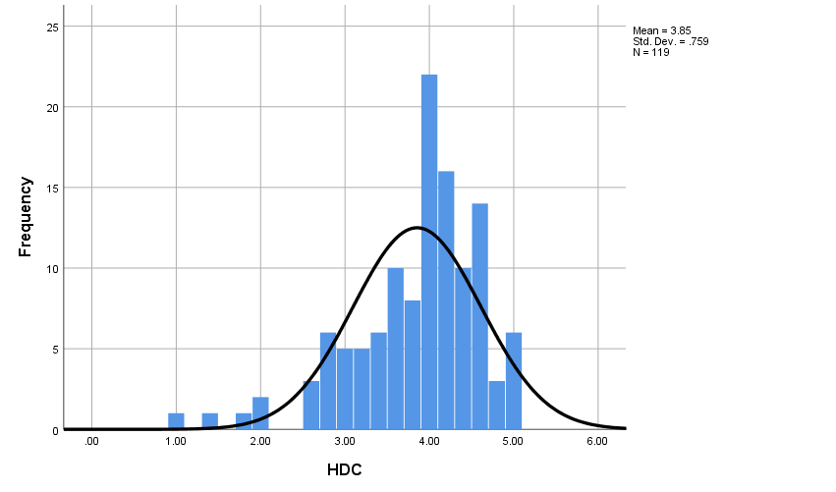
Figure 3. Histogram to check the normality of healthy diet consumption (Source: Authors).

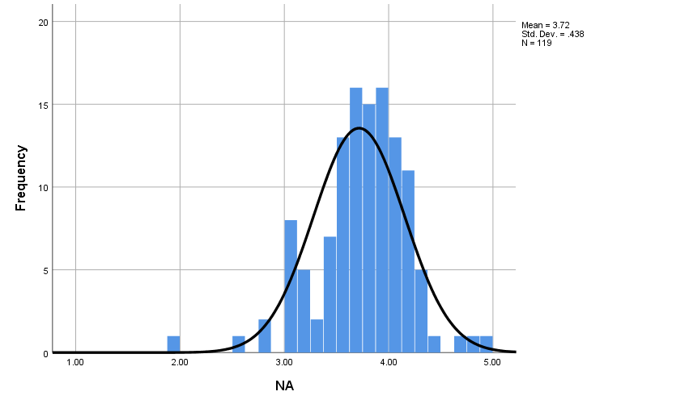
Figure 4. Histogram to check normality of nutritional awareness (Source: Authors).

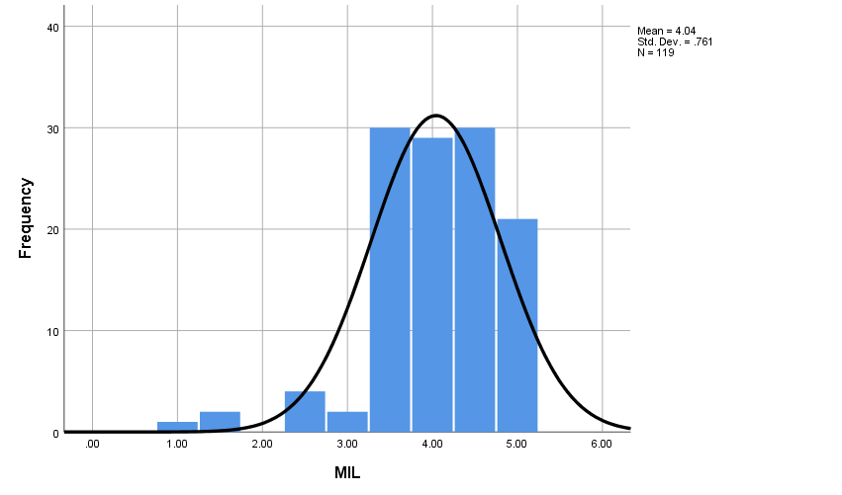
Figure 5. Histogram to check normality of modification in lifestyle (Source: Authors).

Regression Analysis

Impact of Smartphone Apps on Healthy Diet Consumption Behaviours

The first hypothesis (H1) states that smartphone health apps, aesthetics, functionality, social orientation, perceived ease of use, and perceived usefulness significantly impact the healthy dietary consumption behaviours of people in the UK. The model summary (Table 12) indicates that the predictors account for 34.3% of the healthy diet consumption behaviour variance. The adjusted R-square is 31.4%, suggesting a moderate fit of the model. The ANOVA results (Tabl3 13) show that the regression model is significant (p < .001), indicating that the predictors collectively significantly impact healthy dietary consumption behaviours.

Table 12. Model summary.
Model summary
Model | R | R Square | Adjusted R Square | Std. error of the estimate
1 | .586 | .343 | .314 | .67187
a. Predictors: (Constant), PU, A, SO, PEU, F
(Source: Authors)

Table 13. ANOVA test.
ANOVA
Model |  | Sum of Squares | df | Mean Square | F | Sig.
1 | Regression | 26.630 | 5 | 5.326 | 11.799 | .000^{b}
 | Residual | 51.009 | 113 | .451
 | Total | 77.639 | 118
a. Dependent variable: HRA
b. Predictors: (constant), PU, A, SO, PEU, F
(Source: Authors)

Table 14. Coefficients.
Coefficients
Model |  | Unstandardised coefficients |  | Standardised coefficients | t | Sig. | Collinearity statistics
 |  | B | Std. Error | Beta |  |  | Tolerance | VIF
1 | (Constant) | 2.405*** | .610 |  | 3.944 | .000
 | A | .617** | .197 | .648 | 3.125 | .002 | .135 | 7.384
 | F | .080 | .253 | .067 | .317 | .752 | .131 | 7.620
 | SO | .085 | .100 | .074 | .845 | .400 | .756 | 1.324
 | PEU | .078 | .144 | .054 | .541 | .589 | .593 | 1.687
 | PU | .13*** | .170 | .008 | .079 | .000 | .512 | 1.952
N |  | 119
adj. R² |  | .314
t statistics in parentheses * p < 0.10, ** p < 0.05, *** p < 0.01. (Source: Authors).

Examination of the coefficients (Table 14) demonstrates that aesthetics (A) exerts a positive and significant impact (p = .002). In contrast, functionality (F), social orientation (SO), perceived ease of use (PEU), and perceived usefulness (PU) exert non-significant impacts on healthy dietary consumption behaviours. Overall, the findings suggest that smartphone health apps and aesthetics play a significant role in influencing the healthy diet consumption behaviours of individuals in the UK.
H2: Smartphone health apps exert a significant impact on the nutritional awareness of people in the UK.

The Impact of Smartphone Health Apps on Nutritional Awareness

According to the regression analysis (Tables 15, 16, and 17), the use of smartphone health apps exerts a significant influence on the nutritional awareness of UK citizens. The study examines several predictors, including perceived ease of use, aesthetics, functionality, social orientation, and perceived usefulness. The predictors exert a moderate effect on the dependent variable, with an R-squared value of 0.485 (as shown in Table 15), indicating that smartphone health apps explain 48.5% of the variation in nutritional awareness. The coefficients (Table 17) indicate that perceived ease of use exerts the most significant and positive impact on nutritional awareness.

Table 15. Model summary.
Model summary
Model | R | R Square | Adjusted R Square | Std. error of the estimate
1 | .696ª | .485 | .462 | .32099
a. Predictors: (Constant), PU, A, SO, PEU, F
Source: Authors

Table 16. ANOVA.
ANOVA
Model |  | Sum of Squares | df | Mean Square | F | Sig.
1 | Regression | 10.965 | 5 | 2.193 | 21.284 | .000^{b}
 | Residual | 11.643 | 113 | .103
 | Total | 22.608 | 118
a. Dependent variable: NA
b. Predictors: (Constant), PU, A, SO, PEU, F
Source: Authors

Table 17. Coefficients.
Coefficients
Model |  | Unstandardised coefficients |  | Standardised coefficients | t | Sig. | Collinearity statistics
 |  | B | Std. Error | Beta |  |  | Tolerance | VIF
1 | (Constant) | .930** | .291 |  | 3.194 | .002
 | A | .160* | .094 | .312 | 1.700 | .092 | .135 | 7.384
 | F | .058 | .121 | .089 | .478 | .633 | .131 | 7.620
 | SO | .064 | .048 | .104 | 1.336 | .184 | .756 | 1.324
 | PEU | .308*** | .069 | .393 | 4.483 | .000 | .593 | 1.687
 | PU | .148* | .081 | .171 | 1.817 | .072 | .512 | 1.952
N |  | 119
adj. R² |  | .462
t statistics in parentheses* p < 0.10, ** p < 0.05, *** p < 0.01 (Source: Authors).

Impact of Smartphone Health Apps on Lifestyle Modifications

Based on the regression results (Tables 18, 19, and 20), it can be inferred that smartphone health apps significantly influence the lifestyle of UK citizens. The predictors examined in the study include perceived ease of use, aesthetics, functionality, social orientation, and perceived usefulness. These predictors collectively demonstrate a weak effect on the dependent variable, with an R-squared value of 0.207. This indicates that approximately 20.7% of the variation in lifestyle modification is attributable to the use of smartphone health apps.

Table 18. Model summary.
Model summary
Model | R | R Square | Adjusted R Square | Std. error of the estimate
1 | .455ª | .207 | .172 | .69212
a. Predictors: (Constant), PU, A, SO, PEU, F
Source: Authors

Table 19. ANOVA.
ANOVA
Model |  | Sum of Squares | df | Mean Square | F | Sig.
1 | Regression | 14.159 | 5 | 2.832 | 5.912 | .000^{b}
 | Residual | 54.130 | 113 | .479
 | Total | 68.290 | 118
a. Dependent variable: MIL
b. Predictors: (constant), PU, A, SO, PEU, F
Source: Authors

Table 20. Coefficients.
Coefficients
Model |  |  | Unstandardised coefficients |  | Standardised coefficients | t | Sig. | Collinearity statistics
 |  |  | B | Std. Error | Beta |  |  | Tolerance | VIF
1 | (Constant) |  | 1.451** | .628 |  | 2.310 | .023
 | A |  | -.162 | .203 | -.181 | -.795 | .428 | .135 | 7.384
 | F |  | .611** | .261 | .542 | 2.345 | .021 | .131 | 7.620
 | SO |  | -.091 | .103 | -.085 | -.879 | .381 | .756 | 1.324
 | PEU |  | .297** | .148 | .219 | 2.009 | .047 | .593 | 1.687
 | PU |  | .031 | .175 | .021 | .176 | .861 | .512 | 1.952
N |  | 119
adj. R² |  | .172
t statistics in parentheses. * p < 0.10, ** p < 0.05, *** p < 0.01 (Source: Authors).

Among the predictors, functionality appears to exert the strongest impact on lifestyle modification. The coefficient for functionality is 0.611, suggesting that a one-unit increase in functionality is associated with a 0.611-unit increase in lifestyle modification. This implies that individuals who perceive greater functionality in their health apps are more likely to make positive changes to their lifestyles. The report also highlights the fact that perceived ease of use significantly and positively influences lifestyle modification in the UK. However, the information does not provide further details about the specific coefficient and its interpretation. Overall, the findings suggest that smartphone health apps do effectively promote positive lifestyle changes in the UK, particularly when they are perceived as functional and easy to use.

Impact of Nutritional Awareness on Healthy Diet Consumption Behaviours

The findings suggest that people’s nutritional awareness exerts a positive impact on the healthy diet consumption behaviours of users in the UK. The predictor studied is nutritional awareness, which exerts a moderate effect on the dependent variable of healthy diet consumption, with an R-squared value of 0.247 (shown in Table 21). It can be inferred from the value of the R-square that a 24.7% variation in people’s healthy diet consumption can be explained by nutritional awareness. The coefficient for nutritional awareness is 0.863 (shown in Table 23), indicating that a one-unit increase in nutritional awareness is associated with a 0.863-unit increase in healthy dietary consumption behaviours. Overall, the report suggests that improving nutritional awareness is an effective strategy for the promotion of healthy diet consumption behaviours in the UK.

Table 21. Model summary.
Model summary
Model | R | R Square | Adjusted R Square | Std. error of the estimate
1 | .497ª | .247 | .241 | .66172
a. Predictors: (Constant), NA
Source: Authors

Table 22. ANOVA.
ANOVA
Model |  | Sum of Squares | df | Mean Square | F | Sig.
1 | Regression | 16.824 | 1 | 16.824 | 38.422 | .000^{b}
 | Residual | 51.232 | 117 | .438
 | Total | 68.056 | 118
a. Dependent variable: HDC
b. Predictors: (constant), NA
Source: Authors

Table 23. Coefficients.
Coefficients
Model |  | Unstandardised coefficients |  |  | Standardised coefficients | t | Sig. | Collinearity statistics
 |  | B |  | Std. Error | Beta |  |  | Tolerance | VIF
1 | (Constant) | .648 |  | .521 |  | 1.244 | .216
 | NA | .863*** |  | .139 | .497 | 6.199 | .000 | 1.000 | 1.000
N |  |  | 119
adj. R² |  |  | .241
t statistics in parentheses * p < 0.10, ** p < 0.05, *** p < 0.01 (Source: Authors)

4.6.5 Impact of Lifestyle Modification on Dietary Consumption Behaviours
Based on the findings of the simple linear regression analysis (shown in Tables 24, 25, and 26), it is concluded that lifestyle modifications positively impact the adoption of healthy dietary behaviours among users of apps in the UK. This implies that individuals who are likely to change their lifestyle are also more likely to engage in healthy dietary consumption behaviours. The predictor variable considered in the analysis is lifestyle modification, which demonstrates a weak effect on the dependent variable, with an R-squared value of 0.173. This indicates that approximately 17.3% of the healthy diet consumption behaviour variation can be attributed to lifestyle modifications. The coefficient for lifestyle modification is 0.415, suggesting that a one-unit increase in lifestyle modification is associated with a 0.415-unit increase in healthy dietary consumption behaviours. The report suggests that the promotion of positive lifestyle changes is an effective strategy for encouraging healthy eating habits in the UK.

Table 24. Model summary.
Model summary
Model | R | R Square | Adjusted R Square | Std. Error of the estimate
1 | .416ª | .173 | .166 | .69370
a. Predictors: (constant), MIL
Source: Authors
Table 25. ANOVA.
ANOVA
Model |  | Sum of Squares | df | Mean Square | F | Sig.
1 | Regression | 11.754 | 1 | 11.754 | 24.425 | .000^{b}
 | Residual | 56.302 | 117 | .481
 | Total | 68.056 | 118
a. Dependent variable: HDC
b. Predictors: (constant), MIL
Source: Authors

Table 26. Coefficients.
Coefficients
Model |  |  | Unstandardised coefficients |  | Standardised coefficients |  | t | Sig. | Collinearity statistics
 |  |  | B | Std. Error | Beta |  |  |  | Tolerance | VIF
1 | (constant) |  | 2.177*** | .345 |  | 6.306 |  | .000
 | MIL |  | .415*** | .084 | .416 | 4.942 |  | .000 | 1.000 | 1.000
a. Dependent variable: HDC
N |  | 119
adj. R² |  | .166
t statistics in parentheses * p < 0.10, ** p < 0.05, *** p < 0.01 (Source: Authors).

Discussion
The results indicate that the impact of the aesthetics of a smartphone health application on the healthy dietary consumption behaviours of people in the UK is positive. This research partially confirms the findings of previous studies which include similar factors and their implications for healthy dietary consumption behaviours (Samad et al., 2022). Hypothesis H1a is thus accepted in this research. Based on comparison of the results and confirmation of the hypothesis (H1a), it is asserted that people in the UK perceive the application as good, demonstrating the content attractively and improving the design and layout of content and features in the application. Thus, hypothesis H1a (aesthetics) is accepted, although hypotheses H1b (functionality), H1c (social orientation), H1d (perceived ease of use) and H1e (perceived usefulness) are rejected in this study. This may have implications for the decision-making of application developers in the UK because only aesthetics is shown to influence users’ consumption behaviours, although other features and factors do not cause behavioural change, unlike the findings of previous studies (Samad et al., 2022; Yan et al., 2021).

The second objective relates to the impact of smartphone health applications on nutritional awareness and lifestyle changes of people in the UK. It is found that H2 and H3 are supported in this research that Smartphone health apps exert a significant impact on the nutritional awareness of people in the UK (Coughlin et al., 2016). In line with previous studies, this research study demonstrates the fact that health-based smartphone applications may improve consumers' nutritional awareness in the UK, illustrated by a 48% change in the nutritional awareness of smartphone app users. The novel value of this research is that it identifies the impacts of individual factors on nutritional awareness, which have not been investigated in previous studies. This may lead to changes in the design features and style of applications to ensure the inclusion of features such as user location, movement, emotions, social engagement, temperature, and other factors to improve automatic health tracking and to determine nutritional requirements according to the health results of individual users. However, future studies should be conducted with members of different age groups to measure which age group's nutritional awareness is influenced by health applications, and which factors exert a high impact on users’ awareness levels.

The third hypothesis, smartphone health apps exert a significant impact on lifestyle modifications of people in the UK, is accepted. It is determined and explained that greater functionality in health apps is more likely to lead users to make positive lifestyle changes, as confirmed by a previous research study (Samad et al., 2022). Further, it explains the significant and positive effect of perceived ease of use of health applications on lifestyle modifications of UK users. This study's findings align with those of previous studies which affirm that health apps which change people’s lifestyles attract consumers to use them, changing dietary consumption behaviours (Dennison et al., 2013). It is shown that the remaining factors in this study, including social orientation, aesthetics, and perceived usefulness, do not modify users' lifestyles. This is helpful for application developers to inform the improvement of the functionality and perceived ease of use of applications to increase users in future, thus improving market share.

In terms of the third objective, Hypothesis 4 and Hypothesis 5 are supported. Nutritional awareness and lifestyle modifications play as mediating role in this research and shows same trend in other studies (David et al., 2023; Parmenter et al., 2000). In line with this objective, the current study determines the positive and significant mediating role of nutritional awareness to increase people’s engagement with health applications on smartphones and their implications for dietary consumption behaviours and patterns. In this sense, this study supports the conclusions of the authors of previous studies which find that low awareness of users regarding nutrition has serious consequences because people with strong beliefs in their foods and eating patterns are less likely to change their lifestyles and patterns of diet consumption.

In terms of lifestyle modification, this study explains the significant positive effect of lifestyle modification on healthy diet consumption. It demonstrates the positive mediating role of lifestyle modification in order to encourage people in the UK to use health applications to make changes in their dietary consumption and to maintain good health. It provides results in line with those of previous studies which conclude that health applications change users’ lifestyles, which in turn causes modification of dietary consumption patterns (David et al., 2023; Holmen et al, 2014). Overall, it can be asserted that the hypotheses regarding the mediation of nutrition awareness and lifestyle modification illustrate the impact of smartphone applications on the healthy diet consumption of UK users.

Conclusion and Limitations

Conclusion
The main aim of this study was to measure the effectiveness of smartphone apps on change in healthy dietary consumption in the UK. In this aim, the researchers used a survey questionnaire to collect objective information from participants and applies SPSS analysis to measure these data. The researchers’ chosen methods and approach enabled the achievement of the research study’s aims and objectives.
From the results, it is found that the importance of smartphone health apps is increasing in the UK, although the dimensions of these applications impact users differently. In response to first objective, it is noted that the aesthetics of health applications exert a significant positive impact on the healthy dietary consumption of users in the UK. However, the functionalities, social orientation, perceived ease of use, and perceived usefulness of the applications do not explain the variations in the dietary consumption behaviours which are the unexpected result of this research. In response to second objective, impact of smart health app was found significant on nutritional awareness. Nevertheless, only perceived ease of use is identified as having a positive and significant association with people’s nutritional awareness. Further, smartphone health apps can affect lifestyle modifications significant manner. In respect to third objective, this study found that nutritional awareness and lifestyle modifications due to usage of health apps positively affect the dietary consumption behaviours of users in the UK.

Implications
The findings of this study contribute to the improved design and development of health applications to increase the engagement levels of UK citizens. The study enhances researchers' understanding of the impact of different factors of smartphone health apps on healthy dietary consumption behaviors and identifies more aspects of apps that encourage changes in people’s lifestyles and dietary consumption patterns. The use of these applications is very important to promote the interest of the users in tracking their health and controlling food consumption. Therefore, the apps developers should focus on comprehending the consumer behaviour and healthy consumption habits and pattern of the users to differentiate their apps from others. Along with this, nutritional awareness changes the consumption behaviour of the users of health applications in the United Kingdom. The awareness of the food, nutrition and calories of the food remains the important determinant of the consumption behaviour of consumers. Hence, the app developers in the UK that should be aware of the factors of the applications that have effects on the nutrition awareness of the users.

References:
Banerjee, P., Mendu, V.V.R., Korrapati, D. and Gavaravarapu, S.M., 2020. Calorie counting smart phone apps: Effectiveness in nutritional awareness, lifestyle modification and weight management among young Indian adults. Health Informatics Journal, 26(2), pp.816-828. https://doi.org/10.1177/1460458219852531
Bell, E., Bryman, A., and Harley, B. 2018. Business research methods. UK: Oxford university
Chen, J., Cade, J.E. and Allman-Farinelli, M., 2015. The most popular smartphone apps for weight loss: a quality assessment. JMIR mHealth and uHealth, 3(4), p.e4334. https://doi.org/10.2196/mhealth.4334
Coughlin, S.S., Whitehead, M., Sheats, J.Q., Mastromonico, J., Hardy, D. and Smith, S.A., 2015. Smartphone applications for promoting healthy diet and nutrition: a literature review. Jacobs Journal of Food and Nutrition, 2(3), p.021.
Dennison, L., Morrison, L., Conway, G. and Yardley, L., 2013. Opportunities and challenges for smartphone applications in supporting health behaviour change: a qualitative study. Journal of Medical Internet Research, 15(4), p.e2583. https://doi.org/10.2196/jmir.2583
David, C.N., Iochpe, C., Harzheim, E., Sesin, G.P., Gonçalves, M.R., Moreira, L.B., Fuchs, F.D. and Fuchs, S.C., 2023, April. Effect of Mobile Health Interventions on Lifestyle and Anthropometric Characteristics of Uncontrolled Hypertensive Participants: Secondary Analyses of a Randomized Controlled Trial. Healthcare,11(8), p. 1069. https://doi.org/10.3390/healthcare11081069
Edwards, E.A., Lumsden, J., Rivas, C., Steed, L., Edwards, L.A., Thiyagarajan, A., Sohanpal, R., Caton, H., Griffiths, C.J., Munafò, M.R. and Taylor, S., 2016. Gamification for health promotion: systematic review of behaviour change techniques in smartphone apps. BMJ Open, 6(10), p.e012447. https://doi.org/10.1136/bmjopen-2016-012447
Elias, N.F., 2012. Using a deductive approach invalidating a measurement model. Australian Journal of Basic and Applied Sciences, 6(8), pp.329-336.
Farinella, G.M., Moltisanti, M. and Battiato, S., 2014, October. Classifying food images represented as bag of textons. In 2014 IEEE International Conference on Image Processing (ICIP) (pp. 5212-5216). IEEE. https://doi.org/10.1109/ICIP.2014.7026055
Ferrara, G., Kim, J., Lin, S., Hua, J. and Seto, E., 2019. A focused review of smartphone diet-tracking apps: usability, functionality, coherence with behavior change theory, and comparative validity of nutrient intake and energy estimates. JMIR mHealth and uHealth, 7(5), p.e9232. https://doi.org/10.2196/mhealth.9232
Flick, U. 2015. Introducing research methodology: A beginner's guide to doing a research project. London: Sage.
HCL 2023. Adult obesity in England. https://commonslibrary.parliament.uk/research-briefings/sn03336/#:~:text=Since%201993%20the%20proportion%20of,from%2014.9%25%20to%2028.0%25
He, Y., Xu, C., Khanna, N., Boushey, C.J. and Delp, E.J., 2014, October. Analysis of food images: Features and classification. In 2014 IEEE International Conference on Image Processing (ICIP) (pp. 2744-2748). IEEE. https://doi.org/10.1109/ICIP.2014.7025555
Hussain, A., Mkpojiogu, E.O., Musa, J.A. and Mortada, S., 2017, October. A user experience evaluation of Amazon Kindle mobile application. In AIP Conference Proceedings (Vol. 1891, No. 1). AIP Publishing. https://doi.org/10.1063/1.5005393
Koenigstorfer, J., Groeppel-Klein, A. and Kamm, F., 2014. Healthful food decision making in response to traffic light color-coded nutrition labeling. Journal of Public Policy & Marketing, 33(1), pp.65-77. https://doi.org/10.1509/jppm.12.091
Liu, Y., Pu, H., and Sun, D.W., 2021. Efficient extraction of deep image features using convolutional neural network (CNN) for applications in detecting and analysing complex food matrices. Trends in Food Science & Technology, 113, pp.193-204. https://doi.org/10.1016/j.tifs.2021.04.042
Matthews, B. and Ross, L. 2010. Research methods: A practical guide for the social sciences. London: Pearson Longman.
Min, W., Jiang, S., Liu, L., Rui, Y. and Jain, R., 2019. A survey on food computing. ACM Computing Surveys (CSUR), 52(5), pp.1-36. https://doi.org/10.1145/3329168
Ming, Z.Y., Chen, J., Cao, Y., Forde, C., Ngo, C.W. and Chua, T.S., 2018. Food photo recognition for dietary tracking: System and experiment. In MultiMedia Modeling: 24th International Conference, MMM 2018, Bangkok, Thailand, February 5-7, 2018, Proceedings, Part II 24 (pp. 129-141). Springer International Publishing. https://doi.org/10.1007/978-3-319-73600-6_12
Nayak, J., Vakula, K., Dinesh, P., Naik, B. and Pelusi, D., 2020. Intelligent food processing: Journey from artificial neural network to deep learning. Computer Science Review, 38, p.100297. https://doi.org/10.1016/j.cosrev.2020.100297
Peng, W., Kanthawala, S., Yuan, S. and Hussain, S.A., 2016. A qualitative study of user perceptions of mobile health apps. BMC Public Health, 16(1), pp.1-11. https://doi.org/10.1186/s12889-016-3808-0
Peters, D., Calvo, R.A. and Ryan, R.M., 2018. Designing for motivation, engagement and wellbeing in digital experience. Frontiers in Psychology, p.797. https://doi.org/10.3389/fpsyg.2018.00797
Samad, S., Ahmed, F., Naher, S., Kabir, M.A., Das, A., Amin, S. and Islam, S.M.S., 2022. Smartphone apps for tracking food consumption and recommendations: Evaluating artificial intelligence-based functionalities, features and quality of current apps. Intelligent Systems with Applications, 15, p.200103. https://doi.org/10.1016/j.iswa.2022.200103
Saunders, M. and Lewis, P. 2012. Doing research in business & management. An essential guide to planning your project. UK: Pearson Education Limited.
Saunders, M. N., and Lewis, P. 2017. Doing research in business and management. UK: Pearson.
Spronk, I., Kullen, C., Burdon, C. and O'Connor, H., 2014. Relationship between nutrition knowledge and dietary intake. British Journal of Nutrition, 111(10), pp.1713-1726. https://doi.org/10.1017/S0007114514000087
Stancu, V., Frank, D.A., Lähteenmäki, L. and Grunert, K.G., 2022. Motivating consumers for health and fitness: The role of app features. Journal of Consumer Behaviour, 21(6), pp.1506-1521. https://doi.org/10.1002/cb.2108
Statista. 2023. Which of these types of health apps and smart health devices (connected to the internet) have you used in the past 12 months? https://www.statista.com/forecasts/832227/usage-of-health-apps-and-smart-health-devices-in-the-uk?kw=&crmtag=adwords&gclid=CjwKCAjw5MOlBhBTEiwAAJ8e1o8C2NFyw__wAyJadiJumtvbW9IyJtiOcOwHq-YoqJ1EuQMe8PYjSRoCOWAQAvD_BwE
Van Den Broucke, S., 2014. Needs, norms and nudges: the place of behaviour change in health promotion. Health Promotion International, 29(4), pp.597-600. https://doi.org/10.1093/heapro/dau099
van Dillen, S.M., Hiddink, G.J., Koelen, M.A., de Graaf, C. and van Woerkum, C.M., 2008. Exploration of possible correlates of nutrition awareness and the relationship with nutrition-related behaviours: results of a consumer study. Public Health Nutrition, 11(5), pp.478-485. https://doi.org/10.1017/S1368980007000754
Venkatesh, V., Thong, J.Y. and Xu, X., 2012. Consumer acceptance and use of information technology: extending the unified theory of acceptance and use of technology. MIS Quarterly, 36(1), pp.157-178. https://doi.org/10.2307/41410412
Parmenter, K., Waller, J. and Wardle, J. 2000. Demographic variation in nutrition knowledge in England. Health Education Research, 15(2), pp.163-174. https://doi.org/10.1093/her/15.2.163
Weston, D., Ip, A. and Amlôt, R., 2020. Examining the application of behaviour change theories in the context of infectious disease outbreaks and emergency response: a review of reviews. BMC Public Health, 20(1), pp.1-19. https://doi.org/10.1186/s12889-020-09519-2
Worsley, A., 2002. Nutrition knowledge and food consumption: Can nutrition knowledge change food behaviour? Asia Pacific Journal of Clinical Nutrition, 11, pp. S579-S585. https://doi.org/10.1046/j.1440-6047.11.supp3.7.x
World Health Organization. 2021. Obesity and overweight. https://www.who.int/news-room/fact-sheets/detail/obesity-and-overweight
Yan, M., Filieri, R., Raguseo, E. and Gorton, M., 2021. Mobile apps for healthy living: Factors influencing continuance intention for health apps. Technological Forecasting and Social Change, 166, p.120644. https://doi.org/10.1016/j.techfore.2021.120644
Zhang, W., Yu, Q., Siddiquie, B., Divakaran, A. and Sawhney, H., 2015. “snap-n-eat” food recognition and nutrition estimation on a smartphone. Journal of Diabetes Science and Technology, 9(3), pp.525-533. https://doi.org/10.1177/1932296815582222
Holmen, H., Torbjørnsen, A., Wahl, A.K., Jenum, A.K., Småstuen, M.C., Årsand, E. and Ribu, L., 2014. A mobile health intervention for self-management and lifestyle change for persons with type 2 diabetes, part 2: one-year results from the Norwegian randomized controlled trial RENEWING HEALTH. JMIR mHealth and uHealth, 2(4), p.e3882. https://doi.org/10.2196/mhealth.3882

Copyright Statement
© Ziyu Ma, Yutong Feng, & Junkai Wang. This article is licensed under a Creative Commons Attribution 4.0 International Licence (CC BY).

