*Research paper*

The Impact of Task-switching on Executive Functions: Exploring the Effects on Cognitive Flexibility

Radhika Parekh

University of Essex

## Abstract

Task-switching and executive functions have stupefied researchers over decades. This paper delves into finding a correlation between Webexec score and task-switching cost in response time; the hypothesis posits the same anticipation that an increase in the frequency of task-switching would strengthen cognitive flexibility. Participants were given a Webexec questionnaire and a task-switching task. We hypothesized that the higher the score on the Webexec questionnaire, the higher the task-switch cost will be. The results showed a weak negative correlation between the Webexec score and task-switching, thus indicating how complicated and complex cognitive processes are. The findings provide invaluable observations into the intricacies of how task-switching affects executive functions. Further investigation into the underlying mechanisms of task-switching and cognitive flexibility might provide more insights into how we can use our executive functions to their utmost optimal value.

Keywords: task-switching, Webexec score, executive functions, cognitive flexibility

**Date of Submission:** 20.11.2023 **Date of Acceptance:** 10.06.2024

## Introduction

The brain is a fascinating nexus of emotion, behaviour, and cognition. Its complexity and enigma have only perplexed philosophers, scholars, and scientists across time (e.g., Descartes, 2013). Developments and innovations in technology over the years have helped the field of cognitive psychology and neuroscience flourish more and advance in unravelling the complexities hidden in the intricacies of the brain matter (Friedman and Miyake, 2017). At the core of this fascinating object lie the cognitive processes which enable us to monitor and balance our emotions, thought processes, and actions to fulfil our goals. Multitasking is something every person does a lot of times in their daily lives, but is it affecting the brain positively, or slowly degenerating it? If it is affecting us in a good way humanity is doing something right, but if it is not, does it not seem like a problem we need to be solving to keep our brains healthy? Executive functions (EFs) encompass advanced cognitive processes that let individuals operate their thoughts and behaviours effectively in reaching their goals (Friedman and Miyake, 2017). Why is it crucial to understand the importance of task-switching and the way it impacts the executive functions of the human brain?

This paper proposes to explore these processes, namely executive functions, and how they are interlinked to human cognition, well-being, and mental health. In recent years, the study of executive functions has gained noteworthy traction with the advent of neuroscientific technology (e.g., Miller and Cohen, 2001; Monsell, 2003; Rogers and Monsell, 1995). Neuroimaging approaches like functional magnetic resonance imaging (fMRI) and electroencephalography (EEG) have opened a vast scope of understanding underlying mechanisms of the brain like working memory and inhibition. The prefrontal cortex in particular plays an elemental role in the functioning of executive functions, namely cognition, reasoning, task-switching, decision-making, and planning (Miller and Cohen, 2001). When researchers analyse the neurological underpinnings of executive functions, a remarkable tapestry of interconnected brain regions and pathways unfurls, providing intriguing perspectives on the mechanisms underlying our ability to adjust, plan, and make wise decisions.

The knowledge gained from the research on executive functions has tremendous promise in a variety of fields, including mental health and education (Diamond, 2013). Efficient problem-solving, managing impulses, and balancing emotions are made possible by a strong set of executive functions, which give people the abilities they need to negotiate the challenges of contemporary society (Diamond, 2013). In educational settings, teaching approaches that build on children’s cognitive strengths and support their progress are driven by a thorough comprehension of executive functions (Best, Miller and Naglieri, 2011). Furthermore, the link between executive dysfunction (difficulties in working memory, problem-solving, cognitive flexibility, etc.) and a variety of neuropsychological illnesses highlights how important these cognitive processes are across a wide range of domains. People having executive dysfunction tend to struggle with attention-switching, task execution, and situational adaptation (Baddeley, 2012). Executive functioning deficiencies have been associated with diseases like attention deficit hyperactivity disorder (ADHD), autism spectrum disorders (ASD), and substance use disorders, highlighting the critical function that these skills play in preserving one’s psychological well-being (Barkley, 1997; Miyake *et al.*, 2000). Executive functions can be defined by three things: to be able to retain knowledge in the mind, make conscious choices and practice self-discipline and not indulge in impulsive thoughts, and adapt to evolving circumstances. These skills are known as working memory, inhibition, and cognitive flexibility. In tandem, they make up cognitive control and executive functions and have been extensively investigated using a broad spectrum of experimental methods and diversified participant demographics (Davidson *et al.*, 2006).

Although it has been widely established that control systems are necessary to order mental processes, our understanding of executive functions was lacking earlier (Rogers and Monsell, 1995). Over time, studying people switching between tasks (Herd *et al.*, 2014) and investigating switch costs (time taken to execute a task when shifting from another one) has given us an extensive understanding of executive functions (e.g., Kiesel *et al.*, 2010; Monsell, 2003; Vandierendonck, Liefooghe and Verbruggen, 2010). Executive functions are a set of cognitive processes liable for self-control, organizing, and reasoning (Diamond, 2013). Executive functions are also critical for organizing thoughts and behaviour (Blakemore and Choudhury, 2006). Working memory helps people to retain and alter information for a brief amount of time when executing difficult tasks, while inhibition helps in overcoming impulses during focusing on important tasks. (Baddeley, 2012; Diamond, 2013). Selecting a piece of information to be held in working memory does not necessarily mean a deselection of other information. Working memory stores numerous items but only one is chosen and focused on to execute it properly (Oberauer, 2019).

Cognitive flexibility helps people switch between multiple tasks effectively (Miyake *et al.*, 2000). Cognitive flexibility is the ability to change and modify our thought processes and behaviours regarding the environment, while response time is the momentum at which we can culminate cognitive tasks (Monsell, 2003). Switching attention between two or more tasks is a cultivated skill, and task-switching plays an integral part in our day-to-day lives (Allport, Styles and Hsieh, 1994). Directing attention between information that needs to be retained in the working memory is crucial for cognition, although the processes through which this is achieved are undetermined (Mao Chao *et al.*, 2023).

The development of executive functions is distilled and refined through early childhood and adolescence (Best and Miller, 2010). A longitudinal study conducted on children aged between 4 to 13 by Davidson and colleagues (2006) showed that executive functions cultivated with age and task-switching strengthened over time. Physiologically, the prefrontal cortex is a crucial structure of the brain that is necessary for executive control, and damage to it can lead to executive dysfunction; for example, an individual may have difficulty with decision-making and problem-solving (Blakemore and Choudhury, 2006; Stuss and Alexander, 2007). Patients with executive dysfunction also show antisocial behaviour, are quick to age, and are more likely to use drugs (Buchanan *et al.*, 2010). Executive functions are not only related to tasks connected to the brain, but also help to regulate emotions and unmeditative thoughts and assist in the social development of an individual (Zelazo and Carlson, 2012).

To advance in our understanding of regulating processes we need to thoroughly use them to determine their impact on efficiency, just as academics have strongly utilized and determined the mechanisms of word recognition, mental rotation, memory retrieval, and other cognitive functions. Jersild in 1927 pioneered it, where he compared the time it took an individual to finish a task chronologically when they either did or did not have to shift between different tasks. Spector and Biederman (1976) revived Jersild’s paradigm where they brought up the abstraction of “mental set and shift” again, where they reiterated the aspect of task-switching in cognitive flexibility. Further studies by Allport, Styles and Hsieh (1994), and Rogers and Monsell (1995) used their versions to study task-switching.

Jersild’s research explored early understandings of concepts like mental sets and cognitive flexibility. In his paper “Mental Set and Shift,” he delved into matters of problem-solving and mental sets that affected it. He investigated switching between multiple tasks, referring to it as “shift,” and experimented on finding out how exactly was this related to cognitive flexibility and executive functions (Jersild, 1927). In their paper, Spector and Biederman revisit the Mental set and shift Jersild initially spoke of. They furthered their knowledge and research to understand and grasp how problems could be accessed and solved based on different mindsets and mental shifts, expanding on cognitive flexibility in an individual. Their work took us one step closer to understanding the underlying mechanisms of neural adaptation and flexibility (Spector and Biederman, 1976).

This paper talks about “intentional sets” and how they affect the execution of different tasks. Intentional sets attribute to the cognitive blueprint of a functional human being when they do a particular task to enhance and optimize their achievement, and how it affects their executive functions (Allport, Styles and Hsieh, 1994). Rogers and Monsell’s initial research focused on finding cognitive costs analogous to multiple task-switching. They investigated participants’ performance by conducting experiments where they had to switch between tasks and assessed their accuracy, reaction time, and error to identify cognitive flexibility and efficiency (Rogers and Monsell, 1995). Diamond gives us a detailed scrutiny and analysis of executive functions and their impact on cognition and other underlying neural factors like task-switching, inhibition, working memory, and cognitive flexibility. Diamond also talks about how imperative physical and emotional health, as well as social awareness, are. Lack of sleep, loneliness, not working out enough, and stress are also some factors that harm executive functions, but they can be improved and bettered with practice (Diamond, 2013). Their ideas were furthered by other researchers like Meiran in 1996 (Rubinstein, Meyer and Evans, 2001). In a study by Monsell (2003), it was seen that when participants were made to switch multiple times between easy tasks, they still showed delayed responses and made frequent mistakes. On the other hand, neuroimages of task-switching show further stimulation in regions of the brain when participants switch tasks, but this needs more research.

### Executive functions

Many important components of executive functions help an individual be more goal-centric and adaptable to diverse environments, along with being able to make decisions and live a holistic life (Diamond, 2013). Key aspects of executive functions are described below:

***Working memory:*** An elemental aspect of executive functions is the ability to carry the necessary information for brief periods. This way, an individual can preserve a significant amount of information while doing other tasks and is even able to gain more knowledge on top of already existing bits of information (Baddeley, 1992). High-demand tasks that require remembering, questioning, and decision-making put working memory on a pivotal stance of executive functions. Working on math problems or consciously putting plans into action requires working memory (Diamond, 2013).

***Inhibition:*** Inhibition is another substantial executive function that calls for being able to hold back impulsive thoughts and behaviours and retain focus while blocking irrelevant hindrances and interferences, ultimately leading to self-regulation (Nigg, 2000). Children’s inhibitory control can be significantly enhanced by visual cues that aid their memory of the given information. For instance, in the visual aid for 4-5-year-olds – *Tools of the Mind* from Buddy Reading (Bodrova and Leong, 2007), children pick a picture book and pair up to later tell their stories from the book. In the study, every child eagerly wants to share their story, but nobody wants to listen to others’ stories. To assist children with inhibitory control, teachers use a visual memory aid, showing them a drawing of an ear to explain that ears are to listen, not talk. After receiving that reminder, children quiet down and start listening to others. After a short time, the child is seen to have ingrained the reminder, not needing the visual aid any longer (Diamond, 2013).

***Cognitive flexibility:*** Cognitive flexibility is a core aspect of executive functions that calls for an easy flow between switching tasks. It helps individuals plan and execute properly, maintain their attention on multiple things at the same time, and acclimatize themselves to ever-changing environments (Diamond, 2013; Miyake *et al.*, 2000). The most elemental thing cognitive flexibility helps with is problem-solving because it sheds light on new and varying angles and helps individuals assess tasks and challenges in a novel way. Another aspect of cognitive flexibility is the ability to adjust spatial awareness (e.g., how something would look like from a different angle) or interpersonally (e.g., understand something from someone else’s viewpoint). Additionally, cognitive flexibility plays a factor in a person’s ability to think outside the box (e.g., if a person is unable to solve a problem, that person can try thinking of doing it in ways it has not been done before). Cognitive flexibility also allows an individual to be more flexible and understanding (e.g., if a student is unable to understand something, instead of blaming the student the teacher might think of different ways to help them grasp the concept better (Diamond, 2013). Cognitive flexibility is generally examined using task-switching tasks. The Wisconsin Card Sorting Task (Stuss *et al.*, 2000) is one of the oldest tests used. Cards are to be sorted by shape, number, or colour according to the feedback given by the experimenter (Diamond, 2013, Stuss *et al.*, 2000).

***Task-switching:*** Effective task-switching requires the ability to switch from various projects or tasks, which frequently calls for people to alter their mentality and adjust to novel demands (Miyake *et al.*, 2000). Task-switching paradigms usually comprise two tasks attributing to (i) if a letter is a consonant or a vowel (e.g., Monsell, 2003), (ii) if a number is odd or even (e.g., Monsell, 2003), (iii) if a stimulus is of similar or different colour and shape, or (iv) if it is on the right or left side of an upper or lower quadrant (e.g., Meiran, 2000).

Several neurological and social diseases have been found to link to impairments in executive function. For example, people with attention deficit hyperactivity disorder (ADHD) frequently struggle with inhibitory control, working memory, and attention span which affects their social and educational skills (Barkley, 1997). Even individuals who have neurological diseases or autism spectrum disorder (ASD) have impaired cognitive flexibility (Pennington and Ozonoff, 1996). In addition to helping to remediate cognitive deficiencies and promote optimal growth throughout the lifetime, an understanding of executive functions is essential for deciphering the complexity associated with human cognition.

One major and crucial facet of executive functions is task-switching, which necessitates a means to switch focus and concentration amid multiple activities or cognitive tasks. Task-switching affects cognitive flexibility and the amount of time it takes an individual to switch between tasks. More research is being done on cognitive regulation and managing tasks using the task-switching paradigm. Usually, two variances are compared where in one, an antecedent task is repeated, while in the other, there is a switch to another task involved. It can be seen that performance becomes slower and more mistake-prone while switching between different tasks. But switching between tasks is an everyday matter. Our brains are confined to certain types of mental flexibility that they can handle and trying beyond that only makes it more difficult to complete the task as accurately as possible (Vandierendonck, Liefooghe and Verbruggen, 2010).

Task-switching paradigms are a great tool for investigating cognitive flexibility and goal-directed behaviour. It necessitates participants to switch between tasks multiple times. Repeating a task is not as error prone as switching between tasks, which is also slower (Jersild, 1927; Spector and Biederman, 1976), and this only increases over time (Stoet and Snyder, 2007). A task set is specific to the manner in which the cognitive system is set up (Vandierendonck, Liefooghe and Verbruggen, 2010) and is comprised of control variables or task attributes that instruct the system to carry out tasks like stimulus recognition, response choice, and response execution (Logan and Gordon, 2001). On the other hand, another group characterizes switch costs to create conflict between two tasks, namely exogenous processes to address conflict in executing a task (Allport, Styles and Hsieh, 1994; Vandierendonck, Liefooghe and Verbruggen, 2010).

Prior research has argued that task-switching has a positive impact on cognition by strengthening cognitive flexibility (Kiesel *et al.*, 2010). Alternative work has argued that task-switching may affect the brain in a negative way. Constant and incessant switching between tasks damages executive function which, arguably, leads to reduced cognitive flexibility and longer response time (Kiesel *et al.*, 2010). Rogers and Monsell (1995) demonstrated that there is a cognitive loss associated with transitioning between moderate cognitive activities (i.e., where individuals take longer to switch between tasks and make more mistakes).

Tari and Heath (2019) investigated the impact of task-switching on executive functions related to specific populations and tasks. They investigated response suppression in pro and antisaccade task-switching and found that response suppression affected task-set inertia. Task-switching delays are attributed in large part to response suppression (Tari, Fadel and Heath, 2019) which is a cognitive process of inhibiting a prosaccade to accomplish a different task (antisaccade). The outcome of shifting from an antisaccade to prosaccade results in an increased reaction time (called switch cost). Results (Tari and Heath, 2019) showed that response suppression is a key component of task-set inertia, which influences the quick switching between tasks and the reorganization of motor and attentional objectives (Tari and Heath, 2019; Tari, Fadel and Heath, 2019). These results highlight the processes generating task-switch costs and how crucial inhibitory control is for executive function. Moreover, Rubinstein, Meyer and Evans (2001) observed that participants’ response time increased when switching between recognizable and unrecognizable tasks.

A question then arises. Are there any benefits of task-switching or not? Some research shows it positively affects creativity by lowering cognitive fixation (Lu, Akinola and Mason, 2017). So much so that if people are made to switch between tasks frequently, it might enhance their productivity and creativity (Lu, Akinola and Mason, 2017). This highlights the importance of task-switching on creative thinking.

When a direct connection between task-switching and cognition was established through testing numerous human individuals in various trials and research, Stoet and Snyder (2007) investigated the effects of task-switching on monkey cognition. In a previous study (2003), they tested monkeys and humans, using stimulus-response mappings in a task-switching paradigm, and found low switch costs and high interference costs for monkeys, while the opposite of this was true for humans, large switch costs and low interference costs. Sufficed to say, monkeys make good models to test human task-switching for some attributes, but not all (Stoet and Snyder, 2003). The Stroop effect (Stroop, 1935) is a famous illustration of task interference. In this illustration, participants are tested on the ability to name the color of the word and not the ink in which it is written (for example, it becomes challenging to name a print color such as blue when it has been written in red ink). Stoet and Snyder’s 2007 study involved monkeys where they tested to see if practicing a task nullified task interference, which it did not. It was later also tested on humans. Another study that used Stroop paradigms (Stroop, 1935) by Kofman and colleagues (2006) showed that exam-related stress affected executive functions in the brain and found an impact of mild stress on exam performance. They did the study using task-switching and Stroop paradigms and found relatively moderate stress enhanced and heightened the performance of participants, also showing a positive impact on executive functions. It was one of the first studies to find a positive connection between task performance and mildly induced stress.

The impact of task-switching can be seen in other domains as well. For example, Moradzadeh and colleagues (2015) investigated if music impacted executive functions like task-switching or dual-task performance. Their results indicated that individuals trained in music not only showed better and enhanced competence when it came to switching between mental sets, but they also outperformed non-musicians in dual-task performance. Further work examining task-switch performance after exercising, observed that cognitive flexibility was heightened for about an hour after exercising (Shukla and Heath, 2020).

Most research that measures executive function uses objective cognitive tests like verbal fluency or task-switching, or measures that include questionnaires to survey people’s subjective experiences. A questionnaire is more useful for online research as it makes data collection easier (Buchanan *et al.*, 2010). In the current study, we examine if task-switching correlates positively to the Webexec questionnaire. Two variables are measured: the Webexec score (Buchanan *et al.*, 2010) and the task-switching paradigm to measure response time (Rogers and Monsell, 1995).

## Methods

### Design and Participants

A correlational design was used for this study. The data was randomly collected. The study had a total of 76 participants (24 males, 52 females) between the ages of 15 to 63 years (M = 27.12, SD = 7.04) and were recruited through social media channels. The sample size was predetermined for age groups between 15 to 50 and was calculated by the willingness of people who responded to the online survey. Ethical approval was obtained for this study, and all participants willingly took part and gave consent before their data was collected. Of all the data collected, some participants showed an error rate of more than 20%. Data from participants that showed an error rate of more than 20% were removed from the final analysis. Forty-nine participants (16 males, 33 females) between the ages of 15 to 43 years (M = 26.08, SD = 5.36) were included in the final analysis.

### Materials

The materials used in this study include a survey questionnaire (Buchanan *et al*., 2010) that has 6 Likert-type questions and a task-switching paradigm (Rogers and Monsell, 1995) to measure participants’ response time. The questionnaire and task-switch cost were programmed and implemented on PsyToolKit (Stoet, 2010). The Webexec score varies between 6-24 points as each score is between 1-4 (no problems experienced = 1, a few problems experienced = 2, more than a few problems experienced = 3, and a great many problems experienced = 4). See Table 1 for questions displayed to the participants. The task is bivalent (involving two tasks), where the right response for one is wrong for another. The study records the response time and error rates of participants. Figures 1 and 2 show what the task looks like. Figure 1 shows instructions while figure 2 is an example of how the task follows.

Table 1: Webexec questionnaire (Stoet, 2010)

|  |
| --- |
| Do you find it difficult to keep your attention on a particular task? |
| Do you find yourself having problems concentrating on a task? |
| Do you have difficulty carrying out more than one task at a time? |
| Do you tend to “lose” your train of thoughts? |
| Do you have difficulty seeing through something that you have started? |
| Do you find yourself acting on “impulse”? |

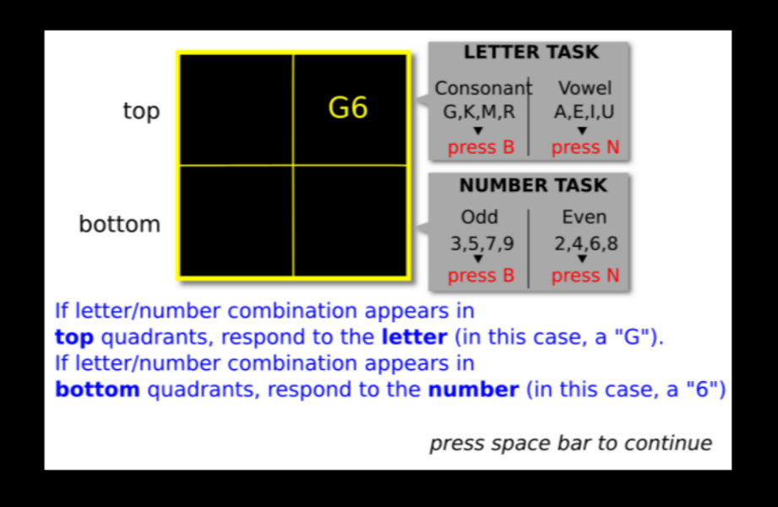

Figure 1. Instructions for the task (Stoet, 2010).

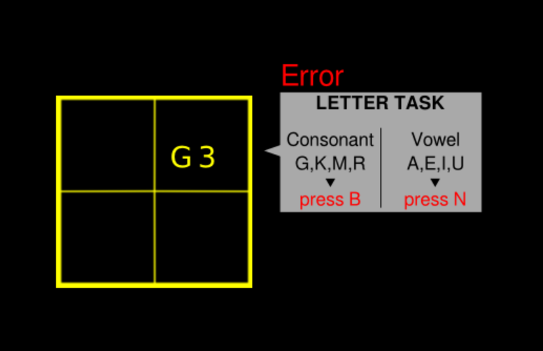

Figure 2. Task (Stoet, 2010).

### Procedure

The study was conducted in an online setting: PsyToolKit (Stoet, 2010), where the Webexec questionnaire and task-switching paradigm were provided. After a brief demographic questionnaire, participants were directed to the Webexec questionnaire (provided under *Materials*) (Buchanan *et al.*, 2010). On finishing these questions, the participants were directed to the task-switching task (see Figure 1 and 2).

During the task-switching, two tasks were counterbalanced: a letter task, involving alphabets and vowels, and a number task, involving odd and even numbers. As per the rules, if a letter/number combination came up on the screen in either of the top two quadrants, the participant had to respond to the *letter*, but if the combination appeared in either of the bottom two quadrants, the participant was supposed to respond to the *number*. Participants were required to press the letter **B** on the keyboard for consonants as well as odd numbers, and the letter **N** for vowels and even numbers. In the first two trials, participants only completed either the letter or number task. The final trial entailed a combination of both letters and numbers, making the task more challenging. At the end of the experiment, the participants were thanked for their time.

Participants’ Webexec scores, response times, error rates, and percentage errors were automatically saved for later analysis. To assess the extent to which task-switching affected a person’s cognitive flexibility and its direct correlation to the Webexec score, a Correlation test was done using SPSS (Statistical Package for the Social Sciences), and statistical significance was set at p < .05.

## Results

The purpose of this study was to find if there was a positive correlation between the Webexec score and the Task-switching paradigm. Participants’ Webexec score, response time (RT), error rate, and percentage error (PE) were calculated using SPSS. Their Webexec scores and response times were compared and correlated for further analysis. The Webexec score is presented in Table 2. It shows the data after removing subjects with an error rate of over 20%, where there were 49 participants (16 males and 33 females with an age range between 15 to 43). There were 27 participants with an error rate of over 20% (M = 13.15, SD = 3.17) with a *p = .455.*

Table 2: Data from the Webexec questionnaire.

|  |  |  |  |  |  |  |
| --- | --- | --- | --- | --- | --- | --- |
|  | Model | | |  | | |
|  | Participants with an error rate under 20% | | |  | | |
| Predictors | *Mean* | *SD* | *p* |  |  |  |
|  | 13.47 | 4.1 | .901 |  |  |  |
|  |  |  |  |  |  |  |

The task-switch cost (RT) data is portrayed in Table 3.

Table 3: Data for the task-switch cost (response time).

|  |  |  |  |  |  |  |
| --- | --- | --- | --- | --- | --- | --- |
|  | Model | | |  | | |
|  | Participants with an error rate under 20% | | |  | | |
| Predictors | *Mean* | *SD* | *p* |  |  |  |
|  | 332.8 | 341.51 | .901 |  |  |  |
|  |  |  |  |  |  |  |

The average mean age of participants was 26.08, with the youngest participant being 15 and the oldest being 43 (SD = 5.36) with a variance of 28.74. Out of the 49 participants, only 16 participants were male while 33 were female. For Percentage error (PE), the minimum was -13.95 while the maximum was 42.37 (M = 5.97, SD = 9.89) with a variance of 97.96.

As seen in Table 4 below, the analysis showed a non-significant negative correlation between the Webexec questionnaire and Task-switching cost, r(N=49) = –.018, *p* = .901. The correlation is not only negative but also a very weak one, as presented in Figure 3.

Table 4: Correlation between Webexec score and switch cost (RT).

|  |  |  |  |
| --- | --- | --- | --- |
|  |  | Webexec | Switch Cost (RT) |
| Webexec score | Pearson correlation | 1 | -.018 |
| Sig (2-tailed) |  | .901 |
| N | 49 | 49 |

*\*p<.05*

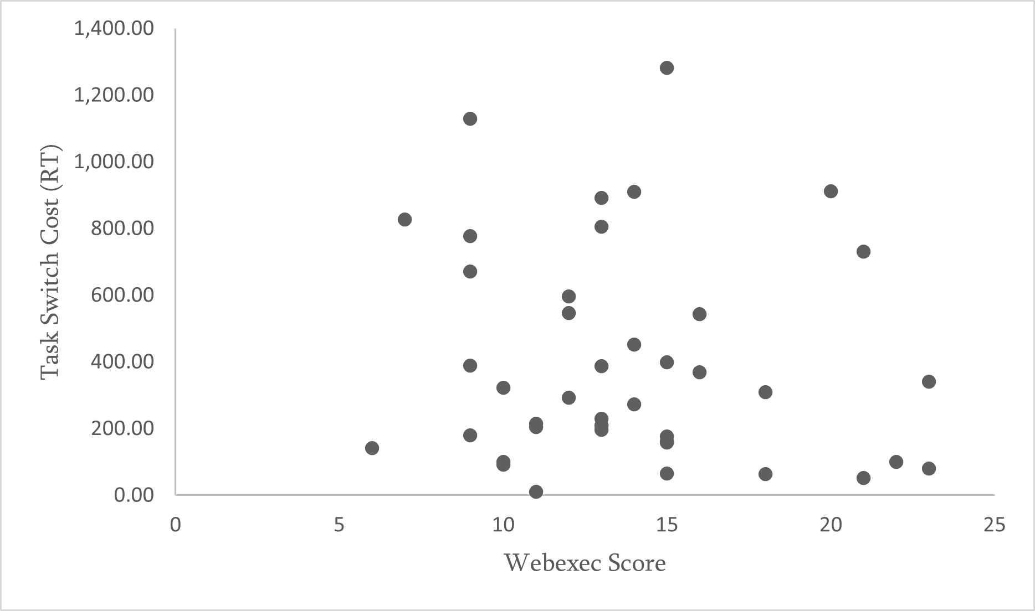

Figure 3. Correlation between Webexec questionnaire and task-switching cost.

## Discussion

The data collected showed a weak negative correlation between the Webexec scores and response times which was not in tandem with our hypothesis. We had predicted a strong positive correlation between the Webexec score and task-switch cost in response time, but the results showed an insignificant and negative correlation between the two variables. Arguably, if the Webexec score is observed to be high, one would have expected the response time to be in line with the score. However, this was not the case. A weak and negative correlation was found. As was seen in previous literature, task-switching impacted executive functions in both positive as well as negative ways, so this was likely to happen. Switching between tasks produces more response time and error rate (e.g., Allport, Styles and Hsieh, 1994; Jersild, 1927; Spector and Biederman, 1976). They are noticeably greater when there is a switch to a new task as compared to a similar or the same task as the previous one (Rogers and Monsell, 1995).

The mind has the capability to retain and interpret intelligence, which makes it accessible to recall and connect things as required. In an ever-shifting world, it is essential to have cognitive flexibility. It is necessary to view things from fresh or alternative perspectives (Davidson *et al.*, 2006). In research using task switching, subjects complete a distinct task on every trial. The task varies on some trials (switch trials) and stays the same on others (repeat trials). Performance in task switches and repetitions is compared with usually a high switch cost in both reaction time (RT) and error rate. In the fields of cognitive neuroscience and experimental psychology, research in task switching has widened (Kiesel *et al.*, 2010).

An exceptional paper by Stoet and Snyder (2007) experimenting with monkeys delved a level further into discovering the ramifications of extensive practice on task-switching performance. Humans have a system to enhance and concentrate on a particular endeavour. This can only be found in our species, which is reflected in switch costs. Among primates, no one else but human beings have developed such a distinctive social cooperation that a single person can concentrate on a specific activity excluding everything else from the limelight.

The nonsignificant results in this study could be because of multiple factors influencing the experiment: not enough participants in the study, or participants not motivated enough to do the study religiously, resulting in a higher error rate. It could also have been the case because not enough means were used in the study to offer a deeper insight into task-switching. A laboratory setting should have benefitted, with more participants involved to increase the sample size, as well as more task-switching paradigms to infer if task-switching does affect executive functions positively.

Task-switching continues to be an active field of research with many questions having been addressed in the past two decades yet challenging new ideas and theories. The possibility that task-switching research provides a doorway into the study of "executive" control processes is one of the most alluring aspects of the field (Kiesel *et al.*, 2010).

## Conclusion

This paper aimed to explore the impact of task switching on executive functions in response time, focusing on cognitive flexibility. The findings suggest that repeated task-switching boosts cognitive flexibility. This emphasizes how flexible and malleable executive functions are in response to cognition. Research clearly shows that task-switching can affect us both positively as well as negatively (e.g., Monsell, 2003). These subtle consequences highlight the importance of having a thorough grasp of the complex interaction between task-switching and executive functions. Additional investigation is bound to enhance our grasp of these cognitive processes as our knowledge of them improves. This could likely lead to the development of more strategic interventions to understand the underlying networks of task-switching and executive functions in various contexts.

## References

Allport, A., Styles, E. A. and Hsieh, S. (1994) ‘Shifting intentional set: Exploring the dynamic control of tasks’, in C. Umiltà and M. Moscovitch (eds) *Attention and performance 15: Conscious and nonconscious information processing.* Cambridge: The MIT Press, pp. 421–452.

Baddeley, A. (1992). Working memory. *Science*, 255(5044), 556-559. [DOI: 10.1126/science.1736359](https://doi.org/10.1126/science.1736359).

Baddeley, A. (2012) ‘Working Memory: Theories, Models, and Controversies’, *Annual Review of Psychology,* 63(1), pp. 1–29. Available at: <https://doi.org/10.1146/annurev-psych-120710-100422>.

Barkley, R. A. (1997) ‘Behavioral Inhibition, Sustained Attention, and Executive Functions: Constructing a Unifying Theory of ADHD’, *Psychological Bulletin*, 121(1), pp. 65–94. Available at: <https://doi.org/10.1037/0033-2909.121.1.65>.

Best, J. R. and Miller, P. H. (2010) ‘A Developmental Perspective on Executive Function’, *Child Development*, 81(6), pp. 1641–1660. Available at: <https://doi.org/10.1111/j.1467-8624.2010.01499.x>.

Best, J. R., Miller, P. H. and Naglieri, J. A. (2011) ‘Relations between executive function and academic achievement from ages 5 to 17 in a large, representative national sample’, *Learning and Individual Differences*, 21(4), pp. 327–336. Available at: <https://doi.org/10.1016/j.lindif.2011.01.007>.

Blakemore, S. and Choudhury, S. (2006) ‘Development of the adolescent brain: implications for executive function and social cognition’, *Journal of Child Psychology and Psychiatry*, 47(3-4), pp. 296–312. Available at: <https://doi.org/10.1111/j.1469-7610.2006.01611.x>.

Bodrova, E. and Leong, D. (2007) *Tools of the Mind: The Vygotskian Approach to Early Childhood Education*. New York: Merrill/Prentice Hall.

Buchanan, T., Heffernan, T. M., Parrott, A. C., Ling, J., Rodgers, J. and Scholey, A. B. (2010) ‘A short self-report measure of problems with executive function suitable for administration via the Internet’, *Behavior Research Methods*, 42(3), pp. 709–714. Available at: <https://doi.org/10.3758/BRM.42.3.709>.

Davidson, M. C., Amso, D., Anderson, L. C. and Diamond, A. (2006) ‘Development of cognitive control and executive functions from 4 to 13 years: Evidence from manipulations of memory, inhibition, and task switching’, *Neuropsychologia*, 44(11), pp. 2037–2078. Available at: <https://doi.org/10.1016/j.neuropsychologia.2006.02.006>.

Descartes, R. (2013) *Meditations on first philosophy*. Edited by A. Bailey and trans. by I. Johnston. Broadview Press.

Diamond, A. (2013) ‘Executive Functions’, *Annual Review of Psychology*, 64(1), pp. 135–168. Available at: <https://doi.org/10.1146/annurev-psych-113011-143750>.

Friedman, N. P. and Miyake, A. (2017) ‘Unity and Diversity of Executive Functions: Individual Differences as a Window on Cognitive Structure’, *Cortex*, 86, pp. 186-204. Available at: <https://doi.org/10.1016/j.cortex.2016.04.023>.

Herd, S. A., O'Reilly, R. C., Hazy, T. E., Chatham, C. H., Brant, A. M. and Friedman, N. P. (2014) ‘A Neural Network Model of Individual Differences in Task Switching Abilities’, Neuropsychologia, 62, pp. 375-389. Available at: <https://doi.org/10.1016/j.neuropsychologia.2014.04.014>.

Jersild, A. T. (1927) *Mental set and shift*. New York: *Archives of Psychology*, No. 89.

Kiesel, A., Steinhauser, M., Wendt, M., Falkenstein, M., Jost, K., Philipp, A. M., and Koch, I. (2010) ‘Control and Interference in Task Switching-A Review’, *Psychological Bulletin*, 136(5), pp. 849–874. Available at: <https://doi.org/10.1037/a0019842>.

Kofman, O., Meiran, N., Greenberg, E., Balas, M., and Cohen, H. (2006) ‘Enhanced performance on executive functions associated with examination stress: Evidence from task-switching and Stroop paradigms’, *Cognition and Emotion*, 20(5), pp. 577–595. Available at: <https://doi.org/10.1080/02699930500270913>.

Logan, G. D., and Gordon, R. D. (2001) ‘Executive Control of Visual Attention in Dual-Task Situations’, *Psychological Review*, 108(2), pp. 393–434. Available at: <https://doi.org/10.1037/0033-295X.108.2.393>.

Lu, J. G., Akinola, M., and Mason, M. F. (2017) ‘“Switching On” creativity: Task switching can increase creativity by reducing cognitive fixation’, *Organizational Behavior and Human Decision Processes*, 139, pp. 63–75. Available at: <https://doi.org/10.1016/j.obhdp.2017.01.005>.

Mao Chao, C., Xu, C., Loaiza, V., and Rose, N. S. (2023) ‘Are latent working memory items retrieved from long-term memory?’, *Quarterly Journal of Experimental Psychology*. Available at: <https://doi.org/10.1177/17470218231217723>.

Meiran, N. (2000) ‘Modeling cognitive control in task-switching’, *Psychological Research*, 63, pp. 234-249. Available at: <https://doi.org/10.1007/s004269900004>.

Miller, E. K. and Cohen, J. D. (2001) ‘An integrative theory of prefrontal cortex function’, *Annual Review of Neuroscience*, 24(1), pp. 167–202. Available at: <https://doi.org/10.1146/annurev.neuro.24.1.167>.

Miyake, A., Friedman, N. P., Emerson, M. J., Witzki, A. H., Howerter, A., and Wager, T. D. (2000) ‘The Unity and Diversity of Executive Functions and Their Contributions to Complex “Frontal Lobe” Tasks: A Latent Variable Analysis’, *Cognitive Psychology*, 41(1), pp. 49–100. Available at: <https://doi.org/10.1006/cogp.1999.0734>.

Monsell, S. (2003) ‘Task switching’, *Trends in Cognitive Sciences*, 7(3), pp. 134–140. Available at: <https://doi.org/10.1016/S1364-6613(03)00028-7>.

Moradzadeh, L., Blumenthal, G., and Wiseheart, M. (2015) ‘Musical Training, Bilingualism, and Executive Function: A Closer Look at Task Switching and Dual‐Task Performance’, *Cognitive Science*, 39(5), pp. 992–1020. Available at: <https://doi.org/10.1111/cogs.12183>.

Nigg, J. T. (2000) ‘On Inhibition/Disinhibition in Developmental Psychopathology: Views From Cognitive and Personality Psychology and a Working Inhibition Taxonomy’, *Psychological Bulletin*, 126(2), pp. 220–246. Available at: <https://doi.org/10.1037/0033-2909.126.2.220>.

Oberauer, K. (2019) ‘Working Memory and Attention - A Conceptual Analysis and Review’, *Journal of Cognition*, 2(1), p. 36. Available at: <https://doi.org/10.5334/joc.58>.

Pennington, B. F. and Ozonoff, S. (1996) ‘Executive Functions and Developmental Psychopathology’, *Journal of Child Psychology and Psychiatry*, 37(1), pp. 51–87. Available at: <https://doi.org/10.1111/j.1469-7610.1996.tb01380.x>.

Rogers, R. D. and Monsell, S. (1995) ‘Costs of a Predictable Switch Between Simple Cognitive Tasks’, *Journal of Experimental Psychology: General*, 124(2), pp. 207–231. Available at: <https://doi.org/10.1037/0096-3445.124.2.207>.

Rubinstein, J. S., Meyer, D. E., and Evans, J. E. (2001) ‘Executive Control of Cognitive Processes in Task Switching’, *Journal of Experimental Psychology: Human Perception and Performance*, 27(4), pp. 763–797. Available at: <https://doi.org/10.1037/0096-1523.27.4.763>.

Shukla, D. and Heath, M. (2020) ‘An Executive Function Benefit Persists For Between 30- And 60-min Post-exercise: Evidence From Task-switching: 459 Board #275 May 27 10:30 AM - 12:00 PM’, *Medicine and Science in Sports and Exercise*, 52(7 Suppl), p. 120. Available at: <https://doi.org/10.1249/01.mss.0000671372.74556.59>.

Spector, A. and Biederman, I. (1976) ‘Mental Set and Mental Shift Revisited’, *The American Journal of Psychology*, 89(4), pp. 669–679. Available at: <https://doi.org/10.2307/1421465>.

Stoet. G. (2010) ‘PsyToolkit: A software package for programming psychological experiments using Linux’, *Behavior Research Methods*, 42(4), pp. 1096–1104. Available at: <https://doi.org/10.3758/BRM.42.4.1096>.

Stoet, G. and Snyder, L. H. (2003) ‘Executive control and task-switching in monkeys’, *Neuropsychologia*, 41(10), pp. 1357-1364. Available at: <https://doi.org/10.1016/S0028-3932(03)00048-4>.

Stoet, G. and Snyder, L. H. (2007) ‘Extensive practice does not eliminate human switch costs’, *Cognitive, Affective, & Behavioral Neuroscience,* 7(3), pp. 192–197. Available at: <https://doi.org/10.3758/CABN.7.3.192>.

Stroop, J. R. (1935) ‘Studies of interference in serial verbal reactions’, *Journal of Experimental Psychology*, 18(6), pp. 643–662. Available at: [https://doi.org/10.1037/h0054651](https://psycnet.apa.org/doi/10.1037/h0054651).

Stuss, D. T. and Alexander, M. P. (2007) ‘Is there a dysexecutive syndrome?’ *Philosophical Transactions of the Royal Society B: Biological Sciences,* 362(1481), pp. 901–915. Available at: <https://doi.org/10.1098/rstb.2007.2096>.

Stuss, D. T., Levine, B., Alexander, M. P., Hong, J., Palumbo, C., Hamer, L., Murphy, K. J. and Izukawa, D. (2000) ‘Wisconsin Card Sorting Test performance in patients with focal frontal and posterior brain damage: effects of lesion location and test structure on separable cognitive processes’, *Neuropsychologia*, 38(4), pp. 388-402. Available at: <https://doi.org/10.1016/S0028-3932(99)00093-7>.

Tari, B. and Heath, M. (2019) ‘Pro- and antisaccade task-switching: response suppression—and not vector inversion—contributes to a task-set inertia’, *Experimental Brain Research*, 237, pp. 3475–3484. Available at: <https://doi.org/10.1007/s00221-019-05686-w>.

Tari, B., Fadel, M.A. and Heath, M. (2019) ‘Response suppression produces a switch-cost for spatially compatible saccades’, *Experimental Brain Research*, 237, pp. 1195–1203. Available at: <https://doi.org/10.1007/s00221-019-05497-z>.

Vandierendonck, A., Liefooghe, B., and Verbruggen, F. (2010) ‘Task Switching: Interplay of Reconfiguration and Interference Control’, *Psychological Bulletin*, 136(4), pp. 601–626. Available at: <https://doi.org/10.1037/a0019791>.

Zelazo, P. D. and Carlson, S. M. (2012) ‘Hot and Cool Executive Function in Childhood and Adolescence: Development and Plasticity’, *Child Development Perspectives*, 6(4), pp. 354–360. Available at: <https://doi.org/10.1111/j.1750-8606.2012.00246.x>.

## Copyright Statement

©Radhika Parekh. This article is licensed under a Creative Commons Attribution 4.0 International Licence (CC BY).