Essay
Culture & Leadership: How leadership impacts cross cultural management?
Endrit Bajrami
University of Essex

Abstract
As globalisation continues at unprecedented rates, there are increasing cultural clashes which commonly result in unsuccessful international business assignments. This essay will discuss the importance of top management acknowledging that there are differences in cultures which need to be considered. Different cultures value certain leadership characteristics differently, which means managers and other business leaders, must not only acknowledge the different characteristics but also adopt these characteristics in order to successfully manage in that environment. Evidence will be used to support methods which leaders and managers can use to identify the type of culture they are going to be working with, and further evidence will be used to identify the different leadership styles preferred by different countries and hence different cultures. However due to the complexity of international business, managers and leaders cannot rely just on several methods of identifying cultures and tools to help guide their leadership styles because there is too much variation between multiple cultures. Instead a global mind set needs to be acquired and developed. A global mind set changes an individual’s perceptions not only about other cultures but also their own. Individuals become more open minded, and are able to adapt their understandings of business conduct to a local point of view, anywhere in the world. A global mind set ultimately increases individual’s capacity to successfully manage cross-cultural international business assignments.
Keywords: Globalization; cultural management; leadership.

Introduction
In the modern global market there is an ever increasing presence in the quantity and diversity of organisations. They all implement different strategies to compete and attempt to gain a competitive edge, in order to grow, or at least maintain their business. These strategies are very important as they can determine the success or failure of the organisation, particularly when an organisation aims to enter foreign markets. Different cultures can result in different ways of thinking, which results in different decision making, and ultimately different ways of conducting business. So when an organisation tries to create a new subsidiary in a different country, or collaborate, or merge, they must at least consider the differences between cultures. As organisations cross national boarders they meet new challenges, such as different culture, business practice, race, religion, ethnicity, different laws, regulation etc. All these aspects fall under globalisation (the spread of current and new organisations across national borders). Globalisation is constantly increasing the number of international assignments and thus the diversity of the workforce resulting in increased cultural clashes which are a major cause of unsuccessful international assignments.
In this essay the significant influence of culture on international business and management will be discussed, with a focus on what top management can do to reduce cultural clashes and reduce failure of international assignments. It is crucial to acknowledge what culture is and that there are differences between cultures. This can significantly influence the type of leadership style that should be used, in order to improve the management of international assignments. As an example, a study conducted by Brodbeck et al (2000) on the different preferred leadership styles across 22 countries in Europe will be examined. With supporting evidence this essay will argue that different cultures require different leadership styles and that the most effective international leaders develop a global mind set.
Across the many different countries in the world there are many different cultures. In today’s world most countries have more than one culture. Further, amongst these countries there are many organisations which may also have their own internal culture, be it the same as their national culture or completely different. This essay will focus on organisational culture. Thus it is important to define what organisational culture is and to try and understand some of its dynamics. There are many different definitions of organisational culture. Some authors define organisational culture as the glue which can maintain the organisation and also encourage its members to commit and perform (Van Den Berg & Wilderom, 2004). The values, customs, beliefs and systems that are unique to an organisation will determine its culture (Burnes, 2004). There are many more authors who give their own definitions of organisational culture, however collectively; culture can be described as a uniting of individuals who share common goals, values, attitudes and behaviour. Culture can influence the way we perceive life, which in effect determines what we as individuals accept as right and wrong. Culture is important because it can determine which leadership style is preferred and effective.
One well known author who has spent many years trying to define and understand culture is Hofstede (1980), who designed four cultural dimensions to distinguish between different cultures:
- Power distance: these are the varying relationships with varying degrees of unequal power between members of the organisation.
- Uncertainty avoidance: the amount of tolerance for uncertainty.
- Individualism versus collectivism: the degree to which the individuals form groups.
- Masculinity versus femininity: the degree of aggression and competitiveness in the working environment to gain wealth, versus the degree of humbleness and caring, where the quality of life is more important then wealth. (Clegg et al., 2008)
This model is commonly used to distinguish which dimension is more important in different cultures (see table 1). For example, Malaysian culture has strong power distance relationships, between the top management and the lower level employees. This means important decision making concerning the organisation’s strategies are likely to be dealt with solely by top management, with disregard of the lower level employees opinions; such practice is widely accepted in Malaysia. However in the U.K. the power distances are less, meaning more members of the organisations will have significant influence over vital decision making. As globalisation increases, the amount of international assignments increase. Thus there is an increase in demand for expatriates or international assignees (individuals who are transferred to another country, to work on an operation for more than one year (Briscoe et al., 2008)). It is important for potential expatriate leaders to have as much understanding as possible of their host country’s culture, because it will help them adapt better to the new culture, new methods of business conduct and perhaps a new way of life. Comprehension of the host country’s culture is very important in order for the leader to adapt their leadership style according to the characteristics and behaviour expected by that country (or possibly a different organisation or foreign subsidiary).

Table 1:The varying degrees of difference in Hofestede’s four cultural dimensions, among different countries (see Hofstede, 1980).
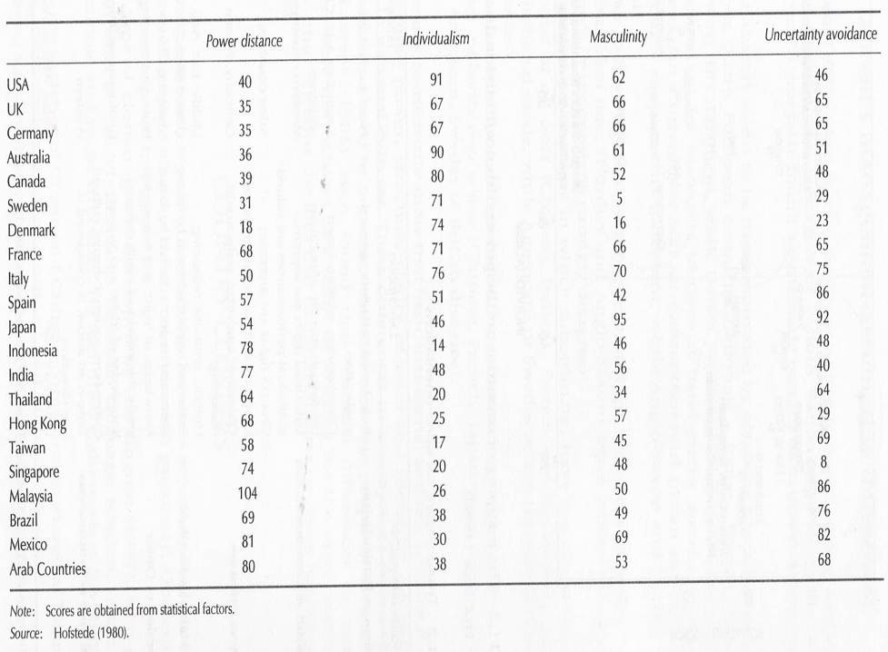

Leadership styles
Leaders are very important to organisations because they are involved in so many essential processes within organisations, such as developing the short term and long term strategy of where the organisation wants be. Leadership can be defined as the process which motivates and inspires others towards the achievement of common goals (Clegg et al., 2008). Understanding leadership is very important in becoming an effective international leader of an organisation and is a vital process of developing a global mind set. There are many different leadership styles which would be best suited to certain cultures. Some of the common leadership styles include the trait theory, behavioural theory, path-goal theory, transformational theory and situational theory. The trait theory, suggests that individuals are born as leaders and they have innate characteristics, such as intelligence, confidence, integrity and a great ability to motivate people. This would imply that leadership is not something that can be learnt but that you are born with. It would also suggest that subordinates must also be innate (Clegg et al., 2008). This one of the oldest leadership theories and has received a lot of criticism.
More recent theories argue that leadership is not innate and that it can actually be learnt and acquired; this is the view adopted by this essay. For example the behaviour theory suggests that you either act like a leader or you do not. This theory is not based on characteristics, instead, it focuses on the behaviour which is observable and can be learnt, developed (if needed) and thus taught. The path-goal theory was designed by Robert House (1971), his theory suggests, effective leaders can motivate their followers by using the job tasks and rewarding good performance and punishing bad performance. The leaders using this theory need to provide psychological and technical support, as well as information and any additional resources necessary to complete the task. This theory has four main characteristics which leaders should have: directive approach, being supportive, being participative and achievement oriented, (Clegg et al., 2008). This leadership style would be suited to more masculine countries like France (table 1). Situational leaders determine leadership style according to how they, as individuals, assess the environment/situation and choose what they believe are the right characteristics or behaviours for that particular situation, (Clegg et al., 2008). The transformational theory of leadership suggests the leader tries to engage with the followers and to engage the followers with the rest of the group and task. The leader also acknowledges the members of the group as individuals and tries to develop them individually to their potential, (Walumbwa & Lawler, 2003). Bass (1985) identifies the four main components of a transformational leadership style: charisma, inspirational motivation, intellectual stimulation and individualised consideration. A study by Walumbwa and Lawler (2003) aimed to find out how transformational leadership can affect organisational commitment, job satisfaction, and withdrawal behaviours, in a collectivist culture. They proposed the framework for transformational leadership and overall job out comes (figure 1) to illustrate the theoretical overview. They implemented hypotheses to test whether transformational leadership in a collectivist culture would enhance job satisfaction and reduce withdrawal behaviours, or whether it would have the opposite effects (reducing job satisfaction and increasing job withdrawal). They conclude; transformational leadership in the collectivist culture does significantly enhance all 3 aspects of job satisfaction and reduces job and work withdrawals. The previous evidence shows the different types of leadership styles, and how they can affect employees and the entire organisation. For the leader to acknowledge which leadership styles are preferred by his organisation is a challenge in itself. However when a leader is working on an international assignment, in a different country or even in project with people from a mixture of different cultures then the challenge becomes even more difficult. The next section will describe how these leadership style vary across different countries and thus cultures.

Figure 1:The relationship between transformational leadership and work related out comes (Walumbwa and Lawler, 2003).

Comparing leadership styles across Europe
It is important for future expatriate leaders to comprehend that there are differences in leadership styles across the world, and it is unlikely that their leadership style will be effective without any adaptation in host countries. Expatriate leaders must identify and then adopt the preferred characteristics and behaviour - of the shared culture within the host country, subsidiary, or host organisation - in their leadership style accordingly in order to work with maximum efficacy. A study by Brodbeck et al (2000) provides very strong evidence demonstrating the different preferences in leadership style in different countries, hence different cultures, across Europe. Over 6,000 middle managers from 22 European countries across three different industries (food, finance and telecommunications) were surveyed using seven point scale questionnaires. The 22 European countries were selected and put into regional clusters. Table 2 shows which countries were selected and the clusters they were grouped in to. The authors claimed; the increasing difference between cultures, will result in the decreased likelihood that cross-cultural leadership styles will be accepted and effective in host countries. Therefore it is important to understand different leadership styles in order to manage effectively in different cultures.

Figure 2:The European clusters. (Brodbeck et al., 2000)
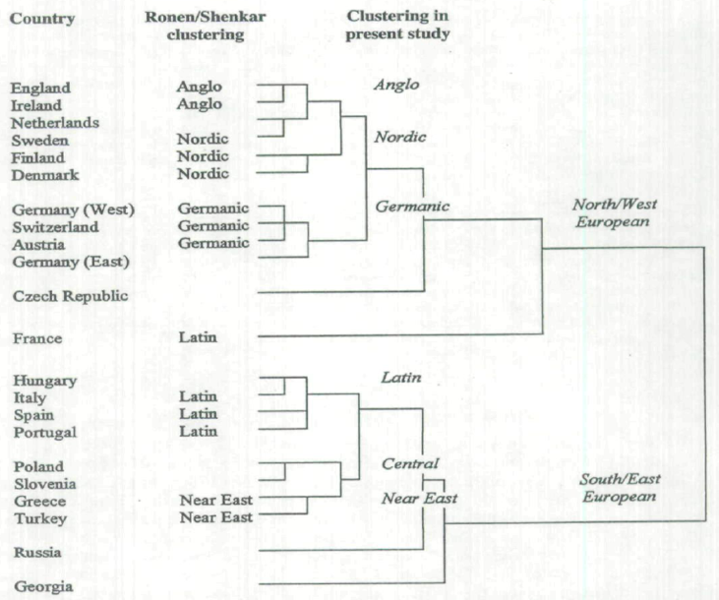

The results of the preferred leadership styles in different cultures are displayed in table 3. The northern European countries preferred leadership styles with higher levels of equality and participation. This leadership style is similar to transformational leadership, where as in the southern European countries there were indications of hierarchy resulting in the preference towards a directing leadership style (similar to the path-goal theory). This study shows how the different characteristics which contribute towards leadership style vary in the different clusters. It is also possible to see that there is a relationship between distances of countries and differences in their culture. In general the closer the countries are together, the similar the preference of leadership style. For example the Germanic cluster (Germany, Switzerland and Austria) have very similar leadership styles, as do the Anglo cluster (U.K. and Ireland). Brodbeck et al (2000) argue this similarity is partly due to the same language being spoken because language can be seen as part of culture. The Russian and the Latin cluster have many differences in the preferences of their leadership style and are also very distant from each other. However there was a characteristic - self centred - which was one of the least preferable characteristics in all the countries except Georgia. Characteristics like inspirational, visionary, integrity, performance oriented and decisive all received high ranking in most countries. The authors conclude that different cultures do have different leadership styles and the higher the difference between cultures the higher the difference between leadership styles. Without understanding the cultural differences it is unlikely an expatriate leader will lead successfully in the host country. By understanding the hosts’ country’s culture it can help anticipate potential problems. Such research on different types of leadership has important benefits to help understand cross-cultural interactions; these should be exploited by leaders, managers, trainers and consultants (Brodbeck et al 2000).
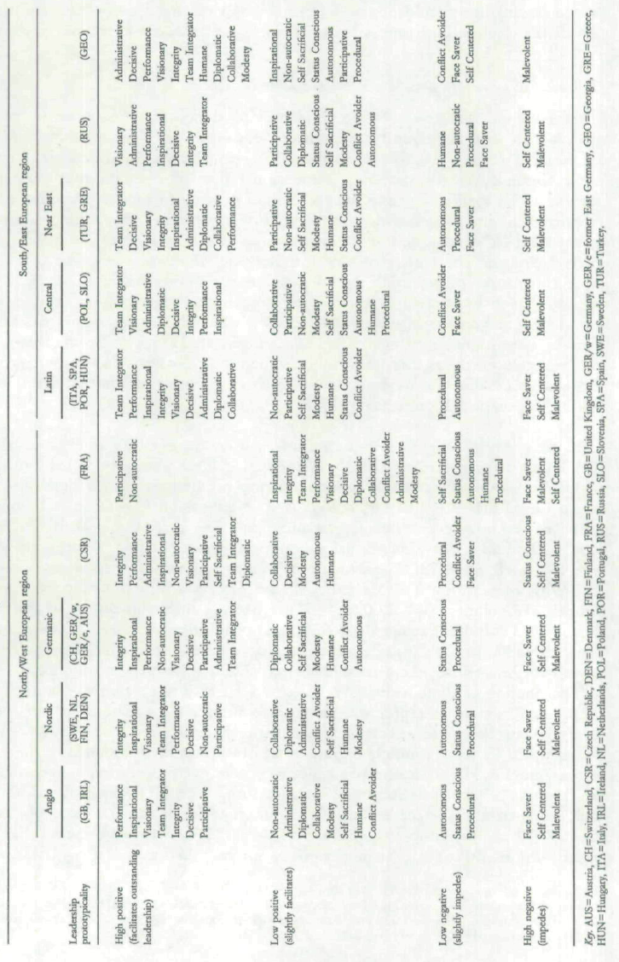
Table 2:. The preferred leadership styles in different European countries, (Brodbeck et al. 2000)

The study across European cultures and the preferred leadership style has its limitations. Even though the sample was quite large it only represents three industries across those selected countries. Thus it would be inappropriate to assume each of those countries have the same leadership style preference in every industry. Different industries demand different types of work; some are less structured then others and demand more guidance. For example I have worked for Network rail, and have had experience working on large projects. In particular I worked at Clapham junction which is Britain’s busiest station. There were over 100 men on the site and project was a power upgrade, which was rather complex. In this situation the leader of our group took on a very autocratic and self centered leadership style, however despite his low popularity, the task was completed on time. Most railway projects I have worked on have been lead by an autocratic leadership style. However according Brodbeck et al (2000), the U.K. prefers a leadership style which is performance oriented, inspirational and visionary. The point of the example is to demonstrate that leadership style can also be determined by the type of work and the situation. It is important to acknowledge that research does help inform people about different cultures. However it does not necessarily provide an answer to how to lead effectively in different cultures and all environments? Thus for a leader it is essential to be aware that differences in different situations and environments exist and they require different combinations of characteristics in order to lead effectively; the aim of the global mind set.

The Social Identity theory
As more multinational enterprises (MNE’s) undergo collaboration (with other MNEs), mergers, acquisitions and out sourcing they are increasing the likelihood of exposure to new cultures. At some point in time, it is very likely that two cultures with a history of conflict will meet. When bringing these two cultures together in the workplace, there is a high possibility that there will be conflict between employees, thus another challenge the leader must over come. It is important for an expatriate leader to be aware there may have been conflicts between countries in the past or even within the same country. A study by Chrobot-Mason et al. (2007) demonstrates how such conflicts can arise between different social identity groups which are usually divided by religion, race, ethnicity and region. When two conflicting identity groups or even individuals are brought together in the work place they can create problems which will result in poor work performance or even lead to task failure, both for the group or the individuals. When such conflicts arise in the work place it is often expected to be dealt with by the leader or manager, their initial reactions can diffuse the situation or escalate it even more. This would be a challenge in itself, but it would be even more challenging if the leader is a member of one of the social groups.
The social identity theory states that we categorise ourselves into social groups, to help us identify our self image as well as others, while at the same time fulfilling our needs for inclusion and differentiation by belonging to social groups (Chrobot-Mason et al., 2007). The attributes used to categorise individuals into social groups are called faultlines, for example race, religion, sex etc. The presences of faultlines are believed to be the driving force for creating discrimination between individuals and social identity groups. When biased individuals or groups come into contact then tensions increase and may result in conflict between social groups. Faultlines vary according to culture and geographic locations. The decategorisation concept proposes, interactions will be most effective when interactions between different social members are not category based, but individually based. This concept is very similar to transformational leadership theory and the leader member exchange theory (LMX- which recommends leaders relate to their followers as individuals).

Table 3:The different cultures when the Decategorisation, Recategorisation, subcategorisation, and cross cutting are models are most effective (Chrobot-Mason et al. 2007)

Re-categorisation, sub-categorisation, and cross cutting are models which attempt to provide solutions for managing social identity conflicts. Re-categorisation reduces bias by extending perceptions of shared belief beyond in group members, thus trying to extend similarities between individuals beyond the social group. Sub-categorisation suggests that social conflict can be reduced by structuring inter-group contact in a way which produces clear distinction between each groups’ task. However the group’s roles must be complementary and both must contribute towards a common goal. The cross cutting model aims to minimise social identity conflict by either systematically or randomly involving members from both social groups. Participation of members from both groups needs to take place in equal amounts, in an attempt to remove social identity related to certain roles. This should produce the perception that both social groups and members are of equal importance. Table 4 summarises which particular cultures prefer the use of these models to be incorporated into the leadership style, to enhance effective leadership, (Chrobot-Mason et al., 2007).

Global competence and the global mind set
The success of MNEs is largely determined by its leaders. Therefore it is vital for the MNEs that their leaders are able to lead in the global environment. The global mind set can be defined as “knowing how to live and work across cultures” (Briscoe et al., 2008 : 216). The global mind set can also be defined as “the ability to develop and interpret criteria for business performance that are not dependent on the assumptions of a single country, culture or context and to implement those criteria appropriately in different countries, cultures and contexts” (Begley and Boyd. 2003: 25-26). There are three main components of a global mind:
- Think globally - when is global standardisation beneficial to an organisation.

- Think locally – deepening the organisations understanding of local and cultural differences will lead to a global organisation.

- Think globally and locally simultaneously, (Begley and Boyd, 2003).

Dutton (1999) purposes a list of criteria which need to meet in order to be develop a global mind set (figure 3).

Figure 3:Some of the components of a global mind set, (adapted from Dutton, 1999)
All these attributes are very important when attempting to acquire a global mind set, but how does one actually go about developing a global mind set? The most effective way to develop a global mind set is to undertake an international assignment. This will expose the expatriate leader to a different culture, where they are likely to experience a cultural shock. This will force the expatriate to develop the coping skills and abilities needed to overcome the cultural shock, (Briscoe et al., 2008), (similar to Stroh and Caligiuri (1998)). Stroh and Caligiuri (1998) claim the most effective method used by MNE’s to enhance their leaders global competence is by sending them on international assignments to accumulate real life experience in different cultures. According to Caligiuri and Di Santo (2001), the global competence these leaders require can be defined in terms of dimensions, which are knowledge, ability and personality. These are also developed by international assignments. The most important dimensions to be improved by international assignments are highlighted in table 5. The authors conclude from their results; personality is unlikely to be influenced. Knowledge is enhanced and it greatly improves the skills and competencies of leaders, both on the international and domestic scene. Thirdly the leader’s cognitions were adapted, making them more culturally sensitive and aware of the differences between cultures and different methods of business conduct, in host countries. As a result, successful international assignments improved the MNE’s financial status and ability to successfully produce globally competent leaders (Caligiuri & Di Santo, 2001). Ultimately a global mind set improves the knowledge, skills, ability and the entire capacity to conduct business on a global scale. A global mind set can be seen as a vital tool which future leaders need to acquire in order to successfully lead their organisation as it competes, or is preparing to compete on a global scale.

Table 4:The dimensions which are targeted on international assignments to enhance global competence (adapted from Caligiuri and Di Santo, 2001).
Dimensions | Proposed Developmental Goal
Ability | Increase an individuals ability to transact business in another country.
Ability | Increase an individual’s ability to change leadership style based on the situation.
Knowledge | Increase an individual’s knowledge of the organisation’s world wide business structure.
Knowledge | Increase an individual’s knowledge of international business issues
Knowledge | Increase an individual’s network of professional contacts worldwide
Personality | Increase an individual’s openness
Personality | Increase an individual’s flexibility
Personality | Reduce an individual’s ethnocentrism

Conclusion
Leaders are extremely important parts of an organisation; they can determine the success or failure of the organisation. Leaders who are driving their organisations into new foreign markets, must understand how business is conducted in the foreign market. Culture has a significant influence on business conduct and therefore its understanding is vital for successful business operations. As has been discussed earlier there is a vast diversity of cultures present and there are many challenges which leaders must overcome, in order to lead effectively. Using Hofstede four cultural dimensions can produce a starting point for understanding the host country’s culture. Determining whether the host country is a collectivist or individualistic culture, can help the leader understand which leadership styles are preferred. The Study by Brodbeck et al (2000) provides strong evidence to demonstrate that different preference of leadership styles exist in different cultures, and also demonstrates the characteristics preferred by different cultures as well as how distance between countries can also influence cultures.
Leadership is not innate and it can be learned and acquired. There are different preferences of characteristics and behaviour in leadership style which are largely determined by the local or organisational culture. These characteristics and behaviour need to be identified and developed by leaders. The social identity theory is an important theory for leaders to be aware of because it demonstrates the practical psychological behaviour of individuals. It can be used to help understand the cultural differences, and predict potential behaviour of employees as well as predicting the characteristics and behaviour of their preferred leadership style which needs to be adopted by their leader.
Even with a lot of experience, learning about host cultures and training to prepare for international assignments; one can never be completely prepared for the task ahead. The most important asset is to have a global mind set, which emphasises the appreciation of different cultures. Understanding the culture in one market or one or two organisations is great; however the development of a global mind set is about understanding and being prepared to adapt leadership styles according to multiple cultures, which is essential for effective for cross-cultural management or leadership. The global mind set changes the leaders perspectives about other cultures, their own culture and broadens there perceptions in their professional working life as well as social life. This broadened perspective should allow any leader or manager to be aware of different business practices and to understand them from the local point of view, anywhere in the world. In essence the global mind set can be acquired and developed. The global mind set changes individual’s cognitions, making them more open minded. This broadens their perspective and collectively allows the individual to adapt to cross-cultural environments, ultimately enhancing the effectiveness of their leadership. So to answer the question directly and sum up the essay, a global mind set should be used to overcome the various challenges created by cultural differences, and lead effectively in cross-cultural management. The role of leadership is the backbone of successful organisations, because the nature of it involves so many organisational processes.

Bibliography
Bass, B.M. (1985) ‘Leadership and Performance beyond Expectations’. New York: The Free Press.
Begley M. T. & Boyd P. D. (2003) ‘The Need for a Corporate Global Mind-Set’ in MIT Sloan Review Management Review, vol. 44: pp. 25-32
Black J. S. & Mendenhall M. (1990) ‘Cross-Cultural Training Effectiveness: A Review and a Theoretical Framework for Future Research’ in Academy of Management Review, vol. 15: pp. 113-136
Briscoe D., Schuler R. & Claus, L. (2008) ‘International Human Resource Management: Policy and Practice for Multinational Enterprises, (3rd Rev. Edn). London: Routledge.
Brodbeck C.F., Frese M., Akerblom S., Audia G., Bakacsi G., Bendova H., Bodega D., Muzaffer Bodur, Booth S., Brenk K., Castel P., Hartog D. D., Donnelly-Cox G., Gratchev V.M., Holmberg I., Jarmuz S., Jesuino J.C., Jorbenadse R., Kabasakal H. E., Keating M, Kipiani G., Konrad E., Koopman P., Kurc A., Leeds C., LJndell M., Maczynski J., Martin S.G., O'Connell J., Papalexandris A., Papalexandris N., Prieto J.M., Rakitski B., Reber G., Sabadin A., Schramm-Nielsen J., Schultz M., Sigfrids C., Szabo E., Thierry H., Vondrysova M., Weibler J., Wilderom C., Witkowski S. & Wunderer R., (2001) ‘Cultural Variation of Leader Types Across 22 European Countries’ in Journal of Occupational and Organisational Psychology, vol. 73: pp. 1-29
Burnes, B. (2004) ‘Managing Change’ (4th edn) pp 172, 176-181 Harlow: Prentice Hall
Caligiuri, P. & Di Santo, V. (2001) Global Competence: What Is It, and Can It Be Developed Through Global assignments? in Human Resource Planning. Vol. 24: pp. 27-35
Chrobot-Mason, D., Ruderman M. N., Weber J. T., Ohlott J. P. & Dalton A. M. (2007) ‘Illuminating a cross-cultural leadership challenge: when identity groups collide’ in International Journal of Human Resource Management vol. 18: pp. 2011–2036
Clegg, S., Kornberger M. & Pitsis T. (2008) ‘Managing and Organising’ (2nd edn) London: SAGE publications.
Dutton, G. (1999) ‘Do You Think Globally?’ in Management Review, vol. 88: p. 6
Hofstede G. (1980) ‘Culture’s Consequences: International Differences in work-related values’. Beverly Hills: CA: Sage
Stroh, L. K. & Caligiuri, P.M. (1998) 'Strategic Human Resources: A New Source for Competitive Advantage in the Global Arena’ in International Journal of Human Resource Management. Vol. 9: pp. 1-17
Van Den Berg, T.P. & Wilderom P.M.C. (2004) ‘Defining, Measuring, and Comparing organisational Cultures’ in Applied Psychology: An International Review, vol. 54: pp. 570-582
Walumbwa, O. F. & Lawler L. J. (2003) ‘Building effective organizations: transformational leadership, collectivist orientation, work-related attitudes and withdrawal behaviours in three emerging economies’ in International Journal of Human Resource Management, vol. 14: pp. 1083–1101.

© Endrit Bajrami. This article is licensed under a Creative Commons Attribution 4.0 International Licence (CC BY).

