Essay
Estimating Future Starting Salaries: Do Anchors Influence the Range of Values Which seem Plausible?
Michael Caley
University of Essex

Abstract
The experiment aimed to determine whether numerical anchors influence the range of values that students believe are plausible for their starting salary following graduation. Three possible accounts of how anchors affect this range were proposed: not influencing the range at all, pulling the entire range towards it, or pulling only the nearest end of the range towards it. Participants were presented with a version of the standard anchoring paradigm, receiving either a high, low or no anchor. A significant interaction between judgement and anchor condition was found. The results are consistent with the third prediction - the high anchor only significantly increased participants' upper judgements whereas the low anchor only decreased lower judgements. It is suggested that anchors will still affect participants' plausible ranges even when information relevant to the anchor value is accessible.
Keywords: Anchors; range of values; experiment.

Introduction
The standard anchoring paradigm is used to demonstrate how the provision of a numerical anchor value can influence intuitive judgements; exposing participants to a high or low anchor in a comparative question biases their judgement when giving their best estimate of the target quantity. Jacowitz and Kahneman (1995) exemplified this effect by asking participants to estimate 15 quantities, such as the height of Mount Everest, having been exposed to a high anchor (e.g. 45,500 feet) or low anchor (e.g. 2000 feet). Evidently participants' judgements were biased towards the anchors, as average estimates of participants in the high anchor condition was 42,550 feet, yet 8000 feet for the low anchor condition. Moreover the effect also arises when the anchors give no actual indication of the true value of the target quantity (Tversky and Kahneman, 1974).
A slightly dated explanation of this phenomenon attributes the effect to the use of an anchoring-and-adjustment heuristic (Tversky and Kahneman, 1974). This proposes that people select the anchor as a reference point and reject it, yet fail to muster the mental effort to sufficiently adjust from this. Evidence suggests that this approach is used for some numeric judgements (e.g. Epley and Gilovich, 2001). However, it is seemingly only useful for self-generated reference points, and research has demonstrated that this does not explain the effect observed in the standard anchoring paradigm (Epley and Gilovich, 2005). The selective accessibility model (Strack and Mussweiler, 1997; Mussweiler and Strack, 1999) offers a better explanation, suggesting that participants complete the comparative task by selectively activating anchor-consistent knowledge – which then biases their judgement due to increased accessibility. Mussweiler and Strack (2000) found evidence for this themselves, concluding that lexical decisions were faster when the letter string contained semantically related words.
Anchoring effects have not only been observed in artificial experimental settings, but also in real-life situations; Northcraft and Neale (1987) reported that presenting a listing price biased real-estate agents' estimations of the value of a house. Anchor effects are thus an important area of psychology and will be the focus of the present experiment. In order to conduct an externally valid study it will address the growing interest in attitudes towards salary as this is frequently linked to well-being; employees' life satisfaction is related to both their absolute salary and their income relative to those of other workers (Boyce et al., 2010; Brown et al., 2008). Consequently this experiment will focus on the judgements of students regarding the estimated salary of their first job following graduation.
Although anchors appear to influence people's best estimates, when making intuitive judgements people tend to use a range of possible values for a target quantity (Mussweiler and Strack, 1999). Asking participants to indicate this has elapsed previous research. Therefore this experiment aims to determine whether anchors affect the range of values people think are plausible. A similar method to Jacowitz and Kahneman (1995) will be used; participants will receive either a high anchor, a low anchor or no anchor (the control condition). All will then indicate a range of salaries which they are highly confident will contain their starting salary, providing a lower judgement (the lower limit of the range of plausible values) and an upper judgement (the upper limit of the range).
One possibility is that anchors influence people's best estimate of a target quantity but not the range of plausible values, which would suggest that people do not adjust their upper and lower limit of the range when provided with a reference point. Another possibility is that both upper and lower judgements will be assimilated to the anchor, dragging the entire range of plausible values towards it. This is in accordance with Jacowitz and Kahneman (1995), who found that anchors also affect people’s confidence in their judgements; participants may treat the anchor as useful information and use it when assessing the range of possible values. A third possibility is that anchors only influence the closest end of the range - pulling that end towards it and not the other end. Notably if the study exemplifies the second or third possibility, not only would the results serve as further support for the anchoring effect, but they would also expand upon previous literature by indicating to what extent ranges are affected.

Method
Participants
A convenience sample method produced 168 participants; however 6 were excluded having produced responses more than 3 standard deviations from the mean – hence 162 were used for the final sample (58 males, 104 females). All were undergraduate students; ages ranged from 19 to 50 years (M = 21.12, SD = 3.94 years).
Materials
Different study materials were used for each anchor condition. Question sheets for the low and high anchor conditions firstly asked participants to indicate whether they believed their starting salary after graduating will be more or less than an anchor value (£8000 for the low anchor condition, £80000 as the high anchor). There was no such comparative question for participants in the no anchor condition.

Materials for all conditions then featured a sentence for participants to complete, asking them to indicate a range of salaries which they were highly confident (90% sure) would contain their starting salary after graduating. Spaces were provided for them to specify their lower and upper judgement.
Design
The participants' 90% confidence intervals for their estimated starting salary were used as the dependent variable. The experiment used a 2x3 mixed design. Judgement was a within-subjects factor with two levels: lower judgement and upper judgement. Anchor condition was a between-subjects factor with three levels: low anchor (n = 57), no anchor (n = 52), and high anchor (n = 53), and participants were randomly allocated to each of these three conditions.
Procedure
Participants were not informed of the true nature of the research prior to completing the experiment, nor of which anchor condition they had been allocated to. They were informed that it would only take a minute of their time and were asked to complete the task in a quiet setting. Participants in the low and high anchor condition completed two parts of the experiment: indicating whether their starting salary will be more or less than an anchor value, and specifying their upper and lower judgements. Participants in the no anchor condition simply provided their upper and lower judgements.

Results
Each participant provided a lower and upper judgement, which were averaged to obtain a mean response for upper and lower judgements in each anchor condition. In the low anchor condition, 8 participants responded “less” to the comparative question and 49 responded “more”. In the high anchor condition, 2 participants responded “more” and 51 responded “less”.
As Table 1 and Figure 1 show, judgements of participants in the low anchor condition are lower than those of participants in the no anchor condition, whereas the judgements of participants in the high anchor condition are high relative to the no anchor condition. This suggests that the anchors influenced the participants' plausible ranges. A 2x3 mixed ANOVA found a statistically significant main effect of judgement, F(1,159) = 164.70, p < .001, eta-squared = .51, indicating that participants' upper judgements were indeed higher than lower judgements (a large effect size).

Table 1:Mean response for upper and lower judgement in each author condition, and their st.deviation.
 | Mean response | Standard deviation
Lower judgement
Low anchor | £13,528.07 | £5,333.38
No anchor | £16,947.12 | £7,496.95
High anchor | £18,394.34 | £9,985.54
Upper judgement
Low anchor | £21,566.30 | £13,305.14
No anchor | £25,250.00 | £10,984.61
High anchor | £33,094.34 | £20,476.31

The 2x3 mixed ANOVA also found a significant main effect of anchor condition, F(2,159) = 7.52, p < .01, eta-squared = .086, indicating that participants' mean responses differed significantly between the anchor conditions (a small effect size). However, this does not show which conditions differ (merely that there are significant differences in group means).
Figure 1: Mean responses for upper and lower judgement in each anchor condition
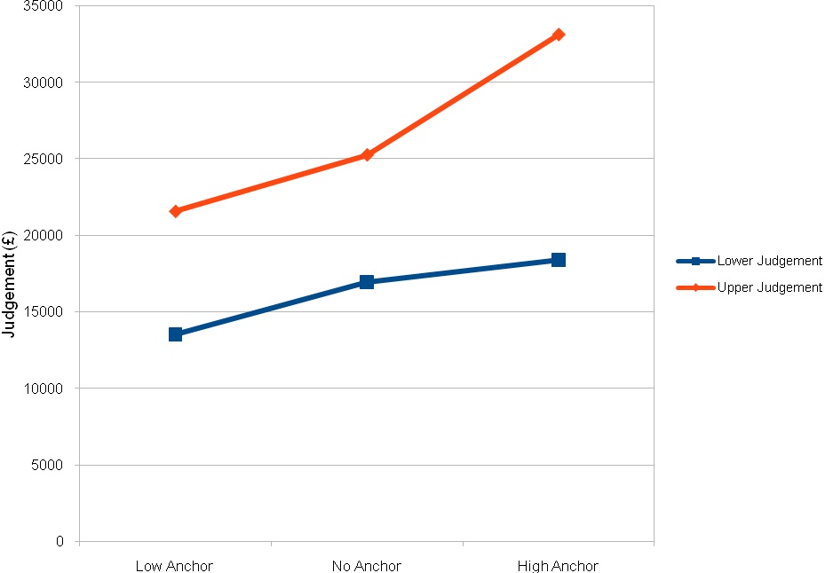

Additionally, the 2x3 mixed ANOVA found a significant interaction between anchor condition and judgement, F(2,159) = 7.25, p < .01, eta-squared = .084. This indicates that the effect of anchor condition depends upon level of judgement; it differs for lower and upper judgements. This is demonstrated in figure 1, as the lines on the graph are non-parallel.
The interaction was decomposed to determine whether anchor condition significantly affects lower and upper judgements. Firstly, a one-way between-subjects ANOVA found a significant difference in participants' lower judgements among the three anchor conditions, F(2,159) = 5.70, p < .01, eta-squared = .067, indicating that there is a significant effect of anchor condition on lower judgements. Subsequently planned comparisons were used to individually compare the low and high anchor conditions against the no anchor condition. An independent-samples t-test found that the lower judgements of participants in the low anchor condition were significantly lower than those of participants in the no anchor condition, t (107) = 2.76, p < .01. This suggests that the low anchor dragged down the participants' lower judgements. However, an independent-samples t-test failed to find a significant difference between judgements of participants in the high and no anchor conditions, t (103) = .84, p > .05, indicating that the high anchor did not affect their lower judgements.
Secondly a one-way between-subjects ANOVA found that participants' upper judgements differed significantly among the three anchor conditions, F(2,159) = 7.92, p < .01, eta-squared = .091, indicating that there is a significant effect of anchor condition on upper judgements. An independent-samples t-test found that upper judgements of participants in the low anchor condition and no anchor condition did not differ significantly, t (107) = 1.57, p > .05, suggesting that the low anchor did not affect participants' upper judgements. However, an independent-samples t-test found that judgements in the high anchor condition were significantly higher than those in the no anchor condition, t (103) = 2.44, p < .05. This indicates that the high anchor increased participants' upper judgements.

Discussion
The research question relates to whether the range of plausible values that students believe will contain their first salary is influenced by anchors. Three predictions proposed how anchors would affect this range: not influencing the range at all, pulling the entire range towards it, or pulling only the nearest end of the range towards it. The results are seemingly consistent with the third prediction; the low anchor dragged down participants lower judgements but did not significantly affect their upper judgements, whereas the high anchor increased participants' upper judgements yet did not affect their lower judgements. This suggests that providing an anchor pulls the nearest limit of the plausible range towards it, but does not influence the other end of the range.
In accordance with previous research including Jacowitz and Kahneman (1995) and Northcraft and Neale (1987), this study further demonstrates that anchors can exert powerful influence over intuitive judgements. The selective accessibility model of this effect would suggest that anchor-consistent knowledge was activated when answering the first question, and this remained activated when providing estimates. However unlike Mussweiler and Strack (2000) further experiments were not conducted to test levels of knowledge activation, which is recommended for replications.

Alternatively, the insufficient adjustment explanation would suggest that anchors biased the closest limit of the range because participants failed to make a judgement that was sufficiently far from it. However since anchor condition was a between-subjects factor, there is little indication of how far participants' anchored responses deviate from their estimates without exposure to an anchor. Thus replications of this study could use a within-subjects longitudinal design, whereby participants provide an estimate before and after receiving an anchor. Using the first, unbiased estimate as a control would minimise possible subject variables such as social rank, as identified by Boyce et al. (2010).
Notably, the difference between the upper judgements of participants in the high anchor and no anchor conditions was greater than the difference between the lower judgements of participants in the low anchor and no anchor conditions. This suggests that providing a high anchor had a greater effect than providing a low anchor; people are seemingly more willing to extend their plausible range towards a higher anchor. This has particular relevance to the study of subjective probability assessments regarding salary judgement: further research could test the prediction that people's plausible ranges are more biased towards an anchor if it seems the more favourable possibility.
Furthermore the results support Jacowitz and Kahneman's (1995) findings regarding people's confidence in their judgements – as participants appeared to treat the anchors as useful information and used it to decide their plausible range. (However, Jacowitz and Kahneman used confidence as a dependent variable). Consequently the findings also support Mussweiler and Strack's (1999) speculations that people do use a range of values when making intuitive judgements, as participants gave their responses in high confidence. Extreme anchors appear to extend this range towards it, and it is suggested that there are mechanisms which compare plausible and implausible values; Mussweiler and Strack (1999) suggest that plausible values generate anchor-consistent information, and implausible values (the anchors) are used as starting points to determine an acceptable value. This is in line with the selective accessibility model. Interestingly Mussweiler and Strack (1999) also indicate that the distribution of possible values for a target may depend on the amount of knowledge about it (i.e. their level of 'certainty') – hence further research could involve testing students with greater knowledge regarding graduates' starting salaries (e.g. finance or economics students) to see whether their plausible range is minimised. Alternatively like Northcraft and Neale (1987), information relevant to the anchor value could be provided (e.g. average starting salaries of graduates in certain professions). Based on previous findings it is expected that anchors will still influence participants' plausible ranges.

References
Boyce, C. J., Brown, G. D. A., and Moore, S. C. (2010). Money and Happiness: Rank of Income, Not Income, Affects Life Satisfaction. Psychological Science, 21(4), pp. 471-475.
Brown, G. D. A. et al. (2008). Does Wage Rank affect Employees' Well-Being? Industrial Relations, 47(3), pp. 355-389.
Epley, N. and Gilovich, T. (2001). Putting Adjustment Back in the Anchoring and Adjustment Heuristic: Differential Processing of Self-Generated and Experimenter-Provided Anchors. Psychological Science, 12 (5), pp. 391-396.
Epley, N. and Gilovich, T. (2005). When Effortful Thinking Influences Judgmental Anchoring: Differential Effects of Forewarning and Incentives on Self-Generated and Externally-Provided Anchors. Journal of Behavioral Decision Making, 18(3), pp. 199−212.
Jacowitz, K. R. and Kahneman, D. (1995). Measures of Anchoring in Estimation Tasks. Personality and Social Psychology Bulletin, 21(11), pp. 1161-1166.
Mussweiler, T. and Strack, F. (1999). Hypothesis-Consistent Testing and Semantic Priming in the Anchoring Paradigm: A Selective Accessibility Model. Journal of Experimental Social Psychology, 35(2), pp. 136-164.
Mussweiler, T. and Strack, F. (2000). The Use of Category and Exemplar Knowledge in the Solution of Anchoring Tasks. Journal of Personality and Social Psychology, 78(6), pp. 1038-1052.
Northcraft, G. B. and Neale, M. A. (1987). Experts, Amateurs, and Real Estate: An Anchoring-and-Adjustment Perspective on Property Pricing Decisions. Organizational Behavior and Human Decision Processes, 39(1), pp. 84-97.
Strack, F. and Mussweiler, T. (1997). Explaining the Enigmatic Anchoring Effect: Mechanisms of Selective Accessibility. Journal of Personality and Social Psychology, 73(3), pp. 437-446.

Tversky, A. and Kahneman, D. (1974). Judgment Under Uncertainty: Heuristics and Biases. Science, 185(4157), pp. 1124-1130.

©Michael Caley. This article is licensed under a Creative Commons Attribution 4.0 International Licence (CC BY).

