Research paper

Sense of belonging: The impact of gender and representation on university students within STEM and Psychology
Lois-lily Olivia Geal
University of Essex

Abstract
Research has indicated that representation (belonging to a gender minority versus a gender majority) can impact one's sense of belonging, with consequences for academic achievement and occupation. Gender disproportion is a problem in the entire STEM industry. The gender difference in the people-things paradigm (a model that outlines the two dimensions of interests and preferences) has robustly accounted for variance in interest, which can predict career choices. In this paper, STEM is divided into the female-dominated subject, Psychology, and the core, more established, male-dominated STEM subjects. In total, 222 university students studying Psychology or STEM participated in an online self-report questionnaire to measure their sense of belonging and people-things orientation. As predicted, men were more things-oriented than women, while women were more people-oriented than men. STEM students were primarily things-oriented, and Psychology students were mainly people-oriented, as hypothesised. Unexpectedly, within STEM, women were less things-oriented than men. In further contrast to the hypotheses, representation did not affect belongingness. Instead, men showed the lowest sense of belonging, regardless of their study subject. Overall, gender had the most significant impact on students' sense of belonging and interest. Intervention programmes for universities and workplaces can use these findings to discourage gender disproportion in STEM and ensure all students can thrive in their environment.
Keywords: Belongingness, representation, psychology, STEM, gender, education, occupation.
Date of Submission: 25.09.2023 Date of Acceptance: 19.02.2024

Introduction

Historical and modern gender roles
Historically, men in Western society provided for their families financially, while women stayed home to care for the children and the household (Machung, 1989). By the late 1980s, the number of working women had doubled in 30 years, with female undergraduate students equally as career driven as their male peers (Machung, 1989). Despite this progress, there is yet to be complete gender parity worldwide in the workplace, with more men than women in high-status and high-paid jobs (Stoet and Geary, 2022). Fields such as science, technology, engineering, and mathematics (STEM) are male dominated in academia and the workplace (Manly et al., 2018). Gagnon and colleagues (2019) reported that women anticipated fewer opportunities, respect, and relatable mentors would be available to them (compared to their male colleagues). Meanwhile, men generally demonstrated a lack of awareness about women's difficulties at work in the computer science field (Gagnon et al., 2019). The current study aimed to understand the factors that could impact the gender disproportion within STEM, to develop interventions that encourage women to enter STEM and feel they belong.

Gender in Psychology and STEM subjects
Within research, there has been an inconsistent understanding of which degrees and careers belong in STEM. This obscurity can complicate students’ view of the field. For example, The National Science Foundation included social sciences in their definition of STEM (Green, 2007), but some literature has excluded the social sciences (Chen and Weko, 2009). Recognising the advancements made by study subjects such as Psychology may seem progressive. For example, psychological research has been pivotal in understanding and treating mental health disorders through medication (e.g., selective serotonin reuptake inhibitors) and cognitive behavioural therapy to support the one in three individuals who are estimated to suffer from a mental disorder (Beck and Clark, 1997; Lai, 2019; Sigurvinsdóttir et al., 2020; Wittchen et al., 2011).
However, not distinguishing between typical STEM degrees (e.g., physics and mathematics) and social sciences may minimise the gender disproportion present within STEM (Baum et al., 2015). When the social sciences were excluded from data exploring the gender imbalance in STEM, the underrepresentation of women in this field was prominent (Manly et al., 2018). To avoid this ambiguity, Baum, and colleagues (2015) separated the two definitions of STEM as core STEM including physical sciences, mathematics, engineering, and computer science, and STEM-ss, which additionally included social sciences. By separating the STEM subjects by gender, the aim is to verify whether there is a prominent issue of gender segregation within STEM, to further allow for a measure of representation; being part of a minority group (e.g., women in STEM/men in Psychology) or a majority group (e.g., men in STEM/women in Psychology). Specifically, Psychology was chosen because it is the primary social science that is respected within STEM as a science (Sage, 2010). Henceforth, ‘STEM’ will refer to the core STEM study subjects outlined above to create a distinction from the female-dominated Psychology study subject (Lippa et al., 2014).

Gender disparity in STEM: Early education and the workplace
Since the late 1990s, more women than men have applied to and begun a university degree, with increasing numbers of women studying a female-dominated science subject and few pursuing an engineering degree (Smith, 2011). This progress has not transferred to the workplace, as women represent only 35% of the workforce across all of STEM (NSF, 2023). An outcome of this gender disparity is evident in the challenges faced by nearly half of the staff in STEM recruitment, who have claimed there was not a substantial number of experienced applicants (CBI, 2012). According to the employers, this is due to the small number of women who apply, and the employers have expressed that the government can ease the problem by encouraging gateway STEM topics earlier in education (CBI, 2012). If more women entered the STEM industry, this could lead to a better environment for employees, economic growth and equality in status and pay. However, research has implied that the main issue starts from a lack of interest or sense of ability in STEM many years before students join university (Nagy et al., 2006). Leslie and colleagues (2015) reported that STEM is often associated with the need for an innate intellectual ability, which has encouraged male students and created doubt for female students. This literature has suggested that male students have a predisposition or an inherent drive for the core sciences that women do not possess.

The People-Things Paradigm (variance in interest)
Moreover, research has suggested that individuals possess many abilities and core characteristics that can explain differences in career choices. Holland’s (1959) model of vocational interests (also called the Realistic, Investigative, Artistic, Social, Enterprising and Conventional [RIASEC] model), outlined six core characteristics of individual vocations, which were later summarised into two main models: the people-things paradigm and the data-ideas paradigm (Prediger, 1982). The people-things paradigm can be further referred to as people-things orientation, separated into people orientation and things orientation accordingly. People orientation refers to jobs that involve interacting with and caring for others, such as teachers, counsellors, and dancers, while things orientation in the workplace includes using career-specific tools, machinery, and mechanisms, such as in laboratories or the building trades (Prediger, 1982). Lippa (1998) investigated gender differences in people-things orientation, concluding that women were significantly more people-oriented in their interests while men were generally more things-oriented. In support, Su and colleagues’ (2009) meta-analysis concluded a significant gender difference across the people-things paradigm. Most women had more social interests than men, with less than a quarter of women more interested in engineering compared to the average man (Su et al., 2009). Men have shown a specific interest in STEM, such as mathematical-based career aspirations (Stoet and Geary, 2022). Recently, more women have reached high-status positions, but these roles are primarily people oriented (Stoet and Geary, 2022). Only 15% of women have secured a things-oriented career, with a specific limitation in STEM (Lippa et al., 2014; Yang and Barth, 2015). Specifically, it was more common for female majors in STEM to report a lack of interest in their degrees (Rainey et al., 2018), thus reinforcing that there is a gender difference in people-things interest and highlighting the paradigm as a strong predictor of women’s choice of degree and career path (Woodcock et al., 2013).

Sense of belonging and representation in university students
Once students have chosen their subject of study, their experiences at university influence how they feel about their degree subject and whether they intend to pursue a related career. Often this has been measured through a sense of belonging, which refers to how much an individual feels included and connected to the people, places, and experiences they encounter (Allen et al., 2021). Belongingness was featured as a love need in Maslow's hierarchy of needs, highlighting a sense of belonging as a required human desire (Baumeister and Leary, 1995; Maslow, 1943). In this paper, belongingness and sense of belonging are interchangeable terms. For students, whether they feel like an accepted and integral member of their chosen institution can impact their sense of belonging, relating to success and academic achievement at university (Ahn and Davis, 2019; Goodenow, 1993). Students with a lower sense of belonging were at a higher chance of considering withdrawal from their degree (Pedler et al., 2021). In male-dominated fields such as STEM, female students believed they would need to work harder and put in more effort than their male peers, resulting in a decreased sense of belonging and academic motivation (Smith et al., 2012). According to Rainey and colleagues (2018), men who majored in STEM reported a higher sense of belonging than women in STEM were likely to. Women who self-identified as a minority had a lower sense of belonging than women who did not, but regardless of identification, maintaining a higher social interaction with peers increased belongingness in all students (Mooney and Becker, 2020). Through a single-gender study program, Rosenthal and colleagues (2011) found that building a social network with similar others improved the sense of belonging for women in STEM. The sense of belonging formed during further education can encourage or dissuade a student from pursuing the field in their future career. Good and colleagues (2012) concluded that female students’ sense of belonging influenced whether they still desired a career in mathematics after graduation. In male students, initially feeling a sense of belonging in their study subject encouraged them to pursue a career in mathematics. Whereas for women, how their sense of belonging evolved throughout their education influenced their desire for a career in STEM (Smith et al., 2012). Sense of belonging throughout education can influence whether women decide to pursue a career in STEM, and the suggestion that they have a lower sense of belonging than men could explain gender segregation across occupations.

Aims and expectations of the current study
This study aimed to measure the impact of gender and representation on the sense of belonging among students studying Psychology or a STEM subject. The minority group refers to being in the underrepresented gender group within a study subject and vice versa. Considering the literature, the first prediction was that level of representation would impact students’ sense of belonging, with minority group students reporting a lower sense of belonging than those in the majority. Specifically, women studying a STEM subject were expected to have the lowest sense of belonging. Secondly, the robust gender difference found in the people-things paradigm was hypothesised to be replicated, with women higher in people orientation and men higher in things orientation. Next, it was predicted that degree subject would align with the people-things orientation, with STEM students higher in things orientation and Psychology students higher in people orientation. Gender and representation were explored concurrently to understand which factors would influence how well students perform at university and how this could influence choices made for future career paths. From here, policymakers, academic institutions, and workplaces could develop interventions to assist all individuals with the tools needed to build a fulfilling career.

Method

Participants
There were 254 participants in the study, but after applying the exclusion criteria, there was a total of 222 (101 females, 121 males). The oldest participant was 54, and the youngest was 18 (median = 22, standard deviation = 6.114).

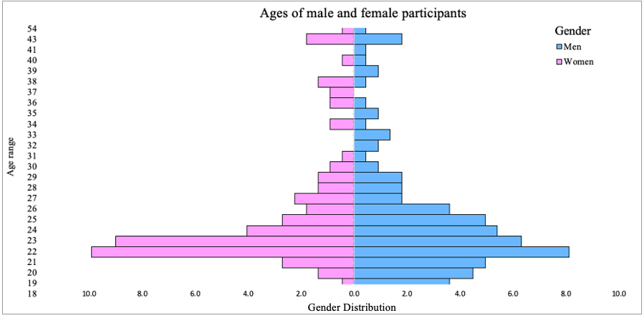
Figure 1. Participants were primarily in their early twenties, with a similar number of men to women.

Exclusion Criteria
One exclusion criterion was not identifying as male or female, so participants of a non-binary gender expression were excluded because the focus was on gender differences in men and women in line with prior literature. Participants of all gender expressions were appreciated but unfortunately, research into gender primarily focuses on cis-men and cis-women at current. Further, participants who reported ‘other’ in the study subject question and did not meet the requirement of either Psychology or STEM were excluded, such as ‘finance’ and ‘neural engineering with psychology’. Finally, participants who did not thoughtfully answer the questionnaire (e.g., missed answers) were omitted from the data to ensure the collection of reliable results.

Recruitment
The group recruited were undergraduate and postgraduate students from the University of Essex in the East of England. The students were either enrolled in the Psychology department or studying a core STEM subject (75 Psychology, 147 STEM). Due to the opportunistic sampling method, the STEM subject participants consisted of Computer Science, Electrical Engineering and Mathematics students. Psychology students were invited to participate in the study through social networking across year groups and at the start of an on-campus lecture. Third-year Psychology students were recruited through the SONA study system for 0.25 credits as part of the PS300 module requirement. STEM students were reached by contacting and meeting with lecturers and module supervisors from the relevant departments. From there, the study link or QR code was uploaded onto Moodle (a University of Essex study website) and presented to students at the start of class.
Participation in this study was voluntary. Research has confirmed that participants withdrew from surveys they deemed too long and repetitive (Sinickas, 2007). Students may be the most challenging group to recruit due to the survey fatigue phenomenon, whereby individuals become inundated with surveys to complete (Karlberg, 2015). To combat this, incentivising a survey to show appreciation for the participants' time can increase response rates (Pecoraro, 2012), especially prize draw lotteries in short surveys (Deutskens et al., 2004). So, an optional prize draw for a £20 shopping voucher was advertised, and a participant was drawn at random using an online spin-the-wheel website after the completion of data collection.

Materials
Data was collected via a self-report questionnaire in the form of an online survey. PsyToolkit was used to compile the questionnaire due to the convenient layout of the website (Stoet, 2010; 2017). Undergraduate students are likely to experience survey fatigue, especially during the dissertation data collection period when there are multiple questionnaires to complete (Porter et al., 2004). Therefore, to ensure valid and reliable results that do not suffer from fatigue, ensuring shorter scale lengths was a factor in finding an appropriate measure.
Two scales formed the questionnaire: sense of belonging and the people-things paradigm. See the appendix for questionnaire items.
Sense of belonging was measured using an instrument developed for research in UK Higher Education (Yorke, 2016). The 16-item questionnaire used a 5-point Likert scale: 5 = strongly agree and 1 = strongly disagree. The questionnaire consisted of three items: belongingness, engagement, and self-confidence. In the current study, only the belongingness item was used to measure sense of belonging in students.
The people-things orientation was measured using Yang and Barth’s (2015) 8-item questionnaire, which used a 5-point scale; 5 = enjoy [the activity] a lot and 1 = not enjoy [the activity], which is a revised version from the 13-item people-things orientation scale (Graziano et al., 2011). Half of the items measured people orientation, and the other half measured things orientation.
Demographic information was collected to monitor potential contributing variables based on participants’ backgrounds. The included data were age, gender, level of study and subject of study.

Design
This study used a between-subjects design, with gender (male or female) and study subject (Psychology or a core STEM subject) as the independent variables. Representation was an additional independent variable used to measure the impact of being in the gender minority (women in STEM and men in Psychology) versus the gender majority (women in Psychology or men in STEM). The three dependent variables were the mean scores of people orientation, things orientation and belongingness.

Procedure
Participants completed the study online via electronic devices (smartphones were acceptable), and the questions were identical for each responder. At the start of the questionnaire, the right to withdraw and an explanation of how to do so were listed in the information and consent form. After completion, a debrief was provided to explain the purpose of the study and remind participants how to contact the principal investigator.

Results

Sense of Belonging
A two-way between-subjects ANOVA was conducted to test university students’ sense of belonging. The analysis showed no significant effect of representation (majority vs minority) on the sense of belonging, F(1, 218) = .514, p = .474, nor a significant effect of the study subject on the sense of belonging, F(1, 218) = .017, p = .895. There was a significant interaction between representation and study subject on the sense of belonging, F(1, 218) = 4.649, p = .032, showing a significant cross-over interaction. These results indicate that male students had a lower sense of belonging than female students due to the interaction between study subject and representation. A follow-up pairwise comparison was conducted to investigate the interaction. Majority students reported a greater sense of belonging based on their study subject, F(1, 218) = 7.038, MSE = .428, p = .009, while there was no significant difference in study subject for minority students’ sense of belonging, F(1, 218) = 1.258, MSE = .428, p= .263. This was inconsistent with the prediction that women in STEM would have the lowest sense of belonging.

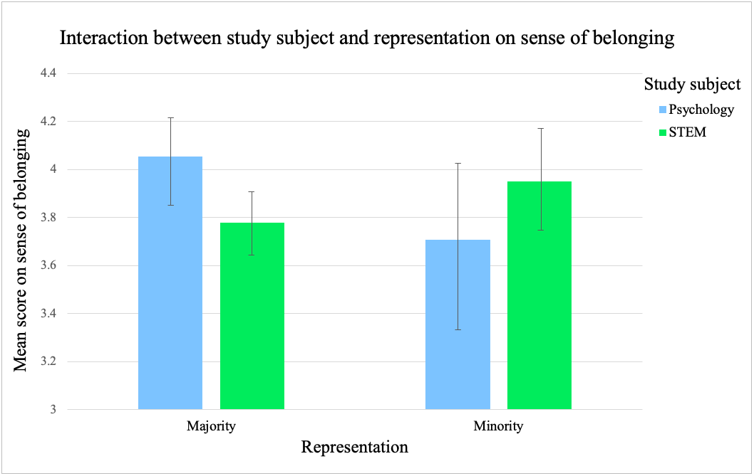
Figure 2. The cross-over interaction between study subject and representation on sense of belonging. Male participants had the lowest sense of belonging compared to female participants.

People-Things Paradigm
A two-way between-subjects ANOVA was conducted to test the mean score of things orientation in university students. The mean for Psychology on things orientation was 10.68 (SD = 4.78) and 15.66 (SD = 3.17) for STEM. The effect size for the difference between these means was large (d = 1.23, using the average standard deviation). The ANOVA showed a significant effect of study subject on things orientation where STEM students were higher than Psychology students on things orientation, F(1, 217) = 29.51, p = <.001. The mean for women on things orientation was 12.0 (SD = 4.86) while the mean was 15.63 (SD = 3.29) for men. The effect size for the difference between these means was large (d = 0.87, using the average standard deviation). The ANOVA showed a significant effect of gender on things orientation where men were higher than women on things orientation, F(1, 217) = 8.51, p = .004. There was not a significant interaction between study subject and gender on things orientation, F(1, 217) = 2.46, p = .119.

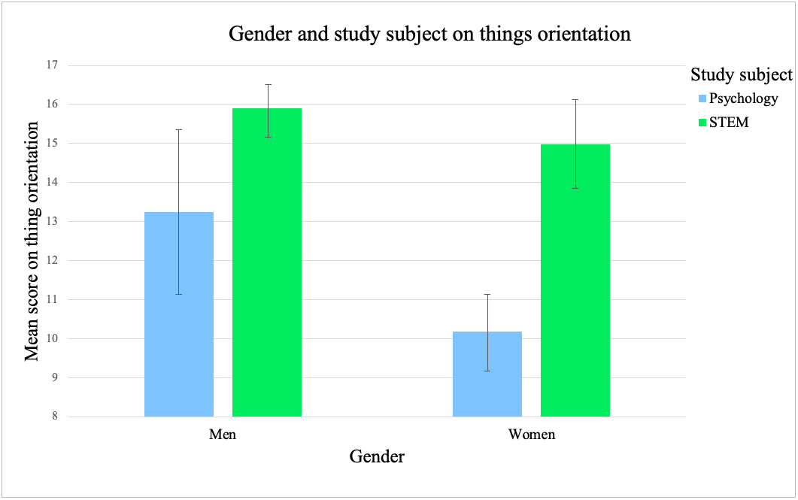
Figure 3. Impact of gender and study subject on the mean scores of things orientation. Men reported higher than women and STEM students reported higher than Psychology students in things orientation. Men in STEM are more things-oriented than women in STEM.

A two-way between-subjects ANOVA was conducted to test the mean score of people-orientation in university students. The mean for Psychology on people orientation was 15.38 (SD = 2.34) and 15.33 (SD = 3.0) for STEM. The effect size for the difference between these means was small (d = 0.02, using the average standard deviation). The ANOVA showed no significant effect of study subject on people orientation where being in STEM compared to Psychology was not impactful on people orientation, F(1, 217) = 29.51, p = <.001. The mean (standard deviation) for women on people orientation was 15.76 (2.74) and 15.0 (2.80) for men. The effect size for the difference between these means was small (d = 0.27, using the average standard deviation). The ANOVA showed a significant effect of gender on people orientation where women were higher than men on people orientation, F(1, 217) = 4.50, p = .035. There was not a significant interaction between study subject and gender on people-orientation, F(1, 217) = .017, p = .896.

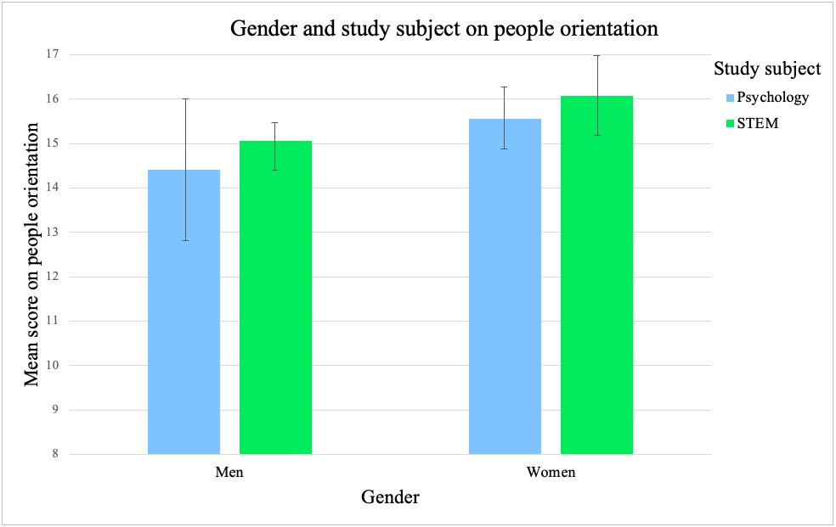
Figure 4. Impact of gender and study subject on the mean scores of people orientation. Women reported higher than men in people orientation, with no impact of study subject on people orientation.

Discussion

Comparison of the predictions versus the results
The current study aimed to measure the impact of gender and representation on sense of belonging across students studying Psychology and core STEM subjects. The first prediction was that minority students, particularly women in STEM, would have the lowest sense of belonging. Instead, this study found that representation did not influence sense of belonging, but gender did. Male students had a lower sense of belonging than female students. Secondly, it was predicted that the robust gender difference reported in the people-things paradigm would be replicated. As anticipated, men were more things-oriented, while women were more people-oriented. The expectation that the study subject would predict orientation on the people-things paradigm was partially confirmed. STEM students were more things-oriented than Psychology students, but study subject did not influence people orientation. Unexpectedly, the results demonstrated a gender difference in things orientation within STEM. Even female students who studied a STEM subject are less things-oriented than their male classmates, which strengthens the impact of gender on the people-things paradigm, rather than degree subject. Gender can account for much of the influence on sense of belonging and people-things orientation, but the exploration of alternative factors will be needed to explain and predict the choices made in study subject and occupation.

A closer consideration of the male student experience
While research on the gender differences in occupations and the challenges women face in STEM is essential for reducing gender disproportion and variance in belongingness (Good et al., 2012; Rainey et al., 2018), focusing research solely on the female experience can neglect the difficulties men experience in academia. For example, the Global Gender Gap Index is formatted whereby only women can appear deprived (Stoet and Geary, 2019). As an alternative, Stoet and Geary (2019) proposed the Basic Index of Gender Inequality measure, which concluded that men were disadvantaged in education, life satisfaction and healthy life span in medium and highly developed countries. This complements the current study’s finding that male students were disadvantaged compared to their female peers, who had a higher sense of belonging. In support of this finding, Xin (2010) reported that female students had a significantly higher sense of belonging than their male peers. Across education, individuals who felt a secure sense of belonging in their environment achieved higher grades than their peers (Brooms, 2019; Pittman and Richmond, 2007). Although women have historically received few academic opportunities (Stoet et al., 2016), more recently, male students have been reported to underperform compared to female students in general achievement across mathematics, science literacy and reading in 70% of all 74 countries that participated (Stoet and Geary, 2015). Alongside this literature, the current findings highlight the need for educational institutes to consider the unique challenges faced by male students and the academic consequences of low belongingness. Going forward, research would benefit from a cross-sectional study to investigate at what stage gender differences in belongingness and academic achievement begin, to build preventative measures for male students. The current findings present gender as a better predictor than representation for students’ experiences at university, but it does not explain the gender disproportion found within STEM.

The importance of socialisation to encourage belongingness in all students
Investigating factors that influence university students’ sense of belonging beyond gender and representation could better explain gender segregation across occupations. Contrary to the literature (Mooney and Becker, 2020), the current study did not conclude that representation influenced university students’ sense of belonging. Instead, one outcome of being in the gender minority is a reduced number of individuals from a similar group to socialise with. Perhaps a measure of socialisation could better explain the imbalance in the sense of belonging among students. According to the interviews conducted by Anistranski and colleagues (2021), social factors accounted for 27% of the variance in students’ sense of belonging. On-campus social connections through extra-curricular activities have assisted students in feeling well-adjusted and valued at university (Baker and Robnett, 2012; Fernandes et al., 2017). Increased peer interaction and social support have been reported as an indicator of a high sense of belonging (Hagerty et al., 1996; Yao, 2015). Specifically, in STEM, women are more likely to seek a handful of similar individuals to build relationships with, whereas men tend to interact with many people (Daniels et al., 2019). Unlike women, men were less focused on building comfortable, close interactions with their colleagues (Daniels et al., 2019). Thus, while men appear to be well socially settled and surrounded by similar others, the quality of such connections may not match those built between women. This could explain male students’ reduced sense of belonging even when they are in the majority group and further rationalise how women are socially well-adapted even when they belong to the minority group. Considering the current study's findings, this has emphasised that being surrounded by many similar others may not be a protective factor for a high sense of belonging. Instead, how students socialise at university may enhance or weaken their belongingness, thus, explaining the gender difference established. Encouraging male students to engage in quality friendships with peers on-campus could improve their sense of belonging. Meanwhile, developing groups for minority women to build relationships with similar others could improve their sense of belonging to the same level as women in the majority (Rosenthal et al., 2011).

Things orientation as an explanation for career choices
As anticipated, the current study complimented the robust gender difference found in the people-things paradigm (Lippa, 1998; Su et al., 2009), further outlining gender as a reliable factor for predicting occupational choices. More specifically, the significance of things orientation was greater than people orientation, which aligns well with research from Graziano and colleagues (2012), who found that gender differences were weaker for people orientation compared to things orientation. Graziano and colleagues (2012) further suggested that things orientation can strongly explain whether students choose to enter STEM. Alongside the findings of the current study, this has indicated that the gender difference in things orientation can most coherently explain the gender difference in occupational choices; more men than women follow things-oriented careers such as STEM.

Interest versus financial security in occupations
Within STEM, women were less things-oriented than men, which could explain the gender disproportion in things-oriented workplaces. Yet, in less developed countries with fewer rights for women, such as Morocco, more women have entered traditionally male-dominated workplaces (Stoet et al., 2022). One explanation for this is the wealth divide across countries. In highly developed countries, closer to gender parity, there are fewer financial limitations which should allow for career choices based on interest rather than necessity (Stoet et al., 2022). Interest as a driving factor was present in the current study as women in STEM were more things-oriented than women studying Psychology. However, the gender difference in things orientation within STEM has indicated that interest cannot entirely explain students’ choice of study subject in a highly developed country.

Considerations for future improvement
Women have become more independent and self-sufficient, which could encourage them to choose well-paid careers, such as in STEM, regardless of interest. In this modern lifestyle, women are more likely to focus on building their profession before considering traditional duties, including marriage and childbearing (Agree, 2017; Sekścińska, 2016). Generation Z employees (born 1996 onwards) reported valuing salary and benefits, highlighting that the younger generation prioritises financial reward more than having a genuine interest in their work (Zahari and Puteh, 2023). The people-things paradigm has robustly presented a gender difference in interest, but the new wave of students joining universities and the workforce appear to hold new values in their decision-making. This could explain the reason for the gender difference in things orientation within STEM; women are choosing their careers based on a combination of interests and financial needs. To encourage more women to join STEM, universities should incorporate people-oriented elements and real-world examples into optional STEM modules to combine the interests expressed between men and women. This could include highlighting female role models such as Nobel prize winner Marie Curie who’s work as a physicist contributed to the fight against cancer – linking STEM to the people-oriented element of care for others. Also, as mentioned previously, dancers are often people-oriented individuals so explaining the laws of physics and movement in relation to dance could engage women in STEM.
Further, interviewing women who have entered STEM, including students who did not complete their course, would allow for a better understanding of how to increase interest, belongingness and build a work/life balance in STEM careers (Yatskiv, 2017). Learning from students directly to build interventions can broaden the likelihood that women will create a good relationship with things-oriented study subjects that can progress beyond education. Additionally, as men and women have robustly shown gender differences in their interests, future interview-based research should focus on how individuals can develop rewarding careers without compromising their passion.
Overall, the challenges faced by men and women in academia need to be studied, and further consideration should be placed on the outcomes of being in a gender minority group rather than representation more generally.

Limitations
A sufficient number of participants were recruited, with an equal distribution of men and women. One problem was that STEM could not be represented entirely by the current population, as the University of Essex does not have a core science department (e.g., physics or chemistry). Rainey and colleagues (2018) included physical sciences when measuring STEM, highlighting their importance when studying STEM subjects. Additionally, less than one-quarter of participants belonged to the gender minority group. An unequal sample can reduce the probability of finding a difference between groups, which could explain why the prediction that women in STEM would have a lower sense of belonging was not found in this study. As should be expected, more majority students will be available for participation, but future research should monitor the recruitment of minority students to ensure less of a substantial group difference. Despite having an uneven distribution of majority versus minority students, Mooney and Becker (2020) found an effect of representation on students’ sense of belonging, so perhaps this limitation was not as critical a contribution towards the null result.
Another limitation could be the interpretation of the measures used. The item “I wish I’d gone to a different university” did not explicitly refer to sense of belonging, so other factors could have impacted how participants responded. Examples include, but are not limited to, feelings of homesickness and loneliness, the location, and a change in preference for the type of university (i.e., city versus campus or traditional versus metropolitan). This has limited the validity of the measure of student sense of belonging, and future research would benefit from considering how clear the measure is to the layperson answering the questionnaire. Potentially, the people-things paradigm measure was too transparent in showing the aim of the study. The investigation of gender differences in sense of belonging and study interests are popular topics in mainstream media. Listing the people-things measure after the sense of belonging measure could have made the topic salient and encouraged demand characteristics. As the two orientations were clearly very different, women in STEM may have rated lower in things orientation than men because of a social desirability bias and an internalised pressure to display an interest in activities that are socially accepted as feminine. Instead, the measure for the people-things paradigm should include ‘neutral’-oriented interests such as art, travelling and music to reduce the likelihood of biased answers.
Further to this, the current study suffered from a restricted sample in terms of gender identifications. One example of this was the exclusion of participants who did not report a binary gender expression. The number of individuals who identify as non-binary (e.g., use they/them pronouns) as their chosen gender expression is rising (Van Caenegem et al., 2014). Although there was only one non-binary participant in the original sample, future research could benefit from learning how non-binary students report on the people-things paradigm. Considering the influence of gender beyond the two traditional sexes would offer a more comprehensive understanding.
Additionally, a weakness of the current study is the lack of consideration for ethnicity as an influence on sense of belonging. World leaders such as Barack Obama have highlighted the need for belongingness in university students, having referred to his struggles with a sense of belonging as a black man (Strayhorn, 2019). In confirmation, research has consistently found that ethnic minorities report a lower sense of belonging than their white peers (Anistranski and Brown, 2021; Yorke, 2014). The current study divided participants based on their level of representation, but this was limited to gender and study subject. Rainey and colleagues (2018) found that black women had the lowest sense of belonging in STEM compared to all other groups of students. The prediction that women in STEM would have a lower sense of belonging might be true for black women but not white women; had ethnicity been a factor in the current study, this could have been verified. Therefore, failing to further distinguish students by ethnicity could explain the unexpected finding that being in the minority group did not reduce sense of belonging for women. Strayhorn (2015) highlighted that the transition period is central for how black students settle into university. Future research could extend the interviews conducted by Strayhorn (2015) to learn how to better integrate students into university, accounting for differences in ethnicity.

Conclusion
To conclude, the current study replicated the gender difference found in the people-things paradigm. This can explain the gender segregation found in the workplace and be used as a tool for predicting occupational choices made by students. Additional factors, such as financial constraints and generational value variances, have been discussed to explain the gender difference in interest within STEM. Future research would benefit from investigating these factors collaboratively to allow policymakers, educational institutes, and companies to encourage women to join the STEM industry and facilitate appropriate support and interest for both genders. The present study further concluded that men were lower in sense of belonging than women, regardless of representation. This has presented the need to consider the difficulties faced by men in academia and the workplace, which should be studied in addition to the extensive literature on the difficulties for women in STEM. Future research should replicate the current study but add ethnicity as a variable to investigate how this influences sense of belonging at university. Interviewing students and qualitatively learning about their experiences could generate a personalised understanding of specific intervention strategies to aid belongingness throughout further education. Gender, but not representation, had a significant impact on the sense of belonging of university students. Going forward, it would be valuable to investigate whether interest in the people-things paradigm can account for sense of belonging.

References
Agree, E. M. (2017) ‘Social Changes in Women’s Roles, Families, and Generational Ties’. Generations 41(2), 63-70.
Ahn, M. Y., and Davis, H. H. (2019) ‘Four domains of students’ Sense of Belonging to University’. Studies in Higher Education 45(3), 622-634. Available at: https://doi.org/10.1080/03075079.2018.1564902.
Allen, K-A., Kern, M. L., Rozek, C. S., McInerney, D. M., and Slavich, G. M. (2021) ‘Belonging: A Review of Conceptual Issues, an Integrative Framework, and Directions for Future Research’. Australian Journal of Psychology 73(1), 87-102. Available at: https://doi.org/10.1080/00049530.2021.1883409
Anistranski, J. A., and Brown, B. B. (2021) ‘A little help from their friends? How Social Factors relate to Students’ Sense of Belonging at a large public University’. Journal of College Student Retention: Research, Theory & Practice, 1-21. Available at: https://doi.org/10.1177/1521025120985107
Baker, C. N., and Robnett, B. (2012) ‘Race, Social Support and College Student Retention: A Case Study. Journal of College Student Development 53(2), 325-335. Available at: https://doi.org/10.1353/csd.2012.0025
Baum, S., Cunningham, A., and Tanenbaum, C. (2015) ‘Educational Attainment: Understanding the data’. Change: The Magazine of Higher Learning, 47(6), 18-27. Available at: https://doi.org/10.1080/00091383.2015.1089755
Baumeister, R. F., and Leary, M. R. (1995) ‘The need to Belong: Desire for Interpersonal Attachments as a Fundamental Human Motivation’. Psychological Bulletin 117(3), 497-529.
Beck, A. T. and Clark, D. A. (1997) ‘An information processing model of anxiety: Automatic and strategic processes. Behavioural Research and Therapy, 35(1), 49-58. Available at: https://doi.org/10.1016/S0005-7967(96)00069-1
Brooms, D. R. (2019) ‘“I was just trying to make it”: Examining urban black males’ sense of belonging, schooling experiences, and academic success’. Urban Education 54(6), 804-830. Available at: https://doi.org/10.1177/0042085916648743
CBI. (2012) ‘Education and Skills Survey’. National Numeracy. Available at: https://www.nationalnumeracy.org.uk/sites/default/files/documents/Recovered/cbi_education_and_skills_survey_-_published_june_2012.pdf (Accessed: 16th April 2023).
Chen, X., and Weko, T. (2009) ‘National Centre for Education Statistics’. Students who study science, technology, engineering, and mathematics (STEM) in postsecondary education. U.S.: Department of Education.
Daniels, H. A., Grineski, S. E., Collins, T. W., and Frederick, A H. (2019) ‘Navigating social relationships with mentors and peers: Comfort and belonging among men and women in STEM summer research programs’. CBE – Life Sciences Education, 18(2). Available at: https://doi/org/10/1187/cbe.18-08-0150
Deutskens, E., de Ruyter, K., Wetzels, M., and Oosterveld, P. (2004) ‘Response Rate and Response Quality of Internet-based Surveys: An Experimental Study’. Marketing Letters 15(1), 21-36. Available at: https://doi.org/10.1023/B:MARK.0000021968.86465.00
Fernandes, A., Ford, A., Rayner, G., and Pretorius, L. (2017) ‘Building a Sense of Belonging among tertiary commuter students: The Monash non-residential colleges program’. Student Success Journal 8(2), 31-42. Available at: https://doi.org/10.5204/ssj.v8i2.380
Gagnon, R. L. Q., Heath, D. S., Koh, K., Lindeman, C., McIvor, A. K., Porthukaran, A. I., and Nicoladis, E. (2019) ‘Exploring Gender Imbalance in Computing Science’. Journal of Interpersonal Relations, Intergroup Relations and Identity 12,33-40. Available at: V12_A3.pdf (jiriri.ca)
Good, C., Rattan, A., and Dweck, C. S. (2012) ‘Why do women opt out? Sense of Belonging and Women’s Representation in Mathematics’. Journal of Personality and Social Psychology 102(4), 700-717. Available at: https://doi.org/10.1037/a0026659
Goodenow, C. (1993) ‘Classroom Belonging among early adolescent students: Relationships to Motivation and Achievement’. Journal of Early Adolescence 13(1), 21-43. Available at: https://doi.org/10/1177/0272431693013001002
Graziano, W. G., Habashi, M. M., and Woodcock, A. (2011) ‘Exploring and measuring differences in Person-thing Orientations’. Personality and Individual Differences (51), 28-33. Available at: https://doi.org/10.1016/j.paid.2011.03.004
Graziano, W. G., Habashi, M. M., Evangelou, D., and Ngambeki, I. (2012) ‘Orientations and Motivations: Are you a “People person” or a “Thing person” or both?’ Motivation and Emotion 36, 465-477. Available at: https://doi.org/10.1007/s11031-011-9273-2
Green, M. M. (2007) ‘National Science Foundation’. Available at: https://wayback.archive-it.org/5902/20160210223704/http://www.nsf.gov/statistics/nsf07307/pdf/nsf07307.pdf (Accessed: 3rd March 2023).
Hagerty, B. M., Williams, R. A., Coyne, J. C., and Early, M. R. (1996) ‘Sense of Belonging and indicators of Social and Psychological Functioning’. Archives of Psychiatric Nursing 10(4), 235-244. Available at: https://doi.org/10.1016/s0883-9417(96)80029-x
Holland, J. L. (1959) ‘A theory of Vocational Choice’. Journal of Counselling Psychology 6(1), 35-45.
Karlberg, C. (2015) The survey fatigue challenge: Understanding young people’s motivation to participate in survey research studies. Master Thesis in Psychology. Lund University Theses. Available at: https://lup.lub.lu.se/luur/download?func=downloadFile&recordOId=7792773&fileOId=7793183 (Accessed: 12th December 2022).
Lai, C-H. (2019) Fear network model in panic disorder: The past and the future. Korean Neuropsychiatric Association, 16(1), 16-26. Available at: https://doi.org/10.30773/pi.2018.05.04.2
Leslie, S-J., Cimpian, A., Meyer, M., and Freeland, E. (2015) ‘Expectations of brilliance underlie Gender Distributions across Academic Disciplines’. Science 347(6219), 262-265. Available at: https://doi.org/10.1126/science.126375
Lippa, R. (1998) ‘Gender-related Individual Differences and the structure of Vocational Interests: The importance of People-things Dimension’. Journal of Personality and Social Psychology 74(4), 996-1009. Available at: https://doi.org/10/1037//0022-3514.74.4.996
Lippa, R. A., Preston, K., and Penner, J. (2014) ‘Women’s Representation in 60 Cccupations from 1972 to 2010: More women in High-status jobs, few women in Things-oriented jobs’. PLoS ONE 9(5), 1-8. Available at: https://doi.org/10.1371/journal.pone.0095960
Machung, A. (1989) ‘Talking career, thinking job: Gender differences in career and family expectations of Berkeley seniors’. Feminist Studies 15(1), 35-58. Available at: https://doi.org/10.2307/3177817
Manly, C. A., Wells, R. S., and Kommers, S. (2018) ‘The influence of STEM definitions for research on women’s college attainment’. International Journal of STEM Education 5(45), 1-5. Available at: https://doi.org/10.1186/s40594-018-0144-1
Maslow, A. H. (1943) ‘A theory of Human Motivation’. Psychological Review 50, 370-396. Available at: https://doi.org/10.1037/h0054346
Mooney, C., and Becker, B. A. (2020) ‘Sense of Belonging: The intersectionality of self-identified minority status and gender in undergraduate computer science students’. In United Kingdom & Ireland Computing Education Research conference (UKICER), 24-30. Available at: https://doi.org/10.1145/3416465.3416476
Nagy, G., Trautwein, U., Baumert, J., Köller, O., and J. Garrett. (2006) ‘Gender and course selection in upper secondary education: Effects of academic self-concept and intrinsic value’. Educational Research and Evaluation 12(4), 323-345. Available at: https://doi.org/10.1080/13803610600765687
National Science Foundation (2023) ‘Diversity and STEM: Women, minorities, and persons with disabilities’. Available at: https://ncses.nsf.gov/pubs/nsf23315/report (Accessed: 21st January 2023).
Pecoraro, J. (2012) ‘Survey fatigue’. Quality Progress, 45(10).
Pedler, M. L., Willis, R., and Nieuwoudt, J. E. (2021) ‘A sense of Belonging at University: Student retention, motivation and enjoyment’. Journal of Further and Higher Education 46(3), 397-408. Available at: https://doi.org/10.1080/0309877X.2021.1955844
Pittman, L. D., and Richmond, A. (2007) ‘Academic and Psychological functioning in later adolescence: The importance of school Belonging’. The Journal of Experimental Education 75(4), 270-290. Available at: https://doi.org/10.200/JEXE.75.4.270-292
Porter, S. R., Whitcomb, M. E., and Weitzer, W. H. (2004) ‘Multiple surveys of students and survey fatigue’. New Directions for Institutional Research 121, 63-73. Available at: https://doi.org/10/100/ir.101
Prediger, D. J. (1982) ‘Dimensions underlying Holland’s hexagon: Missing link between interests and occupations?’ Journal of Vocational Behaviour 21, 259-287. Available at: https://doi.org/10.1016/001-8791(82)90036-7
Rainey, K., Dancy, M., Mickelson, R., Stearns, E., and Moller, S. (2018) ‘Race and gender differences in how Sense of Belonging influences decisions to major in STEM’. International Journal of STEM Education 5(10), 1-14. Available at: https://doi.org/10.1186/s40594-018-0115-6
Rosenthal, L., London., B., Levy., S. R., and Lobel., M. (2011) ‘The roles of perceived identity compatibility and social support for women in a single-sex STEM program at a co-educational university’. Sex Roles 65, 725-736. Available at: https://doi.org/10.1007/s11199-011-9945-0
Sage. (2010) ‘Recognising Psychology as a STEM Discipline’. Available at: https://www.socialsciencespace.com/2010/12/recognising-psychology-as-a-stem-discipline/ (Accessed: 13th April 2023).
Sekścińska, K., Trczińska, A., and Maison, D. A. (2016) ‘The influence of different social roles activation on women’s financial and consumer choices’. Frontiers in Psychology 7(365), 1-13. Available at: https://doi.org/10.3389/fpsyg.2016.00365
Sigurvinsdóttir, A. L., Jensínudóttir, K. B., Baldvinsdóttir, K. D., Smárason, O., and Skarphendinsoon, G. (2020) Effectiveness of cognitive behavioural therapy (CBT) for child and adolescent anxiety disorders across different CBT modalities and comparisons: A systematic review and meta-analysis. Nordic Journal of Psychiatry, 74(3), 168-180. Available at: https://doi.org/10.1080/08039488.2019.1686653
Sinickas, A. (2007) ‘Finding a cure for survey fatigue’. Strategic Communication Management 11(2), 11.
Smith, E. (2011) ‘Women into science and engineering? Gendered participations in higher education STEM subjects’. British Educational Research Journal 37(6), 993-1014. Available at: http://dx.doi.org/10.1080/01411926.2010.515019
Smith, J. L., Lewis, K. L., Hawthorne, L., and Hodges, S. D. (2012) ‘When trying isn’t natural: Women’s Belonging with and motivation for male-dominated STEM fields as a function of effort expenditure concerns.’ Personality and Social Psychology Bulletin 39(2), 131-143. Available at: https://doi.org/10.1177/0146167212468332
Stoet, G. (2010). PsyToolkit – A software package for programming psychological experiments using linux’. Behaviour Research Methods 42(4), 1096-1104. Available at: https://doi.org/10.3758/BRM.42.4.1096
Stoet, G. (2017) ‘PsyToolkit: A novel web-based method for running online questionnaires and reaction-time experiments’. Teaching of Psychology 44(1), 24-31. Available at: https://doi.org/10.1177/0098628316677643
Stoet, G., and Geary, D. C. (2015) ‘Sex differences in academic achievement are not related to political, economic, or social equality’. Intelligence 48, 137-151. Available at: https://doi.org/10.1016/j.intell.2014.11.006
Stoet, G., and Geary, D. C. (2019) ‘A simplified approach to measuring national gender inequality’. PLoS ONE 14(1), 1-18.
Stoet, G., and Geary, D. C. (2022) ‘Sex differences in adolescents’ occupational aspirations: Variations across time and place’. PLoS ONE 17(1), 1-18. Available at: https://doi.org/10.1371/journal.pone.0205349
Stoet, G., Bailey, D. H., Moore, A. M., and Geary, D. C. (2016) ‘Countries with higher levels of gender equality show larger national sex differences in mathematics anxiety and relatively lower parental mathematics valuation for girls’. PLoS ONE 11(4), 1-24. Available at: https://doi.org/10.1371/journal.pone.0153857
Strayhorn, T. L. (2019) College students’ sense of belonging. New York: Routledge.
Strayhorn, T. L., Lo, M-T., Travers, C. L., and Tillman-Kelly, D. L. (2015) ‘Assessing the relationship between well-being, sense of Belonging, and confidence in the transition to college for black male collegians’. Spectrum: A Journal on Black Men 4(1), 127-138. Available at: https://doi.org/10.2979/spectrum.4.1.07
Su, R., Rounds, J., and Armstrong, P. I. (2009) ‘Men and things, women and people: A meta-analysis of sex differences in interests’. Psychological Bulletin 135(6), 859-884. Available at: https://doi.org/10.1037/a0017364
Van Caenegem, E., Wierckx, K., Elaut, E., Buysse, A., Dewaele, A., Van Nieuwerburgh, F., De Cuypere, G., and T’Sjoen, G. (2015) ‘Prevalence of gender nonconformity in Flanders, Belguim’. Archives of Sexual Behaviour Journal 44, 1281-1287. Available at: https://doi.org/10.1007/s10508-014-0452-6
Wittchen, H. U., Jacobi, F., Rehm, J., Gustavsson, A., Svensson, M., Jönsson, B., Olesen, J., Allgulander, C., Alonso, J., Faravelli, C., Fratiglioni, L., Jennum, P., Lieb, R., Maercker, A., van Os, J., Preisig, M., Salvador-Carulla, L., Simon, R., and Steinhausen, H. -C. (2011) The size and burden of mental disorders and other disorders of the brain in Europe 2010. European Neuropsychopharmacology, 21, 655-679. Available at: https://doi.org/10.1016/j.euroneuro.2011.07.018
Woodcock, A., Graziano, W. G., Branch, S. E., Habashi, M. M., Ngambeki, I., and Evangelou, D. (2013) ‘Person and thing orientations: Psychological correlates and predictive utility’. Social Psychological and Personality Science 4(1), 116-123. Available at: https://doi.org/10.1177/1948550612444320
Xin, M. (2010) ‘Sense of belonging to school: Can schools make a difference?’ The journal of Educational Research 96(6), 340-349.
Yang, Y., and Barth, J. M. (2015) ‘Gender differences in STEM undergraduates’ vocational interests: People-thing orientation and goal affordances’. Journal of Vocational Behaviour 91, 65-75. Available at: https://doi.org/10.1016/j.jvb.2015.09.007
Yao, C. W. (2015) ‘Sense of Belonging in international students: Making the case against integration to US institutions of higher education’. Faculty Publications in Educational Administration 45, 6-10.
Yatskiv, I. (2017) ‘Why don’t women choose STEM? Gender equality in STEM careers in Latvia’. International Journal on Information Technologies & Security 1, 79-88.
Yorke, M. (2016) ‘The development and initial use of a survey of student ‘belongingness’, engagement and self-confidence in UK higher education’. Assessment & Evaluation in Higher Education 41(1), 154-166. Available at: https://doi.org/10.1080/02602938.2014.990415
Zahari, S. N. S., and Puteh, F. (2023) ‘Gen Z workforce and job-hopping intention: A study among university students in Malaysia’. International Journal of Academic Research in Business and Social Sciences 13(1), 902-927. Available at: https://doi.org/10.6007/iharbss/v13-i1/15540

Appendix
Questionnaire: Sense of belonging
Question:
For each item below, indicate how much you agree or disagree
Scale:
5 = Strongly Agree
4 = Tend to Agree
3 = Neutral
2 = Tend to Disagree
1 = Strongly Disagree
Items:
- I am motivated towards my studies
- I feel at home in this university
- I expect to do well on my programme
- Being at this university is an enriching experience
- I try to make connections between what I learn from different parts of my programme
- I try to do a bit more on the programme than it asks me to
- I wish I’d gone to a different university
- I seek out academic staff in order to discuss topics relevant to my programme
- I worry about the difficulty of my programme
- I put a lot of effort into the work I do
- I have found this department to be welcoming
- I use feedback on my work to help me improve what I do
- I doubt my ability to study at university level
- I am shown respect by members of staff in this department
- Sometimes I feel I don’t belong in this university
- I’m confident of completing my programme successfully
Questionnaire: People-things paradigm
Question:
For each activity below, indicate how much you would enjoy them
Scale:
5 = Enjoy a lot
4 = Enjoy somewhat
3 = Neutral
2 = Not enjoy somewhat
1 = Not enjoy
Items:
- Redesign and install a stereo system yourself
- Make the first attempt to meet a new neighbour
- Listen with caring interest to an old person who sits next to you on the bus
- Stop to watch a machine working on the street
- Notice the habits and quirks of people around you
- Remove the back of a mechanical toy to see how it works
- Try to fix your own watch, toaster, etc.
- Attempt to comfort a total stranger who has had a disaster happen.

Copyright Statement
©Lois-lily Olivia Geal. This article is licensed under a Creative Commons Attribution 4.0 International Licence (CC BY).

