Research Article
An Assessment of the Problems Affecting Money Markets during the Financial Crisis of 2007-08
Valentinas Civinskas
University of Essex

Abstract
This paper provides an examination of the main problems affecting money markets during the Financial Crisis of 2007-08. Analysis revealed that the most influential problem affecting short-term debt was in repo agreements (repo). Moreover, one of the major roles during the financial crisis was played by the dealer banks, who acted as intermediary in the securities market. This investigation explains how uncertainty in the repurchase agreements led to an increase in the repo haircuts, which was equivalent to substantial withdrawals from the banking system and increased systematic risk. As a result, repo caused an incentive for the financial crisis which had a tremendous impact upon the economy. This research paper concludes that creating a new financial mechanism is vital. Therefore, in order to prevent any possible failure in the future, government needs to ensure that it is taken seriously by providing liquidity support, recapitalisation of distressed banks, whilst also strengthening interbank lending guarantees.

Keywords: 2007-08 Financial Crisis, Money Markets, Financial Crisis, Repo Agreements, Economy

Introduction
As claimed by famous British Historian Ferguson (2012) in his speech, financial markets have been deregulated for more than two decades: “Deregulation in the two decades after the election of Ronald Reagan led to the “disappearance” of thrift from American society and to excessive risk-taking by banks. Deregulation had no macroeconomic benefits; in fact, productivity declined” (Ferguson, 2012, p. 1). As a result of this deregulation, favourable circumstances emerged for the new financial instruments. Gorton and Metrick (2009) stated that the Panic of 2007-2008 was a run on the sale and repurchase market (the “repo” market). The repo market is a very large, short-term market that provides financing for a wide range of securitization activities and financial institutions. This paper will discuss the main problems affecting money markets in 2007-08.
The first part of this essay will offer a brief explanation of the nature of the financial instruments and markets whilst the second will describe how a bank run arises. Finally, this article will conclude with a summary of how the phenomenon affected the money markets.

Financial Instruments and Markets
Money markets are a segment of the financial market in which financial instruments with high liquidity and very short maturities are traded, usually for less than one year. Money markets bring together borrowers and investors without intermediation by banks. The recent problems affecting money markets in 2007-08 took place in the securitized-banking” system, when banks were willing to lend to each other: “The Global Credit Crisis first erupted in summer 2007; in particular, on August 9, 2007, the short-term funding market and interbank lending all but froze” (Shin, 2009, p. 102).

It is worth initially referring to LIBOR (the London Interbank Offered Rate), which is used as a base rate for many financial transactions; in particular, the three-month LIBOR rate which is considered very safe. Based on Arnold’s (2011) research, the official LIBOR rates are calculated by the British Banking Association (BBA) as a panel of 16 UK and international banks are asked at what rates they could borrow money as unsecured loans of various maturities. The loans between banks are made not just in sterling, but in a variety of currencies, and take place in London, one of the leading international financial centres of the world. It is illustrated below how the LIBOR rate was changing; during the Financial Crisis it reached a peak of approximately 6.5% in January 2008, whilst in January 2010, the rate was approximately 0.5%. This example is helpful, as it provides a clear sign that confidence had returned to the banking system and that institutions were willing to lend to each other, thus making the economy more stable after 2007 boom.
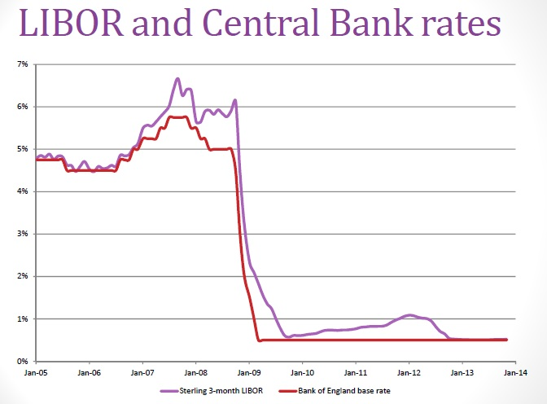
Figure 1 LIBOR and Central Bank rates (Source: lecture money market)

Additionally, the most influential problem affecting short-term debt was apparent in repo agreements. Repo markets are markets in which securities are exchanged for cash with an agreement to repurchase the securities at a future date; in the transaction, securities serve as collateral for what is effectively a cash loan. Repo transactions can be of any maturity, but are generally of a short maturity, ranging between an overnight loan and one year (Group, 1999). Repo markets are a vital source of secured financing for banks and financial institutions, and a key tool for the implementation of monetary policy. When considering the Bank for International Settlements Quarterly Review and the diagrams below, it can be observed that the repo markets have doubled in size since 2002, with gross amounts outstanding at year-end 2007 of roughly $10 trillion in each of the US and Euro repo markets, and another $1 trillion in the UK repo market (Hördahl and King, 2008).
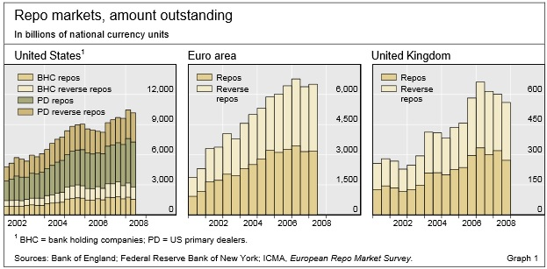
Figure 2 Repo markets and amounts (Source: Hördahl and King, 2008)

In order to mitigate counterparty risk (the risk of the other side reneging), some repurchase agreements are “tri-party” repo. Under tri-party agreement, the securities dealer delivers collateral (something pledged as security for repayment of a loan, to be forfeited in the event of a default) to an independent third-party custodian, such as “Euroclear” or “Clearstream”, who will place it into a segregated tri-party account. This arrangement reduces the administrative burden for the cash-investor. Consequently, the yield on the investor’s cash should be slightly higher. This model is illustrated below (Choudhry, 2012):

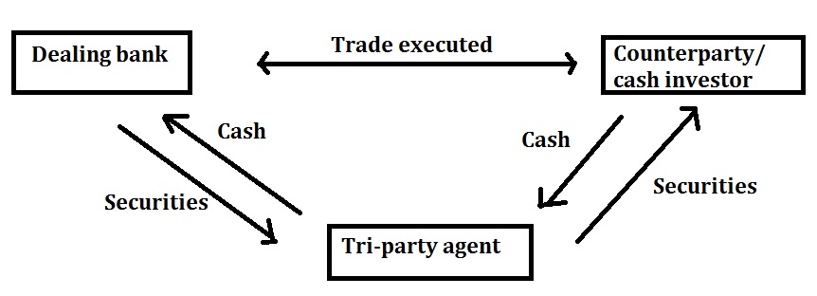
Figure 3 The model of “tri-party” repo (Source: Choudhry, 2012)

Dealer Banks and their Relation to the Recent Problems Affecting Money Markets in 2007-08
During the recent financial crisis, major dealer banks played an influential role in the collapse of the money market. The dealer bank acts as intermediary in the securities market. In substance, they are often part of large financial organizations whose failures can cause significant damage to the economy. As a result, dealer banks, to some extent, are called ‘”too big to fail” and their actions need to be taken seriously in order to avoid collapse within the money market.

In his research paper, Duffie (2010) argues that, in the primary market, the dealer bank sometimes acts as an underwriter that effectively buys equities (the value of the shares issued by a company) or bonds (an agreement with legal force) from an issuer and then sells them after a time to investors. In secondary markets, dealer banks set a ‘bid’ and ‘offer’ price at which they will trade, making profit from the difference between the two prices. Dealer banks dominate the intermediation over-the-counter securities market, covering bonds issued by corporations, municipalities, certain national governments, and securitized credit products. Securities dealers also intermediate in the market for repurchase agreements.

With the purpose to illustrate and give a better indication of the whole situation, the chart below demonstrates that dealer banks tend to generate stocks of collateral in excess of their total balance sheet during periods with stable market conditions. The chart depicts a starting value of around $2.5 trillion in 2005 Q1, that reaches a peak of approximately $4 trillion in 2008 Q1 (Kirk, 2014).
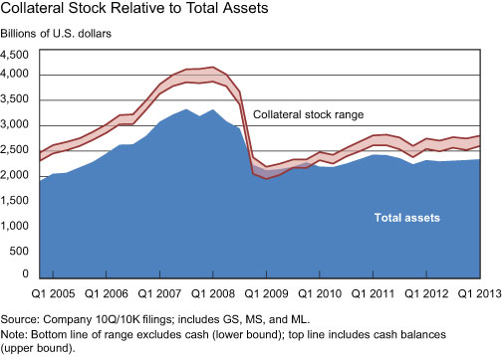
Figure 4 Collateral Stock Relative to Total Assets (Source: Kirk, 2014)

How a Bank Run Arises?
To begin, bank runs occur when a large number of bank customers withdraw their deposits simultaneously, perhaps due to concerns about the bank’s solvency. A bank run is typically the result of panic, rather than actual insolvency. Once an amount of money is deposited into the bank, it goes into a large pool of money alongside everyone else’s. All banks have reserve requirements; therefore some fraction of the money must be kept while the rest is used to make loans. Reserve requirements are vital in order to avoid a traditional-banking run, which occurs when deposits are withdrawn at the same time. Furthermore, securitized banking, or the shadow banking system as Bernanke (2012) defined, is a diverse set of institutions and markets that conduct traditional banking functions. After the recent problems in money markets between 2007-08, it can be stated that ‘‘the biggest threat to the financial system during the crisis was the run of the repurchase market, especially the tri-party operation. Bernanke repeatedly returned to the repo theme, urging the commissioners to include the run on the repurchase market in their research into the causes of the crisis’’ (Bernanke, 2009, p. 1).

This section is based primarily upon the research of Gorton and Metrick (2009), which distinguished between traditional and securities banking’s. In the traditional-banking system, deposits are insured by the government as illustrated in Figure 1. The investors are willing to receive similar protection to that of the traditional banking system; therefore, the investor receives collateral in Step 1 of Figure 2. In practice, this is what is called “repo agreement”. ‘‘Haircut’’ is the difference between the initial and the repurchase prices. It provides the investor with some protection, should the securities (collateral) fall in value before repurchase.
Differe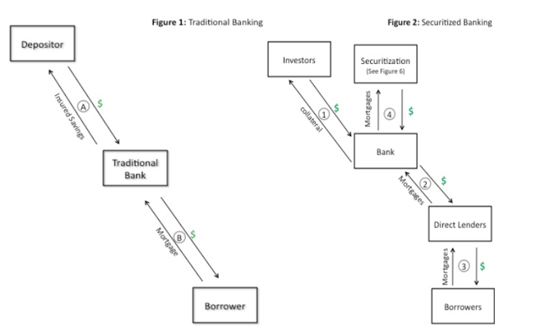
Figure 5 Differences between Traditional and Securitized Banking (Source: Gorton and Metrick, 2009)

The recent “run on repo” can be seen in the graph below, which plots a “haircut index” from 2007 to 2008. The index rose from 0 in 2007, to nearly 45% at the peak of the crisis in late 2008 (Gorton and Metrick, 2009).
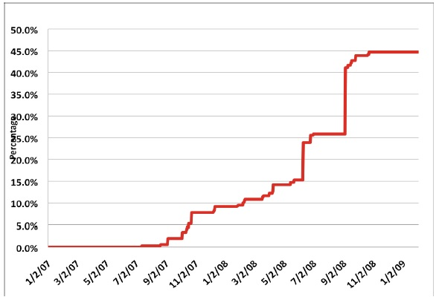
Figure 6 Haircut Index from 2007 to 2009 (Source: Gorton and Metrick, 2009)

Just after the announcement of Lehman Brothers Holdings Inc. bankruptcy, the “haircut index” increased sharply in September 2008: ‘”As much as $75 billion of Lehman Brothers Holdings Inc. value was destroyed by the unplanned and chaotic form of the firm’s bankruptcy filing in September, according to an internal analysis by the company’s restructuring advisers” (McCracken, 2008, p. 1).

Haircuts for repos accurately reflect the overall situation in the recent market that was experiencing many problems. The table below depicts the difference between the typical haircuts rates applied before the peak and the rates during the financial crisis in March 2008. For example, looking at the long term investment, residential mortgage-backed securities, AAA (‘triple A’) would have witnessed a ten time increase in haircuts. As a consequence, an increase in haircuts causes very substantial reductions in leverage. Leverage is the ratio of a company's loan capital (debt) to the value of its common stock (equity). This means that lower leverage involves buying less of an asset through use of borrowed funds (Shin, 2009).

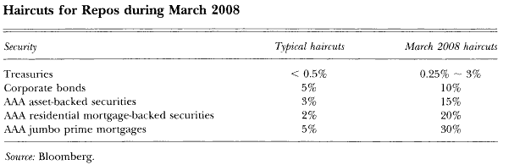
Figure 7 Haircuts for repos during March 2008 (Source: Shin, 2009)

Further to analysis, in order to empirically assess the issue affecting the money markets, subtracting the interest rate on repos from LIBOR can be used as a good measure of risk. The results are illustrated in the figure below which shows the high correlation between the unsecured-secured (Libor–repo) spread and the Libor-OIS spread (Libor-OIS is the difference between LIBOR and the overnight indexed swap (OIS) rates). These results show that the market turmoil in the interbank market was not a liquidity problem of the kind that could be alleviated simply by central bank liquidity tools. Rather, it was inherently a counterparty risk issue (risk of the other side reneging), which linked back to the underlying cause of the financial crisis (Taylor, 2009).
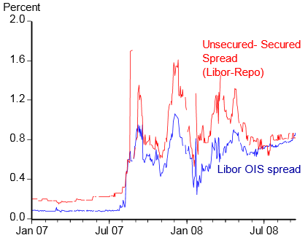
Figure 8 High correlation between the Libor-repo and Libor OIS spreads (Source: Taylor, 2009)

How the Phenomenon Affected the Money Markets?
The crisis was more severe than many were willing to accept and the effect on the global economy was the equivalent of the collapse of the banking system during the Great Depression. After the bankruptcy of Lehman Brothers on Monday, September 15, 2008, the consequences were disastrous; CDS went through the roof, and American International Group (AIG), an American multinational insurance corporation that carried a large short position in CDSs, was facing imminent default. Rescue actions were taken by the Treasury Secretary Henry Paulson, albeit on extremely punitive terms. (Soros, 2009)
Furthermore, Lehman was previously the fourth-largest investment bank in the USA and was one of the main market-makers and a major issuer in commercial paper. The day after Lehman Brothers went bust there was a run on money market funds in full swing, bringing with it instability in the economy. In addition, it caused a panic between depositors according to The Economist (2012):

America’s oldest money-market mutual fund declared that investors could no longer redeem shares at the customary $1 each. In “breaking the buck”, Reserve Primary Fund became the most prominent part of a broader panic that saw investors pull billions from other money-market funds, a major source of short-term lending to banks and companies (Economist, 2012, p. 1).

The next graph shows the actual real GDP (gross domestic product) and estimated real potential GDP in trillions of dollars. By analysing this, it can be assumed that the average annual growth rate starting in 2000 grew steadily without any significant shocks in the market. It would be reasonable to assume therefore, that if the economy had not experienced the financial crisis in 2007, the real GDP trend would have grown alongside the real potential GDP trend. Thus, the output gap between them was 5.5% in 2011 Q4, meaning that the negative output gap caused higher unemployment, lower growth and a fall in output.

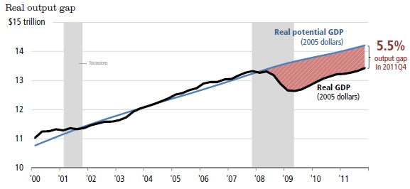
Figure 9 Real output gap (Source: Treasury, 2012)

Eventually, the credit crisis rocked the money market mutual fund industry itself. In September 2008, one of the nation’s largest money market funds, the Reserve Primary Fund, could no longer meet redemptions at a regular level due to the losses it incurred in $800 million worth of Lehman Brothers’ commercial paper and floating rate notes. The effects of the financial crisis were strongly felt and even prompted a mass exodus of withdrawals from money market funds that only halted once the Treasury Department established a $50 billion money market guaranteed fund. Although the panic caused by the initial “run” was halted by the guarantee, total assets held by money market mutual funds have fallen by approximately $1 trillion since the end of 2008. This represents more than a 25% steep decline from the peak holdings of $3.8 trillion. (Papagianis, 2010)

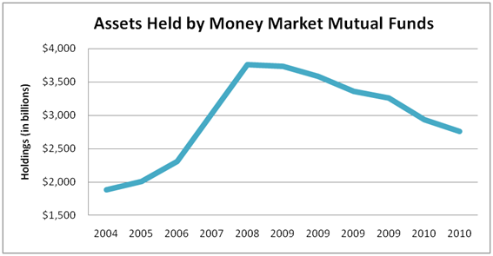
Figure 10 Assets Held by Money Market Mutual Funds (Source: Papagianis, 2010)

Conclusion
In this paper I have demonstrated the impact of repurchase agreements on the problems affecting the money market in 2007-08. After analysis, I can confidently conclude that all of the difficulties can be described as ‘‘a run on repo’’. Uncertainty in the repurchase agreements led to an increase in the repo haircuts, which was equivalent to massive withdrawals from the banking system. Nevertheless, I support the statement of this article, because repo’s undoubtedly deepened the financial crisis and were actually one of its causes. In the cases of Lehman, AIG and other authorities, repurchase agreements played a major role in creating systemic risk, which caused failure of our financial system. All of the above mentioned difficulties could have been avoided if authorities would have been more prudent. However, we can hope to overcome such in the future because economists and the governments are taking it seriously, providing liquidity support and recapitalisation of distressed banks, further strengthening interbank lending guarantees.

I would like to emphasize that only time will show whether we are sufficiently aware and informed after the recent problems affecting the money market. On the other hand, it is always useful to have a careful look back in order to understand and familiarise ourselves with what can be learnt and better performed in the future. The main concept is that creating a new financial mechanism is vital in order to prevent any possible failure in the future.

References
Adam Kirk, J. M. (2014) ‘Mixing and Matching Collateral in Dealer Banks’, Liberty Street Economics, 1 April. Available at: http://libertystreeteconomics.newyorkfed.org/2014/04/mixing-and-matching-collateral-in-dealer-banks.html#.U0QqpVe4bCc (Accessed: 9 June 2016).
Arnold, G. (2011) Modern Financial Markets & Institutions: A Practical Perspective. Harlow: Financial Times/Prentice Hall.
Bernanke, B. (2009) Bernanke emphasizes run on repo and too big to fail. Available at: http://repowatch.org/2011/02/15/bernanke-emphasizes-run-on-repo/ (Accessed: 9 June 2016).
Bernanke, C. B. (2012) ‘Some Reflections on the Crisis and the Policy Response’, Russell Sage Foundation and The Century Foundation Conference on "Rethinking Finance". Princeton Club, New York, 13 April. [s.n.].
Choudhry, M. (2012) The REPO Handbook. Oxford: Butterworth-Heinemann.
Duffie, D. (2010) ‘The Failure Mechanics of Dealer Banks’, Journal of Economic Perspective, 24(1), pp. 51-56.
The Economist. (2012) Money-market funds. Running from the shadows. Available at: http://www.economist.com/news/finance-and-economics/21567078-regulators-seek-shore-up-money-market-funds-against-runs-running (Accessed: 9 June 2016).
Ferguson, N. (2012) The Darwinian Economy. Available at: http://www.bbc.co.uk/programmes/b01jmxqp/features/transcript (Accessed: 9 June 2016).
Gorton, G. and Metrick. A. (2009) Securitized Banking and the Run on Repo. NBER Working Paper No. 15223, pp.1-33. doi: 10.3386/w15223.
Group, R. O. (1999) Implications of repo markets for central banks. Available at: http://www.bis.org/publ/cgfs10.pdf (Accessed: 9 June 2016).
Hördahl, P. and King, M. R. (2008) Developments in repo markets during the financial turmoil. Available at: http://www.bis.org/publ/qtrpdf/r_qt0812e.pdf (Accessed: 9 June 2016).
McCracken, J. (2008) ‘Lehman's Chaotic Bankruptcy Filing Destroyed Billions in Value’, The Wall Street Journal, 29 December. Available at: http://online.wsj.com/news/articles/SB123050916770038267?mg=reno64-wsj&url=http%3A%2F%2Fonline.wsj.com%2Farticle%2FSB123050916770038267.html (Accessed: 9 June 2016).
Papagianis, C. (2010) Do Money Market Mutual Funds Make Sense Anymore?. Available at: http://economics21.org/commentary/do-money-market-mutual-funds-make-sense-anymore (Accessed: 9 June 2016).
Shin, H. S. (2009) ‘Reflections on Northern Rock: The Bank Run That Heralded the Global Financial Crisis’, The Journal of Economic Perspectives, 23(1), pp.101-20.
Soros, G. (2009)The Crash of 2008 And What It Means: The New Paradigm For Financial Markets. New York: PublicAffairs, U.S.
Taylor, J. B. (2009) The Financial Crisis and the Policy Responses: An Empirical Analysis of What Went Wrong. NBER Working Paper No. 14631. doi: 10.3386/w14631.
US Department of the Treasury (2012) The Financial Crisis Response In Charts. Available at: http://www.treasury.gov/resource-center/data-chart-center/Documents/20120413_FinancialCrisisResponse.pdf (Accessed: 9 June 2016).

