Essay

The extent and causes of the declining labour share of income across the globe
Pablo Jose Soriano Mena
University of Essex

Abstract
The global labour share of income has declined over the past few decades. This essay analyses the causes of this trend by studying the relationship between labour share and other economic indicators. Comparisons are made between various regions of the world to assess if the trend is similar worldwide or if there are any observable differences between regional actors. The effects of the COVID-19 pandemic are considered in the study due to its global impact. Finally, a link between the measure of the global labour share and global inequality is addressed while assessing its implications for the economy's future.
Keywords: Labour share of income, gross domestic product, inequality, economics, macroeconomics.

Introduction
The concept of the global labour share and its relationship with other economic measurements, such as the Gross Domestic Product (GDP), will be studied as a first step. Data from the United Nations (UN) is used to assess the trends observed in developed and developing countries and compare results to confirm if the decline is observed with the same intensity worldwide.
Particular attention is paid to the causes of the decline of the labour share of income. The effects of the COVID-19 pandemic are also discussed, particularly in Latin America. Lastly, some possible implications for the economy's future are addressed, especially those related to the relationship between the labour share of income and inequality.

Evidence of the decline in the labour share of income

Labour share
It is the share of GDP paid out in wages, salaries, and other benefits. (Autor and Marginal Revolution University, 2020)
GDP is the market value of all final goods and services produced within an economy in a given period (Mankiw, 2019). It is often represented by: $Y=C+I+G+NX,$ where "Y" is the output, or in this case GDP, "C" is consumption, "I" is investment, "G" refers to government purchases and "NX" is the net exports (Mankiw, 2019).
The production function that describes how economies turn capital into labour is the "Cobb-Douglas production function", $F\left(K,L\right)=AK^{α}L^{1-α}$ where the new addition of "A" stands for the measure of productivity from technology. Finding the corresponding exponent value of Labour $\left(1-α\right)$, correlates to the labour's share of output (Mankiw, 2019).
Another way to arrive at the unadjusted labour share of GDP is by measuring it using the equation below:
$Labour share of income= \frac{Compensation of Employees}{GDP}$ (ILO, 2019)

Cross-country evidence of the declining labour share.
For many years, the labour income share was considered a stable characteristic of macroeconomic work (ILO, OECD and G20 Employment Working Group, 2015). However, a decline has been documented by several authors in recent years, and more attention has been paid to studying its behaviour and causes.
In 2015, the United Nations (UN) adopted the 2030 Agenda for Sustainable Development, including the 17 Sustainable Development Goals (SDGs) that aspire to resolve global economic, social, and environmental challenges.
An "Indicator Framework" was developed in 2017 to track the implementation of the SDGs by all the UN Member States. Indicator 10.4.1 measures the "Labour share of GDP, comprising wages and social protection transfers". This indicator was created to measure the progress towards SDG 10, "Reduce inequality within and among countries" (General Assembly, 2017).
The graph in Figure 1 was created by analysing the UN data for indicator 10.4.1, containing inputs from 2004 to 2017 (United Nations, 2022). It shows a downward trend in the global labour share as a percentage of GDP, as the measure was 53.7% in 2004 and decreased to 51.4% by 2017. The growth reflected between 2007 and 2009 is related to the effects of the Global Financial Crisis, which reduced the global GDP rather than increased employees' overall compensation (World Bank and OECD, 2021).
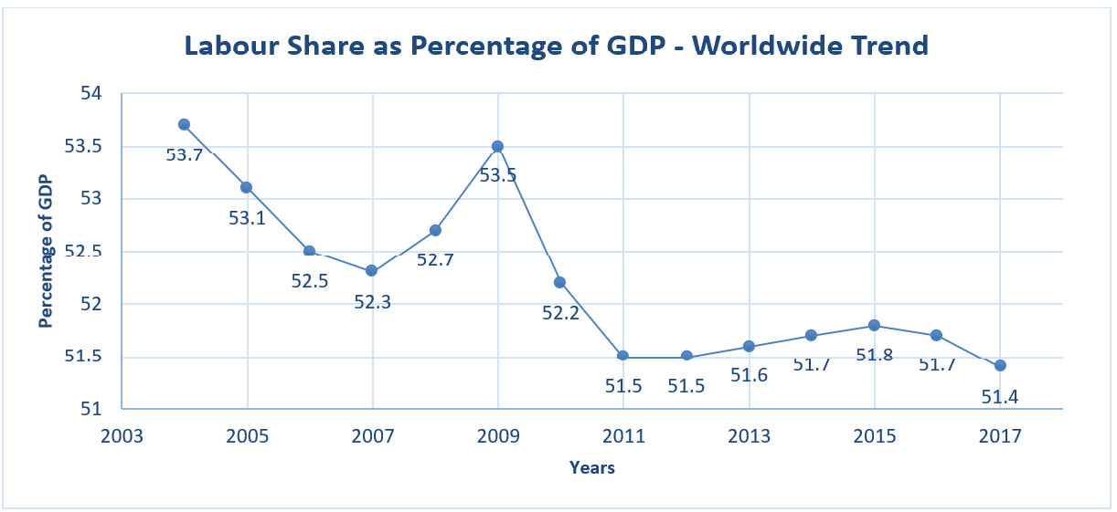
Figure 1: Author calculations based on data for SDG 10.4.1 from unstats.org

In 2019, the UN's Financing for Sustainable Development Report highlighted that the downward trend could have negative consequences on economic growth, for example, if lower income shares constrain household consumption, while the gains of capital are not directed towards investments (Inter-agency Task Force on Financing for Development, 2019).
Having established the existence of a decline in the labour share of GDP, it is also important to examine trends for the different regions around the world and assess if all regions report the same behaviour. This analysis can provide better visibility and explain the decline worldwide.
Figure 2 was constructed with UN data disaggregated by region from 2004 to 2017 (United Nations, 2022). The graph shows that the decline in the labour share of GDP is not a constant trend in all the world regions. Three of the seven regions reported by the UN show an increasing trend, while the other four report a decline. Areas with countries that have higher GDPs are reporting a decline in their labour shares, while regions where countries are in the lower and middle-income spectrum report an increase.
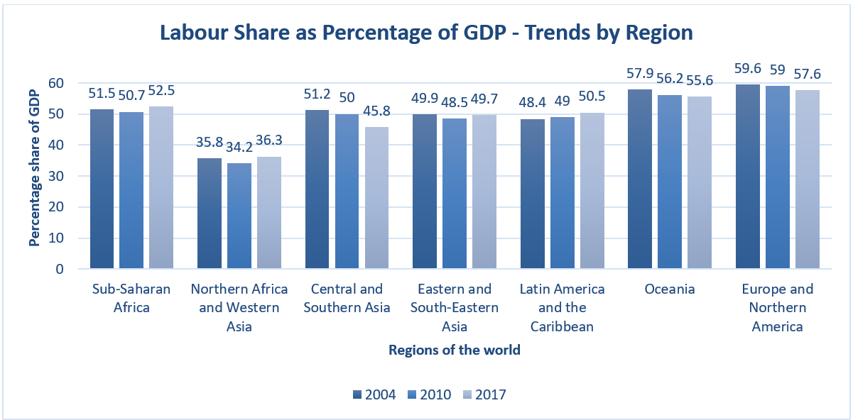
Figure 2: Author calculations based on data for indicator 10.4.1 from unstats.org

It is essential to consider that the graph in figure 2 is not intended to reflect the total GDP output by each region but the trend in the labour share as a percentage of its GDP. Therefore, it does not show the overall weight each region contributes to the global decline trend.
Unfortunately, this disaggregated data was only available from 2004 to 2017, making it challenging to generate a clear assessment until 2021.

Drivers of the decline
Having analysed the decline in the labour share of GDP in most regions around the world, particularly those with higher levels of income, it is essential to assess the different reasons contributing to the trend.
- Investments in capital rather than labour: This has been reported as influencing the decline. The most common investment of capital that can be attributed to contributing towards the reduction of the labour share of income is technology (Autor and Marginal Revolution University, 2020).
This type of investment can occur when firms adopt new technologies and reduce their reliance on labour. Usually, the most affected are the lower-skilled workers, as they perform the tasks easiest to be automated or performed by machines (Autor and Marginal Revolution University, 2020).
- A decline in competition: A firm's market power concentration leads to a decline in competition (Vincent and Kehrig, 2020). This decline means firms no longer have the incentive to lower their prices. The income generated from profits is then directed towards the wages of the owners or shareholders rather than its workers.
- Superstar Firms: Some firms excel in reallocating market shares from small firms, which have a higher labour share, into larger firms, which have a lower share. These large firms have higher productivity and can gain more power in the open market. With their power, they influence the market environment and make it difficult for new firms to enter, therefore protecting their position in the market (Autor and Marginal Revolution University, 2020).
- Trade and globalisation: As observed in the previous section, the decline of the share of labour has not been homogeneous globally. Globalisation implies that firms seek to lower their costs by increasing trade and exploring cheaper alternatives for their goods in the global value chain. Firms may also outsource labour from locations where wages are high to areas where they are low. This activity can provide some rationale for the declining labour income share in developed countries and an increasing trend in developing countries (Inter-agency Task Force on Financing for Development, 2020).
Unfortunately, many developing countries have faced challenges with the collection and systematisation of data, which led to a lack of information available for study. Therefore, it has been challenging to fully validate that trade and globalisation significantly influence labour income share and the different trends observed in developed and developing countries.
All the drivers presented in this section have played a role in the declining trend of the labour income share at the global level rather than one driver on its own (Autor et al., 2017). Since firms have sought to minimise costs and maximise profits, most of these profits were in the form of benefits to their owners and shareholders (Varian, 2020).
This section has demonstrated that a firm is likely to prefer investing in capital, mainly technology, to increase productivity, and to position itself as a better competitor to augment its market share. Firms have also decided to reduce costs by outsourcing labour to markets with lower wages or trading goods produced in countries with cheaper manufacturing costs. Once a firm has achieved a higher market share, it has used its influence to prevent competitors from arising, further solidifying its position. All the increased profits gained through this process are mainly distributed with owners and shareholders, therefore contributing towards a decline in the labour share of income.

Effects of COVID-19
Given that the data presented in previous sections primarily covers from 2004 to 2017, it is essential to consider other significant events that have had substantial effects on the global economy, such as the COVID-19 pandemic in 2020 and analyse how these also affect the labour share of income in recent years.
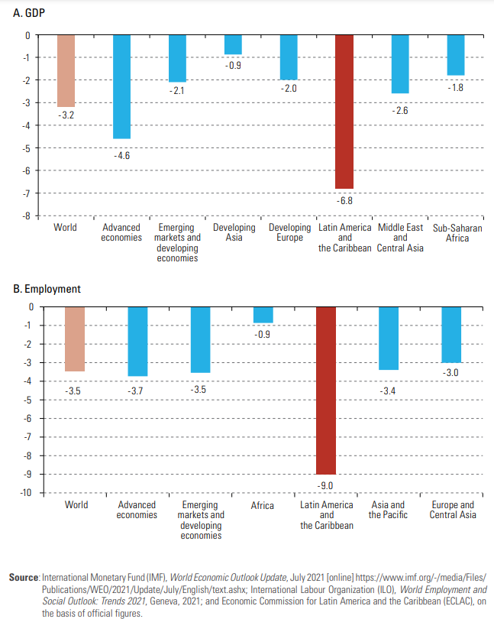
Figure 3: Obtained from the Economic Survey of Latin America and the Caribbean (ECLAC) 2021
The Economic Commission of Latin America and the Caribbean (ECLAC) graphs in figure 3 show how A.-GDP and B.-Employment declined in 2020 due to the pandemic. Worldwide, an estimated 114 million jobs were lost, relative to 2019, which is a figure approximately four times higher than that reported during the global financial crisis in 2008-2009, while an estimated labour income decline of 3.7 trillion USD or 4.4 per cent of global GDP was reported in 2020 (ECLAC, 2021).
The effects on employment and GDP derived from lockdown measures implemented across the globe. Even though the actions propelled the implementation of technologies that allowed remote work, it is essential to note that not all workers could benefit from these developments. Those unable to perform their duties from home were left without pay for a considerable time or faced higher probabilities of contracting the virus by working in exposed environments. Many of these workers were in the informal sector and historically earned lower wages, lacked benefits, and had limited access to social security platforms. It is estimated that this was the case for two billion workers worldwide (Inter-agency Task Force on Financing for Development, 2021).

Implications for the future

Effects on inequality
Another propeller of inequality linked to the decline in the labour share of income is the increased investments towards automation and digitalisation (Inter-agency Task Force on Financing for Development, 2021). Although these lead to higher productivity, there are concerns about a widening gap between productivity and median wages (Inter-agency Task Force on Financing for Development, 2020).
Technological change can be seen as a complementary input to high-skilled workers and a substitute for low-skilled ones (Inter-agency Task Force on Financing for Development, 2020). There is minimal evidence that increased access to digital technologies leads to increased unemployment in developed countries, mainly because introducing these technologies usually implies replacing jobs that become automated for those that are not easily automated (Autor et al., 2017). In developing countries, there is a lack of evidence of this effect. However, this may be more due to a lack of reported data than a lack of impact, as it is considered that the competitive advantage of low labour costs in developing countries may erode due to automation (Inter-agency Task Force on Financing for Development, 2020).

Conclusion
It has been observed that the decline in the labour share of GDP is present in most regions of the world, mainly those with higher GDP, while the regions with poorer countries have not experienced such a decline at the same rate.
However, it has been evident that the economic shocks of the COVID-19 pandemic affect the drivers that influence the decline of the labour share of income, which may become more prominent with time and can serve as the focus for future studies when more data becomes available.
The digital divide was also explored as a driver for inequality with varied effects in developed and developing countries, where labour market skills are contrasting.
The drivers of inequality worldwide are expected to continue to increase if no further action is taken to address them. More inclusive policies can be implemented to foster the regulation of technological advancements and their benefits, which can be shared with the entire population rather than the people in a position to afford them.
Lastly, to have better visibility and higher accuracy of global trends, more effort can be put into studying the economies of developing countries, as activities such as trade and more active participation in the global value chain translate into a higher correlation with the economies of developed countries.

References
Autor, D., Dorn, D., Katz, L.F., Patterson, C. and Van Reenen, J. (2017) ‘The Fall of the Labor Share and the Rise of Superstar Firms’, National Bureau of Economic Research [Preprint]. Available at: http://www.nber.org/papers/w23396 (Accessed: 30 January 2023).
Autor, D. and Marginal Revolution University (2020) The Rise of Superstar Firms and the Fall of the Labor Share. Youtube.com. Available at: https://www.youtube.com/watch?v=wQM-xydsB-s&ab_channel=MarginalRevolutionUniversity (Accessed: 30 January 2023).
ECLAC (2021) Economic Survey of Latin America and the Caribbean, 2021. Santiago. Available at: https://repositorio.cepal.org/bitstream/handle/11362/47193/S2100607_en.pdf?sequence=10&isAllowed=y (Accessed: 30 January 2023).
General Assembly (2017) ‘A/RES/71/313 - Work of the Statistical Commission pertaining to the 2030 Agenda for Sustainable Development’, Resolutions adopted by the General Assembly [Preprint]. Available at: https://undocs.org/A/RES/71/313 (Accessed: 30 January 2023).
ILO (2019) The Global Labour Income Share and Distribution, Methodological description. Available at: https://www.ilo.org/ilostat-files/Documents/Labour%20income%20share%20and%20distribution.pdf (Accessed: 30 January 2023).
ILO and OECD (2015) The Labour Share in G20 Economies. Antalya. Available at: https://www.oecd.org/g20/topics/employment-and-social-policy/The-Labour-Share-in-G20-Economies.pdf (Accessed: 30 January 2023).
Mankiw, N.G. (2019) Macroeconomics. New York: Macmillan Learning.
Vincent, N. and Kehrig, M. (2020) ‘Looking under the hood of the labour share decline: A tale of superstars, rising stars, and shooting stars’, The Centre for Economic Policy Research (CEPR), 14 November. Available at: https://cepr.org/voxeu/columns/looking-under-hood-labour-share-decline-tale-superstars-rising-stars-and-shooting (Accessed: 30 January 2023).
United Nations (2022) SDG Indicators Metadata Repository, United Nations Statistics Division. Available at: https://unstats.un.org/sdgs/metadata/ (Accessed: 30 January 2023).
Inter-agency Task Force on Financing for Development (2019) Financing for Sustainable Development Report 2019. New York. Available at: https://developmentfinance.un.org/fsdr2019 (Accessed: 30 January 2023).
Inter-agency Task Force on Financing for Development (2020) Financing for Sustainable Development Report 2020. New York. Available at: https://developmentfi nance.un.org/fsdr2020 (Accessed: 30 January 2023).
Inter-agency Task Force on Financing for Development (2021) Financing for Sustainable Development Report 2021. New York. Available at: https://developmentnance.un.org/fsdr2021. (Accessed: 30 January 2023).
Varian, H.R. (2020) Intermediate Microeconomics: A Modern Approach. W.W. Norton & Company.
World Bank and OECD (2021) GDP (current US$) | Data. Available at: https://data.worldbank.org/indicator/NY.GDP.MKTP.CD (Accessed: 30 January 2023).

