Essay

Stanstrete
Jimmy Measures
University of Essex

Abstract
Stanstrete is a psychogeographic work of semi-fiction. Rooted in the first-person present-tense style of ‘new nature writing’, the essay follows a real-life journey from London Bridge to Chichester, Sussex, which took place across February and March 2022. The Romans built Stane Street in order to ferry troops and goods in three day’s walk from Noviomagus Reginorum, their new capital of Britain, to the new point of crossing the Thames. The road kinks to avoid inconvenient topography. It is unclear, forgotten, yet still present. The spirit of John Clare looms large as this unreliable narrator and their familiar take us on an extended dérive along Stane Street in reverse, assessing and speculating on the layers of history that form the palimpsest of the nation. 2,000 years of history are bound together in Stanstrete, and stories unfold within stories as thoughts and ideas rise to its surface. Anything could happen, but nothing does.
Keywords: Psychogeography; dérive; détournement; Stane Street; Romans; John Clare; Suffragettes; witches; capitalism; plagiarism; here; the.

London Bridge to Morden
The road is straight, forward; the task is perfectly straightforward. London Bridge to Noviomagus. It begins HERE.
A single word still visible on a gravestone pinned by other long-forgotten memorials to the northern wall of St George The Martyr. A busy wren chirrups; flits from raised chard bed to stack of headstones, and to my shoulder. Her sharp slick of eyeliner makes her look as though she’s ready for battle, or adventure, or at least a night out. I name her Pocket. I am building my legion.
We head south-southwest, waiting for lights to turn colours. The pink elephant has gone now. Elephant recurs on surface after surface. Everyone knows the Elephant, no need to use ‘and Castle’. We skirt Little Portugal, passing deferential pubs and Georgian streets named after landowners, nothing to see HERE, and arrive at Tooting in the dark.
A bustling marketplace on Stane Street, aromas drive us peckish. The legion has a short break. We take crab claws and shell-on prawns deep fried nose to tail. The onward road beckons us into dirty suburbia. Leaving the best guess at Stane Street, we find the Wandle. Still quite a river despite, or because of, its culvert. There is life here. We would have gladly slipped into the Traf for a swift half, but it’s gone. Standing empty, it remembers drunken nights, revolutionary discussions, fistfights. ‘This Pub is Protected by Guardians’ the message runs, warding off occultists, squatters.
Trudging on with bored, cold steps, Morden eventually arrives. A vixen, iridescent under a streetlight, eyeballs us as she chuffs a discarded hotdog. A network of non-human intelligence seeks refuge in marginal and hidden locations, determined to preserve the possibility of life’s survival on the planet. She uses the shadows. I wish blessings upon her sisterhood. We fall into step behind her.

Morden to Ewell
Albion, already bilious, is ailing like a lame animal. A plague has been sweeping the land for the best part of two years, bringing sickness and death to our island, and I have caught the malaise. A storm rages outside, but I’m too delirious to pay attention. A setback, but the free time is useful to undertake further travel around England, with The Narrator as tour guide, from the comfort of a nest.
The virus eventually lifts, and Stane Street beckons. A slighter task to begin with because I am weakened. Pocket is glad to be back outside. The day runs from glorious warm sunshine into torrential hailstorm then bitter cold wind. The Stane Street footpath runs out at Stoneleigh, so we enter Nonsuch Park, and get lost. Cold to the bone, tired and overwhelmed legs nearly knocked up and beginning to stagger. The only sound is my own breath, my feet stuttering to make a path. Are we the only ones in the only world? And just when we work out what’s happened a redwing emerges from the scrub. She doesn’t want to join our legion. Not that she’s aloof, just busy. She has her own business to attend to and doesn’t have time for names, introductions, tasks other than her own.

Ewell to Mickleham
Stane Street loses itself in the back gardens of suburban Epsome. It cannot be traced but a semblance offers a dérive through culs-de-sac, down footpaths, across railway lines, and around graves. A triumvirate of boneyard crows, a conspiracy to murder, eye us dubiously. Pocket stays close, nestles on my clavicle.
A few yards from the route stands the Cottage Hospital where, on the 8th of June 1913, Emily Wilding Davidson was brought to die of her injuries. She had on her a return ticket to Victoria. Perhaps she doubted whether she’d go through with the plan, or perhaps the plan was to disrupt the Derby, attempt to pin a green/white/purple banner on the King’s horse, or perhaps she thought she wouldn’t be too badly injured, or perhaps she thought she’d be able to evade capture by the agents of the state, or perhaps it was to trick those agents that she was just going for a day out at the races.
Instead, she martyred herself. The pack passed, Anmer was off the pace, third to last. Davidson climbed under the fencing sighting her target. She was resolute. It was beyond brutal. The newsreel cuts as spectators rush to ogle. Wholly past saving, she was brought to die HERE. On the centenary, Tory-run Epsom & Ewell Borough Council planted a commemorative Acer davidii and small plastic sign noting the dignitaries’ contribution in a corner of the car park.
The route of Stane Street is cordoned off, not for an incident, but to protect privately owned land from legions retracing Roman steps. No access onto the Royal Automobile Club’s Private Members Golf Course. We search for form and land. A diversion climbs onto Epsome Downs and leads us to where Davidson committed her act of freedom. If she had survived, she would have been further subjected to force feeding and state-sponsored torture. Davidson and comrades protested and died to win the vote. Every adult regardless of gender now has the opportunity to spoil their ballot paper.
The neurotic government, comprised of abject incompetents, which won power by lying to the credulous about the causes of their problems, is obsessed with stoking a culture war. Encouraged by the Telegraph and other gutter press, it seeks to poison everyday life and criminalise protest. The deliberately vague language will enable the police to act unilaterally with near unlimited discretion, all because citizens woke up to institutional police brutality against still-oppressed minority groups, downed colonial statues and threw them in the docks. We have never left the age of the slave traders.
One hundred and seventy furlongs and Stane Street becomes a green lane. We are walking on chalk; compacted crustacean remains fifty miles from the sea and 100m above sea level. A burnt-out car rusts into the earth. The aftermath of the storm is evident and the mud is dense, but we manage. I chat with suspicious passersby while Pocket enjoys the thickets. A jay is busy in the understory, searching for her buried acorns. We cross the M25, the bridge marginally less terrifying than anticipated, and descend in a kind of vale.

Mickleham to Holmwood
Bikers meet at the foot of Box Hill. Surrey County Council improved road safety on the stretch of A24 from Leatherhead following large numbers of crashes and deaths. The café feared for its business model, but the bikers still come. They admire one another’s shiny machines in the extensive car park.
Romans crossed the Mole HERE at Burford Bridge and so has every civilisation thereafter. There’s no sign of Stane Street so we use footpaths across the vineyard. A slight climb on south-facing slopes before descent into Darking. The remains of a peregrine kill shimmering redly feed the grass in St Martin’s churchyard.
Alleyways link the Darking streets. We pop out in West Street, next to its junction with South Street and the High Street. Elizabeth Hatton, the last witch condemned to death in Surrey, was hanged HERE in 1655. Two children had died of bewitchment. Someone whispered about Elizabeth. The whisper became plausible, became open talk, became truth enough although still a lie. Society used to kill women with lengths of rope and with the king’s horse and with one hundred thousand pinpricks. Society kills women still, with each spurious arrest while the current government refuses to consider making misogyny a hate crime.
Stane Street is lost in the tunnels under Darking. There are no clues until it reappears as a dotted line on a paper map in the fields to the south as:
Stane Street
ROMAN ROAD
(course of)
The land is privately owned, empty paddocks fenced and gated. There is no access to 92% of England’s land. The landowner lives in fear. We might wake up from our stupor, we might think to abolish private property and reclaim the commons. We went no further in that direction.
We traipse across bogs, slog uphill through pine forest, navigate undergrowth, and clamber over huge trees downed from above by the storm like a domino rally. Reality off-kilter. Lost, found, lost again. Glimpses appear, disappear, reappear, seen through a filter. Doubt and hopelessness make me turn feeble. Another peregrine kill: a rabbit this time, stripped of everything but its head and short length of porcelain spine. Nothing seems clear when looked at straight on until a song thrush stoops from the hedgerow. Like a gipsey she dances in circles, all around us and all over the world. The sun begins to set across the AONB. We are in the shadow of Leith Hill, the dark descending.
Out of place as ever, a pheasant stalks Platform 1.

Holmwood to Billingshurst

I walk; therefore I am.
Billingshurst to Bignor
Shapes move in peripheral vision. A kestrel has been following us since Ockley, where the Pharisees moved the church from its intended position. She stays in sweep just the other side of the road, keeps eyes on us. She doesn’t worry Pocket; she watches over us. We navigate the verges of the A29 stepping in, avoiding blowouts, when large fast vehicles approach. This is often.
On the 17th of July 2000, the body of Sarah Payne, a violated seven-year-old schoolgirl, was found HERE, on Stane Street just north of Pulborough. Sarah’s mother became a campaigner and enjoyed the support of the reactionary tabloids, yet still had her phone hacked by Rebekah Brooks. Sarah’s father took 14 years to drink himself to death. There is no memorial in this place. People forget if they can. The land remembers.
Stane Street kinks at Hardham Station: a Mansione to serve the needs of legions one day’s march from Noviomagus Reginorum, the new capital. We hop over the stile and immediately lose way. Mud thickens, blisters chafe. A civil old woman and a young country wench set us in an approximation of the right direction. An ash broken by the storm blocks the way. Fractured split skin reveals pale white flesh. I touch it, drink it in, run my lip against a smooth inch, Pocket soothed by this interaction. My blood simulating ecstasy, swirl around and let go.
We follow a former railway line, likely closed by the 1960s Torys, then a footpath more like a stream, pause at the view across private land as we re-cross Stane Street briefly, find the A road again then country lanes, head up into the Downs and onto muddy bridleways. Blackcaps caper in the margins. We are tired and hungry but thankfull to have a leg to move on. That night, we are visited by owls and an angel. She hangs brightly over me, fades into me.

Bignor to Noviomagus
Everything we are building is already a ruin - Raoul Vaneigem
We climb Bignor Hill in thin drizzle, as rain up on the forehead where the mist’s for hire if it’s just too clear. Rivulets develop into clear chalk streams. Primroses thrive at the roadside. Ramsoms push through the dappled woodland floor. We are lost again, for quite a time. Then Stane Street pitches off the Downs in relief. Beech, introduced by the Romans, grows directly out of the Street. The storm has done for this one; like Albion the heartwood was apparently rotten.
Stane Street runs through Maudlin and past the Household Waste Recycling Centre. A veteran holm oak gives a pleasing asymmetry to a new roundabout on the edge of town. A clear chalk stream, culverted, runs beside Stane Street into Noviomagus. We could drink it, bathe in it, let the clear cool Downs water cleanse away the day’s walk, but there’s no way down, or back up again. We are alienated, cut adrift inland.
Caesar brought the entire military-industrial complex of the Empire to bear HERE. Engineers, and legions; conscripts, and slaves; employed and indentured; invested in infrastructure. All for hubris and the Britons’ freshwater pearls. England is a colony, there was nothing here before the Romans came. Taught by the masters and then again by the Normans, once we had the industrial strength, we would go on to become the world’s colonists, painting the globe pink. The evil that men do lives after them, the good is oft interred with their bones. We have never left the age of the slave traders.
We were left with a Roman Road that wasn’t even straight, built on a seam of blood beneath the earth. A violent artefact carving its way through the Jerusalem we’ve been continuously unable to imagine, let alone build.
We walk around the walled city ramparts, destroyed, and rebuilt by William the Bastard, marvel at the warmth of March just shy of the Ides, and head for the station. Nearby, the culverted chalk stream has become virtually stagnant. It trickles over thick black sludge, a shopping trolley, accumulating detritus. Alienated again; no one would bathe in this. I say goodbye to Pocket and wish her well. She eyes me quizzically, hands speaking for me and with relief I realise she’s HERE to stay. Phew for a minute there I lost myself.
I lost myself.
Out of place as ever, we stalk Platform 1.

Stanstrete: Commentary
My notes from the Memory Maps seminar held on 10th February 2022 amounted to two words and a symbol: original + experimental. I’d resolved to walk the length of Stane Street with very little planning; confidence based on belief that something would turn up: “original + experimental” was the only advice needed to set off.

Plagiarism / Détournement.
Plagiarism | ˈpleɪdʒərɪz(ə)m |
The practice of taking someone else's work or ideas and passing them off as one’s own.
Early 17th century: from Latin plagiarius ‘kidnapper’ (from plagium ‘a kidnapping’, from Greek plagion).
The major influence on the development of Stanstrete was the concept of plagiarism, or détournement as applied psychogeographically. Stewart Home has written extensively on the subject in both Festival Of Plagiarism and Neoism, Plagiarism & Praxis:
“Plagiarism is the conscious manipulation of pre-existing elements in the creation of ‘aesthetic’ works. […] Isidore Ducasse (1846-70), who is better known by his pen name Lautreamont […] wrote: ‘Plagiarism is necessary. Progress implies it’. This maxim summarises the use to which plagiarism has been put ever since. Two, or more, divergent elements are brought together to create new meanings. The resulting sum is greater than the individual parts.
“The Lettristes, and later the Situationists, called this process ‘détournement’ (diversion is a literal translation from the French), but the activity is still popularly known as plagiarism – the term that Lautreamont used.
“Plagiarism enriches human language. It is a collective undertaking far removed from the post-modern ‘theories’ of appropriation. Plagiarism implies a sense of history and leads to progressive social transformation.”
Elsewhere, Home discusses plagiarism as being a “positive creative technique”, giving as an example Malcolm Dickson’s appropriation of the May ’68 slogan “Beneath The Cobble Stones The Sewer” as a reference, bleakly reframed, to the failure of the uprising. Home sees plagiarism/détournement as generating creativity whilst debasing notions of ownership. Home states: “there is no absolute truth”, and this inspired the use of others’ work as part of the text. This is mitigated by adding a footnote wherever such a détournement appears.
Anne Fadiman has also written on the subject. Fadiman’s essay Nothing New Under the Sun is a meditation on plagiarism and its effect on her own family. Fadiman has a humorous take on the subject, stating: “The more I’ve read about plagiarism, the more I’ve come to think of literature as one big recycling bin”, acknowledging the debt owed to Alexander Pope (1776) for that particular inspiration.
The concept of détournement offers the freedom to pluck inspiration from wherever it can be gained. Altogether, I came to the psychogeographic conclusion that blatantly nicking other people’s work is absolutely fine if you’re brazen and honest about it, brazenness and honesty being two qualities I greatly admire.

Influences.
Along with Stuart Home’s various writings on plagiarism, the key texts influencing this work are John Clare’s Journey from Essex, Raoul Vaneigem’s The Revolution of Everyday Life, and Patrick Keiller’s triptych of Robinson films (and accompanying texts).
John Clare’s Journey is a heartbreakingly painful and beautiful account of his days on the road to Northamptonshire following his absconding from an asylum in Essex. I sought to capture the essence of Clare’s mental illness/ neurodivergence/ deep melancholy that permeates his text in the more eccentric and quixotic elements of Stanstrete. Détournement on Clare’s text succeeds in the sections describing the natural world and I used his words to embellish the text on my own mental and physical health during the walk. Clare’s Journey has beguiling turns of phrase which work well when used verbatim as détournements in Stanstrete.
Both Vaneigem and Keiller, however, see the world through clear eyes, and their work inspired the lucid tracts of Stanstrete. Vaneigem tackles capitalism’s effect on human society. Unsure about The Revolution of Everyday Life to begin with; I had concerns that he was ranting incoherently (albeit amusingly), but these was dispelled by learning he was a member of the Situationniste Internationale alongside Guy Debord. They attended Henri Lefebvre’s social science module together at Nanterre in the late 1950s. I guess that makes him pretty cool (to me anyway).
Keiller (second-hand through Robinson’s words as related by The Narrator) confronts a wide range of subjects critiquing English society, such as land ownership, the monarchy, the Conservative Party, defence of the realm, and how we punish those judged to be criminals. These stark analyses have clarity and anger. I sought to achieve a similar examination of some of our current society’s ills, which frankly can mostly all be blamed on twelve years (and, sadly, counting) of inept and utterly damaging Conservative government. There are tracts in Stanstrete which the reader could hear in Paul Scofield’s voice (as The Narrator of Keiller’s London and Robinson in Space).
A wide variety of music, musicians, and song lyrics became significant elements of the walk, much of Stane Street follows modern, noisy, roads which needed drowning out. In Robinson in Ruins, The Narrator states: “The music industry is one of the UK’s most successful and brings in more money from abroad than motor manufacturing, its products often characterized by sexual ambivalence and a traditional English contempt for petit-bourgeoise England.” Aphex Twin, David Bowie, th’ Faith Healers, PJ Harvey, King Krule, Massive Attack, The Nightingales, The Orb, Radiohead, Marry Waterson, The Wedding Present, Working Men’s Club, Young Marble Giants, and plenty more international artists all had a guiding hand on the walk. It was inevitable that song lyrics would make their way into the text as détournements, particularly when they add a Clareian, ethereal, or abstract quality. They were indeed Little Hits of Dopamine. I was glad to unplug, however, during Stane Street’s rural sections.

Psychogeography.
A former Memory Maps student stated: “The uncanny (unheimlich), the uneasy sense that all is not well, that there is a lurking unidentifiable threat, is something that is central to psychogeography”. I don’t disagree with that statement, but I believe that there is more to it. To self-plagiarise from introductory text written for the Language of Experimental Cinema showing of Robinson in Space on 23rd March 2022: consider that maybe you’re the threat, you’re noticing rather than complicitly engaging. The Establishment finds that threatening, it prefers the appearance of solemnity. Reject and subvert […] institutions [that] seek to wear you down and make you conform. They demand deference, don’t give it to them. Keiller’s Robinson draws back the curtain to show us the real England. Embarking on a quixotic, uneventful, quirky, and disturbing dérive is, in my view, the essence of psychogeography.
I completed eighty miles of walking and strove not to mention too much about it. The walk was time for thinking, listening to music and the ambient sounds of rural England (whenever possible), and gaining inspiration. The reader has a feeling that there is travelling going on, but… well that’s not what it’s about. It’s about observing one’s surroundings. Taking an active, critical role in assessing the environment. Noting what I saw, heard, smelled, touched, or otherwise perceived. Noticing architecture, infrastructure, dereliction, liminal spaces, rust, typeface, flora, magical animals, non-verbal communication. Straying from the path (intentionally or otherwise), engaging and developing the imagination, making connections, taking notes, taking pictures. Wondering if everything was okay, or if it was ever so slightly out of kilter.

Original + Experimental.
Modern English psychogeography has a lineage running in a wonky line, like Stane Street, from Dada to the London Psychogeographical Association (LPA), via surrealism and the Situationists. The Glossary pages on the LPA’s website define of everyday words (‘Association’, ‘or’, and ‘Queen’, for example) in a psychogeographic context. The entry for ‘the’ offered the opportunity to begin the piece with an immediate footnote, a statement of intent.
Psychogeography is, in essence, experimental. It encourages thinking in new and unusual ways. In Stanstrete, the use over-long and digressive footnotes take the reader on a series of meanders away from the main journey. In How I Escaped My Certain Fate, Stewart Lee uses extensive footnotes to describe his creative processes when developing and delivering stand-up comedy routines. …My Certain Fate would still be very funny without his footnotes, but he uses them to both illuminate and undermine his main text. With Lee as inspiration, I sought to use the footnotes as subtexts in which I could add further Keillerian explorations and add supporting information where necessary.

The walk.
On the three main historical events discussed: Emily Wilding Davidson’s protest, Elizabeth Hatton’s hanging, and the discovery of Sarah Payne’s body; each offered an opportunity to consider violence carried out against women and girls by, respectively, the state, society, and the media.
The News of the World, under Rebekah Brooks’ editorship, betrayed the trust of Sarah’s grieving mother. Emily Wilding Davidson’s protest was no doubt scorned at the time by the likes of the paternalistic colonialist Hilaire Belloc, but today is lauded while the government passes legislation to limit protest. With the treatment of Elizabeth Hatton’s hanging, I sought to explore the notion that women should know their place, that still persists in our patriarchal society (memorably skewered by Harry Enfield and Chums). The notion of witchery, or, rather, that witchery is evil and must be punished, is deeply rooted in the inherent misogyny of the patriarchy. I took the opportunity to address these issues in a Vaneigemesque/Keillerian manner. The reference to spurious arrests is intended to not only invoke the abduction and murder of Sarah Everard by a serving Metropolitan policeman, but also the heavy-handed policing of the subsequent vigil. Vaneigem rails at the one hundred thousand pinpricks meted out by society on its own members. I put forward that what Vaneigem terms “pinpricks” could also be called “spurious arrests”.
My pencilled note in the margin of my copy of Merlin Coverley’s passage regarding Alfred Watkins in Psychogeography reads “Stane Street”. I wasn’t sure what it was; a vague notion, perhaps, of a Roman Road, a straight line in the nearby landscape before I’d properly read Watkins (he might have put me off the idea). Watkins led me to Belloc, further research led me to citizen historians; enthusiasts who have considered and attempted to find Stane Street, often failing. Defoe doesn’t need reading from start to finish, I dipped in to find what he made of the places I was visiting. Searching for folklore and occultic shenanigans turned up some fascinating stories. Stanstrete is an amalgamation of that prior knowledge.
In a nutshell, if the Romans had built Stane Street in a straight line, it would have been 55 miles 3 furlongs. They took topography into account, avoiding the most inconvenient hills and passing opportune watercourses, constructing it over 57 miles 1 furlong. It’s surprisingly hilly. It’s mostly invisible, lost, under private and public land. It’s garden paths, it’s suburbia, it’s the A29. It crosses fields, where you can still see traces, clues. A gateway or an out-of-place straight line across a field. You learn to see it in places where it’s long forgotten. It is almost a dream; it requires the imagination to bring it into the present. You can’t follow it faithfully anymore, and I got lost a lot. I contrived to extend it to 80 miles 1 furlong. Stane Street, Stanstrete, it just means ‘Stone Street’.
I asked the man in the food bank in the crypt of St George The Martyr if it was okay to poke around. He wasn’t aware of any Roman Roads. It’s a large church and I imagine the grounds were once extensive, now much reduced. There were raised beds, a few unstable looking chairs, and headstones stacked leaning against the wall. HERE the only word still legible. [YOU ARE] HERE became the recurring motif, like a tourist information board.
A straight retelling of a journey from point A to Point B would have been neither original nor experimental, and certainly not psychogeographic. A general feeling of travel on foot is present and drives the narrative. I had company, human company, for two sections of the walk: Mickleham to Holmwood, and Bignor to Noviomagus, and I can confirm Will Self’s assertion that there are only two types of walk: accompanied or unaccompanied. It was great fun to share the experience with people who understood the purpose. Btw, each encounter with an animal really did occur: the fox, the redwing, the crows, the jay, the peregrine kills, the song thrush, the pheasant, the kestrel (or kestrels, probably, she seemed to be following us for quite some miles), the blackcaps, the owls in the nighttime, and even the angel (yes, really). I was thrilled to see a wren in what remains of the churchyard on Southwark High Street, and it felt right to have her join me for the walk. First person still, but slightly off-kilter. I felt her presence comfort me, and honestly, I still do. I have tried to work out what Pocket represents; I have some ideas, but I can’t say for sure. I am, however, certain that John Clare would understand.
The Walk
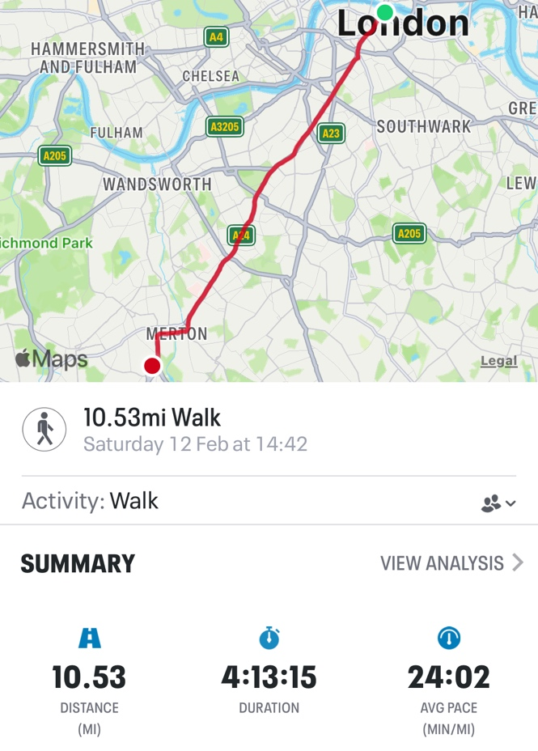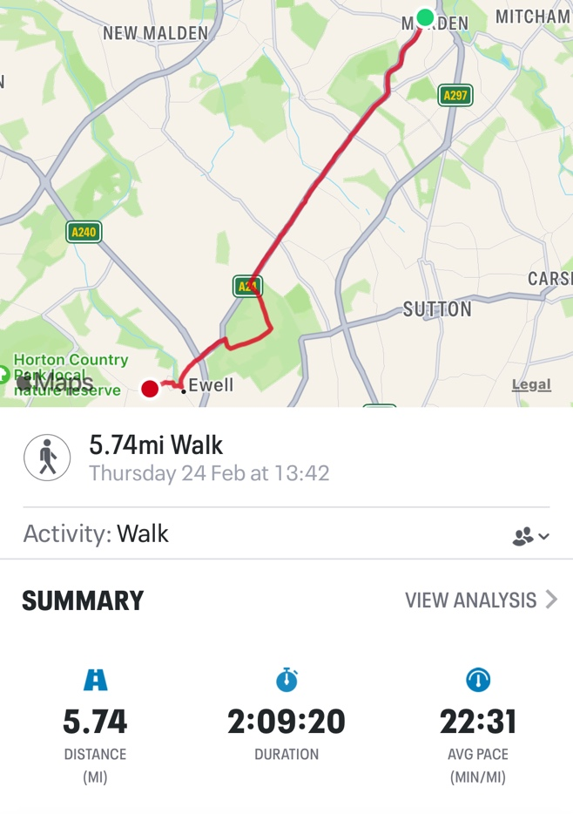

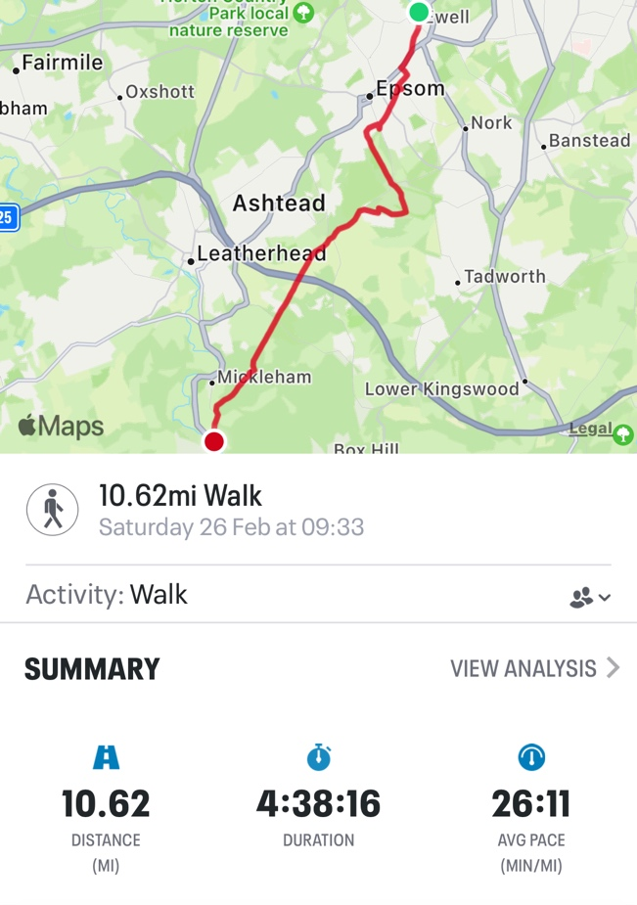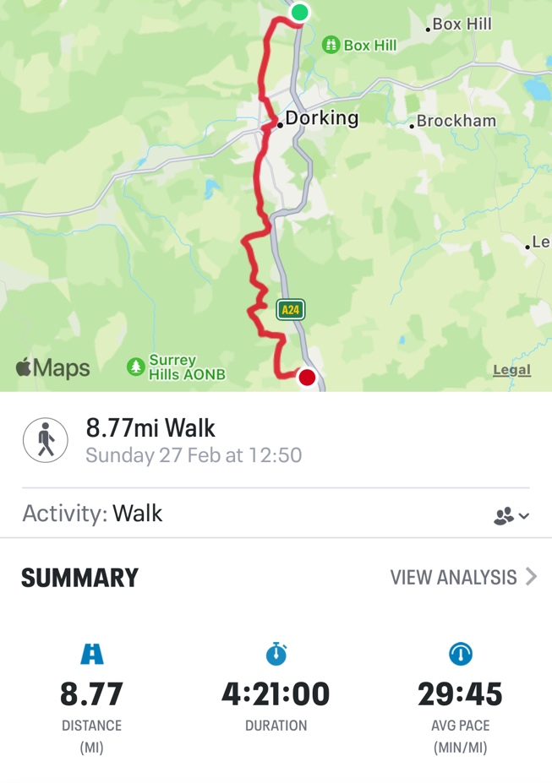
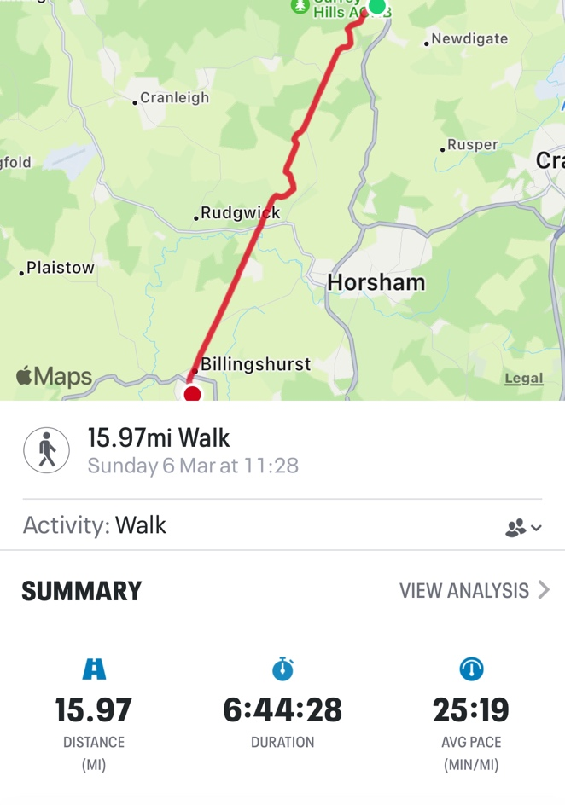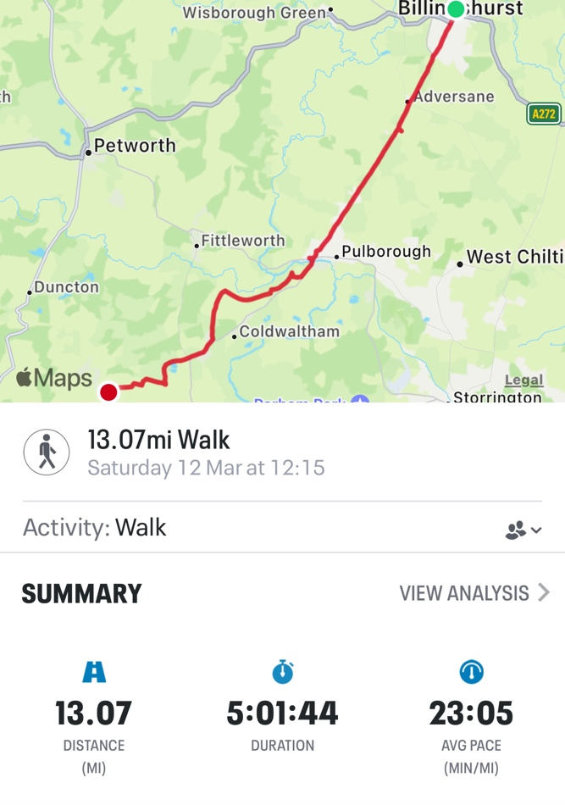

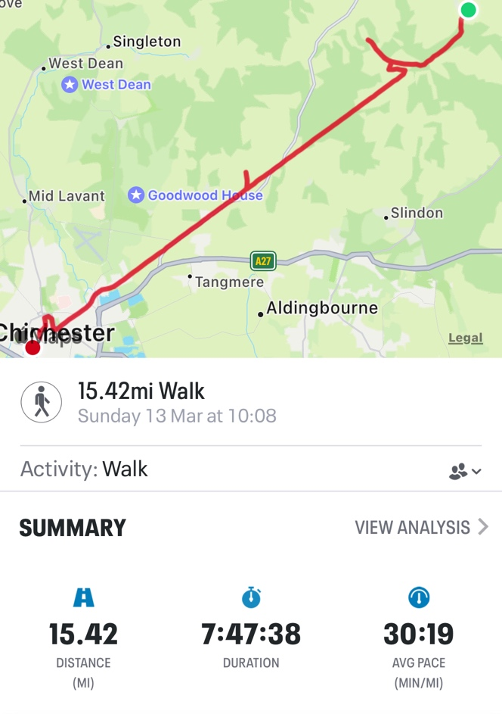

Bibliography
Alexander, Matthew, Folklore of Surrey. Abinger Hammer, Dorking: Surrey Archaeological Society, 2021.
Anarchist Communist Group, Land and Liberty. n.d. n.p. Available to order from: https://www.anarchistcommunism.org/publications/
BBC Studios, “Women: Know Your Limits! Harry Enfield – BBC Comedy.” YouTube, accessed 31.03.2022, https://www.youtube.com/watch?v=LS37SNYjg8w
Belloc, Hilaire, The Stane Street. London: Constable & Company, 1913.
Berger, John, Ways of Seeing. London: Penguin Design Series, 2008.
Blackie, Sharon, If Women Rose Rooted. Tewkesbury: September Publishing, 2019.
Clare, John, “The Journey from Essex.” In John Clare: The Journals, Essays, and the Journey from Essex, edited by Anne Tibble, 117-124. Manchester: Carcanet New Press, 1980.
Clare, John, The Shepherd’s Calendar. Edited by Eric Robinson and Geoffrey Summerfield. London: Oxford University Press, 1964.
Coverley, Merlin, Psychogeography. Harpenden: Pocket Essentials, 2010.
Cuervo, Maria J. Pérez (ed), The Hellebore Guide to Occult Britain. England: Hellebore Books, 2021.
Defoe, Daniel, A Tour Through the Whole Island of Great Britain. Harmondsworth, Middlesex: Penguin Books, 1971.
Fadiman, Anne, Ex Libris, London: Penguin Books, 1998.
Foulds, Adam, The Quickening Maze, London: Jonathan Cape, 2009.
Goodare, Julian, “Women and the Witch-Hunt in Scotland”, Social History Vol. 23, No. 3 (Oct. 1998), pp. 288-308, accessed 26.03.2022, https://0-www-jstor-org.serlib0.essex.ac.uk/stable/4286516?seq=2
The Guardian, “Suffragette Emily Davidson knocked down by King’s horse at Epsom,” You Tube, accessed 24.02.2022, https://www.youtube.com/watch?v=8qkU_imbFoE
Home, Stewart, Conspiracies, Cover-Ups & Diversions. London: Sabotage Editions, 1995.
Home, Stewart, “Events Leading To The Festival Of Plagiarism,” 1989, accessed 22.02.2022, https://stewarthomesociety.org/festplag.htm
Home, Stewart, Neoism, Plagiarism & Praxis. Edinburgh and San Francisco: AK Press, 1995.
Home, Stewart, “Part II: The Festival Of Plagiarism,” 1989, accessed 25.02.2022, https://stewarthomesociety.org/features/festplag2.htm
Home, Stewart, “The Situationist International in its ‘Heroic’ Phase (1957-62)” (pp 31-40), in The Assault on Culture, (Stirling: AK Press, 1991).
Keiller, Patrick, London. London: Fuel Design & Publishing, 2020.
Keiller, Patrick, director. London. Koninck/BFI, 1994. 85 minutes. https://player.bfi.org.uk/subscription/film/watch-london-1994-online
Keiller, Patrick, The Possibility of Life’s Survival on the Planet, London: Tate Publishing, 2012.
Keiller, Patrick, director. Robinson in Ruins. Royal College of Art, 2010. 101 minutes. https://player.bfi.org.uk/rentals/film/watch-robinson-in-ruins-2010-online
Keiller, Patrick, Robinson in Space. London: Reaktion Books, 1999.
Keiller, Patrick, director. Robinson in Space. Koninck, 1997. 79 minutes. https://player.bfi.org.uk/rentals/film/watch-robinson-in-space-1997-online
Kill the Bill Official, “Joint Statement”, n.d., accessed 07.03.2022, https://docs.google.com/document/d/1NFw4I_yp30IdY8RFc1rGx7hURzcHWBMTppSZS9IDBys/edit
Lee, Stewart, How I Escaped My Certain Fate, London: Faber & Faber Ltd, 2011.
London Psychogeographical Association, The, n.d., accessed 21.02.2022, https://www.unpopular.org.uk/lpa/words/the.html
London Psychogeographical Association, What is Psychogeography?, n.d., accessed 24.02.2022, https://www.unpopular.org.uk/lpa/words/psy-geo.html
London Psychogeographical Association, Words, n.d., accessed 25.02.2022 https://www.unpopular.org.uk/lpa/words/word.html
Macfarlane, Robert, “Introduction” In The Old Straight Track by Alfred Watkins, XII-XLV. London: Head of Zeus, 2021.
Macfarlane, Robert, Landmarks, London: Penguin Books, 2016.
Macfarlane, Robert, The Old Ways, London: Penguin Books, 2013.
Neill, W. N., “The Professional Pricker and His Test for Witchcraft”, The Scottish Historical Review, Apr. 1922, Vol. 19, No. 75, pp. 205-213, accessed 26.03.2022 https://0-www-jstor-org.serlib0.essex.ac.uk/stable/25519442?seq=1
Ordnance Survey, Explorer Map 120 Chichester [1:25,000], Southampton: Ordnance Survey, 2007.
Ordnance Survey, Explorer Map 121 Arundel & Pulborough [1:25,000], Southampton: Ordnance Survey, 2010.
Ordnance Survey, Explorer Map 134 Crawley & Horsham [1:25,000], Southampton: Ordnance Survey, 2009.
Ordnance Survey, Explorer Map 146 Dorking, Box Hill & Reigate [1:25,000], Southampton: Ordnance Survey, 2008.
Ordnance Survey, Explorer Map 161 London South [1:25,000], Southampton: Ordnance Survey, 2007.
Pavey, Philip, “Following Roman Stane Street on foot through Epsom and Ewell.” 2021, accessed 18.02.2022, https://eehe.org.uk/wp-content/uploads/2021/05/StaneStreetWalkersGuide.pdf
Public Delivery, “Barbara Kruger’s I shop therefore I am – What you should know”, n.d., accessed 23.02.2022, https://publicdelivery.org/barbara-kruger-i-shop/
Self, Will, and Macfarlane, Robert, “Walking Wild Britain”, The Big Issue, 25th June 2012, accessed 05.04.2022, https://moodle.essex.ac.uk/course/view.php?id=4146&section=8
Siddique, Haroon, “Campaign to make misogyny a hate crime rebuffed by Law Commission”, The Guardian, 7th December 2021, accessed 26.03.2022, https://www.theguardian.com/lifeandstyle/2021/dec/07/campaign-to-make-misogyny-a-hate-rebuffed-by-law-commission
Suetonius, The Twelve Caesars. Translated by Robert Graves. Harmondsworth, Middlesex: Penguin Books, 1962.
Tversky, Amos, and Kahneman, Daniel, “Availability: A Heuristic for Judging Frequency and Probability”. In Cognitive Psychology, 5, (1973), 207-232, accessed 24.02.2022 https://0-www-sciencedirect-com.serlib0.essex.ac.uk/science/article/pii/0010028573900339?via%3Dihub
Vaneigem, Raoul, The Revolution of Everyday Life. Translated by Donald Nicholson-Smith. Oakland: PM Press, 2012.
Victim Support, “Modern Slavery”, n.d., accessed 05.04.2022, https://www.victimsupport.org.uk/crime-info/types-crime/modern-slavery/
Watkins, Alfred, The Old Straight Track. London: Head of Zeus, 2021.

Discography
Bowie, David, The Man Who Sold the World, track 8 on The Man Who Sold the World. Westminster: Parlophone, 1970.
Harvey, PJ, Good Fortune, Track 2 on Stories from the City, Stories from the Sea. Universal Island Records, 2000.
Mazzy Star, Fade into You, track 1 on So Tonight That I Might See. Santa Monica: Capitol Records, 1993.
Mazzy, Star, She Hangs Brightly, track 4 on She Hangs Brightly. Santa Monica: Capitol Records, 1990.
Pavement, Here, Track 9 on Slanted and Enchanted. NYC: Matador Records, 1992.
Pom Poko, My Blood, track 2 on Birthday. London: Bella Union, 2019.
Radiohead, Karma Police (Remastered), track 6 on OK Computer OKNOTOK. London: XL Recordings, 2017.
St Vincent, Rattlesnake, track 1 on St. Vincent. NYC: Seven Four Entertainment and Republic Records, 2013.
Waterson, Marry, and Barker, Emily, Little Hits of Dopamine, track 3 on A Window To Other Ways. London: One Little Independent Records, 2019.
Williams, Ralph Vaughan, The Lark Ascending, track 3 on Vaughan Williams: Tallis Fantasia, Fantasia on Greensleeves & The Lark Ascending by Academy of St Martin in the Fields & Sir Neville Marriner. Kensington: Decca, 197.

© Jimmy Measures. This article is licensed under a Creative Commons Attribution 4.0 International Licence (CC BY).

London Psychogeographical Association (LPA), The, nd, https://www.unpopular.org.uk/lpa/words/the.html According to the LPA, ‘the’ “is defined by definition defining itself.” It is proposed that it was first word in the English lexicon, evidenced in the Testament of St John: “In the beginning was the word” (my emphasis).
Belloc, Hilaire, The Stane Street, (London: Constable & Company Ltd, 1913), 280. A détournement from Belloc’s assertion: the task is perfectly hopeless. He was exasperated that adequate records of Stane Street’s correct route through urban London were no longer available, if they ever had been. It’s hard to feel too sorry for Belloc, nothing’s ever his fault and he would have much preferred Stane Street to have been entirely privately owned by the landed gentry these last two thousand years. Belloc would never trust the commoner, nor “the barbaric inhabitants of Ireland and of Scotland” (9), to take adequate care of an historical monument.
Pavement, Here, track 9 on Slanted and Enchanted, (NYC: Matador, 1992). The walk developed a soundtrack, the headstone provided the first cue; a pleasing symmetry happening between Pavement and the act of walking. There was inspiration in Pavement’s unconventional early-90s indie, which set the tone for plagiarisation and détournement of song lyrics.
Belloc, The Stane Street, 286. I don’t know if I was at the correct St George. Belloc calls it St George’s Church in Southwark, so close enough.
Great Expectations, directed by David Lean (Cineguild, 1946). Shortly after completing filming on Great Expectations, Alec Guinness was arrested for soliciting. Displaying an admirable and justified contempt for the law, he gave his name to the arresting officer as ‘Herbert Pocket’.
Clare, John, The Journey from Essex, (Manchester: Carcanet New Press, 1980), 118. In Journey, Clare first mentions that he has an army (comprised of honest courage and himself), but by two days later it has been reduced to a garrison.
Watkins, Alfred, The Old Straight Track, (London: Head of Zeus Ltd, 2021) 266-267. Watkins is dismissive of Roman Roads in general, of course they were built over pre-existing ley lines in the English landscape, with occasional gap filling where necessary, but does sit up and pay attention to a place name that denotes a Celtic Divinity had passed by: “It is a fact that sighting mounds called Tot, Toot, Tout, Tute, and Twt abound all over the Kingdom […]”, and “In the London Districts are several places called from tot-hills, as Tottenham, Tooting [etc.]”. He puts this down to the depiction of an attendant carrying a sighting staff found in the tomb of Tutankhamen (Toot-ank-hamen). Each Egyptian, Greek, Roman, or prefer not to say deity just happened to have an alternative name from the Celtic one they misrepresented, in this case Tout, who equates to Hermes in Greek mythology or Mercury in the Romans’ version. Who am I to argue with Watkins?
Robinson in Ruins, directed by Patrick Keiller (Royal College of Arts, 2010). A détournement from Keiller’s script. Robinson, the unseen protagonist of Keiller’s ‘fake documentary’ has a greater awareness of ecological concerns in Robinson in Ruins, which lends a more magical and bucolic understanding to his later travels around the UK. I posit John Clare would take a similar viewpoint of his place within the natural world and his ability to notice it and communicate with it.
London, directed by Patrick Keiller (BFI/Koninck, 1994); Robinson in Space, directed by Patrick Keiller (Koninck, 1997); & Robinson in Ruins, directed by Patrick Keiller (Royal College of Arts, 2010). Keiller’s triptych of Robinson films take the viewer on a series of uneventful, disturbing, and ultimately quixotic dérives around the UK.
Clare, The Journey from Essex, 118. A détournement from Clare’s description of overwhelming fatigue after his first day on the road.
St Vincent, Rattlesnake, track 1 on St. Vincent. (NYC: Seven Four Entertainment and Republic Records, 2013). St Vincent’s lyrics suited much of the walk, whether lost in rural fields or navigating unsuitable verges beside the roaring A29.
Defoe, Daniel, A Tour Through the Whole Island of Great Britain, (Harmondsworth, Middlesex: Penguin Books Ltd, 1971), 143. I enjoy Defoe’s 17th Century spellings of place names.
Pavey, Philip, “Following Roman Stane Street on foot through Epsom and Ewell.” 2021, https://eehe.org.uk/wp-content/uploads/2021/05/StaneStreetWalkersGuide.pdf I am indebted to Philip Pavey for his work on tracing a route through Epsom. I wouldn’t like to hazard a guess at where I might have ended up otherwise.
The Guardian, “Suffragette Emily Davidson knocked down by King’s horse at Epsom,” https://www.youtube.com/watch?v=8qkU_imbFoE Other than for academic research purposes there is really no sane reason to watch the footage.
Bowie, David, The Man Who Sold the World, track 8 on The Man Who Sold the World, (Westminster: Parlophone, 1970). A Bowie détournement was bound to make its way into Stanstrete. The Man Who Sold the World is an appropriate concept in the context of Stanstrete, linking with the theme of land ownership.
Kill the Bill Official, Joint Statement, https://docs.google.com/document/d/1NFw4I_yp30IdY8RFc1rGx7hURzcHWBMTppSZS9IDBys/edit Plagiarisation of Kill the Bill’s Joint Statement, which goes on to say: “This appears to be a blatant attempt to create an authoritarian police state, where the voices of ordinary people, particularly those most marginalised and disadvantaged, are silenced by state sanctioned penalties.” As Robinson puts it in London: “the middle class in England had continued to vote Conservative because, in their miserable hearts, they still believed that it was in their interests to do so” (75).
Vaneigem, Raoul, The Revolution of Everyday Life, trans. Donald Nicholson-Smith (Oakland: PM Press, 2012), 23. There are a good number of truths to be found in amongst Vaneigem’s rants. Victim Support (2022) notes that modern slavery, often hidden, can comprise “servitude, forced and compulsory labour and human trafficking. A victim is usually used and exploited for someone else’s gain, without respect for their human rights and involving some element of coercion, such as threats, use of force, deception, or abuse of power so that the victim performs acts or services against their will. Victims can be any nationality, gender, and age but children, young people and vulnerable adults are often targeted.”
Defoe, A Tour Through the Whole Island of Great Britain, 161. Defoe’s description of the landscape near to Box Hill is still accurate. This section of the walk was wonderful, even with a sinus infection.
Defoe, A Tour Through the Whole Island of Great Britain, 441. Having enjoyed ‘Epsome’, ‘Darking’ was irresistible.
Baker, J.A., The Peregrine, (Harmondsworth: Penguin Books Ltd, 1976), 84. Baker uses colour to evoke the landscape and peregrine kills he encounters, turning ‘red’ into an unusual adjective.
Alexander, Matthew, Folklore of Surrey. (Abinger Hammer, Dorking: Surrey Archaeological Society, 2021), 41. Between 1559 and 1736, thirty-four Surrey women, and one man, stood trial accused of witchcraft. He was collateral damage, charged alongside his female relatives. The exact location of Elizabeth Hatton’s hanging is unknown, but likely to have taken place at the confluence of Dorking’s three main thoroughfares.
Vaneigem, The Revolution of Everyday Life, 9. Vaneigem returns to his assertion that: “a hundred thousand pinpricks kill just as surely as a couple of blows with a club” at various points throughout The Revolution of Everyday Life. Capitalism, and attempts to constrain capitalism either through ideology or conflict (often both simultaneously), are amongst his pinpricks. He sees bloodshed in each failed attempt to remake the economic order. Additionally, in the seventeenth century, pinpricks were used to test whether a woman was a witch. Julian Goodare (1998, 301) states that a Devil’s Mark indicated that the Devil had “nipped the witch’s body when the demonic pact was made, as a kind of inversion of Christian baptism”. “Professional Prickers” would be employed to subject suspected witches to a series of tests to determine their guilt (W. N. Neill, 1922, 206).
Ordnance Survey, Explorer Map 146 Dorking, Box Hill & Reigate [1:25,000], (Southampton: Ordnance Survey, 2008). Whenever I had to ask someone the way, which was often, they all seemed to have their maps on their phones. ‘Fools’, I would think to myself, as I wandered off with my map upside-down.
Right to Roam (@Right.2roam), “If you think the English countryside is beautiful, wait until you see the 92% of it we’re not allowed to access!” Instagram photo, 21.02.2022, https://www.instagram.com/p/CaPqQIwK7Zs/?utm_medium=share_sheet
B.Y. (@art_by_b.y), “I didn't make anything for International Women's Day but private property is some patriarchal bullshit, so there's that.” Instagram photo, 08.03.2022, https://www.instagram.com/p/Ca2avaSJ2y9/?utm_medium=share_sheet
Keiller, Robinson in Space, (London: Reaktion Books Ltd), 122. Robinson and The Narrator attempt to: “visit Robin Hood’s Well, near Eastwood, but the wood had been fenced off by the owner. We did not go any further in this direction.”
Waterson, Marry, and Barker, Emily, Little Hits of Dopamine, track 3 on A Window To Other Ways, (London: One Little Independent Records, 2019). As near to a perfect lyric to plagiarise for this section. In hindsight, the whole endeavour was a search for dopamine hits.
Clare, The Journey from Essex, 121. A détournement from Clare’s description of being tired and unsure of his direction on day two of Journey.
PJ Harvey, Good Fortune, track 2 on Stories from the City, Stories from the Sea, (NYC: Universal Island Records, 2000). A Clareian détournement of Harvey’s lyrics.
Williams, Ralph Vaughan, The Lark Ascending, track 3 on Vaughan Williams: Tallis Fantasia, Fantasia on Greensleeves & The Lark Ascending by Academy of St Martin in the Fields & Sir Neville Marriner, (Kensington: Decca, 1972). A détournement noting the proximity of Vaughan Williams’ home at Leith Hill Place, Wooton.
Vaneigem, Raoul, The Revolution of Everyday Life, trans. Donald Nicholson-Smith (Oakland: PM Press, 2012), 19. A détournement of René Descartes’ ‘cogito’ is hardly ground-breaking, something of a cliché in fact. However, Vaneigem’s appropriation (I envy therefore I am) is a détournement that supports Stewart Home’s theory of plagiarism as a ‘positive creative technique’ as set out in Neoism, Plagiarism & Praxis. So commonplace have détournements of I think therefore I am become that it possibly no longer has ability to shock, amuse, or otherwise entertain the reader. Any verb, or indeed any word if one wanted to be surreal, could replace ‘think’ in order to create the sentence again (“I dance therefore I am” could advertise a nightclub, for example). It is the ‘therefore I am’ element which imbues it with humanity and personal immediacy. The most ubiquitous détournement of Descartes is Barbara Kruger’s 1987 artwork Untitled (I shop therefore I am). Kruger’s image (1.25m x 1.25m) of a hand holding a business card-sized message is anti-capitalist, obfuscating what could either be an advertising message or a protest. The font size of ‘therefore’ is diminished, almost to provide a mere punctuation gap between the boldness of “I shop” and “I am”. No doubt many, very likely the majority, will have mistaken it for an encouragement to engage in consumerism. It appears on fridge magnets. Descartes’ message was that, if one has doubts (the almost forgotten precursor to the more famous five words), then one is thinking, and if one is thinking, then one is existing: one is truly alive. A revolutionary statement in 1637. Kruger’s appropriation therefore critiques a late-stage capitalist society that places greater value on material possessions than it does on thought, creativity, and mental wellbeing due to the unbridgeable chasm that exists between who we are and who we are told we should be. This is the basis of advertising/publicity in capitalist societies. As John Berger tells it in Ways of Seeing (p142) (de-gendered): “The purpose of publicity is to make the spectator marginally dissatisfied with [their] present way of life. Not with the way of life of society, but with [their] own within it. It suggests that if [they] buy what it is offering, [their] life will become better. It offers [them] an improved alternative to what [they are].” Kruger’s Untitled (I shop therefore I am) offered a subversive availability heuristic in an attempt to counter the prevailing economic free market capitalism espoused at the time by the charlatan Milton Friedman and his sycophantic followers Thatcher and Reagan, and which due to a miserable lack of imagination has remained entrenched. The Narrator of Robinson in Ruins (Keiller, 2010) states that Robinson “went to the library and photocopied Jamieson’s anticipation of the crisis. It seems to be easier for us today to imagine the thoroughgoing deterioration of the earth and of nature than the breakdown of late capitalism. Perhaps that is due to some weakness in our imaginations.” The film does not explicitly tell us who Jamieson is, it doesn’t matter. At 1 minute 40 seconds into Robinson in Ruins, we are essentially being told that Robinson will question, reject, subvert, and destabilise capitalism. Imagination is the most important element of psychogeography, the discipline encourages participants to make previously undetected connections. The London Psychogeographical Association quotes the Situationniste Internationale No.1 (1958) statement from Preliminary Problems in Constructing a Situation, that psychogeography is: “The study of specific effects of the geographical environment, consciously organised or not, on the emotions and behaviour of individuals.” If we study the effects of the geographical environment and its subsequent effect on our emotions and behaviour, then we will inevitably return to the way in which society is ordered. Looking, seeing, observing closely, the psychogeographer will use their imagination to make connections between the endemic sickness of capitalism and the human suffering at all levels of society, both faraway and in proximity, that it engenders and entrenches. In If Women Rose Rooted (34), Sharon Blackie correctly assesses Descartes utterance as having been a harbinger of human society’s disengagement from the natural world. By endowing Homo sapiens with sentience, Descartes’ message was “perfectly in tune with the sonorous preachings of Western religious authorities, who quoted their scriptures to demonstrate that God had indeed given humans dominion over nature – and over women.” This paved the way for the rampant capitalism and environmental destruction of the Industrial Revolution. Women were just as side-lined as nature in men’s single-minded pursuit of profit. Returning then to Vaneigem’s assertion that “I envy therefore I am”. This also acts a critique on how western society is economically ordered from the top-down. Vaneigem feels constant humiliation because he is simplistically reduced to being yet another object in capitalist society. Capitalism requires everything to be an objectified, including our own private selves, which gives Vaneigem an “aggressive lucidity” that his belief in the happiness of others, which they achieve through taking part in that same capitalist society, is designed to represent an inexhaustible source of envy and jealousy. By choosing to engage in society, the more you are therefore allowed to live, and to live in capitalist society is to be humiliated: “This is the cunning of reification, the way it passes undetected, like arsenic in the jam.” Capitalism’s endless objectification is killing the planet, and us. It is a death cult. Both Vaneigem and Kruger successfully plagiarised Descartes’ cogito in order to offer an alternative analysis of the human condition. To think may have been enough to be, in Descartes’ day, but by the late 20th Century it was no longer enough, in itself, to be able to claim objective free will. Lastly, on Holmwood to Billingshurst and the text “I walk; therefore I am”, it remains to be said that: - Walking is an anti-capitalist, anarchist act. By walking, the participant rejects consumerism, opting instead to take themselves outdoors and into the urban environment or natural world rather than a shopping centre or other area or activity designed to prise out money tokens from the exploitable, unless the purpose of visiting such areas is to observe. Engaging in flânerie, taking oneself on a dérive, are psychogeographic acts. This inevitably makes the act of walking seem odd, suspicious even, in a society where the achievement of capitalist profit gain is humankind’s sole daily objective. “Land used for quiet recreation does not make a profit in itself” states the Anarchist Communist Group. Walking therefore devalues land that could be used for profit, such as for “house building, grouse moors, golf courses or admission-charging entertainment in public parks.” - “I walk; therefore I am” is a détournement that also rejects the constraints of capitalist society. If Kruger’s “shop” détournement subverts by showing the viewer that they are being manipulated into being oblivious consumers, and Vaneigem’s “envy” détournement reveals to the reader the ultimate end result of capitalism, the “walk” détournement is intended to offer the reader a practical and achievable, albeit temporary, solution to help them make everyday anti-capitalist choices. - The majority of Stane Street from Holmwood to Billingshurst was quite boring, although I highly recommend the pickled eggs at The Chequers.
Alexander, Folklore of Surrey, 11. ‘Pharisees’ is the local name for ‘fairieses’, itself a “Surrey double plural”. Ockley isn’t the only ecclesiastical parish in Surrey to have had its church relocated by fairieses. Both Dunsfold and Puttenham were also targeted, while “evil spirits” were responsible for church-relocations at both Titsey and Worplesdon.
Clare, The Journey from Essex, 119. My favourite phrase, amongst many contenders, from John Clare’s Journey.
Pom Poko, My Blood, track 2 on Birthday, (London: Bella Union, 2019). Pom Poko’s bouncy Norwegian noise-pop was excellent to walk with.
Clare, The Journey from Essex, 119. John Clare’s Journey is even more heartbreakingly beautiful because of his hasty misspellings. Indulged, incarcerated, and dismissed as a ‘peasant poet’ in his lifetime, Clare has the last laugh now because no work of ‘high’ literature could ever come close to being as prepossessing and melancholy as his description of his journey home.
Mazzy Star, She Hangs Brightly, track 4 on She Hangs Brightly, (Santa Monica: Capitol Records, 1990), & Fade into You, track 1 on So Tonight That I Might See (Santa Monica: Capitol Records, 1993). How else to describe a visitation from an angel?
Pavement, Here. Stephen Malkmus’ lyrics are dreamy, ethereal, and often utter nonsense: And all the sterile striking it/ Defends an empty deck you cast away/ As rain up on the forehead/ Where the mist’s for hire if it’s/ Just too clear.
Suetonius, The Twelve Caesars, translated by Robert Graves, (Harmondsworth, Middlesex: Penguin Books Ltd, 1962), 30. This detail in Suetonius’ life of Julius Caesar brings a strange purpose to the construction of Stane Street.
Keiller, London, (London: Fuel), 136. Robinson advances this statement as he and The Narrator stand on the north bank of the Thames at London Bridge (although he states, correctly, that London wasn’t there before the Romans). Just as fitting to use it at the other end of Stane Street.
Shakespeare, William, Julius Caesar, Ed S. P. Cerasano, (New York/London: W. W. Norton & Company, Inc., 2012), 3.2.71-72. Thanks, William.
Shakespeare, Julius Caesar, 3.1.76. A détournement of Casca’s line as Caesar is assassinated.
Radiohead, Karma Police (Remastered), track 6 on OK Computer OKNOTOK, (London: XL Recordings Ltd, 2017). Thom Yorke’s lyrics, like Malkmus’, can have a dreamlike and confusing quality: Karma Police/ Arrest this man/ He talks in maths/ He buzzes like a fridge/ He’s like a detuned radio, for example.
Home, Stewart, “Plagiarism”, (p 51), in Neoism, Plagiarism & Praxis, (Edinburgh & San Francisco: AK Press, 1995).
Home, Stewart, “Part I: Events Leading To The Festival Of Plagiarism”, 1989, https://stewarthomesociety.org/festplag.htm
Home, Stewart, “Part II: The Festival Of Plagiarism”, 1989, https://stewarthomesociety.org/features/festplag2.htm
Fadiman, Anne, Ex Libris, (London: Penguin Books, 1998), 90.
Home, Stewart, “The Situationist International in its ‘Heroic’ Phase (1957-62)” (pp 31-40), in The Assault on Culture, (Stirling: AK Press, 1991).
Keiller, Patrick, Robinson in Ruins, (London: Reaktion Books Ltd, 1999), 8.
London Psychogeographical Association, Words, nd, https://www.unpopular.org.uk/lpa/words/word.html
Lee, Stewart, How I Escaped My Certain Fate, (London: Faber & Faber Ltd, 2011), pick any page.
“Women: Know Your Limits! Harry Enfield – BBC Comedy,” YouTube, https://www.youtube.com/watch?v=LS37SNYjg8w
Coverley, Merlin, Psychogeography. (Harpenden: Pocket Essentials, 2010) 52.
Defoe, Daniel, A Tour Through the Whole Island of Great Britain. (Harmondsworth, Middlesex: Penguin Books Ltd, 1971).
Belloc, Hilaire, The Stane Street, (London: Constable & Company Ltd, 1913), 58.
Self, Will, and Macfarlane, Robert, “Walking Wild Britain”, The Big Issue, 25th June 2012, https://moodle.essex.ac.uk/course/view.php?id=4146&section=8 Self declares that: “There are two main types of walk so far as I’m concerned – and I expect Robert would agree: the determining factor is not a walk’s length, whether up hill or down dale, if it is sleeting or shining, but only accompanied/unaccompanied.” He is correct.

