Essay
‘For Us, Heaven is Green’: Resistance Symbolism in Wadjda and Offside
Jennifer Chante
University of Essex

Abstract
Under repressive regimes, wherein overt social, political and/or religious criticism is censored, filmmakers rely on symbolism to express resistance. This essay analyses and compares two Middle Eastern films which both use vehicles and colour symbolism in narratives about female suppression. Haifaa Al-Mansour’s Wadjda (2012) follows a young female protagonist’s effort to purchase a bicycle – a vehicle forbidden to girls in Saudi Arabia, while Jafar Panahi’s Offside (2006) explores tensions between female football fans trying to sneak into a World Cup qualifying match in Iran, and the male guards whose duty it is to stop them. Both the bicycle in Wadjda and the football fan buses in Offside are green: a religiously significant colour in Islam, as well as a colour more widely associated with growth and new beginnings. In film, vehicles have historically symbolised freedom and social mobility. By making them green, Al-Mansour and Panahi create potent, multi-layered, culturally specific symbols which address what Al-Mansour refers to as a ‘tension between tradition and modernity’. Blending the traditionally significant colour green with symbols of modernity, these filmmakers acknowledge the necessity of compromise and negotiation. As audiences we benefit from learning how to read and understand the rich visual language of symbolism.

Keywords: Colour Symbolism, Feminism, Film Analysis , Haifaa Al-Mansour, Iran, Jafar Panahi.

Introduction
In Saudi Arabia and Iran, overt criticism of social, political and/or religious issues in film is forbidden. Censorship of this sort results in an increased reliance on allegory in the arts, leading filmmakers to use symbolism to comment on contentious issues (Chaudhuri, 2005). Bakony (1974) defines a symbol as an image ‘surrounded by a complex of conscious and unconscious associations.’ This essay analyses and compare two cinematic symbols of resistance against female oppression in the Middle East: the bicycle in Haifaa Al-Mansour’s Wadjda (2012) and the bus in Jafar Panahi’s Offside (2006). The symbolic functions of these vehicles as representations of social mobility are explored, as well as the significance of the use of the colour green in both. Green is widely associated with growth and, more specifically, holds religious significance in Islam. Therefore, as green vehicles, the bicycle, and the bus, negotiate what Al-Mansour (2016, p.36) refers to as a ‘tension between tradition and modernity’– not only in the fictional narratives of Wadjda and Offside, but for the filmmakers themselves as they navigate and resist censorship in their respective countries.
First, a clarification of what is meant by ‘tradition’ and ‘modernity’. These are not to be taken as synonymous terms for ‘Islam’ and ‘the West’, as this framework would oversimplify a matter too complex for the parameters of this essay (Kandiyoti, 2001). Rather, ‘tradition’ refers to the respective combinations of political, religious, and local cultural influences in Saudi Arabia and Iran, while ‘modernity’ simply refers to what is ‘new’. Furthermore, this essay recognises that these terms do not function as a strict binary. As Sullivan (1998, p.215) explains, they instead operate in ‘coexistence and tension’ with each other in ‘a dialectical (but not mutually exclusive) relationship’. With that in mind, let us now look at a resistance symbol which encapsulates this ‘dialectical relationship’ between tradition and modernity: the green bicycle in Wadjda.

Wadjda’s Bicycle: ‘A Metaphor for Freedom of Movement’
Wadjda is both the first feature film directed by a woman in Saudi Arabia and the first to be shot in its entirety in the country (Al-Mansour and Nam-Thompson, 2014). It tells the story of ten-year-old Wadjda (Waad Mohammed), who wants to own a bicycle so that she can race her friend, Abdullah (Abdullrahman Al Gohani). Although girls are prohibited from riding bicycles, Wadjda nonetheless enters a Qur’an recitation competition, hoping to win the prize money so that she can buy one. Despite winning, she is denied her prize money after unwisely revealing her plans to buy a bicycle. In the end, it is Wadjda’s mother (Reem Abdullah) who buys it for her. After the mother’s ‘disillusionment in male privilege’ (Mahdi, 2016, p.101), she uses the money she had put aside for a dress to instead buy the bicycle for her daughter. Wadjda then not only races Abdullah, but also beats him. The bicycle here acts as a clear symbol of feminist modernity, which manifests in three keyways. First, it represents the ambitious dream of a young female character that she realises through determination and perseverance. Second, it facilitates connection between mother and daughter, through which they both benefit. The mother finds increased autonomy, which she then shares with Wadjda by giving her the bicycle. Last but not least, it models a more modern attitude toward women for the new generation of boys. Abdullah respects Wadjda’s desire to beat him in the race. Sullivan (1998, p.216) describes both modernity and feminism as ‘vehicles’ which produce ‘a series of tensions’ between ‘ideological systems and the clumsy challenges of real life.’ Therefore, Wadjda’s bicycle becomes quite literally a tension-producing vehicle, resisting restriction and striving for change. Al-Mansour (2014, p.10), confirms this, describing the bicycle as ‘a metaphor for freedom of movement that does not exist for women and girls in Saudi Arabia’ as well as a ‘very modern concept (2013, p.36).’
This imagery is informed by pre-existing symbolic associations between social mobility and the bicycle in film and culture (Hambuch, 2019). For example, Al-Mansour (2013, p.37) has cited Vittorio De Sica’s Bicycle Thieves (1948) as an influence for her film. In his post-World War II neo-realist classic, De Sica offers a haunting example of the bicycle’s power to liberate. As Hambuch (2019, p.213) explains, it ‘literally liberates a family from their poverty’, before plunging them back into desperation with its loss. While less extreme, the bicycle in Wadjda conveys a similar liberatory power. Bicycles are also historically associated with feminism. For early American feminists they countered the conservative values of the Victorian era (Mahdi, 2016). Or to be more specific, the ownership and use of bicycles by women did this. Similarly, in Wadjda, it is not the bicycle alone that acts as the symbol of modernity. As Ciecko (2016, p.244) explains, the ‘bicycle and its rider have repeatedly appeared on-screen as a composite vehicle at the intersection of reality and filmic storytelling’. We see this in Wadjda; the girl and the bicycle forming a ‘composite vehicle’, merging associations of mobility, resistance, feminism, youth, and, as I will argue later, even spirituality.
Another influence cited by Al-Mansour is Panahi’s Offside, which offers its own version of the composite vehicle, consisting of a bus and a group of both men and women. In contrast to Al-Mansour’s narrative which centres around the female experience, Panahi follows a trend in Middle Eastern cinema in which, as Chaudhuri (2005, p.57) notes, films about female oppression are often in fact ‘covert critique[s] of political regimes that oppress men as well as women’. However, what the two vehicles have in common is that they both represent traditionally masculine spaces which become occupied by women by the end of the film. Furthermore, this process is facilitated visually through the use of a shared colour symbolism: in both films, the achievement of, or advancement toward, female freedom flourishes on-screen in green.

A Vision in Green
Although Ciecko (2016, p.245) rightly describes the bicycle as ‘a global cinematic emblem of human perseverance’, the green colour of this emblem in Wadjda anchors it firmly in a Middle Eastern context. Green is a spiritually significant colour in Islam: it is associated with power and well-being and is ‘the colour of the prophet’s family’ (Namiri and Sani, 2017, p.99). When discussing the bicycle’s colour, Al-Mansour (2013, p.37) acknowledges its significance, saying: ‘For us, heaven is green’. This is because heaven is conceptualised as a garden paradise in Islam. Therefore, the bicycle symbolises modernity while referencing Islamic tradition. This combination of associations skilfully negotiates the ‘tension between tradition and modernity’ that Al-Mansour refers to; the symbol itself is a negotiation, demonstrating visually the co-existence and dialectical relationship that Sullivan (1998) describes. As Tauke (1994, p.23) explains, colour itself acts as a ‘vehicle’ for meaning. The composite vehicle of Wadjda and the bicycle is therefore enhanced with an additional spiritual element, which is affirmed in the bicycle’s first appearance in the film, where it is ‘presented as a vision’ (La Caze, 2020, p.159).
Wadjda first sees the bicycle while she is walking through a dusty, empty plot of wasteland. She looks up to see it seemingly floating through the air as it is driven along on the top of a truck (Figure 1). For a moment, she is transfixed by the vision (Figure 2), and then she follows, magnetically drawn to it as if being called to her journey of transformation. The accompanying score – called, incidentally, ‘The Vision’ (Hornig and Richter, 2013) – confirms the transcendental nature of the moment with its profound melody. Furthermore, in The Green Bicycle – Al-Mansour’s book based on the film – she describes the scene in exactly these terms: ‘And still her eyes followed the bicycle. It was like a vision, a dream. The most beautiful dream she’d ever had’ (Hambuch, 2019, p.205). In Sufism – the mystical branch of Islamic tradition – dreams and visions are valued for revealing understanding of ‘transcendental, spiritual realities’ (Sviri, 2013, p.83). Furthermore, women’s dreams are valued, as evidenced by the collection of mystical writings, Women of Sufism: A Hidden Treasure (Helminski, 2013). Sufism’s influence on resistance cinema can be seen across the Middle East. For example, writing about Iranian cinema, Atwood (2016, p.29) argues that utilising mystical imagery enables filmmakers to reconcile a commitment to Islam with the creation of ‘a space for reform’, concluding that for this reason, mysticism became ‘central to reform cinema’.
Figure 1. Wadjda's first ‘vision’ of the bicycle.
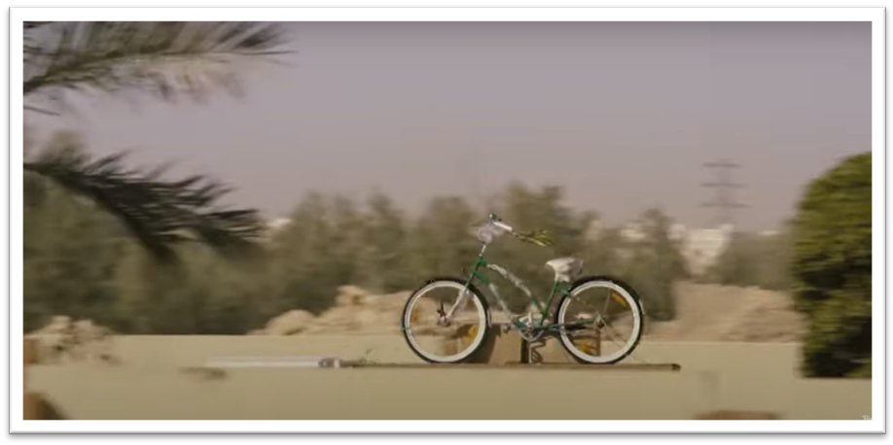

Figure 2. Wadjda stands transfixed as she watches the bicycle 'float' past.
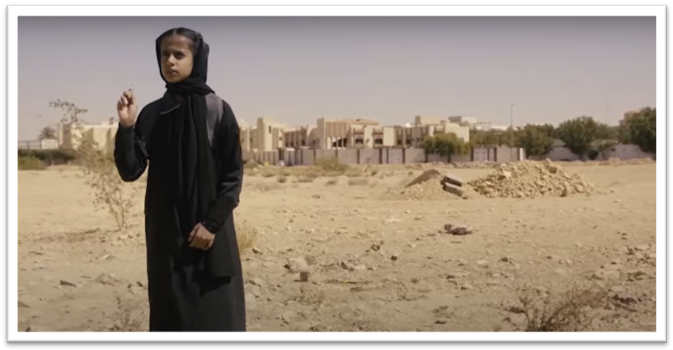

Therefore, Al-Mansour uses what Tauke (1994, p.23) calls ‘invisible notions of colour’– specifically Islamic notions – and connects them with the bicycle symbol. This results in what Freud (1976, p.383) called a ‘condensation’ of imagery – whereby multiple thoughts become distilled into a single image– as well as an example of Bakony’s (1974) definition of a symbol – a complex of conscious and unconscious associations. The unique condensation of meaning held within this image makes it an important resistance symbol. As Mohamed Aziza explains, the ‘process of modernization amounts to the process of acquiring new images’ (Shafik, 1998, p.47). In presenting a Saudi girl on a green bicycle, Al-Mansour provides exactly such an image – one that is simultaneously modern and rooted in culture. As she says herself (2014, p.11), the ‘interplay between tradition and modernity creates just the right amount of tension for great stories’.

Flourishing Female Presence in Offside
Jafar Panahi (2016) offers a resistance narrative more rooted in realism thanWadjda. The progress his characters make in Offside is significantly less triumphant, and yet despite this, the film was still banned in Iran. Panahi is also more outspoken against the restrictions of tradition. For example, he refutes the idea that censorship benefits art, arguing that censorship does not so much drive creativity, but that only talented artists are able to overcome its restrictions, and that, furthermore, such an artist might make better films in a free society (Panahi, 2016).
Offside follows a group of female football fans who are detained by stadium guards when they attempt to watch a World Cup qualifying match. Having been detained in an area that is tantalising close to a view of the pitch, the young women try to reason with the male guards to convince them of why they should be allowed to watch. Similarly, the men explain to the women why they cannot let them, arguing that they are protecting female purity (Toffoletti, 2014). Although Panahi’s mobility symbol is a bus in Offside, like the bicycle in Wadjda, it is established as a masculine space early in the film. In the opening scenes, we see a solitary young woman on the bus, dressed in men’s clothing, surrounded by male football fans who are singing loudly and fighting. This parallels the introduction of the bicycle in Wadjda, where we see Abdullah and his male friends riding bicycles while Wadjda follows on foot. In this way, both filmmakers present the vehicle as a space which is at first prohibited to females. After the bus arrives at the stadium, the young woman tries to make her way in but is detained by a guard, who escorts her to a cordoned off area where she meets several other female fans who are similarly dressed. Notably, the barriers here are pale green, and it is within this space that the men and women negotiate. They each share their frustrations – the women for being detained, and the guards for having to detain them. Everyone would rather not be there. Unlike Wadjda, who gets her bicycle and therefore her happy ending, the women in Offside do not get to see the match. Instead, they are arrested and placed on a bus to be taken to the vice squad headquarters. However, they nonetheless end up occupying, and in their own way dominating the space of the bus in the final scenes. This coincides with another symbolic use of the colour green, which grows in vibrancy between the beginning and end of the film.
The bus in the opening scenes of the film has a pale green stripe and is dirty, needing a fresh coat of paint (Figure 3), while the second has a much more vivid green stripe and is cleaner and newer (Figure 4). Here, as in Wadjda, colour is used in what Namiri and Sani (2017, p.95) describe as ‘a non-verbal and wordless language’. It communicates that growth has occurred, though it is small and easy to miss. However, this growth is demonstrated through interactions between the characters during the final journey, where the fans, the guards and the bus become Ciecko’s (2016) ‘composite vehicle’. In this more vividly green bus, the women have found companionship and confidence in each other. In contrast to the opening scene, where one woman quietly shrinks away so as to not be detected in the male-dominated space, the women in the final scenes are loud, they gesture and move around, they joke with each other and the guards, and they are expressive in their emotions about the football match. In other words, a female presence is flourishing and jostling for space, just as a plant does when it catches just enough light to start growing. In addition, the guards have softened, stopping to buy the women drinks (though they have been told not to stop), or leaning from an open window to position the radio antenna so that the women can hear the match results. These are minor victories compared to Wadjda’s, however, the colour symbolism encourages viewers to, as La Caze (2020, p.157) describes, ‘consider the importance both of gradualism and nonviolent resistance in politics and of realistic film-making’s capacities to anticipate and foster those advances’.
Figure 3. The first bus in Offside.
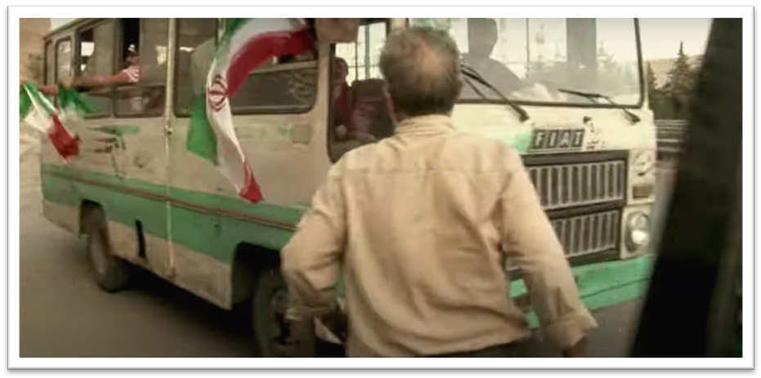

Figure 4. The last bus in Offside.
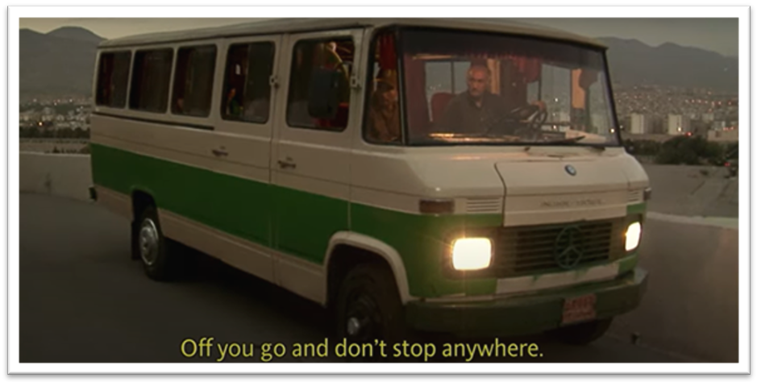

Presenting realistic narratives is important to Panahi’s filmmaking. He describes himself as a ‘social filmmaker’, insisting that this is the ‘exact opposite’ of a political filmmaker who takes a specific political position (2016, p.166). Rather, Panahi aims to hold a mirror to society, showing it as he finds it, leaving the viewer to make their own conclusions. ‘That is why I do not condemn anybody in Offside,’ he explains. ‘They are all prisoners of this society and in fact there is no difference between the prisoner and the prisoner’s guard’ (2016, p.167). Al-Mansour (2013, p.36) similarly distances herself from the political filmmaker label, saying that she did not aim to make a film that ‘clashes with the society’. Nonetheless, both films offer explorations of tension created through personal resistance; they are narratives of negotiation between tradition and modernity, between men and women, and, on a production level, between ‘censorship constraints… and passionate engagement’ (Chaudhuri, 2005, p.71).

Conclusion
As Ι have explained above, filmmakers use non-verbal, symbolic languages to communicate ideas, and this method is particularly useful for expressing resistance narratives in restrictive regimes. Al-Mansour’s Wadjda and Panahi’s Offside both use representations of mobility to explore modernity and feminism, as well as compromise – their vehicles navigate complicated, liminal spaces defined by negotiation and tension. When analysing established cinematic symbols, such as the bicycle, it is important to take into account culturally specific elements of both the symbol and its presentation. Colour can add layers of meaning to a symbol, such as in Wadjda, or can transform the meaning of a symbol through the course of a film, as we see in Offside. Ultimately, in regimes where creative voices are restricted, symbolism gives filmmakers the ability to still speak volumes, and as audiences we benefit from learning how to read and understand this rich visual language.

References
Al-Mansour, H. (2013) ‘A Woman's Voice Is Her Nakedness: An Interview with Haifaa Al Mansour’, interview by Maria Garcia, Cinéaste 38(4), pp. 34 – 37.
Al-Mansour, H. and Nam-Thompson, M. (2014) ‘Anatomy: of a Saudi Female Filmmaker’, World Policy Journal, 31(1), pp. 10 – 15.
Atwood, B. (2016) Reform Cinema in Iran: Film and Political Change in the Islamic Republic. New York: Columbia University Press.
Bakony, E. (1974) ‘Non-verbal Symbolism in the Feature Film’, Journal of the University Film Association, 26(3), pp. 34 – 38.
Chaudhuri, S. (2005) Contemporary World Cinema. Edinburgh: Edinburgh University Press.
Ciecko, A. (2016) ‘Bicycle Borrowers after Neorealism: Global Nou-Velo Cinema’, in Withers, J. (ed.) Culture on Two Wheels: The Bicycle in Literature and Film. Lincoln: University of Nebraska Press, pp. 244 – 262.
Freud, S. (1976) The Interpretation of Dreams. Harmondsworth: Penguin Books.
Hambuch, D. (2019) ‘Liberating Bicycles in Niki Caro’s Whale Rider and in Haifaa Al-Mansour’s Wadjda’, Imaginations Journal, 10(2), pp. 195-219.
Hornig, A. and Richter, M. (2013) The Vision. [Wadjda Original Soundtrack]
Kandiyoti, D. (2001) ‘The Politics of Gender and the Conundrums of Citizenship’, in Suad, J. and Slyomovics, S. (eds.) Women and Power in the Middle East. Philadelphia: University of Pennsylvania Press, pp. 52-58.
La Caze, M. (2020) ‘Realism as Resistance’, Angelaki, 25(5), pp. 156 – 170.
Mahdi, W. F. (2016) ‘Wadjda’, Journal of Islamic and Muslim Studies, 1(1), pp. 100 – 102.
Namiri, M. E. and Sani, R. M. (2017) ‘Symbolic Meaning of Colours in Safavid and Ottoman Mosques’, Journal of Shi'a Islamic Studies, 10(1), pp. 91 – 123.
Offside (2006) Directed by Jafar Panahi [Film]. Jafar Panahi Film Productions.
Panahi, J. (2016) ‘Jafar Panahi: Cinema and Resistance’, interview by Shiva Rahbaran, in Rahbaran, S. (ed.) Iranian Cinema Uncensored: Contemporary Film-Makers Since the Islamic Revolution. London: I.B. Tauris, pp. 163 – 178.
Podeh, E. (2011) ‘The Symbolism of the Arab Flag in Modern Arab States: Between Commonality and Uniqueness’, Journal of the Association for the Study of Ethnicity and Nationalism, 17(2), pp. 419 – 422.
Shafik, V. (1998) Arab Cinema: History and Cultural Identity. Cairo: Oxford University Press USA.
Sullivan, Z. T. (1998) ‘Eluding the Feminist, Overthrowing the Modern? Transformations in Twentieth-Century Iran’, in Abu-Lughod, L. (ed.) Remaking Women: Feminism and Modernity in the Middle East. Princeton: Princeton University Press, pp. 215 – 242.
Sviri, S. (2013) ‘Hidden Ways’ in Adams Helminski, C. (ed.) Women of Sufism: A Hidden Treasure. Boston: Shambhala, pp. 83 – 93.
Tauke, B. (1994) ‘Stain: Phenomenal and Literary Approaches to Color Studies’, Design Issues 10(1), pp. 19 – 28.
Toffoletti, K. (2014) ‘Iranian Women’s Sports Fandom: Gender, Resistance, and Identity in the Football Movie Offside’, Journal of Sport and Social Issues, 38(1), pp. 75-92.
Wadjda (2012) Directed by Haifaa Al-Mansour [Film]. Razor Film Production.
© Jennifer Chante. This article is licensed under a Creative Commons Attribution 4.0 International Licence (CC BY).

